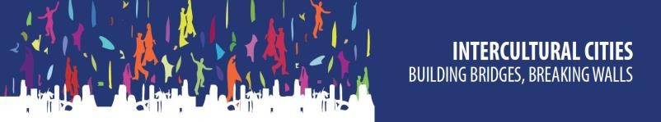 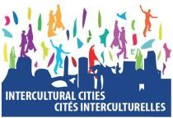 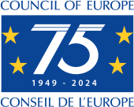

**Annual meeting of Intercultural Cities (ICC) Coordinators**

Braga and Vila Verde (Portugal)

14-15 November 2024

MEETING REPORT

**Published 20 March 2025**

Table of Contents

Introduction 3

14 November 2024 – Part I 3

Overview of 2024 4

2024 Highlights from national networks 10

Presentations of intercity grants 2024 12

Good practices presented by international cities 13

14 November 2024 – Part 2 13

Interactive workshop - Looking ahead. Ideas and proposals for ICC work in 2025 13

Reforming and renewing the ICC Programme 14

15 November 2024 – Part 3 15

Opening and welcoming words 15

Thematic workshop 1 – Disinformation and positive narratives in intercultural cities 16

Field visit to Bordando Pontes (Embroidering Bridges) 19

Thematic workshop 2 – Promoting inclusion of Roma and Travellers, the role of intercultural cities 20

Closing remarks 23

Field visit to the Ciga Giro Project 23

Annex I - AGENDA 25

Annex II - List of participants 28

# Introduction

The annual meeting of Coordinators of the Council of Europe’s Intercultural Cities (ICC) Programme took place in Braga and Vila Verde (Portugal) on 14-15 November 2024.

The annual meeting of ICC Coordinators reviewed accomplishments, addressed challenges and potential solutions, and facilitated the exchange of ideas for future collaborative efforts aimed at strengthening the ICC Programme.

The agenda also featured field visits to initiatives led by Vila Verde, workshops on strategies for cities to counter disinformation, develop alternative narratives, and promote the inclusion of Roma and Travellers.[1]

Additionally, the programme included presentations from national and regional ICC networks, the sharing of best practices, and an overview of the outcomes from the 2024 ICC intercity grants.

The agenda and list of participants of the meeting can be found in Appendices I and II.

# 14 November 2024 – Part I

**Opening of the meeting and welcoming words**

**Ricardo Rio**, Mayor of Braga, inaugurated the session, extending a warm welcome to the ICC members and network coordinators.

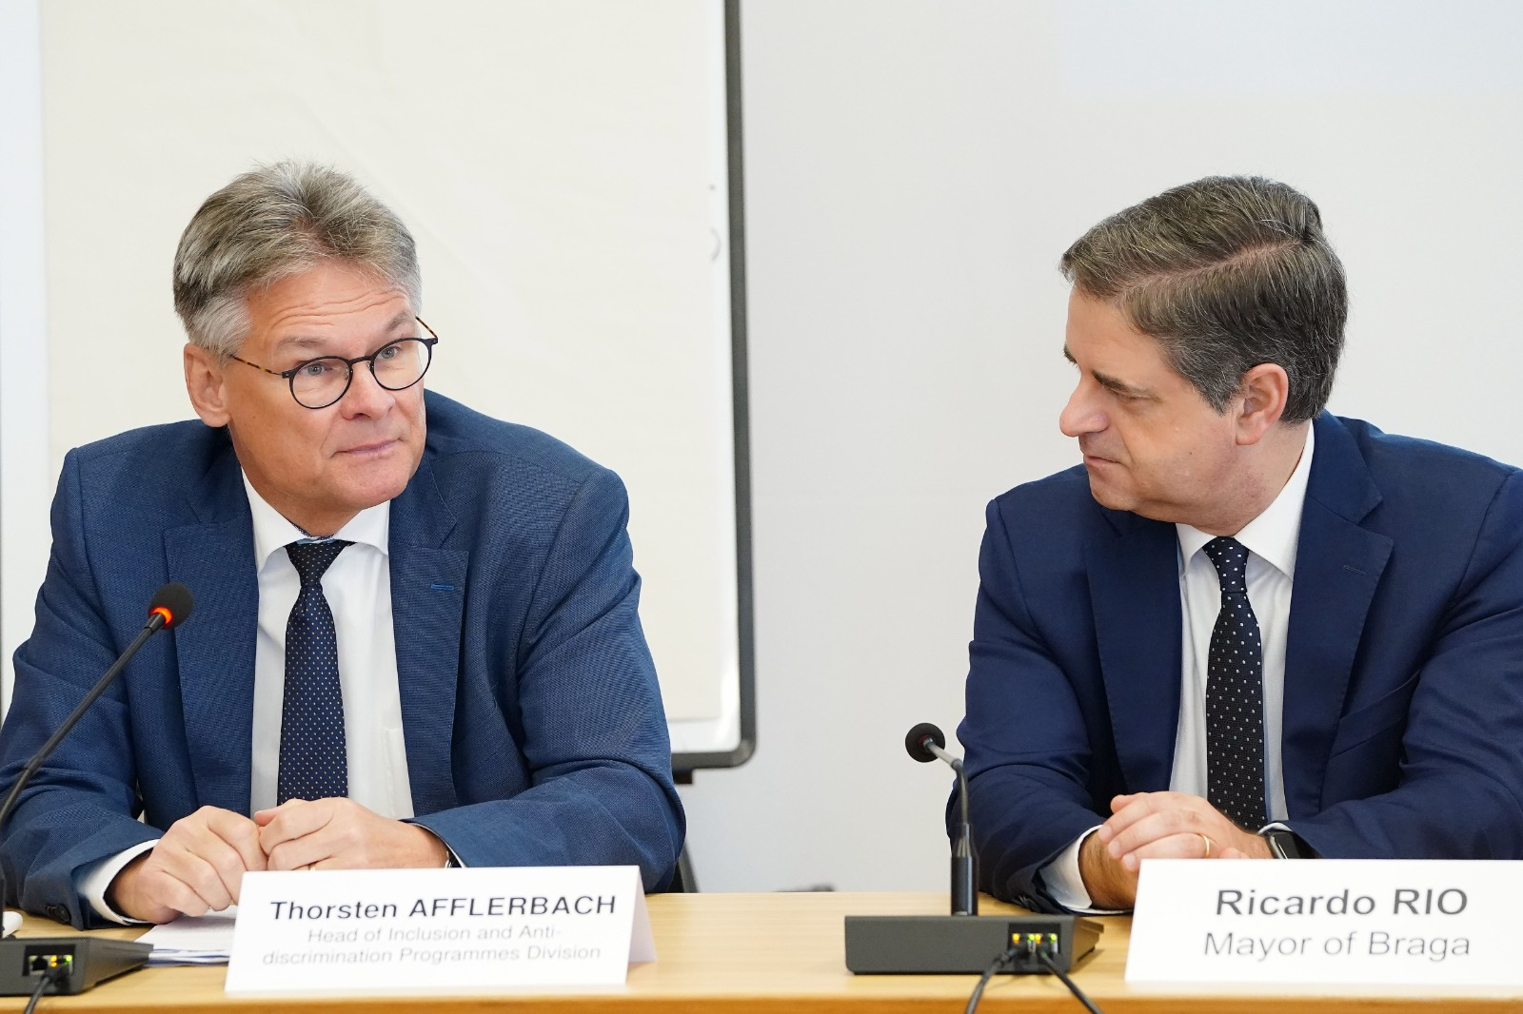

He highlighted that Braga is an internationally engaged city committed to exchanging experiences with other countries. The city has long prioritised improving policies, particularly in the area of intercultural inclusion. Efforts initially focused on enhancing the living conditions of the Roma community. Over time, Braga has adapted to rapid demographic changes, including migration waves from Eastern Europe, followed by a significant influx from Brazil, South America, and other regions. Today, Braga represents a diverse population of 130 nationalities.

In response to these changes, the city has implemented effective measures to manage and promote diversity. However, the exchange of ideas and experiences with other ICC cities remains a cornerstone of Braga's efforts to continuously refine its policies and foster an inclusive urban environment.

**Thorsten Afflerbach**, Head of Inclusion and Anti-discrimination Programmes Division, expressed gratitude to Mayor Ricardo Rio and the City of Braga for hosting the meeting.

He recalled Portugal’s accession to the Council of Europe in 1976 and noted that 2024 marks the 75th anniversary of the Council, a milestone to reflect on its contributions to human rights, democracy, and the rule of law over the past seven decades, and the 50th anniversary of the “Carnation Revolution” in Portugal, leading to democracy, decolonisation and development. This anniversary also provides an opportunity to celebrate member states' ongoing efforts to uphold shared values and standards.

Mr. Afflerbach highlighted Braga's integration into the Portuguese National ICC Network in 2016 under the coordination of Carla Calado. Among the city’s notable practices are a digital platform supporting the integration of new citizens through a multilingual approach (offered in five languages) and the "Human Library," where persons, including migrants and newcomers, share their personal stories and contributions to the city.

**Rita Marascalchi**, Head of the Intercultural Inclusion Unit, also expressed her appreciation to all participants and officially commenced the working session with an overview of key activities undertaken in 2024.

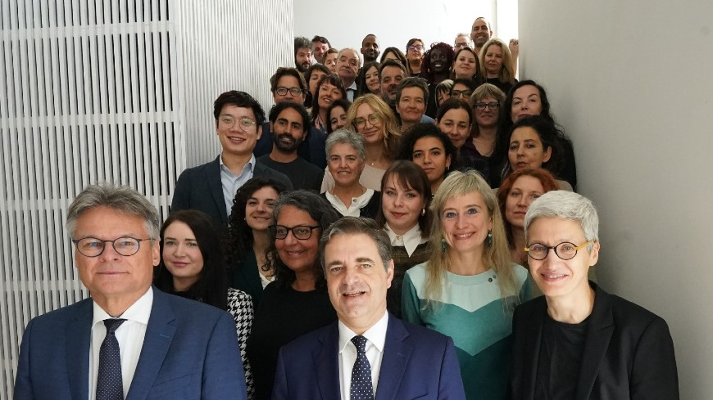

*Family photo of Council of Europe’s ICC Programme coordinators and Secretariat with Ricardo Rio, Mayor of Braga*

## **Overview of 2024**

***Membership developments***

The session commenced with the introduction of four new members who joined the international network of the ICC Programme in 2024:

* City of Asan (South Korea)
* City of Besançon (France)
* Department of Seine Saint Denis (France)
* City of Zagreb (Croatia)

***Indexes and visits***

Rita Marascalchimentioned the ICC members and cities involved in IIU projects having completed the questionnaire and contributed to the development of the **ICC Index in 2024**:

* Cities of Hämeenlinna, Kuopio, Tampere, Turku and Vaasa (Finland)
* Cities of Melton (Australia), Reggio Emilia, Montesilvano, Pontedera (Italy), Krakow (Poland), Mannleu (Spain), Asan (South Korea), Department of Seine St. Denis (France).

The Index Reports are available here: <https://www.coe.int/en/web/interculturalcities/index-results-per-city>.

The following cities were **visited by experts** from the Council of Europe as part of their efforts to engage with local communities, assess ongoing initiatives, and provide tailored recommendations:

* City of Botkyrka (Sweden)
* City of Riga (Latvia)
* Cities of Hämeenlinna, Kuopio, Tampere, Turku and Vaasa (Finland)

Additionally, the data on the **ICC Programme's website** has been regularly updated, with particular attention given to the Index Charts (<https://icc.bak-economics.com/>) and the Facts and Figures pages (<https://www.coe.int/en/web/interculturalcities/facts-and-figures>).

***Publications and translations***

The following **main documents** were published during 2024:

* [The Annual Survey Report of the ICC Programme 2024](https://rm.coe.int/icc-annual-survey-2024-results/1680b0d5ef),which presents the results of a survey conducted from 12 December 2023 to 26 January 2024 among member cities to gather information on their work on interculturalism.

* Immagine che contiene testo, schermata, silhouette

  Descrizione generata automaticamenteThe[Training manual on equality data collection   
  and analysis to prevent and address systemic discrimination](https://rm.coe.int/en-manuel-de-formation-sur-la-collecte-et-l-analyse-de-donnees-sur-l-e/1680aebefd), published by the Committee of Experts on intercultural inclusion (ADI-INT).

Two publications were produced within the framework of EU-CoE joint projects:

* Immagine che contiene testo, schermata, silhouette

  Descrizione generata automaticamente[Review of Current Practices in Multi-Level Governance in Finland](https://rm.coe.int/review-of-current-practices-in-multi-level-governance-in-finland/1680ae4990)
* [Report on social cohesion monitoring in Cyprus](https://rm.coe.int/report-monitoring-regional-social-cohesion-cyprus-2024/1680b1e520)

Rita Marascalchi pointed out the importance of receiving feedback on the use of the publications and tools, as these publications are aimed at being used by cities, regions and organisations interested in the issues.

In addition, **the following translations** were produced:

* [Anti-rumours handbook ([Finnish](https://rm.coe.int/anti-rumours-handbook-finnish-version/1680b1184c) and Polish](https://rm.coe.int/anti-rumours-handbook-in-polish/1680b0d357))
* The  [Intercultural Citizenship Online Test (Finnish)](https://www.coe.int/fi/web/interculturalcities/intercultural-citizenship-test)
* Immagine che contiene testo, Viso umano, persona, schermata

  Descrizione generata automaticamenteICC Policy Briefs on “Building meaningful public participation in Intercultural cities” ([Finnish](https://rm.coe.int/policy-brief-meaningful-participation-finnish/1680b26855)) and “Identifying and Preventing Systemic Discrimination at the Local Level” ([Finnish](https://rm.coe.int/policy-brief-systemic-discrimination-finnish/1680b26856))
* [The Intercultural Cities Step-by-step guide (Swedish](https://rm.coe.int/den-interkulturella-staden-steg-for-steg/1680afc698) and [Finnish](https://rm.coe.int/step-by-step-guide-finnish-version/1680b1184d))
* Two publications of the Committee of Experts on intercultural inclusion (ADI-INT):
  + Model Framework for an Intercultural Integration Strategy at the National Level ([Finnish](https://rm.coe.int/model-framework-for-intercultural-integration-fin/1680ae8a86))
  + Manual for the design of a training course on intercultural competence (in Polish - [Part 1](https://rm.coe.int/part-1-manual-for-creating-intercultural-training-courses-in-polish/1680b0d358) and [Part 2)](https://rm.coe.int/part-2-manual-for-creating-intercultural-training-courses-in-polish/1680b0d359)

Rita Marascalchi emphasised that translations are an important way to disseminate materials and experiences developed by the ICC Programme, and offering the document in a greater number of languages allows greater use of the shared practices and content developed by the Programme.

***Capacity Building***

Numerous capacity-building activities were implemented and supported in 2024, among which the following were particularly highlighted:

* Anti-rumours training for Polish Cities in Wroclaw
* Attendance of three Intercultural Cities at Placemaking Week in Rotterdam
* Workshop on active citizenship and participation in Strasbourg
* Anti-rumours training course held during Council of Europe’s No Hate Speech Week 2024
* Intercultural competences training in Nicosia and online in Greek
* Anti-rumours training for local and national levels in Cyprus
* Study visit of representatives from national bodies in Cyprus to Madrid in co-operation with Spanish Observatory on Racism and Xenophobia (OBERAXE)
* Media & Communication Training for Finnish municipalities
* Study visit of officials from Finnish cities to ICC cities in Portugal on intercultural integration and multi-level governance

***Communication and awareness***

The ICC Programme confirmed and expanded its presence both on the web (website) and on the main social media (X, Facebook).

The website is currently being revised and improved to make it more accessible and user-friendly.

Finally, **Rita Marascalchi** invites the coordinators to report useful content, which can then be shared by the ICC Programme to other cities in the network, complementing the information on activities carried out directly by the Programme.

The following events were attended by ICC Programme staff:

* The Placemaking Week in Rotterdam
* The ICC symposium in Japan
* The Disinformation cities workshop in Prato co-organized by ICEI
* The Italian network annual event in Torino

***Committee of Experts on Intercultural Inclusion (ADI-INT)***

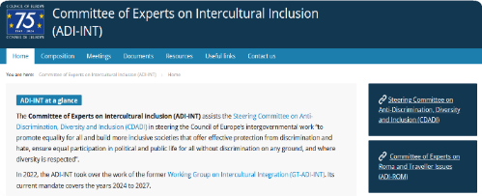

The committee has characteristics that make it a unique instrument, as it allows for cooperation between different governance levels, national, regional and local levels. Eight member municipalities of the ICC Programme participate in the committee, in addition to representatives from two regional authorities and from 10 national governments.

The objectives of the committee are to:

* Immagine che contiene vestiti, persona, sorriso, uomo

  Descrizione generata automaticamenteStrengthen the exchange between national level and regions and cities
* Implement the Committee of Ministers recommendation CM/Rec(2022)10
* Promote multilevel cooperation
* Increase Council of Europe’s member states awareness about the ICC programme and member cities
* Work on capacity building for intercultural integration

***EU/CoE joint projects***

**Nichola Howson**, Senior Project Officer in the Intercultural Inclusion Unit, presented the two joint projects being implemented in Cyprus and Finland. Co-funded by the DG Reform of the European Commission, these initiatives are executed in close collaboration with the governments of Cyprus and Finland.

The *“****Enhancing Structures and Policies for Intercultural Integration in Cyprus****,”* project represents the second joint effort between the European Commission and the Council of Europe, undertaken in partnership with the Deputy Ministry for Migration and International Protection of the Republic of Cyprus.

Commencing in October 2023 and scheduled for completion in December 2024, the project was designed to strengthen the previous project achievements and to support the rollout and use of the new tools which had been developed. The project aimed to further support intercultural integration policy both at the national and at the local levels, through capacity building, research and monitoring, as well as supporting the five Regional Intercultural Networks (Nicosia, Larnaca, Paphos, Limassol and Famagusta) in the implementation of activities from their intercultural action plans

For more information: [Intercultural integration in Cyprus - Intercultural cities programme (coe.int)](https://www.coe.int/en/web/interculturalcities/intercultural-integration-in-cyprus)

The project *“****Building an Inclusive Integration Approach in Finland****”* commenced in September 2022 and is scheduled to conclude in March 2025. Its primary aim is to support Finland in enhancing its integration policies, aligning these efforts with the Finnish concept of "good relations" and the intercultural integration framework championed by the ICC Programme.

Collaborating with seven Finnish municipalities — Hämeenlinna, Kuopio, Oulu, Tampere, Turku, Vaasa, and Vantaa — the project addresses integration policies and reinforces multilevel governance mechanisms to advance both integration and good relations policies.

For more information: [Building an inclusive integration approach in Finland - Intercultural cities programme (coe.int)](https://www.coe.int/en/web/interculturalcities/inclusive-integration-approach-in-finland)

***Cooperation with other international organisations***

**Ben Freeman**, Project Officer in the Intercultural Inclusion Unit, provided an overview of the collaboration between the ICC Programme and the **Placemaking Europe initiative**.

Placemaking represents a human-centred approach to urban planning and design, prioritising the needs and experiences of the people who use public spaces over the physical structures themselves.

In 2024, three cities — Reggio Emilia, Vinnytsia, and Wroclaw — were supported by the Council of Europe to participate in the Placemaking Week held in Rotterdam. During this event, the ICC Secretariat, along with representatives from participating cities, showcased the intercultural approach to inclusion, highlighting the potential synergies between the Intercultural and Placemaking methodologies.

As part of this collaboration, the *“Cities in Placemaking”* project (<https://placemaking-europe.eu/project/cities-in-placemaking/>) focused on developing a comprehensive roadmap and manifesto aimed at institutionalising the Placemaking approach, with a particular emphasis on securing political backing from city leadership.

Opportunities for stronger linkages between the placemaking and the intercultural approaches are being explored, particularly in relation to specific topics such as gentrification, neighbourhood segregation, and the integration of participatory approaches across various domains.

The ICC Programme has expressed its commitment to furthering efforts aimed at identifying synergies and promoting practices where the intercultural approach can be effectively applied within the framework of placemaking.

Additionally, the ICC Programme has announced that the forthcoming Placemaking Week, scheduled for 2025, will be hosted by Reggio Emilia, Italy.

***ICC evaluation and management response***

The evaluation carried out in 2022 – including 40 interviews, review of some 80 documents and web pages, data analysis (index results, around 600 best practices) and a survey addressed to ICC coordinators, generated 19 strategic and operational recommendations included in the [Evaluation report](https://rm.coe.int/dio-eva-dec-iccevaluation2022-finalreport/1680ab440c).

**Rita Marascalchi** outlined a series of key recommendations aimed at enhancing the effectiveness and impact of the ICC Programme. These suggestions reflect a strategic vision for the programme's growth and the optimisation of its governance and operations.

Firstly, the establishment of an **Advisory Group** was proposed to guide the programme's strategic direction and provide a structured framework for decision-making. This would be complemented by the **strategic involvement of cities** in forward planning, fostering a sense of shared ownership and collaborative development.

Another recommendation emphasised the need to transition from a single coordinator approach to a **group-based model for ICC coordinators**, enabling a broader exchange of ideas and expertise.

**Clear and transparent communication** was also highlighted as a priority, with a specific focus on restructuring the ICC website and its good practices database to ensure that information is presented in an accessible and user-friendly manner.

Improving communication on objectives and governance was identified as a critical area for development, alongside regular **follow-ups with international cities** to review progress in implementing strategies, address specific needs, and provide tailored support where necessary.

Additionally, the allocation of resources for the systematic collection, analysis, and dissemination of information was recommended. This would ensure that cities have **access to comprehensive data** on changes influenced by the programme, fostering evidence-based decision-making and best practices.

Further recommendations aimed at strengthening the programme included the promotion and **mainstreaming of the ICC Programme** within the Council of Europe’s structures. This would enhance its advocacy and influence at the national level.

To encourage broader participation, the introduction of a **simplified assessment mechanism** was proposed, enabling cities to gain experience before fully engaging with the comprehensive ICC Index.

Lastly, cities were encouraged to take a **more active role** in thematic work and the development of tools, reinforcing their engagement and contributing to the programme's overall effectiveness.

***ICC Programme Advisory Group***

The establishment of the Advisory Group follows the recommendation from the evaluation presented at the previous session and has the following composition (period 2023-2025):

**ICC national networks**

* Spanish network of Intercultural Cities (RECI) - Gemma Pinyol-Jiménez

**ICC international network (Europe)**

* Bradford - Barry Cusack [withdrew/membership suspended for 2024]
* Canton of Neuchâtel - Grégory Jaquet
* Stavanger - Ingrid Hauge Rasmussen
* Reykjavik - Joanna Marcinkowska / Aleksandra Kozimala
* Donostia/San Sebastian - Silvia Carballo Paz

**ICC international network (Overseas)**

* Salisbury - Vesna Haracic

Joanna Marcinkowska (City of Reykjavik) presented the activities of the group, which has met five times since its creation:

* 4-5 July 2023 – Strasbourg (France)
* 13 November 2023 – Bilbao (Spain)
* 21-22 May 2024 - online
* 30 September 2024 - online
* 13 November 2024 – Braga (Portugal)

The work of the group is based on the objectives that emerged from the evaluation of the ICC Programme carried out in 2022 and its recommendations.

The Group's mandate covers the period 1 July 2023 - 30 June 2025. At present, the Advisory Group has completed the following 4 Actions:

1. Team approach in cities was added to the mission of the coordinators and letters to Mayors;
2. Use of annual survey for inputs on priorities
3. Use of annual survey for inputs on needs
4. AG public statements for World Cities Day on 31 October and International Migrants Day on 18 December 2023

while the following 4 other Actions are currently in progress:

1. Questionnaire/survey for cities to track progress
2. Inspirational videos – Encourage members to share
3. Restructuring of website
4. Template for city strategies

and 2 Actions are in ‘pending’ status:

1. Annual Welcome Session
2. FAQ/tools (or other support) on engaging politicians

The Group's mandate expires at the end of June 2025, a call for interest will be launched in February/March 2025 to select new members.

The session ended with the video made by the City of Reykjavik to promote the city's intercultural policies ([ICCities Reykjavík Working Group on Intercultural Inclusion on Vimeo](https://vimeo.com/882830125?share=copy)).

## **2024 Highlights from national networks**

1. A panel discussion with national coordinators presented the main priorities and achievements of the ICC national networks in 2024.
2. The following topics and priorities have been presented by the ICC networks:

|  |  |
| --- | --- |
| 1. **Australian network** | * Recruit new cities to enlarge the network * Raise knowledge on interculturalism in Australian cities * The following activities have been carried out in 2024: * Webinars on different sectors (sport, young people, etc.) * Training for elected officials and technicians * Opened public discussion on interculturalism, with a multilevel approach |
| **Canadian**  **network** | * Increase in the number of participating cities * Contact with the Ministry of Immigration and preparation of a report to present an analysis on the financing of local policies for migrant inclusion * Preparation of a case study on intercultural cities outside Europe |
| **Italian**  **network** | * Capacity building on intercultural competences for Cities and CSOs (200 participants from 16 ICC cities from 6 countries) * Elaboration of intercultural and anti-discrimination local plans in 6 Italian cities + sharing with other cities of the network * Citizens’ participation in local intercultural policies through the intercultural assemblies’ methodology in 8 ICC cities in 4 countries * Young people engagement and activation in anti-rumours actions (14 Italian municipalities + 20 European cities) * Roma inclusion and antigypsyism (new topic for the Italian Network) * New narratives and disinformation: a new initiative (project STAND) will start on 1st January 2025 |
| **Marocain**  **network** | The network worked especially with cities, migrant communities and NGOs to foster the inclusion of sub-Saharan communities within Moroccan cities, through:   * + - The creation of focal points within municipalities     - Advocacy actions to influence legislation on migrants' rights     - Work with schools to promote intercultural values, including through the use of the anti-rumours strategy |
| **Portuguese network** | In 2024, the network focused on the theme intercultural inclusion through ‘Education’, in particular:   * The implementation of webinars for teachers on interculturalism * The implementation of workshops in 4 schools on anti-racism. * The publication of a guide on how to implement workshops in schools and a set of resources for cities. * Participation in the “EPIC-IDEA Empowering youth Participation for Inclusive and plural Communities” project, coordinated by ICEI and funded by the EC. * In addition, the network shared experiences with Cyprus and received the Finnish delegation in the framework of two joint projects promoted by the ICC Programme. |
| **Spanish network** | In 2024 the network focused on promoting thematic working groups on the following topics:   * Anti-rumours * Narratives * Indicators to demonstrate the success of interculturalism in the different sectors * Intercultural strategies * Fight racism via sport (new working group)   At the next national meeting of the network, the groups will present a work plan to deepen and concretise their work |
| **Ukrainian network** | Considering the context of the country, the network saw five cities implement activities on community resilience and support for displaced persons.  In addition, city needs analyses were carried out to try to address these needs, including psychological support for people who have become disabled as a result of the conflict. |

## **Presentations of intercity grants 2024**

**Brave Space Café – Cities of Leeds and Camden (United Kingdom)**

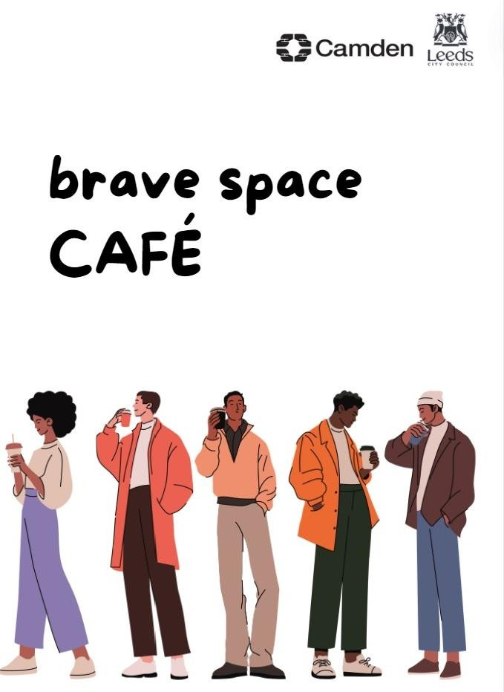

The Cities of Camden and Leeds have each implemented four "Brave Space cafes”, concentrating on countering rumours on different topics of community interest as a way of addressing prejudice. These sessions provided a series of opportunities for meaningful dialogue on areas of misunderstanding, informed by the Anti-Rumours methodology.

In particular, Camden's sessions focused on misconceptions and beliefs around domestic violence, refugees, LGBTI communities, and racism amongst black and Asian communities.

The sessions in Leeds discuss gender identity, disturbances across the UK and online misinformation, hyper-local rumours and finish with a podcast to bring the discussions together.

Thes “Brave spaces” for dialogue created an opportunity to dismantle false rumours and provide an alternative narrative. They also identified issues causing tension, helped break down barriers and build and promote good relationships in neighbourhoods.

**BRIDGE – Cities of Ravenna and Montesilvano (Italy)**

The BRIDGE project involved the municipalities of Ravenna and Montesilvano, both part of "Città del Dialogo”, the Italian Intercultural Cities network.

The project focused on the capacity building of local authorities to transfer competences and expertise in the field of intercultural policy and the management of welcoming and integration programmes.

Moreover, it worked to promote awareness raising of citizens through the involvement of groups of unaccompanied foreign minors to create a more informed, engaged, and empowered society.

Two study visits have been carried out in Ravenna and Montesilvano, involving 24 young migrants and 12 municipality officials. In addition, the exhibition "Along the Border" on human rights and migration has been hosted in both cities.

**Young Ambassadors project - Cities of Reykjavik (Iceland) and Wrocław (Poland)**

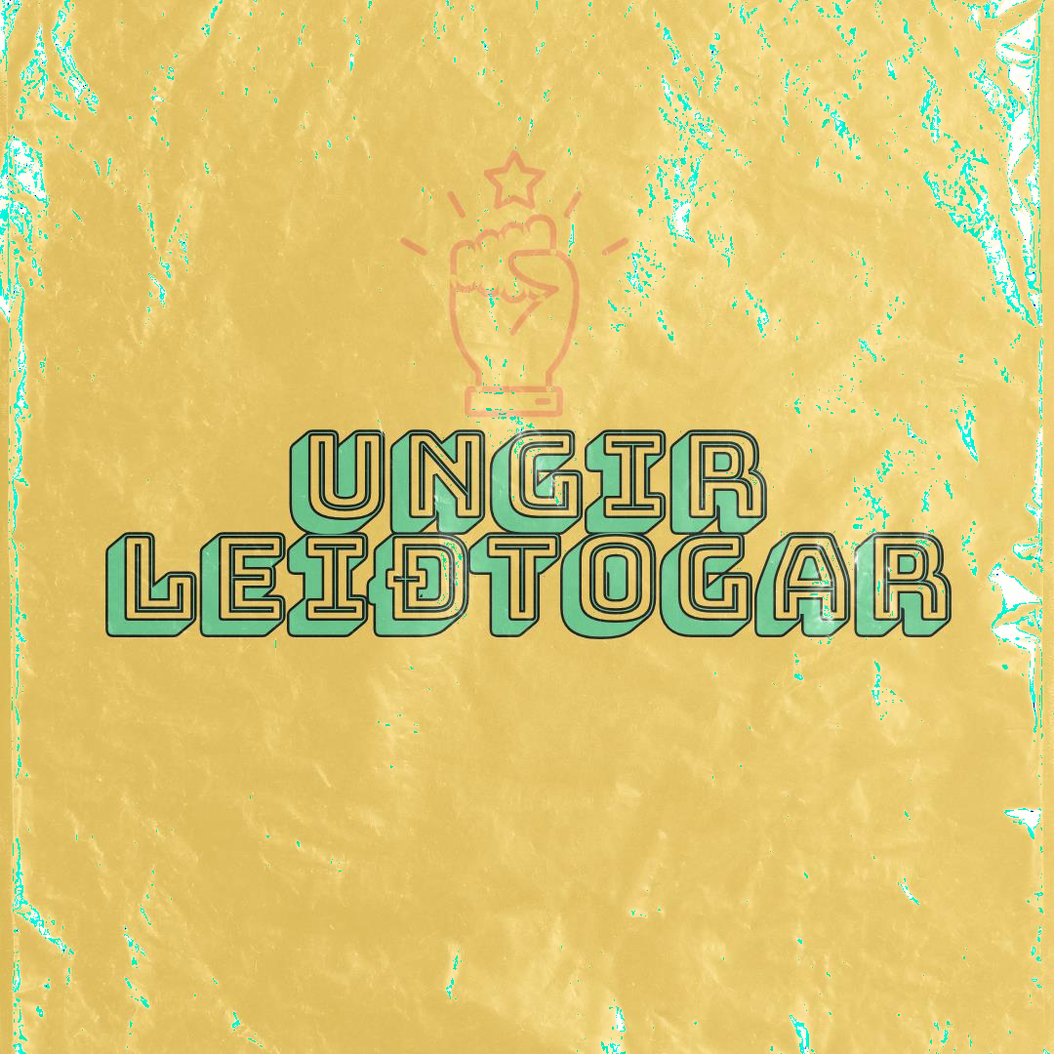Objectives of the Young Ambassadors project isto promote youth leadership and raise awareness among youngsters of foreign origin about the importance of being visible in public life, take space in public debate, and foster community engagement among young people.

For this, young citizens aged 13-16 from primary schools in Reykjavik and Wroclaw received extensive training in leadership skills, communication, public speaking, advocacy, project management, creativity, and innovation in campaign ideas on social media platforms, and participated in an exchange visit in Wrocław.

## **Good practices presented by international cities**

**City of Bergen (Norway)**

The city made a major investment of 90M euro to create a 17,000 square metre area for newcomers to teach them language, sports facilities, library (also for human library), café to exchange

**City of Besançon (France)**

Besançon carried out a diagnosis on interculturalism in the city and in 2024 started working with associations creating an Agora for newcomers to facilitate their participation in local policies with intercultural breakfasts to put in touch migrant associations with staff and politicians of the Municipality.

**City of Lublin (Poland)**

The City of Lublin carried out work on systematic inclusion overcoming the emergency for the inclusion of newcomers to stabilise the services and invest in psychological support, acting in a strategic long-term way.

**City of Paris (France)**

The city has developed an integration project to foster the language integration pathways of newcomers, based on 3 axes of work: 1) Assessment of language skills 2) Training integration stakeholders active in different fields to better orientate newcomers 3) Networking at local level (also through informal breakfasts) and creation of a network membership card.

**City of Sherbrooke (Canada)**

The city implemented an awareness-raising campaign to prevent racism promoted by the city with posters, panels, gadgets, etc., adopting the slogan: “*Sherbrooke contre le racisme et les discriminations”*.

# 14 November 2024 – Part 2

## **Interactive workshop - Looking ahead. Ideas and proposals for ICC work in 2025**

The workshop, facilitated by Simone Pettorruso and the ICC Programme team, aimed to gather ideas on the needs, priorities and challenges envisaged for the Programme's work in 2025. The participants' work focused on the following four questions:

* 1. What are your city/network’s intercultural priorities for 2025?
  2. What type of activities/support would you like to receive from ICC in 2025?
  3. What can your city/network contribute to / share with the programme in 2025?
  4. What are the challenges you see coming for intercultural inclusion in the coming years?

Through a dynamic methodology, the workshop gathered proposals from participants and identified the top 3 priorities for each question listed above.

*Question #1: What are your city’s / network’s intercultural priorities for 2025?*

1. To increase **transversality** across services within administration to implement intercultural process / methodologies
2. To design and **implement policies** against racism, discrimination, hate speech and rumours
3. To build **more inclusive cities** for migrants and refugees

*Question #2: What type of activities / support would you like to receive from ICC in 2025?*

1. **Capacity building** to strengthen cities' competences on key issues
2. **Cities to cities collaboration**, including more study visits and shared data for better collaboration
3. **Practical implementation of ICC methodologies** such as:

* Anti-rumours, repairing wounded communities, intercultural dialogue, antiracism, disinformation
* ICC Index, focusing on how to engage across departments and between elected policy makers and administrative roles

*Question #3: What can your city / network contribute to / share with the programme in 2025****?***

1. **Knowledge and good practice exchange** on:
   * Visual, creativity, inclusion, community of practices
   * Cultural mediators and intercultural champions
   * Training contents
2. **Hosting the next ICC event and thematic study visits**
3. **Analyse and share citizen’s need** to orient intercultural policies

*Question #4: What are the challenges you see coming for intercultural inclusion in the coming years?*

1. **Disinformation and Hate Speech** contributing to (and/or deriving from) polarization of society
2. **Finance** in different forms: low financing for intercultural policies, lack of funds for associations and communities, etc.
3. Hostile **political climate**

## **Reforming and renewing the ICC Programme**

**Rita Marascalchi** recalled that the evaluation, carried out in 2022, had provided recommendations with respect to the need to reform the programme and its modes of operation, in particular to increase transparency of membership and of the fee system.

This need and a proposal for action was then discussed in the Advisory Group and through meetings with the national Coordinators.

The rationale of the reform of the membership structure was presented and is based on the following objectives:

* Fairness, consistency, transparency, as well as clarity, and predictability of the membership system (membership criteria, benefits, fees)
* Equal treatment of members
* Stronger potential for outreach and strategic planning
* Stronger and more sustained commitment and ownership of members
* Longer term sustainability (overall resources: financial and participation)
* Stronger cooperation in resource mobilisation and strategic planning

Reforming the membership structure will lay a solid foundation for the programme's future development, fostering sustainability and enhancing its capacity for long-term growth.

This reorganisation will establish a more robust and equitable framework, enabling the Programme to adapt to evolving needs, engage more effectively with its members, and expand its impact across diverse contexts.

Furthermore, in order to propose an effective reform, the Secretariat had carried out research to compare with other networks **(21 networks analysed**). This research made it possible to identify some models for reflection on the future of the ICC Programme.

The proposed approach is designed around three main pillars:

1. Reform: This pillar focuses on strengthening the programme’s sustainability, credibility, and growth potential. By refining structures and processes, the programme aims to achieve both qualitative improvements in outcomes and quantitative expansion in participation.
2. Renew: This involves laying the groundwork for deeper engagement and collaboration among members. It emphasizes a more strategic use of expertise and capacity building while fostering ownership, involvement, and commitment from cities. Greater contributions from participants and enhanced collaboration in resource mobilisation will drive this renewal effort.
3. Reach-out: Clearer communication and well-defined rules will support the strategic growth of the network by fostering a more coherent and transparent approach.

To implement these changes, **transitional measures** that ensure gradual adjustments will be essential. Similarly, consultation with all stakeholders, including ICC members and national networks, is crucial to build consensus and align with shared objectives. Attention must also be paid to legal considerations, ensuring compliance and protection of all parties. Furthermore, maintaining fairness and transparency in membership fees will foster trust and accountability, creating an inclusive and fair system for all.

After considering the consultations and concerns raised by stakeholders, a potential **direction of travel** has been outlined to ensure the programme’s long-term sustainability and inclusivity.

One key proposal is the adoption of a **single membership category** for all participants, ensuring a unified structure that applies equally across the board. Under this framework, **all members would be expected to contribute** to the programme through a membership fee. Non-payment of this fee would, after due process, result in the suspension of membership until payment is resumed, to maintain fairness and accountability.

# 15 November 2024 – Part 3

## **Opening and welcoming words**

**Júlia Fernandes**, Mayor of Vila Verde, extended a warm welcome to the ICC Programme and the annual event. She introduced her city saying that Vila Verde is a dynamic city with a significant presence of individuals from migrant backgrounds. The city promotes policies and initiatives aimed at fostering welcoming environments and improving the quality of life for its new citizens.

**Thorsten Afflerbach**, Head of the Inclusion and Anti-discrimination Programmes Division, thanked Mayor Julia Fernandes for hosting the meeting, highlighted the significance of 1976, the year Portugal joined the Council of Europe, marking the culmination of a pivotal period of transformation. Vila Verde became part of the ICC national network in 2022 and is a committed city within the programme.

*Family photo of Council of Europe ICC Programme coordinators and Secretariat with Júlia Fernandes, Mayor of Vila Verde*

During the day, participants will have the opportunity to learn about two key initiatives in the city during short study visits. Additionally, the city is involved in other significant projects to support the integration of newcomers. While proud of its heritage, Vila Verde is also dedicated to inclusion and creating a welcoming atmosphere for all. Special thanks were extended to the municipal team and the Portuguese Network Coordinator, Carla Calado, for her support in organising the event.

## **Thematic workshop 1 – Disinformation and positive narratives in intercultural cities**

*Facilitated by Claudio Tocchi, ICEI*

At the start of the workshop, Claudio Tocchi asked the ICC members to answer some questions related to the topic of disinformation and the current level of experience in this area.

The participants confirmed that **disinformation is a relevant problem** (100% of respondents), while half of the participants frequently or regularly encounter this issue, with many addressing it on a daily basis. Furthermore, they perceive their knowledge, skills, and network capacity as inadequate to effectively manage the task.

The introductory presentation primarily addressed the difference between two fundamental concepts: misinformation and disinformation:

* **Disinformation** is false information that is deliberately created to harm, mislead or evoke an emotional response in a target audience.
* **Misinformation** is false or misleading information held and shared without intent to harm, often due to unconscious bias or by accident.

The Council of Europe addresses the issue of rumours, which are often spread unintentionally. In contrast, disinformation is deliberately created with the intent to mislead or harm. Disinformation and misinformation have long been present in political communication; however, in recent years, they have acquired pathological traits driven by three interrelated dynamics:

1. The advent of the internet and social media has facilitated the faster, more cost-effective, and broader dissemination of information.
2. These platforms have also enabled the monetisation of false but emotionally engaging news, supported by revenue models based on metrics such as “page views” and aggressive strategies like click-baiting.
3. Furthermore, disinformation and misinformation exploit and exacerbate the widespread distrust in institutions, a characteristic of many contemporary societies.

**Impacts of disinformation on city administrations**

Disinformation undermines trust both in institutions and between different societal groups. It also poses a threat to social cohesion, particularly as certain groups — such as migrants and ethnic minorities, religious minorities, LGBTI persons, and women — are disproportionately targeted in disinformation campaigns.

In particular:

*1. Targeting individuals*

Disinformation campaigns often target individuals within city administrations, particularly elected representatives and senior staff. These attacks frequently centre on specific policy platforms or initiatives, aiming to discredit or undermine trust in leadership. This type of disinformation not only erodes individual confidence but also discourages diverse representation in leadership roles, perpetuating systemic inequalities.

*2. Impacting communities*

At a community level, disinformation exacerbates divisions and amplifies distrust, both within and between different groups. Vulnerable and marginalised communities are disproportionately targeted, with disinformation often exploiting existing prejudices or societal tensions. For example, Roma communities in Italy have frequently been subjected to targeted disinformation campaigns, perpetuating harmful stereotypes and fostering exclusion.

*3. Impacting organisational functioning*

The organisational functioning of city administrations is also affected by disinformation. Threatening behaviour stemming from disinformation campaigns creates an unsafe working environment for staff, diminishing their engagement and overall well-being. Furthermore, the resources required to counter disinformation divert attention from core administrative responsibilities, undermining overall efficiency.

*4. Influencing elections*

Disinformation has a profound impact on democratic processes, particularly during elections. By eroding trust in the electoral process, it undermines the legitimacy of democratic institutions. Disinformation often discourages voter participation, with minority groups being disproportionately affected. Furthermore, false narratives and manipulative content can influence voter decisions, thereby skewing election outcomes and compromising the integrity of the democratic process.

**Response to disinformation is good governance**

In recognising the critical role of cities in combating disinformation, practical solutions and strategies are essential. Elements for a possible response to this phenomenon are contained in the [**Playbook “*Disinformation in the City”***,](https://www.gmfus.org/sites/default/files/2024-08/Disinformation%20in%20the%20City%20RESPONSE%20PLAYBOOK_0.pdf) recently published by the Melbourne Centre for Cities at the University of Melbourne and the German Marshall Fund.

The focus is not on determining which information is accurate or which channels are permitted to disseminate information (or censored): as the Playbook emphasises, “disinformation response must be non-partisan to be effective.” Instead of concentrating on deciding which news should or should not be shared, the Playbook highlights strategies for cities to prevent, respond to, or recover from disinformation outbreaks by fostering trust, strengthening community ties, enhancing communication, and promoting collaboration.

**Countering Disinformation**

*1. Building Trust*

Trust forms the cornerstone of any effort to combat disinformation. Establishing and maintaining trust involves ensuring the credibility and reliability of institutions, individuals, information sources, and even physical spaces. Trusted institutions—such as local governments, healthcare providers, and educational organisations—must prioritise transparency, consistency, and accountability in their operations.

*2. Building Communication*

Effective communication is essential in addressing disinformation, as it serves to bridge gaps in understanding and reduce the appeal of misleading narratives. Communication must be recognised as a two-way process, requiring both the dissemination of accurate information and the active engagement of audiences.

*3. Building Community*

Disinformation often exploits divisions within communities, magnifying existing social fault lines. Addressing this requires a concerted effort to understand these divisions and foster unity. By promoting inclusivity and shared understanding, city administrations can create a sense of belonging that counters the alienation often targeted by disinformation.

*4. Building Collaboration*

Collaboration is a critical component in the fight against disinformation, requiring the establishment of an interconnected ecosystem within the city. This ecosystem should bring together a range of stakeholders, including government institutions, think tanks, media organisations, academia, and civil society groups.

**Groupwork**

The participants were divided into five groups, with each group assigned a specific case of disinformation. Their task was to identify actions to address the issue from an intercultural perspective:

|  |  |
| --- | --- |
| **Building trust and collaboration** | Create platforms with other relevant stakeholders:   * Other institutions (police, health agencies, schools, etc.) * Local CSOs * Migrant and religious leaders/communities * Cultural spaces (libraries, museums, music halls, etc.) * Local news outlets * Academia * Other aggregation venues (pubs, sport clubs, etc.)   Be clear with potential victims that they will be protected and with potential perpetrators that they will be prosecuted. |
| **Building community** | Improve media literacy and critical thinking, with a specific focus on AI.  Map existing social and economic cleavages and vulnerable communities, groups, and spaces.  Build counter- and community narratives. |
| **Building communication** | Improve and maintain communication channels   * both online (municipality website and social network accounts) * and offline (regular meetings with stakeholders, public assemblies) |

Download the full report on the thematic workshop 1 – Disinformation and positive narratives in intercultural cities: <https://rm.coe.int/report-workshop-disinformation-and-positive-narratives-in-intercultura/1680b4d70a>

## **Field visit to Bordando Pontes (Embroidering Bridges)**

The *Bordando Pontes* (Embroidering Bridges) initiative is a compelling project that uses the art of embroidery as a medium to foster diversity, intercultural understanding, and social inclusion. Through a series of creative and educational activities, the project connects cultural heritage with contemporary social challenges, promoting engagement across different communities.

**Júlia Fernandes**, Mayor of Vila Verde, underscored the historical significance of sewing in the region, explaining how *Bordando Pontes* revitalises this tradition by integrating it into modern contexts. The initiative not only preserves cultural heritage but also strengthens social bonds, creating a sense of belonging among participants and the broader community.

A notable aspect of the project is its focus on empowering unemployed migrant women. These women receive training in producing traditional items, equipping them with valuable skills that can be applied within the local and global marketplace. Their participation fosters social inclusion, helping them to integrate into Vila Verde society while contributing to the local economy.

The products created through the project are sold in shops, with the support of over 70 partners who distribute them both nationally and internationally.

## **Thematic workshop 2 – Promoting inclusion of Roma and Travellers, the role of intercultural cities**

*Facilitated by Terezia Rostas, Welcoming Cultures UK*

Terezia Rostas introduced the **Welcoming Cultures Initiative** ([www.welcomingcultures.com](http://www.welcomingcultures.com)), a project devoted to preserving folk heritage, promoting inclusivity, and fostering intercultural understanding. Through events such as the *Cultural Caravan Showcase*, the initiative connects communities and celebrates diverse cultural expressions.

**The Sheffield example**

A case study from the city of Sheffield was then presented, highlighting the municipality's policies, including its approach to the Roma community. Sheffield boasts a rich cultural mosaic, with a significant proportion of residents representing diverse ethnicities. Local folklore traditions reflect this diversity, yet on a national level, there remains a noticeable gap in the visibility and support for these cultural expressions. The *Welcoming Cultures* project seeks to bridge this gap by raising awareness and providing a platform for folk traditions to thrive.

**Challenges faced by underserved communities**

Underserved communities often encounter numerous obstacles, including:

* Stereotypes that devalue minority traditional arts.
* Scarcity of funding and resources to sustain cultural practices.
* Generational disconnect, leading to a loss of cultural continuity.
* Limited access to platforms where cultural expression can flourish.

The initiative adopts a multifaceted approach to tackling these challenges, focusing on three key strategies. Firstly, it emphasises the importance of advocating for increased funding and the equitable allocation of resources to support cultural initiatives. Secondly, it promotes the creation of intergenerational events as a means to preserve and strengthen cultural continuity, ensuring that traditional practices and values are passed down through generations. Lastly, it seeks to educate the public about the intrinsic value of folk traditions, fostering a deeper appreciation and understanding of their significance in shaping community identity.

In practice, several effective interventions have been identified. These include fostering collaboration with local artists and cultural organisations to amplify the reach and impact of cultural projects. Additionally, the initiative organises community-driven events that celebrate and prioritise diverse folklore traditions, creating spaces where cultural expression can flourish. Importantly, it also focuses on engaging young people by establishing platforms that connect them with folk heritage, ensuring the sustainability of these traditions for future generations.

**Impact in Sheffield**

This year, the project engaged over 100,000 people through an array of workshops, festivals, and exhibitions. These events have been instrumental in fostering cultural appreciation and integration across Sheffield's diverse communities.

Historically, Sheffield’s music programmes have predominantly focused on classical genres and the initiative aims to diversify these offerings to better reflect the city's multicultural population. Research into decolonising music education has yielded several recommendations, including the integration of folk music in school curricula, the involvement of local musicians in educational initiatives, and the presence of folk music in community events to increase its visibility and appreciation.

For folk educators, several strategies are recommended to effectively promote and sustain the richness of cultural traditions.

Firstly, it is essential to actively engage with local communities to develop meaningful and collaborative partnerships. Building trust and fostering dialogue ensures that educational initiatives are rooted in the lived experiences and needs of the communities they aim to serve.

Secondly, educators should prioritise the creation of inclusive educational content that authentically represents and respects diverse cultural traditions.

Finally, encouraging intergenerational learning is a crucial component of preserving and revitalising cultural heritage. By bridging cultural and generational gaps, educators can facilitate the exchange of knowledge, experiences, and values between older and younger generations, ensuring that traditional practices remain vibrant and relevant in contemporary society.

**The importance of celebrating Cultural Heritage**

Cultural heritage plays a vital role in reinforcing our sense of identity and boosting confidence, both on an individual and collective level. Sharing cultural heritage not only strengthens the fabric of our communities but also fosters respect, understanding, tolerance, solidarity, and empathy. These values are essential for creating inclusive and harmonious societies.

To proactively celebrate and embrace cultural heritage, organisations should consider implementing the following initiatives:

* Incorporate community languages: Use languages spoken within the community in communications and events.
* Host traditional dress days: Encourage participation to showcase and celebrate diverse attire.
* Invite guest speakers and performers: Engage cultural ambassadors to share insights and talents.
* Celebrate cultural and national occasions: Mark festivals, days, weeks, or months significant to different communities.
* Encourage community engagement: Invite local residents to participate in workplace events.
* Diversify art and music: Integrate representative art, music, and cultural expressions into the workplace environment.
* Share traditional foods: Organise "bring and share" events to celebrate culinary traditions.
* Engage locally: Attend events and connect with local community groups to foster relationships.

**Groupwork**

The participants were divided into groups, with each group assigned 3 questions:

1. How does Roma inclusion look like in an ideal world in your city?
2. What is stopping you from achieving it?
3. How could you achieve it and who could help you?

|  |  |
| --- | --- |
| **How does Roma inclusion look like in an ideal world in your city?** | * Equal treatment and opportunities than other minorities and citizens * Inclusion in the urban areas (housing) * Trust of LAs * Safe locations * High level employment and education * Voice in the decision-making process |
| **What is stopping you from achieving it?** | * Lack of representation * Stereotypes, rumours, discrimination * Institutional discrimination/stigma * Negative narratives * Lack of knowledge about Roma communities * Mutual distrust * Lack of will of Roma to be integrated in the community * Difficult to engage the community |
| **How could you achieve it and who could help you?** | * Involve the leaders of Communities * Positive discrimination? * Capacity building and political will * Different Departments of the Municipality (housing, police, social services, etc.) |

Participants then carried out a “**Cultural Audit**” exercise to reflect on Roma inclusion.  
The cultural audit has been designed to help cities reflect on their efforts to include Roma communities and other marginalized groups by identifying strengths, gaps, and areas for meaningful change, with a focus on reducing discrimination, improving access to services, and fostering equity.

The following questions and participants’ contributions have been presented:

|  |  |
| --- | --- |
| **Strengths:**  **What practices or initiatives are currently working well in fostering Roma inclusion?** | Cultural events  Identify Roma communities’ leaders  Dialogue with community leaders with intercultural working groups  Roma Heritage month to spread message on Roma culture and fight stereotypes  Events gathering Roma from different cities  Dismantling stereotypes  National strategy on social integration of Roma people (national level)  Roma NGOs that are quite strong and involved in participation processes |
| **Gaps:**  **Where do you see the most significant opportunities for improvement?** | Engagement and communication  Hard to evaluate impacts  Specific public policies addressing inequalities  Low understanding among communities  Lack of cooperation with Roma communities and their leaders  Communication and engagement in city life  Education and understanding the needs on this sector  Aware of culture and social needs |
| **Story of Change:**  **Imagine a future where these gaps are addressed—what does Roma inclusion look like in your city?** | People feel part of the society  Promote inclusion of Roma in decision-making – More belonging to society  Community will be more diverse and inclusive  Increase the visibility of the Roma Community |

**Thorsten Afflerbach** highlighted the significance of 8 April (International Roma Day) as a pivotal date for raising awareness and visibility of the Roma community, emphasising its cultural and historical importance. He also underscored the relevance of the 5 November, dedicated to celebrating the Romani language and its rich heritage.

The Council of Europe is actively engaged in promoting Roma culture and inclusion, notably through its co-funding of the European Roma Institute for Arts and Culture (ERIAC), based in Berlin (<https://eriac.org/>), with a branch office in Belgrade, Serbia. This institute serves as a vital platform for showcasing Roma contributions to arts, culture, and society at large.

Additionally, the CoE collaborated with the European Commission (EC) on the [RomED project](https://coe-romed.org/romed1). The RomED project was designed to foster the inclusion and active participation of the Roma population through education. It aimed to enhance access to quality education for Roma persons while simultaneously strengthening the capacities of local communities to support educational integration.

Download the full report on the thematic workshop 2 – Promoting inclusion of Roma and Travellers, the role of intercultural cities, here: <https://rm.coe.int/report-workshop-reflecting-on-inclusion-of-roma-and-travellers-in-inte/1680b4d729>

## **Closing remarks**

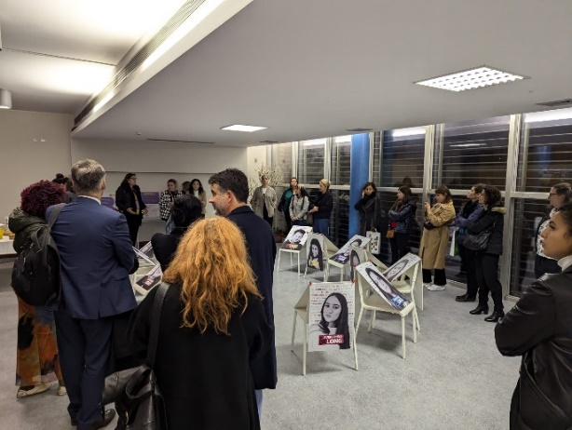**Rita Marascalchi** expressed her heartfelt thanks for the active participation and the valuable contribution the participants make in their daily work.

As we look ahead to the next year, she kindly invited cities to express their interest in hosting the upcoming meeting. The City of Paris has indicated its willingness to serve as the host for the next gathering.

In addition, the possibility of organising a study visit has been mentioned. Cities are encouraged to reflect on this opportunity and consider potential collaborations over the coming months. Such initiatives would further strengthen our shared objectives and foster deeper exchanges among participating communities.

## **Field visit to the Ciga Giro Project**

The Ciga Giro Project, based at the Vila de Prado Community Centre, is dedicated to supporting Roma communities through a comprehensive and strategic approach aimed at fostering social inclusion and integration.

The project’s overarching objectives include:

* Promoting equal opportunities for persons from disadvantaged backgrounds, with a particular focus on children, youth, and families of Roma ethnicity.
* Encouraging active citizenship to empower community members to participate meaningfully in societal and civic life.
* Combating discrimination by addressing systemic barriers and fostering understanding and respect.

A central pillar of the initiative is recognising and harnessing the educational and transformative power of arts and sports. By integrating these mediums into its programmes, the project seeks to inspire, engage, and equip persons with the tools and confidence needed to thrive in an inclusive society. The Ciga Giro Project serves as a vital platform for promoting diversity and equality, while celebrating the unique cultural heritage and potential of Roma communities.

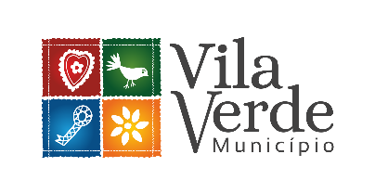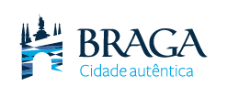

# Annex I - AGENDA

7 November 2024

**Purpose of the meeting:** The meeting of Intercultural Cities (ICC) coordinators is the annual gathering of coordinators of ICC international network members and coordinators of ICC national networks. This meeting aims to take stock of achievements, discuss challenges, and outline the next programme of work with a view to further developing both the ICC programme and the intercultural inclusion policy model.

**Participants:** Coordinators of cities which are member of the international ICC Network, and Coordinators of ICC national networks.

**Venue:** Braga & Vila Verde

**14 November**, Rua de São Domingos 94B, 4710-435 **Braga**

**15 November**, Praça 5 de outubro, n. 55. 4730-731 **Vila Verde**

**Working languages:** English and French

|  |
| --- |
| **14 November 2024 – Part 1** |

**9:00 Arrival and Registration of participants**

**9:30 – 09:45**

**Opening of the meeting** **and welcoming words**

* Ricardo Rio, Mayor of Braga
* Thorsten Afflerbach, Head of Inclusion and Anti-Discrimination Programmes Division
* Rita Marascalchi, Head of the Intercultural Inclusion Unit

**09:45 – 10:45**

**Presentations – 2024 in review - Council of Europe and ICC Programme**

* Recent relevant developments in the CoE
* Implementation of the recommendations from the 2022 evaluation
* Advisory Group

**10:45 – 11:15** Coffee break

**11:15 – 12:45**

**2024 Highlights from national networks and international cities**

* Panel discussions with national coordinators
* Intercity grants and good practices of international cities

***12:45 – 14:30***Lunch break

|  |
| --- |
| **14 November 2024 – Part 2** |

**14:30 – 15:45**

**Interactive workshop - Looking ahead – Ideas and proposals for ICC work in 2025**

*Facilitated by Simone Pettorruso, ICEI*

**15:45 – 16:00** Coffee break

**16:00 – 17:30**

**Presentation - Reforming and renewing the ICC Programme**

*By the ICC Secretariat*

**17:45 – 18:45**

**Informal meeting** between the ICC Secretariat and coordinators of national networks

**20:00** Dinner at La Porta Braga

[R. Dom Diogo de Sousa 19, 4700-421 Braga](https://www.google.com/maps/search/R.+Dom+Diogo+de+Sousa+19,+4700-421+Braga?entry=gmail&source=g).

|  |
| --- |
| **15 November 2024 – Part 3** |

**8:00 – transfer to Vila Verde by bus**

The meeting point for all participants will be in front of Mercure centro Braga hotel.

**9:00 – 9:15**

**Opening**

* Júlia Fernandes, Mayor of Vila Verde
* Thorsten Afflerbach, Head of the Inclusion and Anti-discrimination Programmes Division

**9:15 – 10:45**

**Thematic workshop 1 – disinformation and positive narratives in intercultural cities**

*Facilitated by Claudio Tocchi, ICEI*

* Introductory presentation
* Groupwork

**10:45 – 11:15** Coffee break

**11:15 – 12:30**

**Field visit**

Bordando Pontes (Embroidering Bridges). The goal of the project is to promote diversity and interculturality through:

* Implementation of Embroidery Workshops in educational contexts aimed at children and young people, including foreign students;
* Creation of scarves with poems in different languages in Aliança Artesanal (study visit place) ;
* Annual exhibition to showcase the work;
* Organization and realization of 1 exhibition to demonstrate the results and work developed throughout the various workshops and artistic modalities.

**12:30 – 14:00** Lunch break

|  |
| --- |
| **15 November 2024 – Part 4** |

**14:00 – 15:30**

**Thematic workshop 2 – Promoting inclusion of Roma and Travelers, the role of intercultural cities**

*Facilitated by Terezia Rostas, Welcoming Cultures UK*

* Introductory presentation
* Groupwork

**15:30 – 16:30** Coffee break and informal exchanges

**16:30 – 16:45**

**Closing remarks**

**17:00 – 18:00**

**Field visit**

Presentation of the project Ciga Giro on the way back, headquartered at the Vila de Prado Community Center.

The goal of the project is to support Roma communities with the strategic goal of promoting social inclusion and integration, equal opportunities, active citizenship, and non-discrimination for children, youth, and families from disadvantaged backgrounds, particularly those of Roma ethnicity, by valuing the educational power of arts and sports.

**18:30 Return to Braga**

# Annex II - List of participants

**ICC members**

*Besançon (France)*

STUYVERS Emily

*Canton de Neuchâtel (Suisse)*

BANISADR Zahra

JAQUET Gregory

*Bergen (Norway)*

SÆTRE Sølve

*Braga (Portugal)*

DIREITO António

*Donostia/San Sebastian (Spain)*

ADARRAGA Carolina

CARBALLO PAZ Silvia

*Krakow (Poland)*

FURDZIK Magdalena

*Leeds (United Kingdom)*

EVANS Becca

*Lisboa (Portugal)*

GUARITA Luís

*London Borough of Camden (United Kingdom)*

MOHAMED Ahmed

*London Borough of Lewisham (United Kingdom)*

HUYNH Edison

*Lublin (Poland)*

GNYP-ŚCIGOCKA Magdalena

*Modena (Italy)*

BARALDI Irene

*Paris (France)*

CHIKHAOUI Dora-Elysa

TEMIN Isabelle

*Reykjavik (Iceland)*

KOZIMALA Aleksandra

MARCINKOWSKA Joanna

*Riga (Latvia)*

VASILJEVA Irina

*Salisbury (Australia)*

HARACIC Vesna

*Sherbrooke (Canada)*

IDRISSA ABDOULAYE Roukayatou

*Stavanger (Norway)*

RASMUSSEN Ingrid

*Strasbourg (France)*

MUTI CHARLES Manon

*Vila Verde (Portugal)*

CERQUIERA Alexandrina

*Wroclaw (Poland)*

GOLAB-NOWAKOWSKA Ewa

ADAMIEC Maria

**ICC national networks**

*Australian ICC Network*

BALLANTYNE Glenda

*Canadian ICC Network (REMIRI)*

WHITE Bob

*Italian ICC Network (ICEI)*

DE PAOLI Rosaria

*Moroccan ICC Network*

LAMRANI Abderrahman

*Portuguese ICC Network (RPCI)*

CALADO Carla

*Spanish ICC network (RECI)*

PINYOL JIMÉNEZ Gemma

*Ukrainian ICC Network (ICC-UA)*

KHOVANOVA RUBICONDO Kseniya

**Facilitators**

PETTORRUSO Simone, *ICEI*

ROSTAS Terezia, *Welcoming Cultures UK*

TOCCHI Claudio, *ICEI*

1. The term “Roma and Travellers” is used at the Council of Europe to encompass the wide diversity of the groups covered by the work of the Council of Europe in this field: on the one hand a) Roma, Sinti/Manush, Calé, Kaale, Romanichals, Boyash/Rudari; b) Balkan Egyptians (Egyptians and Ashkali); c) Eastern groups (Dom, Lom and Abdal); and, on the other hand, groups such as Travellers, Yenish, and the populations designated under the administrative term “Gens du voyage”, as well as persons who identify themselves as Gypsies. The present is an explanatory footnote, not a definition of Roma and/or Travellers.