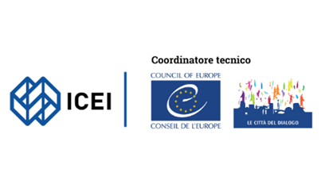Activity report

Italian ICC Network *Rete Città del Dialogo*

April-June 2024

*The opinions expressed in this document are the responsibility of ICEI, Coordinator of the Italian ICC Network and do not necessarily reflect the official policy of the Council of Europe.*

*This document is published as it was submitted to the secretariat.*

# Summary

In the second quarter, the Italian network continued the work of strengthening its activities and launched a number of important initiatives, both at the thematic level (e.g. on the inclusion of the Roma communities) and at the level of the network's strategy, thanks to the project CITIES - Cities Initiative Towards Inclusive and Equitable Societies, which started its activities in five cities.

At the same time, work continued to strengthen local civil society organisations in youth empowerment and anti-discrimination.

**Network coordination**

During the second quarter of the year 2024 ICEI organized the webinar “'**Local strategies for the inclusion of Sinti, Roma and Caminanti. Projects, services, and policies'** (10 April 2024) in cooperation with the City of Reggio Emilia, the University of Modena and Reggio Emilia and with the participation of UNAR - National Office Against Racial Discrimination and national experts on this topic.

The webinar started with an introductory speech by Mr Mattia Peradotto, Director of UNAR - National Anti-Racial Discrimination Office.

Mr Gianluca Grassi, Municipality of Reggio Emilia, presented the Local Action Plans and Anti-Gypsyism strategy.

Eva Rizzin, Scientific Responsible of the National Observatory on Anti-Gypsyism, presented an intervention on the topic “Anti-Gypsyism. The past and the present"

A round table has been then carried out, focusing on the role of cities – and their challenges and experiences – including interventions from Reggio Emilia, the Municipality of Milan and an exchange of experiences with other participants cities.

A total of 47 representatives of cities and institutions participated in the meeting.

Following this webinar, the Network decided to create an informal working group to continue the exchange of experiences and deepen the work on local strategies for the inclusion of Sinti, Roma and Caminanti.

The **Coordination meeting of the Italian network** was held on 25 June 2024 (online).

The Agenda included the following sessions:

* Greetings and introduction
* Introductory speech by Ms Rita Marascalchi - Acting Head of the Intercultural Inclusion Unit
* Interventions and actions implemented in the Cities (update)
* Intercity grant presentation by the cities of Ravenna and Montesilvano
* Presentation of the project CITIES by the Municipality of Reggio Emilia
* Presentation of results of the project NET-IDEA
* Presentation of results of the project DiverCities
* Recap on Roma webinar and proposal of working group between cities
* Conclusions

18 representatives of cities participated in the meeting, including representatives from the city of Portomaggiore, a new member of the network.

**New cities**

Following the resolution deliberated by the City Council and signature of the Statement of Intent by the city Mayor and the ICC Program, the city of **Portomaggiore** has formally joined the Italian network of intercultural cities.

# Activities

# The project *CITIES - Cities Initiative Towards Inclusive and Equitable Societies* started on the 21 March 2024 and carried out the kick off meeting on the 26-27 March in Reggio Emilia.

The project, that has been developed by ICEI, is lead by Reggio Emilia and it’s based on a partnership of Municipalities (Reggio Emilia, Modena, Ravenna, Olbia, Casalecchio di Reno), University of Modena and Reggio Emilia (UNIMORE) and 2 CSOs (ICEI, Mondinsieme).

Moreover, CITIES can count on important associated entities: UNAR - National Office against Racial Discrimination, the Emilia-Romagna Region and the Sardinia Region, the Council of Europe - Intercultural Cities Program, the cities of Leuven (BE) and Strasbourg (France), the Intercultural Cities Networks of Spain, Portugal and Sweden.

Its main objective will be to support cities in the participative definition of local anti-discrimination plans and the strengthening of prevention and anti-discrimination services. In addition, there will be an experimental component of a data collection service on discrimination, in cooperation between cities and academia.

In the first months of its implementation, the initiative started an analysis of the context and the need of the cities, that will provide information for the following training programme of LAs and CSOs.

The project "***Evolving Futures: Youth participation in EE24 and beyond***", promoted and financed by the European Parliament, aims at increasing the participation of young citizens in the creation and dissemination of new visions of the future of Europe. More specifically, the project supported their active role at local and European level, thus contributing to a more effective participation of young citizens in the construction of the present and future of the EU and raising awareness on intercultural and anti-discrimination actions.

Through a strategy based on the intercultural and inclusive approach and through the Future Thinking methodology, the project activated and involved a total of around 120 young people in 3 cities of the Italian Network: Modena, Venezia and Reggio Emilia.

The following activities have been carried out:

* 4 Youth forums: 40 young people, led by youth workers, were involved in a discussion on the issues of interculturalism and rights
* 3 Future Thinking Workshops: 38 young people took part in the workshops, starting from the reflections that emerged during the forums through the technique of role playing, involved the participants in imagining the future they want.
* 4 Creative Workshops: based on the reflections and results that emerged from the forums and workshops, 17 young people were involved, with the support of a local expert, in the creation of a communicable and digitally disseminable product: a podcast, an animated video and two video interviews
* 4 Local events: In each city, a public event was organised to disseminate and raise awareness on the issue of civic participation, reaching a peak of more than 100 participants
* 1 Final event: finally, 20 young people from Modena and Reggio Emilia came together in Milan (on 14 and 15 June) for a two-day event to discuss the path taken within the project.

The project **NET-IDEA *Network of European Towns for Interculturalism, Diversity, Equality and Anti-Discrimination*** concluded its activities at the end of April.

The following cities of the Italian ICC Network are directly involved in this initiative: Torino, Modena, Pontedera, Reggio Emilia.

After a major 2-year journey, the project achieved excellent results that can be summarized as follows:

* Curriculum on Intercultural Competence Training elaborated and tested
* More than 200 municipal staff trained
* More than 300 people in the community of practice
* More than 200 CSO representatives involved
* More than 200 youth activists involved
* Thousands of people reached by awareness-raising activities
* 18 workshops with young people carried out
* 18 public events
* BE EVERYTHING BELONG portrait exhibition
* BE EVERYTHING BELONG communication campaign

Central to the project are awareness raising high-impact public events focusing on self-identity and belonging, involving youth, and an international social media campaign “BE EVERYTHING – BELONG”. The following landing page has been created: <https://icei.it/be-everything-belong/>

The project **DIVERCITIES – *European cities for diversity and participation*** concluded the implementation of intercultural assemblies in all 8 partner cities in Italy (cities of Montesilvano, Modena and Pontedera), Spain, Portugal and Greece, with the active cooperation of local stakeholders.

DiverCities promoted and implemented innovative democratic approaches and tools to help citizens make their voices heard, with a strong focus on the participatory elaboration of local intercultural strategies through the organization of Intercultural Citizens’ Assemblies, knowledge sharing events and activities of awareness.

An important number of participatory sessions have been carried out in the 8 cities to provide a safe and open space for discussion for citizens and CSOs, to define cities’ recommendations for the design and implementation of intercultural policies.

A final event has been held in Strasbourg, at the European Youth Centre, to promote transnational Exchange and Dissemination of the project (4 and 5 June 2024), in cooperation with the ICC Programme of the Council of Europe.

The agenda of the 2 days has included the following programme:

4th June 2024

09:00 – 09:30 Welcoming & Registration

09:30 – 09:45: Introduction, Chiara Sorge, European Commission

9:45 – 11:45: DiverCities project: a general wrap-up/Intercultural Assemblies: an instrument for active participation

11:45 – 12:30 Exchange of views with the Committee on Migration, Refugees and Displaced Persons of the Parliamentary Assembly of the Council of Europe (PACE)

14:00 – 14:45 Exchange of views with the Youth Policy Division, European Youth Foundation

15:00 – 15:45 Exchange of views with the Hate Speech, Hate Crime and Artificial Intelligence Unit

16:00 – 16:45: Exchange of views with the Congress of Local and Regional Authorities session

16:45 – 17:15: DiverCities 2.0: Reflect upon a possible follow-up of the project

17:15 – 17:30: Closing Session

5th June 2024

09.00 – 09.30: Welcoming and registration

09.30 – 09.45: Opening

Giulia Bianchini, Senior Project Officer, Intercultural Cities Programme

Rosaria De Paoli, Director, ICEI/Italian Network of Intercultural Cities

09.45 – 10.00: Active citizenship and participation: the fourth principle of the Council of Europe’s intercultural integration model, Giulia Bianchini, Senior Project Officer, Intercultural Cities Programme

10.00 – 10.15: “DiverCities”: Conclusions and lessons learned from the project on active citizenship and participation, ICEI

10.15 – 10.30: Practical example: the Intercultural and Citizenship Council of Strasbourg

11.15 – 12.30: Group work on Active Citizenship for Intercultural Approach & Strategies

14.00 – 14.30: Group work on Active Citizenship for Intercultural Approach & Strategies

14.30 – 15.30: Presentation in plenary of the results of the group work

15.30 – 16.00: Looking forward and closure of the event

The project ***PAMI – Antidiscrimination Plan of the City of Milan*** concluded the training programme addressed to the Steering Committee of the municipality with 4 training events on different thematic aspects.

ICEI also supported the City of Milan in the elaboration of the local Antidiscrimination Plan that has been produced in a first draft version, that will be presented to the city council and approved in the coming months.

The Project **#Diversamente – Young people against discrimination** carried out the following main actions:

* Transnational Youth Camp of young anti-rumours activists held in Reggio Emilia from the 22 to the 27 of April 2024 with the participation of young activists from the Italian cities and from other EU countries (a total of 45 participants)
* Creation of an edutainment tool (collective game) for combating discrimination
* Starting of the participatory process for co-designing city strategies to fight youth discrimination
* Implementation of Anti-Rumours actions to fight discrimination within youth spaces in the 5 cities

Moreover, the project is working to increase protagonism and mobilisation of young activists to influence public policy-making and awareness-raising for diversity: young activists in the five cities will reach "new spheres of influence", strengthening their role as change-makers also at national level through the creation of a national network of "Young Anti-Rumours" that will co-design and implement advocacy actions addressed to institutions and awareness-raising campaigns for a wide audience.

# Communication

During Q2 2024 we focused on supporting and disseminating the communication and awareness raising campaigns of the main projects realized together with the intercultural cities of ICC networks, specifically the Italian RCD. We lunched the international campaign BE EVERYHING-BELONG in 16 intercultural cities of 6 countries, including Torino, Modena, Pontedera and Reggio Emilia, members of Italian network Rete Città Del Dialogo. The campaign was based a wide editorial plan on social media (Facebook, Instagram, LinkedIn and YouTube, included the Facebook page of RCD) with reels and video, a dedicated landing page and several press releases that gave visibility to RCD, the intercultural cities involved and the Intercultural Cities Programme. We also organized awareness raising events in all cities involved in the project, spreading the messages of the values of diversity, inclusion and interculturalism.

<https://icei.it/be-everything-belong/>

In this quarter we also launched the campaign related to the project Evolving Futures, Youth participation in EE24 and beyond, promoting the engagement of young generations in the European Election 2024 and the message of interculturalism as value and booster for the development of the Europe in the future. The communication campaign was national, while the cities involved were Modena, Reggio Emilia e Venezia Mestre, members of the RCD network. We developed and published a specific editorial plan, created a dedicated landing page and launched a survey on the perception of Europe and civil participation among young people promoted also by third party's media channels. A press release was distributed targeting local and national journals, and showing the results of the survey

[evolvingfutures.icei.it](http://evolvingfutures.icei.it)

The third communication campaign launched was related to project DiverCities, with a specific editorial plan and awareness raising event promoting participation and civil activism.

[icei.it/divercities](http://icei.it/divercities)

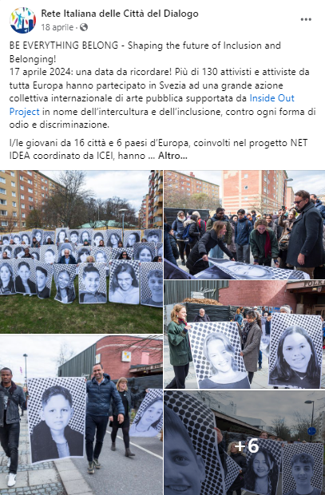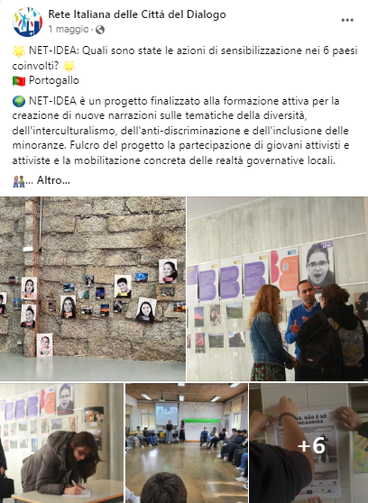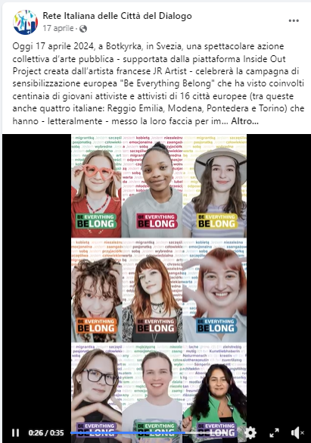

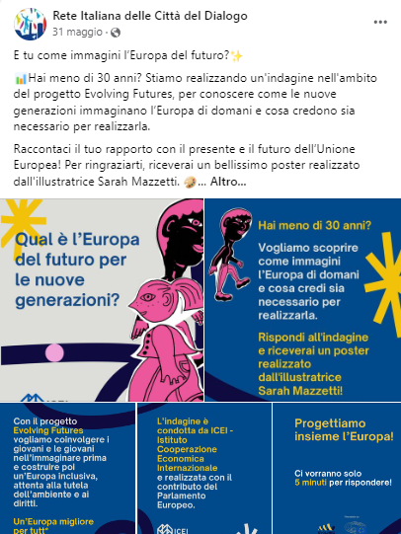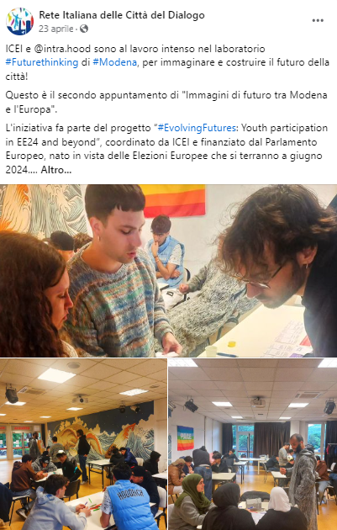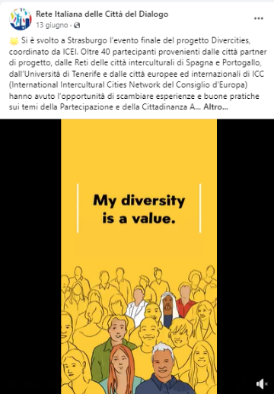

Specifically on RCD Facebook page we published 14 posts, highlighting local initiatives and projects and cities’ activities.

Our RCD Facebook Community is made up of 12.546 followers with raising engagement rates.