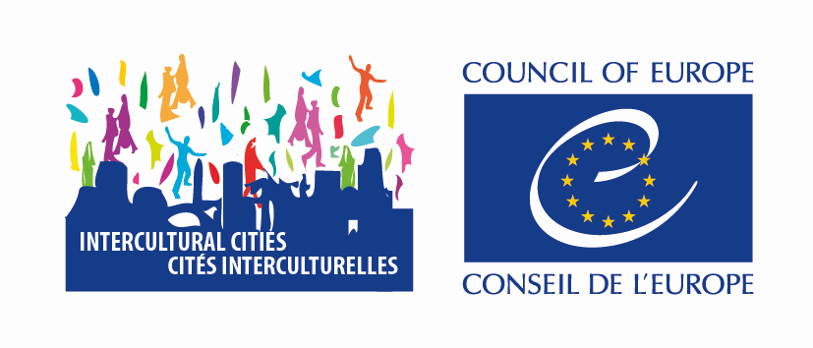

26 November 2025



COLLECTION OF GOOD PRACTISES: Guide & models

PURPOSE

The Council of Europe Intercultural Cities (ICC) Programme is a network of cities which find strength in diversity, sharing their hands-on experience to build resilient local communities for all.

The collection of good practices is a key pillar of the Intercultural Cities (ICC) Programme.

It enables participating cities to:

- Showcase concrete impact of intercultural policies and actions.

- Inspire and support replication of effective initiatives across the ICC network.

- Demonstrate political commitment to equality, inclusion, and diversity, and contribute to building resilient local communities for all, based on equality, diversity, interaction, and participation.

- Benefit from the experiences and expertise of other cities that have faced similar challenges, and work collectively to identify solutions and advance intercultural principles in local governance.

By joining the ICC programme, cities commit to sharing good practices on a regular basis.

WHAT QUALIFIES AS A GOOD PRACTICE?

A good practice is an action, methodology, experience, technique, or policy that has proved
to be successful, and which includes several of the following elements:

Is goal-oriented – with clear aims that advance human rights, democratic participation, and social inclusion.

Generates measurable results and impact that demonstrate change from the perspective of beneficiaries.

Is transferable and adaptable to other contexts, supported by clearly defined essential elements and processes.

Embeds environmental, social, and economic sustainability not only within the project scope, but also by linking with broader city strategies to ensuring long-lasting, systemic impact.

GOOD PRACTICES RELEVANT TO THE ICC

Addresses inequalities and combats discrimination in tangible ways. Promotes diversity as a shared asset, not a source of division.
Strengthens community cohesion, trust, and meaningful citizen participation.

Responds to the real-life needs of both newcomers and long-standing residents, ensuring that all members of the community benefit.

Integrates gender mainstreaming by combating discrimination and/or unequal treatment based on gender.

Applies an intersectional lens – responding to the specific realities of people who face multiple and overlapping vulnerabilities (e.g. women from migrant backgrounds, young people with disabilities, LGBTI persons with migration background, Roma and Travellers).

HOW TO DOCUMENT
YOUR GOOD PRACTICE?

When preparing your good practice, please ensure that it is:

- Clear, concise, and structured, but sufficiently detailed to allow others to understand and replicate it.

- Centered on the problem and the solution – briefly explain:

  - The challenge addressed (social, economic, environmental, cultural, etc.). The objectives you set out to achieve.
  - The main stages of implementation.
  - The actors and partners involved, including community representatives.

- Evidence-based – describe results and impact, showing positive changes and using (if applicable) both quantitative (numbers, statistics, indicators) and qualitative (stories, quotes, testimonies) evidence.

- Explicit about cross-cutting aspects:
  - Gender mainstreaming: Show how gender equality was considered and acted upon in all phases.
  - Integrating the youth perspective: Demonstrate how young people were involved with and benefited from the action.
  - Intersectionality: Mention how the initiative addressed multiple, overlapping forms of disadvantage.
  - Sustainability: Explain measures taken to ensure long-term benefits, and how the action can or was integrated into the city’s strategy on inclusion.

- Focused on replicability – outline the key factors for success, potential challenges, and any preconditions needed for transfer to other cities or contexts.

- Supplemented with resources – include links to relevant reports, websites, policy documents, or visual materials.

GOOD PRACTICE FORM

Any section marked with an asterisk must be completed

Contact information*
City name (Country)
Contact person
Position / Role
Department / Service
Email

Theme of the good practice*
Anti-discrimination and Equality
Anti-rumours
Business and Employment
Communication and public awareness
Culture, Leisure and Heritage
Developing a culture of openness and Interculturality
Education
Gender equality and Intersectionality
Health, Social care and Family support
Housing and urban planning
International outlook
Leadership and Political Commitment
Mediation and conflict resolution
Multilingualism
Neighbourhood
Political and public participation
Public and Community Services
Refugees
Religion and Interfaith
Roma
Security, Justice and Safety
Welcoming and social integration
Youth
Combating disinformation

Title and summary of the initiative*
Short, clear and engaging title
Please also specify the relevant theme of the initiative based on the website classification to help with processing and organisation.

Concise description of the action: main objectives, target groups, expected change
Dates of implementation

Context / Problem identified*
- Origin of the initiative (how the idea emerged, consultations, data, etc.)
- Target groups (residents, specific communities, etc.)
- Challenge, need or barrier addressed: (Inequalities, discrimination, social, economic, environmental or cultural challenges)

Implementation process*
- Timeline (key dates / duration)
- Main steps:
  - …
- Stakeholders and partners involved (municipal departments, civil society, economic actors, citizens, etc.)

Results achieved*
- Quantitative (figures, statistics, before/after indicators)
- Qualitative (testimonies, stories, quotes)
- Outcomes – short to medium term
- (expected) impacts
- Overall impact on cohesion, equality and diversity
- Please mention specifically the key success factors you have identified.
- Please highlight the challenges you faced and how you overcame them.

Cross-cutting aspects*
Please indicate how, to the extent possible and relevant, the following aspects were integrated into the good practice:

- Gender equality (how gender equality and inclusion of multiple gender identities were integrated)
- Youth perspective
- Intersectional approach (addressing multiple and overlapping vulnerabilities)
- Sustainability (measures to ensure long-term continuity of the action)

Resources and Documentation
Reports, photos & videos (with credit and permissions of participants), web links, policy documents, etc.

Link to UN Sustainable Development Goals (SDGs) [tick max. 2-3]
- No poverty
- Zero hunger
- Good health and wellbeing
- Quality education
- Gender equality
- Clean water and sanitation
- Affordable and clean energy
- Decent work and economic growth
- Industry, innovation and infrastructure
- Reduced inequalities
- Sustainable cities and communities
- Responsible consumption and production
- Climate action
- Life below water
- Life on land
- Peace, justice and strong institutions
- Partnerships for the goals

