SUPPORTING WOMEN’S ACCESS TO JUSTICE IN TURKEY
BH4697/GA/2021

Declaration on the exclusion criteria for EU funds (applicant legal person)

Done in [Click here to insert the place name]
On [Click here to insert the date]

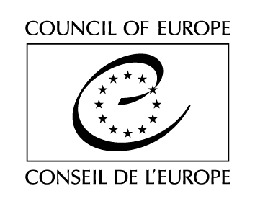
I, the undersigned, [Click here to insert the first name and family name of the signatory of this document]

acting as the representative of
Name and legal form: [Full official name and official legal form]
Address: [Full official address]
VAT No.: [VAT registration no. (if any)]

hereby declare that:

a) Neither the Organisation I represent nor its owners or executive officers have ever been convicted by final judgment for any of the following offences: participation in a criminal organisation, corruption, fraud or money laundering, terrorist financing, terrorist offences or offences linked to terrorist activities, child labour or trafficking in human beings;
b) Neither the Organisation I represent nor its owners or executive officers is bankrupt, being wound up, no longer allowed to trade or subject to a judicial insolvency procedure or an arrangement with creditors or in any similar situation resulting from a procedure of the same type or subject to a procedure of the same type;
c) Neither the Organisation I represent nor its owners or executive officers have ever been convicted by a final judgment for serious professional misconduct or any other offence relating to professional conduct;
d) The organisation I represent and/or its owners or executive officers have fulfilled all obligations relating to the payment of social security contributions, taxes and duties under the legislation of the country in which it is established;
e) Neither the Organisation I represent nor its owners or executive officers are in a situation of a conflict of interests or a potential conflict of interests in relation to this grant award procedure. The Organisation I represent, its owners or executive officers have been notified and understand that a conflict of interests may arise, in particular, from economic interests, political or national affinities, emotional or family ties or any other type of shared relationship or interest;
f) the organisation I represent is not included in the lists of entities subject to restrictive measures applied by the European Union (available at www.sacntionsmap.eu);
f) the information provided to the Council under this procedure is complete, correct and truthful;
g) if a grant is awarded, I will provide the Council with the following documents upon request:
- In relation to the matters referred to in sub-paragraphs a), b) and c) above, a recent extract from the criminal record or an equivalent recent document issued by a judicial or administrative authority in the country of origin or provenance, showing that the requirements referred to have been met. If the national law of the country in which it is established does not provide for such documents to be supplied to legal persons, these documents shall be requested for natural persons concerned, such as the administrators or any person vested with powers of representation, decision or supervision on the participant’s behalf;
- In the case referred to in sub-paragraph d) above, recent certificates or letters from the relevant authorities of the state concerned are required. These documents must provide proof of payment of all the taxes, duties and social security contributions owed by the applicant including VAT, corporation tax and social insurance contributions;
- In relation to the matter referred to in sub-paragraph f) above, an extract from the companies register or an equivalent official document.
If necessary, where one of the documents referred to above is not issued in the country concerned, it may be replaced by a sworn or, failing that, a solemn statement made by the interested party before a judicial or administrative authority, a notary or a qualified professional body in the applicant’s country of origin or provenance.

In signing this form, I acknowledge that I have been notified that if any of the statements made or information provided prove to be false, the Council of Europe reserves the right to exclude the proposal concerned from the procedure or to terminate any existing contractual relations related to the latter.

[Click here to insert the name of the signatory (e.g. J. Smith)]

