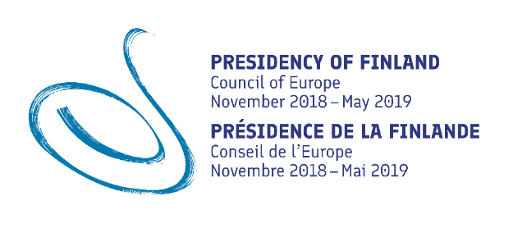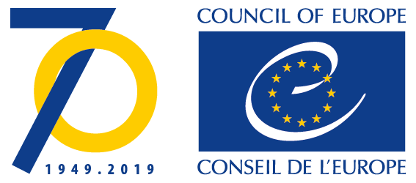
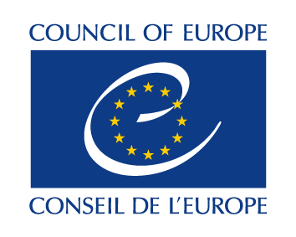
DGII/EDU/EPAN (2019) 1 Final
11.04.2019

“ENCOURAGING DEMOCRATIC CULTURE AND HUMAN RIGHTS – SCHOOLS
IN ACTION”
Council of Europe Conference of the Finnish Presidency of the Committee of Ministers
Helsinki Congress Paasitorni
16-17 April 2019

Concept and Programme

Background and context
The Council of Europe’s Reference Framework of Competences for Democratic Culture (RFCDC) was developed by a multi-disciplinary expert group from 2013 to 2017 and launched at the Council of Europe Conference of the Danish Chairmanship of the Committee of Ministers “Democratic culture – from words to action”, which was held in Copenhagen 23-24 April. The Reference Framework comprises three volumes: volume 1 contains the model of Competences for Democratic Culture endorsed by the Ministers of Education in April 2016, which sets out the Values, Attitudes, Skills and Knowledge and critical understanding that all citizens need to participate actively in modern democratic societies; volume 2 contains the bank of descriptors designed to help educators to teach and assess the competences; and volume 3 offers guidance on how the model of competences may be used in developing curricula, pedagogical and teaching approaches, assessment and resilience to radicalisation. Ongoing development of the Reference Framework includes descriptors for younger learners, guidance on implementation of the competence model in the field of higher education, and a portfolio. The French version will be published in 2019 and translations into other languages are under way.

The Copenhagen conference also hosted the first meeting of the Education Policy Advisers Network (EPAN) established by the Steering Committee for Education Policy and Practice (CDPPE) to develop national and regional strategies for implementing the Council of Europe’s resources in the field of democratic citizenship and human rights education, in particular the Reference Framework and the Charter. The members of the Network, appointed by the education authorities of all the signatory states of the European Cultural Convention, are also active in promoting the new education project “Free to Speak, Safe to Learn – Democratic Schools for All”.

Relevance to the Presidency

The main goal of the Finnish Presidency of the Committee of Ministers of the Council of Europe is to further strengthen the crucial work of the Council of Europe in advancing human rights, democracy and the rule of law. This core mandate of the Council of Europe is particularly important now that human rights are being challenged at both the European and global level.

The European system of human rights and the rule of law does not function in a vacuum. It needs the capacity/to be able to react to changes and new challenges arising in Europe and beyond. The enjoyment and the protection of human rights must be guaranteed also in the future. Here, education plays a central role. Promoting education on human rights and democratic values lies at the core of the Council of Europe. Therefore, the priorities of the Finnish Presidency Programme are fully in line with the priorities of the Council of Europe Education Programme.

A whole-school approach is advantageous when improving critical and creative thinking, participation, collaboration and social inclusion of young people as well as eliminating bullying, hate speech, discrimination and marginalization, all elements that also help preventing violent extremism.

The theme of the conference

The main theme of the conference will be “Encouraging Democratic Culture and Human Rights – Schools in Action”. The goal is to promote the dissemination of the Reference Framework of Competences for Democratic Culture (RFCDC) and enable it to be applied in member states in a system-wide manner, with a special focus on 1) curriculum development, 2) teacher’s profession, including initial and in-service education, and 3) assessment practices.

The conference will take stock of effective practices in Finland and other member states and identify areas and challenges that require further attention in the future.

Format of the Conference
Several plenary sessions, keynote presentations and EPAN working group sessions will offer opportunities for participants to discuss and share knowledge and examples of good practice.

Conference budget
The Conference is being co-organised by the Finnish Ministry of Education and Culture, Finnish National Agency for Education and the Council of Europe’s Education Department under the Finnish Presidency of the Committee of Ministers. The Council of Europe will cover transport and accommodation costs for the appointed members of the Education Policy Advisers Network and invited experts as well as provide interpretation between the Council of Europe’s official languages (English and French). The Finnish hosts will provide meals during the conference and organise a cultural programme for participants at the end of the first day.

Programme

Pre-Conference Day, Monday 15 April 2019 (Optional – List now full)

School visit: Lycée Franco-Finlandais d’Helsinki, 11.00 – 14.00.
The bus for school will leave from in front of the Hotel Scandic Paasi at 10h30
Free lunch provided at the school

Day 1, Tuesday 16 April 2019
09:00 | Registration of participants, coffee  Venue: Helsinki Congress Paasitorni  Paasivuorenkatu 5 A, FIN-00530 Helsinki
10:00 –10:45 | Opening Ceremony “Encouraging Democratic Culture and Human Rights – Schools in Action”  Congress Hall/ 2.5th floor  Music: Pupils of Kruununhaan yläaste School  Welcoming remarks  Mr Timo Soini, Minister for Foreign Affairs of Finland  Mr Olli-Pekka Heinonen, Director General, Finnish National Agency for Education  Mr Matjaž Gruden, Director of Democratic Participation, Council of Europe  Welcome by Ms Maija Innola, Education Counsellor, Finnish Ministry of Education and Culture, Vice Chair of the Steering Committee for Education Policy and Practice of the Council of Europe (CDPPE)  Chair: Mr Jorma Kauppinen, Director, Finnish National Agency for Education, Member of CDPPE
10:45 - 11:45  11.45 – 12.00 | Plenary Session 1:  Democracy as culture and practice – the Finnish approach  Chairs: Mr Michael Remmert, Head of the Education Policy Division, Education Department, Council of Europe  and Ms Maija Innola, Education Counsellor, Finnish Ministry of Education and Culture, Vice Chair of the CDPPE  Keynotes:  - Towards a better Democracy, Mr Matti Rautiainen, Senior lecturer, PhD, Faculty of Education and Psychology, University of Jyväskylä  - Aspects on CDC and assessment, Ms Najat Ouakrim-Soivo, Senior Adviser, PhD, Ministry of Education and Culture  - Whole School Approach and Democratic Competences in practice  - Ms Laura-Maria Sinisalo, MA, teacher, Latokartano School, Helsinki  - Student’s voice: Mr Onni Härkönen, Kallio Upper Secondary School, Helsinki  Discussion  Introduction to the workshops for the Council of Europe Education Policy Advisers Network (EPAN)  Mr Christopher Reynolds, Ms Katerina Toura, Education Policy Division, Council of Europe
12:00–13:30 | Lunch, Restaurant Paasi, 2nd floor
13:30– 15:30 | Parallel Workshops for EPAN Members  Alternative activity for non-EPAN participants:  Implementation of Competences for Democratic Culture in co-operation with NGOs and other stakeholders  Room 304/ 3rd floor
13:30– 15:30 | Curriculum development  Congress Hall/ 2.5th floor  RFCDC in the Finnish Core Curriculum (15 min.)  Ms Kristina Kaihari, Counsellor of Education, Finnish National Agency for Education, Lead Expert of Finland to EPAN  Moderator: Mr Călin Rus  Rapporteur: Mr Hugo Wester | Teaching  Room 303/ 3rd floor  Finnish example: RFCDC in teacher training and classroom practices (15 min.)  Mr Matti Rautiainen, Senior lecturer, PhD, Faculty of Education and Psychology, University of Jyväskylä, Expert of Finland to EPAN  Moderator: Ms Claudia Lenz  Rapporteur: Ms Angeliki Aroni | Assessment  Room 302/ 3rd floor  Finnish example: How does assessment promote Democratic competences?  (15 min.)  Ms Najat Ouakrim-Soivio, Senior Adviser, PhD, Ministry of Education and Culture, Finland  Case Study on assessment of global and HR competences  Ms. Elina Särkelä, MA. PhD  researcher, teacher, Helsinki University Teacher training school  Moderator: Mr Martyn Barrett  Rapporteur: Mr Aidan Clifford

15:30 – 16:00 | Coffee break, in front of Congress Hall/ 2.5th floor
16:00 – 17:30 | Workshops (continued)
17:30 | Meeting for all rapporteurs and moderators  Congress Hall/ 2.5th floor
19.00 | Dinner for the participants at ”Meripaviljonki”, a floating panorama restaurant  Säästöpankinranta 3, Helsinki  Hosted by M. Olli-Pekka Heinonen, Director General, Finnish National Agency for Education  Cultural programme by students

Day 2, Wednesday 17 April 2019

9:00 – 9:05 | Welcome and introduction to the day  Congress Hall/ 2.5th floor  Chair: Ms Maija Innola, Education Counsellor, Finnish Ministry of Education and Culture, Vice Chair of the CDPPE
9:05 –9:30 | Plenary session 2:  Brief feedback from Working Groups
9:30 – 10.15 | Implementation of Competences for Democratic Culture:  3 national case studies (15 minutes each):  - Andorra - Mr Salvador Sala  - Moldova - Ms Lilia Parhomenco and Ms Corina Lungu  - Ukraine – Ms Khrystyna Chushak
10:15 – 11:15 | ’Learning café’  Participants are invited to move from table to table to discuss the presentations and share experiences of CDC implementation in their respective countries.  Coffee will be available on a self-service basis during this session
11:15 – 12:15 | Plenary session 3: Free to Speak, Safe to Learn - Democratic Schools for All  Congress Hall/ 2.5th floor  Mr Michael Remmert, Ms Katerina Toura  - Democratic Schools Network: practices in Council of Europe member states  - Preparations for the Athens conference (6-7 June 2019)
12:15 – 12:45 | Closing Session: Conference conclusions  Congress Hall/ 2.5th floor  Chair: Mr Jorma Kauppinen  General Rapporteur: Ms Elizabeth Moorse, Chief Executive  Association for Citizenship Teaching, United Kingdom  Concluding remarks:  Mr Pekka Timonen, Permanent secretary, Ministry of Justice  Mr Michael Remmert, Head of the Education Policy Division, Council of Europe
12:45 – 13.30 | Lunch & Departure (packed lunch to eat on the spot or take away)

