**GETTING TO STRASBOURG**

Strasbourg, the host city of the Council of Europe, is the capital of the French region of Grand Est region (Alsace-Champagne-Ardenne-Lorraine), close to the border with Germany. It is accessible by air, rail or car.

**By air**

**Strasbourg-Entzheim** International Airport is just 10 km from Strasbourg town centre via the motor-way.

Strasbourg can easily be reached from other nearby international airports such as **Karlsruhe/Baden-Baden airport** (Distance: 58 km from Strasbourg), **Basel-Mulhouse airport** (Distance: 130 km from Strasbourg) or **Frankfurt airport** (Distance: 210 km from Strasbourg).   
  
**By train**

Strasbourg is connected to Paris by a high-speed train called TGV (train à grande vitesse). Paris-Strasbourg is 1.40 hrs with 16 daily return services. There are hourly train connections from Frankfurt Airport with change in Offenburg, every other hour also in Mannheim. There are also several Lufthansa shuttle buses per day, see below.

**GETTING TO THE COUNCIL OF EUROPE / PALAIS DE L’EUROPE**

**From Entzheim airport**Taxis are available at the airport until 11 p.m. (the arrival time of the last flight).

Train shuttles connect the airport to Strasbourg railway station and run up to 4 times per hour, with a journey time of 9 minutes.

**From Strasbourg railway station**

Take **tram C** from outside the Railway Station, direction ‘Neuhof Rodolphe Reuss', and get off at ‘République’ from where you can take **tram E** direction ‘Robertsau-Boecklin' directly to the ‘Droits de l’Homme' stop (you are in front of the European Court of Human Rights). Then turn right and walk to the Palais de l’Europe.

**From the city centre**

Take tram line B or C, change at ‘**République’** and take **Tram E** direction ‘Robertsau-Boecklin' or take the direct **bus 6**.

**From Frankfurt airport**

From Frankfurt airport you may continue by **train** or Lufthansa **shuttle** bus to Strasbourg.

The Lufthansa shuttle bus is at **Terminal 1: THE SQUAIRE WEST, near the long-distance train station**. It takes 2h30-3h to travel to Strasbourg.

2 stops in Strasbourg: a) Boulevard de Metz station b) Hilton Hotel - intersection of Avenue Herrenschmidt and Rue Fritz Kieffer

Time schedule: <http://www.lufthansa.com/de/en/Lufthansa-Express-Bus>

**By taxi**  
There is a taxi rank at the airport, at the railway station and by the main entrance to the Council of Europe (Tel. +33 (0)3 88 36 13 13)

[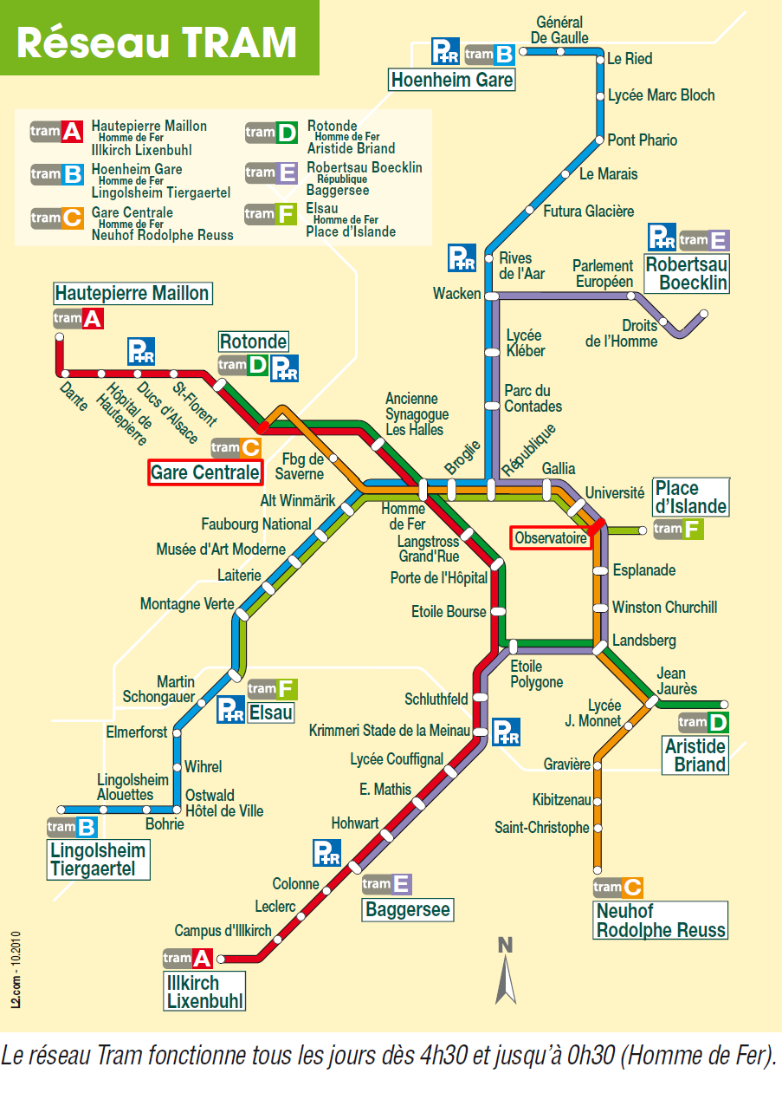](http://www.google.fr/url?sa=i&rct=j&q=&esrc=s&source=images&cd=&ved=0ahUKEwjIh8OI9fXYAhWSr6QKHUbSCqwQjRwIBw&url=http://www.beta-umr7522.fr/Acces-aux-sites&psig=AOvVaw3xiRk6nNL4HmMJ4Nr-fQwB&ust=1517065910444925)

A close up of a map

Description generated with very high confidence