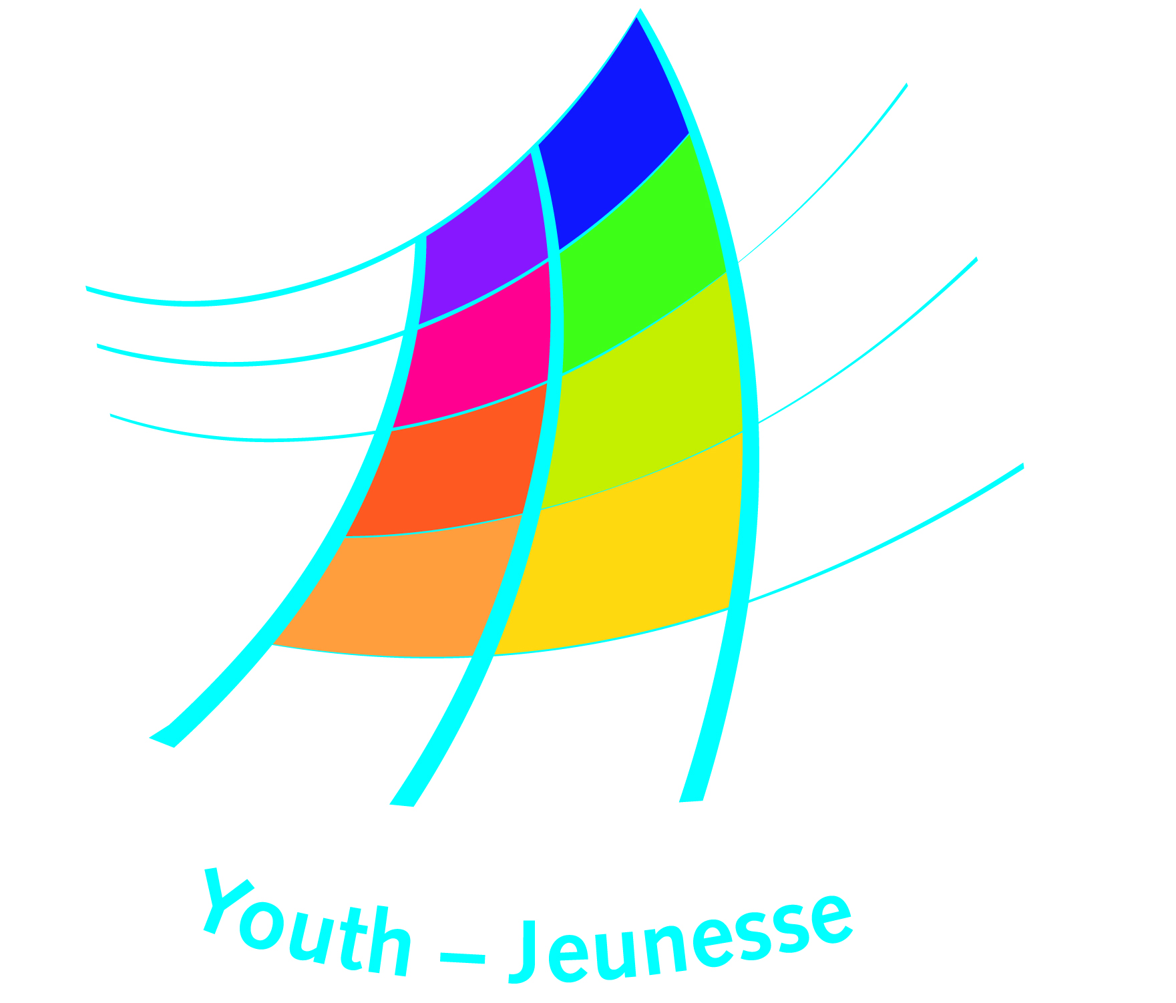
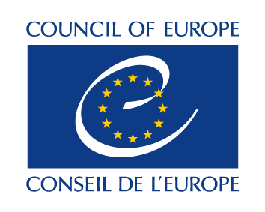
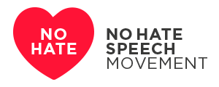

DDCP/YD/ETD (2017) 45 Updated October 2019

Expression of interest to translate the manuals

Bookmarks or We CAN!

- Name of the applicant organisation(s)?

- Which manual (Bookmarks or We CAN!) is the applicant organisation(s) interested to translate?

- In which way(s) is/are the applicants organisation(s) involved in the No Hate Speech Movement?

- Which are the target groups to be reached by the applicant organisation(s) (notably those in the formal and non-formal education contexts)?

- Address and contact details (including, telephone, e-mail and web site, if available).

- Contact person for the project (name and contact details).

- Into which language is the manual to be translated?

- Please indicate your experience in translation and/or publishing and provide a list of publications, if available

- Please indicate the name(s) and the profile(s) of the translator(s) who will translate the manual, specifying their expertise in translating publications on human rights and training materials.

- How will the translation and publishing be financed? Please indicate details of sponsors and funders, including contributions in kind.

- How do you intend to disseminate the translated publication (eg printed form/online)?

- What measures do you intend to put into place to reach school communities and agents of non-formal education?

- Please provide the timeline of the planned translation and printing of the manual containing:

- translation (eg ready within xx months)
- quality control by the Council of Europe (takes maximum two months)
- implementation of changes of the quality controller (xx months)
- design and printing (ready within xx months of the date of agreement of the Council of Europe)
We have taken note of the conditions of the Memorandum of agreement on copyrights. We are ready and committed to undertake the translation of the manual [insert name of manual to translate] under the conditions outlined in the memorandum, once approval from the Council of Europe has been received.

Date: Signature:

Please submit this form by e-mail to:

Council of Europe
Directorate of Democratic Citizenship and Participation
European Youth Centre Strasbourg
30 Rue Pierre de Coubertin - 67000 Strasbourg
France
Tel + 33 3 88 41 23 00 - email: eyc.programme@coe.int

