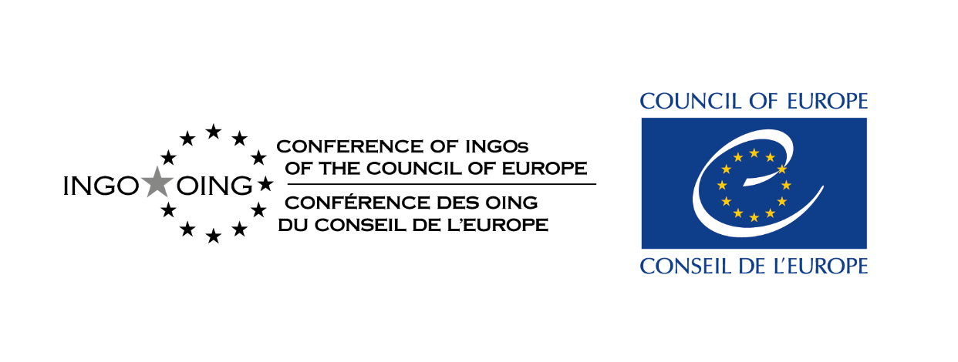

Expert Council on NGO Law

Study of less favourable treatment of NGOs

Questionnaire

Background

This questionnaire is concerned with NGOs that are treated less favourably than other NGOs because of the objectives and/or activities that they pursue. It aims to understand the difficulties that NGOs face because they work on a particular topic or in support of a particular group, for example, work to promote women’s rights or to combat corruption. The questionnaire’s focus is on the specific difficulties that these NGOs face in addition to those faced by all NGOs operating in your country.

The questionnaire has been prepared by the Expert Council on NGO Law of the Conference of INGOs of the Council of Europe. The questionnaire will be distributed to NGOs working in each of the 46 Council of Europe States and Kosovo,* as well as ones from Belarus and Russia. The results will be compiled in a report and utilised in advocacy efforts aimed at combatting the trend of restricting the legitimate activities of NGOs across Europe.

For the purpose of this questionnaire, NGOs are understood in a broad sense as groups separate from the State who organise themselves to pursue shared non-profit objectives. Informal groups and movements are also invited to complete the questionnaire. This study does not cover political parties or trade unions.

Examples of less favourable treatment are provided in question three but broadly this includes any type of restriction or detriment, for example criminal charges, and being excluded from advantages such as funding or public promotion.

We are keen to understand the differences between any official reasons given for less favourable treatment and the reason that you understand restrictions have been imposed, for example, because of discrimination or other ulterior motives.

We would be grateful for any case studies. Please include links to publicly available stories and information, court judgments, legislation, policy documents or other relevant materials if you have these. If you share case studies, please let us know if you consent to them being shared in the published report.

We will not publish your completed questionnaire, but we may share summarised information or short quotes from it in the published report. We will not publish the names of those who complete the questionnaire. If you have any specific requests or concerns in relation to confidentiality or use of information, please note them on your completed reply or contact us to discuss these.

If you have any questions, please contact EC.Study@coe.int. Please return the questionnaire to EC.Study@coe.int by 31 May 2023.

Questions

- Please provide your name and email address, the organisation you represent (if relevant) and specify which country you are providing information about.

- Are some NGOs in your country treated less favourably than others because of the objectives and/or activities that they pursue? If so, what is the nature of the objectives/activities that lead to this?

For example, prevention of corruption, promotion of democracy, protection of minority rights (identify which minorities), assistance to migrants, academic freedoms, climate action.

- What form does this less favourable treatment take and is it based on law, on policy or is a matter of practice?

For example, a prohibition on certain objectives/activities, de-registration, limited access to funding, restrictions on working with those outside of the country, travel restrictions, restrictions on working with international and regional human rights bodies such as the Council of Europe and the United Nations, charges against NGOs/individuals, verbal attacks by politicians/public figures, hostile treatment by the media, harassment or physical attacks, surveillance, SLAPPs, failures to protect NGOs/individuals from attacks, NGOs self-censoring or changing their own behaviour, failure to consult NGOs. Is there a requirement for NGOs or individuals to label themselves in a certain way (e.g., “foreign agent”, “extremist”)?

- Who is the source of the less favourable treatment, e.g., the authorities, media, corporations, public, particular groups of the public? What, if any, reason do they give for this?

For example, preventing extremism, national security, protection of public morals, promotion of family values.

- What is the extent of the less favourable treatment (how many NGOs does it impact and for how long has it been occurring)?

- Has this less favourable treatment ever been challenged by the NGOs concerned or anyone else through informal methods, such as advocacy efforts, or through more formal methods such as via complaints bodies, ombuds offices, national human rights institutions, national courts or international or regional human rights procedures? If so, what was the outcome?

- What do you think would help to combat less favourable treatment (e.g., improved legal frameworks or public engagement), and what support would assist these NGOs to better carry out their work?

- Please provide any further information that you think will be helpful.

*All references to Kosovo, whether the territory, institutions or population, in this text shall be understood in full compliance with United Nations' Security Council Resolution 1244 and without prejudice to the status of Kosovo. This may include NGOs located outside of their home State due to the current human rights situation.

