**1st Consultation Meeting on the Assessment of Pilot Judgment* (Group of Identical Cases) Procedure**

**(Activity A.3.3)**

**27 May 2021**

**DRAFT AGENDA**

**Overall objective:** Activity A.3.3 aims to reduce the length and number of cases before the Turkish administrative courts by application of an efficient procedure on delivering rapid and coherent judgements with regard to a large number of identical cases, resulting from the same issue and can form a precedent. At present there are procedures applied under different names for resolution of group of cases, such as “pilot judgment procedure” applied by the European Court of Human Rights (ECtHR) or the *jonction d’affaires* (joining cases) applied in the French law, which allows the resolution of group of cases rapidly and coherently. In this context, the project will facilitate the consideration and the understanding of how the pilot judgment procedure which was developed by the ECtHR can be applied in the Turkish courts. It is also intended to analyse similar procedures applied in other Council of Europe member States such as France due to similarities between the French and Turkish administrative justice systems. Subsequently, the project will support the administrative judiciary to create and apply its own group of cases procedure.

**(*) Pilot judgement procedure** allows for selection of a case or cases by the ECtHR to prioritise adjudication when there are large groups of identical cases that result from the same underlying issue. The aim is to render judgments on selected case or cases primarily to find a solution that could be applied to similar cases deriving from the same root cause. The judgment rendered in this framework is applicable to other disputes as pilot judgment. A significant characteristic of this procedure is that the other similar cases except the one selected as pilot case can be put on hold for a certain time. Such adjournment, which will usually be for a set period of time, may be subject to the condition that the respondent State acts promptly and effectively on the conclusions drawn in the pilot judgment. The Court may at any time resume its examination of any case that has been adjourned if this is what the interests of justice require, for example where the particular circumstances of the applicant make it unfair or unreasonable for them to have to wait much longer for a remedy.

**Expected Results**: Relevant procedures applied by the ECtHR and in the French administrative justice system will be investigated during the meeting. Subsequently, the national stakeholders are expected to develop their own model to be piloted and make recommendations concerning the steps required in the corresponding implementation plan. It is also expected that the representatives of the Registry of the ECtHR will be involved in further meetings and consulted about the draft implementation plan and/or possible recommendations made by the Turkish stakeholders before finalisation of series of meetings.

**Online platform KUDO Web-conferencing System**

Morning session link: <https://live.kudoway.eu/ad/220219104116>

Afternoon session link: <https://live.kudoway.eu/ad/220215233058>

**Language: Turkish, English, French** *(Simultaneous interpretation will be provided through the KUDO system)*

**Moderator: Dr.** **Yusuf Sertaç Serter**, Anadolu University Law Faculty.

**Participants:**  Representatives from the Turkish Ministry of Justice, Council of State, Constitutional Court Turkish Court of accounts, and Council of Judges and Prosecutors; presidents and judges of Regional Administrative Courts, first instance administrative and tax courts and pilot courts; Speakers from the European Court of Human Rights, French Council of State; Council of Europe Consultants and project team.

**MORNING SESSION LINK:** <https://live.kudoway.eu/ad/220219104116>

* Turkish Time (CET+2, GMT+3)

***10:00-10:30****\** Registration and testing the system

***10:30-10:35* Dr. Yusuf Sertaç Serter (Moderator)**,Welcoming participants, introduction of the agenda, speakers, and explanation about the ground rules for the meeting.

***10:35-11:00* Opening Remarks**

**Ms. Mariana Chichu, *Project Coordinator, Council of Europe***

**Mr.Metin Engin, *Head of Department, Directorate General of Legal Affairs, Ministry of Justice***

**Mr.Murat Şen, *Secretary General, Turkish Constitutional Court***

**Mr.Yalçın Ekmekçi, *Member, Turkish Council of State***

**PANEL PRESENTATIONS 1: Exploring the ECtHR pilot judgment procedure.**

***11:00-11:20*** Relevance of a possible pilot judgment / group of identical cases procedure for Turkey, ***Mr.*** ***Murat Azaklı, Head Rapporteur, Turkish Constitutional Court***

***11:20-11:40*** Options for the ‘group of identical cases procedure’: aspects to consider in administrative justice, ***Ms. Seran Karatarı Köstü, Judge Rapporteur, Turkish Council of State***

***11:40-12:00*** European Court of Human Rights Pilot Judgment Procedure – ***Mr.*** ***Hüseyin Hezer, Registry of the ECtHR - Turkey Section - Senior Lawyer***

***12:00-12:30*** Introduction of a ‘group of identical cases’ procedure in Turkish administrative judiciary system

* Areas requiring legal reform, ***Prof. Dr. Nilay Arat, Kadir Has University Law Faculty***
* Approaches for the model preferred, ***Prof. Dr. Murat Sezginer, TOBB University Law Faculty***

***12:30-13:00* Questions and Answers**

***13:00-14:30* Lunch break**

**AFTERNOON SESSION LINK:** <https://live.kudoway.eu/ad/220215233058>

**PANEL PRESENTATIONS 2: Considering the French pilot procedures before the Conseil d’État**

***14:30-14:50*** Functioning of *Avis Contentieux (*Judicial opinion) in French system **– *State Councillor Christine Maugüé, Deputy President of the Litigation Section, Conseil d’État***

***14:50-15:10*** Functioning of *jonction d’affaires (Joining Cases)* in French administrative judiciary, ***State Councillor Christine Maugüé, Deputy President of the Litigation Section, Conseil d’État***

***15:10-15:30* Questions and Answers**

**PANEL PRESENTATIONS – 3: Introducing a group action procedure in Turkey – key aspects [moderated discussions]**

***15:30-15:45*** Review of international models and consideration for implementation of a group of cases procedure in Turkish administrative justice – ***Mr.*** ***Yalçın Ekmekçi, Member, Turkish Council of State***

***15:45-16:00*** Summary of discussion and conclusions, ***Mr.*** ***Yalçın Ekmekçi, Member, Turkish Council of State***

***16:00* Closing and final comments**

***

**Curricula Vitae of CoE Consultants and Representatives of the ECtHR**

**Prof. Dr. Murat Sezginer**

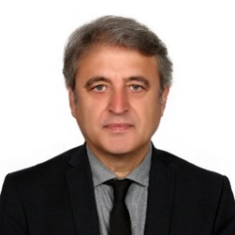Prof. Dr Murat SEZGINER graduated from the Ankara University Law Faculty in 1986. He started as a research fellow in the Selçuk University Law Faculty in the department of Administrative Law the same year, receiving his master’s degree in 1988 and PhD in 1991 in the same university. His master’s thesis is titled as “Inspection of Decree Laws” and his PhD thesis as “Unlawfulness in terms of Purpose in Administrative Actions”. He received assistant professor title in 1993 and associate professor in 1998 and he was assigned as a professor to the Gazi University Law Faculty in 2008. He currently acts as a professor in department of Administrative Law in the TOBB ETU Law Faculty. Besides his academic studies, he acted as a member of science committees in drafting and amendment of legislation on various subjects in particular within the Ministry of Justice; a manager in various positions in the university; a member of executive boards in public companies and institutions; a deputy undersecretary and a diplomat abroad. He has numerous books and articles in Administrative Law and Administrative Proceedings Law.

**Hüseyin Hezer**

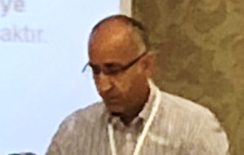He is a graduate of Paris II Assas and Istanbul Law Faculty. He completed his master’s in Strasbourg University in the field of International Law and Human Rights. “(An evaluation of human rights issues in Turkey under the light of Customs Union)”. Since March 2000, he has been acting as a lawyer in the Registry of the ECtHR (He mainly deals with Articles 2, 3, 6, 10, 11, Right to Property and Vote). 2016-2019: He acts as a senior non judicial rapporteur in thee ECtHR. He has been working in Unit Rule 39 (“precaution and measure”) of the ECtHR since 2020 (He is the responsible person for quality control in requests regarding bylaw 39).

**Assoc. Prof. Dr. Nilay Arat**

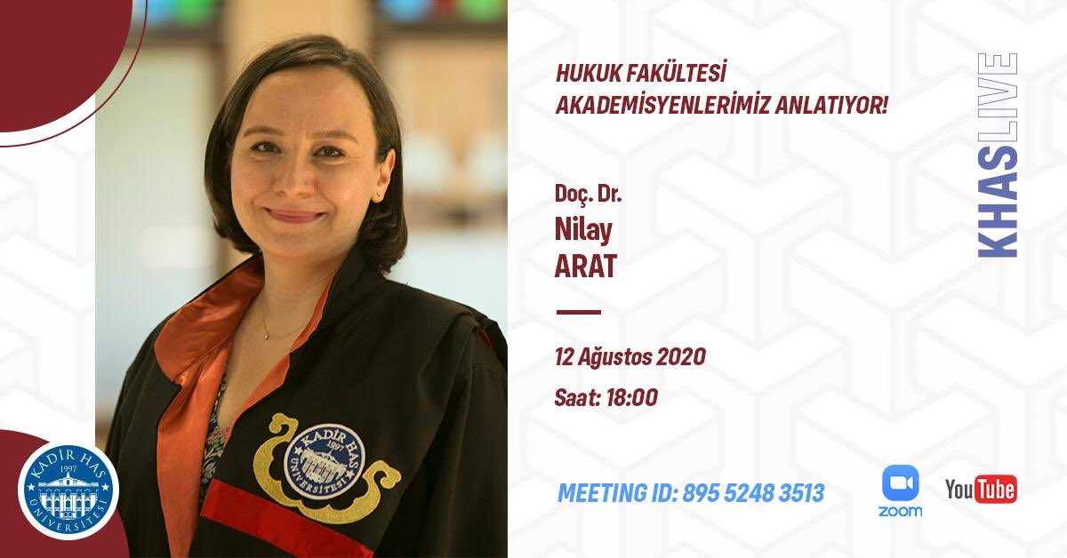Assoc. Prof. Dr Nilay Arat graduated from University of Istanbul Faculty of Law in 1999. She gained her LL.M. degree in International and Comparative Law from Tulane University Law School in 2002. Afterwards, she started her Ph.D. at the University of Istanbul Social Sciences Institute and she started to work as research and teaching assistant of Prof. İl Han Özay at the Administrative Law Department of the University of Istanbul at 2003. She wrote her Ph.D. thesis on “ADR in Turkish Administrative Law” and got her Ph.D. degree in 2009. Since 2010 she has been working at the University of Kadir Has Faculty of Law and lecturing abroad as well. In the meanwhile, she conducted research at Oxford University, Max Planck Institute for Comparative Public Law and International Law and Institut Suisse de Droit Comparé. She wrote her post-doctoral dissertation on “Discretionary Powers of Administration and Its Judicial Review” and has been working as associate professor of Administrative Law since 2017.

**Assistant Prof. Yusuf Sertaç Serter (Webinar moderator)**

Yusuf Sertaç Serter works in the fields of administrative law and constitutional law. Between 2005 – 2009, Serter worked in international law offices in Istanbul as an intern lawyer and lawyer and provided consultancy services to foreign companies investing in Turkey. Serter worked in Law Faculty of Anadolu University between 2009-2016 as a research associate and has been working as an Associate Professor in the Department of Administrative Law of the same faculty since 2016 and teaches Administrative Law.

Having completed his undergraduate law study in Galatasaray University, Serter has master’s degrees in the field of Internet Law from Paris 1 Panthéon University and of Law and Economics from İ.D. Bilkent University. Serter received his PhD title on public law from Galatasaray University. Serter is the author of “Administrative Recourses as An Alternative Dispute Resolution Method” and “A Comparison Between Virtual Public Service and Universal Service within the Context of the Transformation of Public Service Based on Economic Grounds” published by Adalet Publishing. Articles of Serter have been published on various journals including those scanned in international indexes.