**Webinar on Alternative Dispute Resolution Methods in French Administrative Judiciary System and Practices in Turkish Administrative Judiciary System**

Agenda, **16 December 2020 (Wednesday)**

**BRIEF**

We would like to thank you for your participation and contribution to this webinar, organised within the framework of the Joint Project on *Improving the Effectiveness of the Administrative Judiciary and Strengthening the Institutional Capacity of the Council of State.*

**Overall Objective :** This webinar will aim to explore available alternative dispute resolution (ADR) mechanisms in the French Administrative Justice System, to provide a platform for the Turkish stakeholders to exchange opinions on applicability of ADR methods in the Turkish Administrative Justice System and developments in civil mediation and reveal opinions and new approachesfor ADR mechanisms applicable in the Turkish Administrative Justice system.

**Specific Objectives:**

* To understand existing legal framework and practices in France, ADR methods applied on pre-trial and during trial within the administrative justice system;
* To understand which types of administrative disputes are dealt with through ADR mechanisms in France and how such mechanisms are applied;
* To explore applicability of ADR methods in administrative cases in Turkey;
* To discuss studies in Turkey regarding mediation practices and assessment of mediation in administrative judiciary.

**Date:** Wednesday, 16 December 2020

**Online Platform:** KUDO Web Conferencing;

Morning session link: <https://live.kudoway.eu/ad/220219685151>

Afternoon session link: <https://live.kudoway.eu/ad/220217347389>

**Duration**: 6 hours (10.30 – 16.45 Turkey time / 08.30 – 14.45 CET) – **Please note the two hour time difference between Turkey and Central Europe)\***

**Language:** Turkish, French, English (simultaneous interpretation)

**Moderator:** **Dr Yusuf Sertaç Serter**, Anadolu University, Law Faculty

**Participants:** Council of State, Court of Accounts, Council of Judges and Prosecutors, Ministry of Justice, Union of Turkish Bar Associations, presidents and members of the Regional Administrative Courts and Pilot Courts, administrative and tax judges, Ombudsman, representatives from public administrations, lawyers, academics, Team of Consultants, CoE Team

**Keynote Speaker(s)**

1. **Assoc Prof Selami Demirkol**- Council of State, Member of the Council of State
2. **Hakan Öztatar** - Director General of Legal Affairs, Ministry of Justice
3. **Metin Engin** - Head of Department, Directorate General of Legal Affairs Ministry of Justice
4. **Prof Sabine Bousard** - Université Paris Nanterre
5. **Assoc Prof Karine Gilberg** - Université Paris Nanterre, Head of the Office for European and International Law, Ministry of Economy and Finance
6. **Assoc Prof Nilay Arat -** Kadir Has University
7. **Abdürrrahim Taş-** Judge**,** Mediation Department, Directorate General of Legal Affairs, Ministry of Justice

**Webinar Programme**

**Wednesday, 16 December 2020**

**MORNING SESSION LINK:** [**https://live.kudoway.eu/ad/220219685151**](https://live.kudoway.eu/ad/220219685151)

* Turkish Time (GMT+3, CET+2)

**09:30-10:30**\* Registration and testing the system

**10:30-10:45** **Dr. Yusuf Sertaç Serter (Moderator),** Anadolu University Law Faculty: Welcoming participants, introduction of the agenda, speakers, and explanation about the ground rules for webinar

**10:45-11:05** Opening Remarks

*10:45-10:55* **Hakan Öztatar, Director General of Legal Affairs, Ministry of Justice**

*10:55-11:05* **Assoc. Prof Selami Demirkol**, **Member of the Council of State**

**11:05-11:15** Brief Information on the Project, **Metin Engin, Head of Department, Directorate General of Legal Affairs Ministry of Justice**

PANEL PRESENTATIONS -1

**11:15-12:25** Joint presentations on ADR in French Administrative Justice System

*11:15-11:25* Introduction to the Alternative Dispute Resolution methods (ADR) in French Administrative Justice System, **Prof Sabine Boussard, Université Paris Nanterre**

*11:25-11:55* Alternative Dispute Resolution (ADR) methods in pre-litigation cases in French Administrative Justice System: best practices and challenges, **Assoc Prof Karine Gilberg, Université Paris Nanterre, Head of the Office for European and International Law, Ministry of Economy and Finance**

*11:55-12:25* Alternative Dispute Resolution (ADR) methods during litigation in French Administrative Justice System, **Prof Sabine Boussard, Université Paris Nanterre**

**12:25-12:30** Opinion Poll for participants

**12:30-14:00** Lunch break

**AFTERNOON SESSION LINK:** [**https://live.kudoway.eu/ad/220217347389**](https://live.kudoway.eu/ad/220217347389)

**14:00-15:00** Questions and answers on the morning session

PANEL PRESENTATIONS – 2

**15:00-15:20** Applicability of Alternative Dispute Resolution Methods in pre-litigation cases in Turkey, **Assoc Prof Selami Demirkol**, **Member of the Council of State**

**15:20-15:40** In search of the most applicable ADR method in Turkish Administrative Justice System **Assoc Prof Nilay Arat, Kadir Has University**

**15:40-16:00** Evolution of mediation process and current developments in Turkey, assessment of possibility of mediation in administrative judiciary, **Abdürrahim Taş, Judge,** **Mediation Department, Directorate General of Legal Affairs, Ministry of Justice**

**16:00-16:30** Questions and answers on the afternoon session

**16:30-16:40** Opinion Poll for participants

**16:40-16:45** Wrap up and closing of the webinar

**Webinar Features / Notes**

**Live recording – Webinar will be recorded in Turkish.**

**Webinar Report**: Reports with consultants’ comments will be prepared after the webinar. Presentations from the webinar will be uploaded after the event to the project websites.

**Questions**: **a.** written questions- Participants will be able to write their questions on the KUDO chat section during and after the presentations. Due to high number of participants, some of the questions will be forwarded to the moderator in written.

**b.** verbal questions (moderation) – Participants will be able to ask their questions at the time provided for the relevant part.

**Polling/Evaluation**: Instant polling will be carried out through short questions during the webinar. An online evaluation form will be submitted to the participants after the webinar to receive feedback.

**Communications/Visibility**: Media consent of the participants will be sought for the photograph or video to be recorded for drafting news or short film about the webinar event

**BRIEF CURRICULUM VITAE OF THE CONSULTANTS**

**Prof. Dr. Sabine Boussard**

S. Boussard is a professor of public law at the University of Paris Nanterre where she teaches administrative law, administrative litigation and administrative property law. She directs the Research Centre on Public Law and the Master of Public Law.

A specialist in administrative litigation, she wrote a thesis on “The scope of appeal control before the Conseil d’ État. Tributary Control on excess of power (Dalloz 2002)”. She is particularly interested in the reform of administrative jurisdiction and the evolution of the court. She thus participated in the drafting of two collective works: Alternative Dispute Resolution Methods in Administrative Matters (Lextenso 2018) and Chimeras of Alternativity (Mare & Martin 2018). She also worked on the court through the Vincent Lambert case ("The Lambert Case" *in S. Rohlfing-Dijoux, U. Hellmann*, *Droit et Culture: Regards croisés pluridisciplinaires sur la fin de vie- Recht und Kultur: Interdisziplinäre Betrachtung der Sterbebegleitung, Nomos, Baden-Baden 2019*).

Her research also focuses on administrative property law and changes in public service law. She has written several articles devoted to public hospital service and is the author of a book devoted to Administrative Property Law (LGDJ, Manuals collection, 2nd ed. 2019).She co-directs with 3 other colleagues a collective research project, “Common goods, a legal tool to be sharpened” and organized a multidisciplinary and international seminar devoted to “Water a common good?” whose acts will be published in June 2021.

**Assoc. Prof. Dr. Karine Gilberg**

Dr. Karine Gilberg completed a PhD in Public Law at Paris University Panthéon-Assas (Paris 2) in 2007. She is currently associate Professor at Paris Nanterre University and Head of International and European Law Office at the French Ministry of Economy and Finance. She approached public law and administrative justice as an academic (1998-2020) but also in her positions at the French Ministry of Justice and since 2020 at the French Ministry of Economy and Finance. As from 2003 to 2018, she worked for the French ministry of Justice in high-level positions, which included being an advisor to the Minister and heading up several departments. She had been the French representative to the CEPEJ (Council of Europe) for 8 years and to the EU Justice Scoreboard, as well as the representative of France in the European Commission Rule of Law working group and OECD working group on Access to Justice.

In line with her PhD, she has developed research, seminars and training programs in order to support lawyers, national authorities and officials in the design and implementation of regulatory policy in the field of Justice and the Rule of Law.

By reason of her experience, academic record and publications, since 2009, she has been regularly solicited by large international organizations to support legislative processes, Justice reforms and ex post evaluation of those reforms. She was the team leader of an EU project (CQFD) on the Evaluation of the Quality of Justice systems in EU Member States (2015-2017).

**Assoc. Prof. Dr. Nilay Arat**

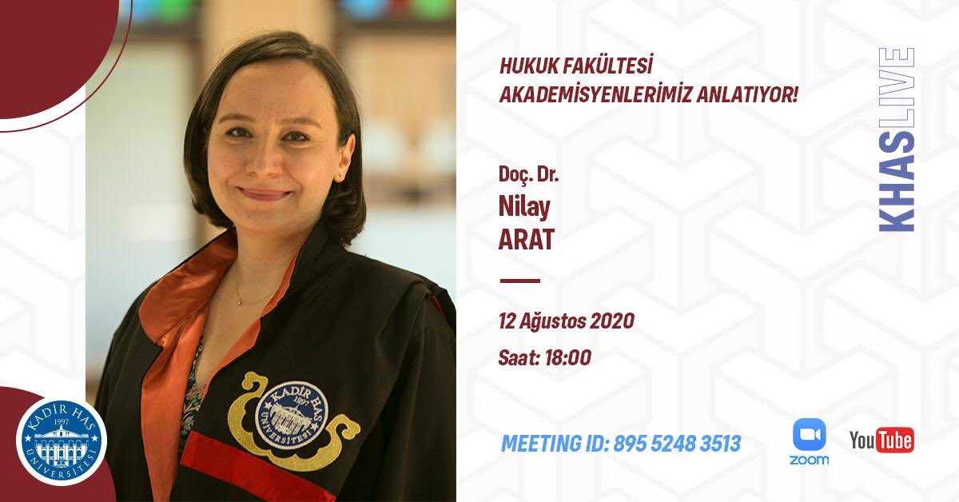Nilay Arat graduated from University of Istanbul Faculty of Law in 1999. She gained her LL.M. degree in International and Comparative Law from Tulane University Law School in 2002. Afterwards, she started her Ph.D. at the University of Istanbul Social Sciences Institute and she started to work as research and teaching assistant of Prof. İl Han Özay at the Administrative Law Department of the University of Istanbul at 2003. She wrote her Ph.D. thesis on “ADR in Turkish Administrative Law” and got her Ph.D. degree in 2009. Since 2010 she has been working at the University of Kadir Has Faculty of Law and lecturing abroad as well. In the meanwhile, she conducted research at Oxford University, Max Planc Institute for Comparative Public Law and International Law and Institut Suisse de Droit Comparé. She wrote her post-doctoral dissertation on “Discretionary Powers of Administration and Its Judicial Review” and has been working as associate professor of Administrative Law since 2017.

**Assistant Prof. Yusuf Sertaç Serter**

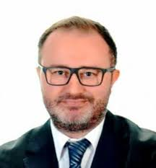Yusuf Sertaç Serter works in the fields of administrative law and constitutional law. Between 2005 – 2009, Serter worked in international law offices in Istanbul as an intern lawyer and lawyer, and provided consultancy services to foreign companies investing in Turkey.

Serter worked in Law Faculty of Anadolu University between 2009-2016 as a research associate and has been working as an Associate Professor in the Department of Administrative Law of the same faculty since 2016 and teaches Administrative Law.

Having completed his undergraduate law study in Galatasaray University, Serter has master’s degrees in the field of Internet Law from Paris 1 Panthéon University and of Law and Economics from İ.D. Bilkent University. Serter received his PhD title on public law from Galatasaray University.

Serter is the author of “Administrative Recourses as An Alternative Dispute Resolution Method” and “A Comparison Between Virtual Public Service and Universal Service within the Context of the Transformation of Public Service Based on Economic Grounds” published by Adalet Publishing. Articles of Serter have been published on various journals including those scanned in international indexes.