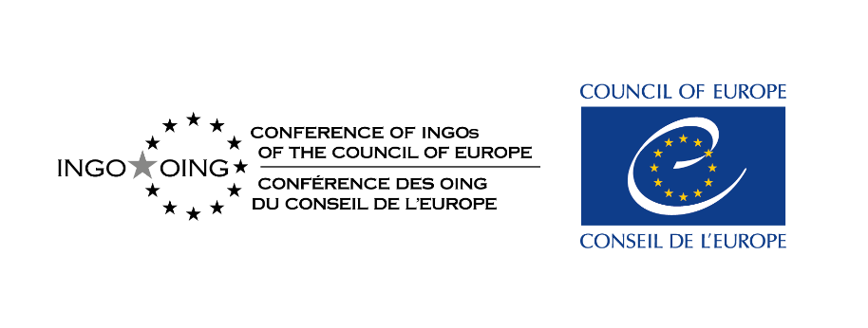
CONFERENCE OF INGOs
CONF/AG(2025)OJ2

MEETING OF THE GENERAL ASSEMBLY
Draft agenda
13-16 October 2025

Hybrid meeting
(Agora G.03 & G.02 / Kudo)

Monday 13 October 2025

09:00-10:00 Standing Committee Meeting (room B4 06C) - members only
9:00-11:00 Meetings of the thematic committees in parallel
and Rooms have been allocated in accordance with the needs expressed
11:00-13:00 by the committees and task forces. Small rooms offer the possibility for hybrid meetings, big rooms only in presence.

11:00 -13:00 Meeting of the Task Force on Civic Space Monitoring (room Agora G03) - hybrid / with EN/FR interpretation

14:00-17:00 Special event on “Climate justice and civil society” organised by the Committee on Inclusive territories, environment and health and the Standing Committee (room Agora G03) - hybrid / with EN/FR interpretation

14:30-16:30 Meetings of thematic committees in parallel
and Rooms have been allocated in accordance with sent demands from
16:30-18:30 committees and task forces. Small rooms offer the possibility for hybrid meetings, big rooms only in presence.

17:00-18:00 Meeting of the Standing Committee with the representatives of the CINGO thematic committees to prepare interventions in the General Assembly following results of the committee meetings - (room Agora G03)

18:00 Reception hosted by the Permanent Representation of Austria to the Council of Europe with possibility to meet representatives of the CoE and members of the Permanent Representations of the member States and observers.
Place: Agora, in front of room G.03

Tuesday 14 October 2025

9:30-13:00 First Session of the General Assembly open to the member States

English/French interpretation provided

1. 9:30 Opening of the meeting by Gerhard Ermischer, President of the Conference of INGOs

2. Nomination of the Rapporteurs of the meeting

3. Draft agenda – for adoption

4. 9:45 Exchange of views with high-level representatives of the Council of Europe

4.2 Ambassador Caitriona Doyle, Permanent Representative of Ireland to the Council of Europe, Chair of Rapporteur Group Democracy (GR-DEM)

4.3 Ambassador Vebjørn Heines, Permanent Representative of Norway to the Council of Europe, Vice-Chair of Steering Committee on Democracy (CDDEM)

4.3 Ambassador Daniela Cujbă, Permanent Representative of Moldova to the Council of Europe on the upcoming presidency

10:45-11:00 Break

Special item on the civic space

5. 11:00 Report from Jeremy McBride, President of the Expert Council on NGO Law

6. 11:30-13:00 Exchange with Permanent Representations, especially Georgia, Greece, Hungary, Serbia, Slovak Republic, Türkiye in the light of recent developments

*
* *

14:30-17:30 Second Session of the General Assembly open to CINGO members only

English/French interpretation provided

7. Activity report of the Standing Committee and the President

8. Report of the CINGO representatives at Steering Committees and other bodies of the Council of Europe

9. Presentation and discussion of CINGO texts to be adopted

9.1 Draft Recommendation on State Accountability in the Provision of Housing for People on the Move, Refugees and Asylum Seekers – A fundamental matter of respect of human rights

  - Draft Recommendation proposed by the Committee for Interreligious and Interconvictional Dialogue “For a permanent Platform for Ongoing Interreligious and Interconvictional Dialogue within the Council of Europe” and Explanatory note

  - Draft Recommendation on Access to sport for all as a recognised fundamental right

  - Draft Statement “The human cost of war: a call for peace and protection in Gaza”

19:30 Informal dinner for all interested participants organised by OING-Service at Brasserie Le Tigre, Strasbourg

*
* *

Wednesday 15 October 2025

9:30-13:00 Third Session of the General Assembly open to CINGO members only

English/French interpretation provided

10. Communication by the Secretariat on the implementation of the Council of Europe’s Roadmap on engagement with civil society 2024-2027, the Conference on Shaping democratic renewal: civic space and the path to a New Democratic Pact for Europe, Strasbourg, 2-3 February 2026, and the annual reporting exercise.

11. OING Service: some remarks from its President, Harry Rogge

12. Thematic Committee presentation on results of Monday meetings and on major ongoing activities (updates only if significant proposals/results)

13. Discussion (cont.) and adoption of CINGO texts

13.1 Draft Recommendation on State Accountability in the Provision of Housing for People on the Move, Refugees and Asylum Seekers – A fundamental matter of respect of human rights

13.2 Draft Recommendation proposed by the Committee for Interreligious and Interconvictional Dialogue “For a permanent Platform for Ongoing Interreligious and Interconvictional Dialogue within the Council of Europe”

13.3 Draft Recommendation on Access to sport for all as a recognised fundamental right and explanatory note

13.4 Draft Statement “The human cost of war: a call for peace and protection in Gaza”

13:00-14:30 Exhibition and Cocktail, offered by the Permanent Mission of Mexico to the Council of Europe
Place: Agora, in front of room G03

*
* *

14:30-16:45 Fourth Session of the General Assembly open to CINGO members only

English/French interpretation provided

14. Revision of CINGO’s Communication Charter – consideration and approval of a draft

15. Workplan 2026

16. Adoption of the list of decisions

17. Dates of the 2026 CINGO Sessions [suggestion: week of 13-19 April and 12-16 October]

17:15-18:00 Ceremony to mark the International Day for the Eradication of Poverty, Palais de l’Europe, lower forecourt

*
* *

Thursday 16 October 2025

9:30-12:00 Fifth Session of the General Assembly open to the member States: Special event on Democracy and Civil Participation: The Council of Europe’s Response (with presentation of the outcome of the Bridge project) – (room Agora G02)

English/French interpretation provided

This event will present important information on the ongoing Reykjavik Process of the Council of Europe and offer members the possibility to engage in the discussion of a future strategy for Democracy as promised by the Secretary General and with representatives of member States on the future development of democracy and civil participation in Europe.

At the end a lunch buffet will be offered by Volonteurope.

*
* *

Please take note of special events:

On Monday evening a reception will be offered by the Permanent Representation of Austria to the Council of Europe.

On Tuesday evening OING-Service will again organise a dinner as a get together for our members in the restaurant “Le Tigre”, same venue as last year.

On Wednesday noon an opening of an exhibition and a Mexican Buffet will be offered by the Permanent Mission of Mexico to the Council of Europe.

On Wednesday afternoon the Ceremony to mark the International Day for the Eradication of Poverty, will be held at the Palais de l’Europe, lower forecourt.

On Thursday noon a lunch buffet will be offered by Volonteurope.

There will be parallel events for closed or small groups of participants:

- 15 October afternoon, Palais de l´Europe, room 12/13 a meeting of partners on the Bridge Project

Youth Events:
- 13 October 14:00–15:45 | Agora Room: G.05 (and B4_06C) | Hybrid format
Empowering Youth Knowledge and Engagement to Drive Policy Impact
(This event is organised together with Yourope.)
- 15 October, 10:30–12:00 | Agora Room: C3.05C
Healthier Youth - Addressing the Risks of Online Gambling and Video Gaming
(This event is run together with the Pompidou Group team from the Council of Europe.)
Please note: the youth events have limited capacity — we can host 10 young participants here. The results will be presented to the GA on Wednesday afternoon.

