Mental health in digital environments
The role of European Youth Card in supporting a resilient generation.

18 October 2021, online
Ljubljana, Slovenia

The seminar is organised under the Partial Agreement on Youth Mobility through the Youth Card and the European Youth Card Association (EYCA)

Concept Note and Provisional Programme

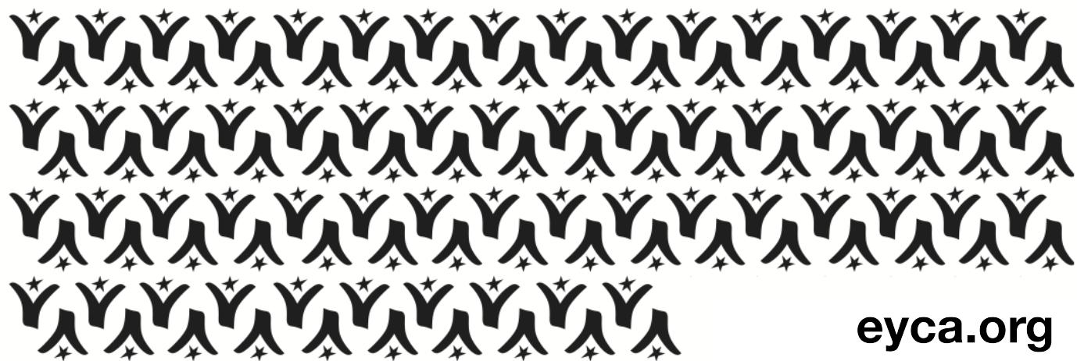

Introduction
One of the strongest side effects of the COVID-19 pandemic is a rise in anxiety, depression and other mental health issues among young people. Youth Work services across Europe have to re-adapt and pay more attention to the well-being of youth, as they are navigating unprecedent challenges, uncertainty and economic instability. The seminar will be dedicated to policy makers, youth workers/service providers, mental health professionals and researchers, youth NGOs and youth card holders.

About the organisers
The Partial Agreement on Youth Mobility through the Youth Card exists since 1991 and is a programme of the Council of Europe aimed at developing the youth card scheme, particularly at European level, in the best interests of young people with a view to facilitating their mobility as well as access to the various goods and services necessary for their personal and cultural development.
The European Youth Card Association (EYCA) groups around 36 youth card organisations all over Europe and is the Partial Agreement’s statutory partner. EYCA’s vision is a Europe where all young people are mobile and active (socially, culturally, educationally and economically). EYCA’s mission to reach this objective consists in delivering quality youth card services and in contributing to a better policy on youth mobility and active citizenship. Today, over seven million youth card-holders benefit from youth card opportunities.
The Slovenian Youth Agency (SLOAM) represents the juncture between young people, non-governmental organisations, public institutions, and responsible companies. Through the development and implementation of programmes and regular communication, young people are encouraged into active citizenship, social and environmental responsibility and enable their personal growth.
SLOAM is a non-profit organisation in the public interest in the youth sector in Slovenia aimed at bringing together different stakeholders for the overall well-being of young people.
The Slovenian Youth Agency helps young people to develop competencies, being aware that during this period young people are most susceptible to personal growth and the development of skills that will be most useful to them later in life.
The International Youth Health Organisation (YHO) is an international network of youth organisations that co-create environments and policies for all-inclusive youth health. YHO works towards health and wellbeing of young people through promotion of healthy lifestyles, prevention activities, capacity building and advocacy for effective, comprehensive and inclusive policies. The main priority areas include non-communicable diseases, mental health and environmental health, with a special focus on health inequities, health literacy, determinants of health and meaningful youth engagement. YHO’s vision is to empower young people to take care of their own health, make informed decisions about their wellbeing, conduct high quality work in the field of youth health and actively engage in decision-making processes.

About the seminar
The Council of Europe is the leading Pan-European international organisation promoting inclusive, human-rights based youth policies. One of the priorities of the Partial Agreement on Youth Mobility for 2021 is to ¨Support and encourage innovation in youth work and youth services, especially in the context of COVID-19 challenges¨. The pandemic has represented a major disruption to everyone’s life. As our societies get back to normal, young people are left with invisible scars that we need to be pro-active in addressing, through youth policy development and tailored programmes for youth.
The pandemic has particularly impacted young people in complex ways, from taking a toll on their mental health to negatively impacting their education process as schools moved classes online, or to disproportional loss of their already vulnerable jobs. Addressing the effects of the pandemic requires creativity and cross-sectoral approach in youth policy development.
Since the start of the pandemic, the everyday life of young people has transitioned to the virtual setting. While younger generations have been characterised as the “digital natives” even before the pandemic, the COVID-19 measures together with lockdowns and social distancing contributed to major lifestyle changes which is why youth are spending more time online and in different digital environments than ever before. Even before the pandemic, there was evidence of how the digital world negatively impacted mental health, and COVID-19 only exacerbated the problem.
Youth in the COVID-19 era are reporting rising levels of depression, anxiety and feelings of isolation and loneliness. Heightened levels of stress and substance use amongst the young people have been noted as well. We are seeing a rise of new and emerging mental health issues, such as Zoom fatigue or Snapchat and Instagram dysmorphias, as well as the worsening of mental health disorders like gaming addiction, self-harm and other psychiatric illnesses.
The worsening state of mental health and wellbeing of youth also reflects exponential levels of uncertainty that young people are facing in their everyday lives. Spending an increased amount of time engaging with digital technologies and social media is influencing the mental health of youth by disturbing their sleep patterns and making them more vulnerable towards cyber-bullying.
That is why mental health in digital environments is a crucial topic to be addressed throughout Europe. It is critical to intervene early and ensure a cohesive, holistic and rigorous policy action to transform the narrative. Prioritising the topic on the national and European levels requires a cross-generational and interdisciplinary policy approach with a non-siloed mentality, keeping in mind the potentials and limitations of digital environments. There should be investing in solutions, such as - but not limited to - digital mental health, increasing health literacy of youth on appropriate digital use and risks, and establishing support systems for young people.

The seminar aims to:
- Ensure mental health is being promoted as a policy priority at national and European levels, respectively that youth work adapts and includes services to identify, guide and support young people with mental health challenges;
- Offer the space for professionals and young people to have a coordinated approach on this topic and make recommendations for policy makers;
- Identify how the European Youth Card infrastructure and resources can be used to raise awareness and destigmatise mental health issues.
The format is an interactive on-line seminar, bringing together policy makers, experts in the youth mental health issues, civil society representatives and EYCA members.
At the end of the seminar, participants will:
- Have a better understanding on the trends in mental health illnesses faced by young people;
- Have a better understanding on how and why they can mainstream mental health as a topic for youth policies;
- Use the European Youth Card as a tool to reach out to youth and provide them with support services.
Profile of the participants

This one-day activity (09.00-14.00 CET) is open to participants with expertise in youth affairs/youth mobility, youth work and mental health:

- Governmental representatives,
- EYCA member organisations,
- Researchers in youth policies, particularly in mental health,
- Youth workers/service-providers,
- Youth card holders.

Practical information

The event is organised fully online. All selected participants will receive the final agenda, if need be, and a link to connect to the seminar. We recommend participants to have a stable connection to the internet and use of headsets.

Confirmation of interest
Please send your confirmation of interest (Appendix II) to youthmobility@coe.org copy natalja.turenne@coe.int by 12 October 2021.

Contact
Regarding organisational issues: Corina Pirvulescu, EYCA: corina.pirvulescu@eyca.org

APPENDIX I

DRAFT PROGRAMME

DAY 1 | Monday 18th October 2021
9.00 – 9.45 | Welcome and short presentations  - Ministry of Health, Slovenia  - Ministry of Education, Slovenia  - World Health Organisation  - Council of Europe – about PA on Youth Mobility  - EYCA Director – about EYCA  - SLOAM, EYCA member organisation in Slovenia
9.45 – 10-00 | Aim and objectives  -mapping the audience  -expectations  Introduction of the facilitator, presentation and expectations of participants
10.00 – 11.00 | New realities for young people  - Key note speaker on youth mental health – Young Minds (TBC)  - Key note speaker on institutional perspective - Wold Health Organisation (TBC)
11.00 – 11.15 | Coffee break
11.15 – 12.00 | BREAKOUT ROOMS: Thematic working groups led by EYCA members  - Jugendkarte, Austria – providing relevant information to tackle mental health  - SLOAM, Slovenia – sustainability and mental health at the core of youth participation  - Centre for Youth Education, Montenegro – EYC as a tool to connect young people to mental health professionals  - Instituto Andaluz de la Juventud, Spain - EYC as a tool to offer integrated youth services  Participants will work in parallel groups:  - Attend a short presentation on how EYC is used as a tool for supporting young people  - Share good practices and challenges they face given the new realities of young people  - Map and identify possible new policy priorities and topics to be tackled in youth agenda
12.00 – 12.15 | Back to plenary and Q & A session
12.15 – 12.30 | Coffee break
12.30 – 14.00 | Round table event: Mental Health in the Digital World: Future of Policy  - Mental Health Europe: Dominique de Marne, Senior Policy Advisor for Youth  - World Federation for Mental Health (one of their directors for Europe) or John Torous, JMIR Mental Health Editor, Harvard Medical School (digital psychiatry)  - YHO: Andrej Martin Vujkovac, President  - EFPSA: Deianara Couwet, President (or their external representative)  - IFMSA: Mohamed Mamdouh Eissa, Liaison Officer for Public Health Issues (or the Regional Director for Europe)  Closing remarks
DEADLINE FOR EXPRESSION OF INTEREST –

Sunday 12 October 2021 midnight ECT

All applications should be sent to
youthmobility@coe.int

APPENDIX II

Application form/Expression of interest

Personal detaIls
First name
Last name
Date of birth (dd/mm/yyyy) |  | Nationality |  |  | Gender (M/F)
Permanent address
 | Postal code
 | Town |  |  | Country
Place of work
Address of the employer
Email
Telephone (with country and city codes!)
Mobile
Emergency contact details

DETAILS OF THE NOMINATING ORGANISATION
Name of organisation
Postal address
 | Zip code
 | City |  | Country
Email address
Telephone
Fax
Brief info about your organisation (field of work, activities etc.)

What are your role and tasks within your organisation?

What are your expectations from this event and how can you use the gained knowledge in your work?

A silo mentality is the unwillingness to share information or knowledge between employees or across different departments within a company.

