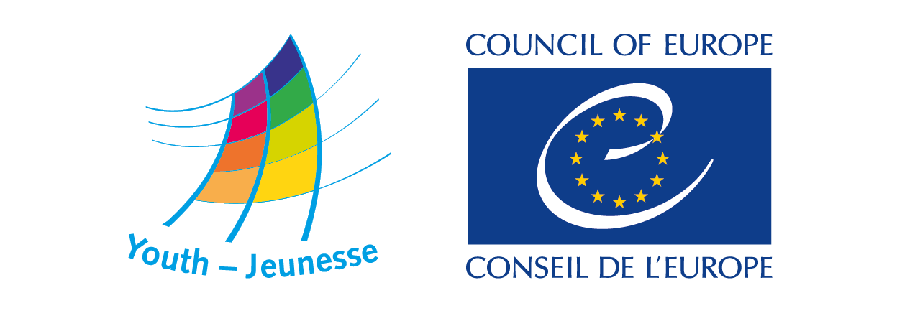

DDP- DDP-YD/ETD (2021) 148 Strasbourg, 8 October 2021

Call for expressions of interest

Review of the implementation
of the
Council of Europe Charter on Education for Democratic Citizenship
and Human Rights Education - CM/Rec(2010)7

Consultants for conducting survey,
focus groups and analysis

Deadline for submitting expressions of interest: 24 October 2021

BACKGROUND

The Council of Europe supports the promotion of human rights and democracy through education, as a mean of building peaceful societies where the human dignity of all people is respected.

With the adoption of the Charter on Education for Democratic Citizenship and Human Rights Education (Recommendation CM/ Rec(2010)7, the member states committed themselves to “the aim of providing every person within their territory with the opportunity of education for democratic citizenship and human rights education”. Although the charter is a non-binding legal instrument, it provides a unique common European framework of reference and is a focus and catalyst for action in the member states.
The first review cycle of the implementation of the Charter was organised in 2012. It consisted of a report and a conference “Democracy and Human Rights in Action – Looking Ahead. The impact of the Council of Europe Charter on Education for Democratic Citizenship and Human Rights Education” organised in cooperation with the European Commission and the European Wergeland Centre.
The second review cycle was conducted five years after. The Council of Europe implemented in 2016-2017 a review on the State of Citizenship and Human Rights Education in Europe. The main input to this second review cycle consisted of a survey for the governments (organised by the Education Department) and a survey for civil society organisations (organised by the Youth Department). The goals of this second review cycle were to provide a clear and reliable picture of what has been achieved since 2012, to define strategic guidance for future and effectively support and promote stronger actions in the member states in the area of EDC/HRE.
The 3rd Compass Forum on Human Rights Education (Budapest, 2016), provided initial input and proposals from non-governmental partners and governmental experts active in the Joint Council on Youth. Among other things, the forum called for continuation of the Human Rights Education Youth Programme.
The conclusions of the review can be found in the Report on the state of Citizenship and Human Education in Europe. They formed the basis of the Conference on the Future of Citizenship and Human Rights Education in Europe held in Strasbourg in June 2017, involving representatives of public authorities, education professionals, and non-governmental organisations active in the education and youth fields. The conference confirmed its shared commitment to democracy, human rights and the rule of law and affirmed education for democratic citizenship and human rights education as an integral part of the right to education. It called on the Council of Europe, its member states, and all relevant actors to renew their commitment to the Charter’s implementation to further enhancing EDC/HRE.

In 2022 a new review of the Charter should be undertaken. Within the Italian Presidency of the Committee of Ministers, a Forum on Democratic Citizenship and Human Rights Education with young people will be held in Torino from 11 to 13 April. This activity will be devoted to assess the situation, trends and needs for EDC/HRE across the Council of Europe and identify future priorities for the upcoming five years.

The Joint Council on Youth tasked the secretariat with preparing the review process. The purposes of this review cycle are further strengthening the Charter implementation, support the development of strategic goals for the next five years and facilitate the development of national indicators/benchmarks/priorities that can allow assessing progress achieved and guiding further action at national and international level. The third review of the charter will thus be carried out between November 2021 and March 2022, in the framework and conditions outlined in this call.

The review process will be carried out with support and under the supervision of the Monitoring Group set up by the Joint Council on Youth and will connect with the preparation of the forum in Turin.

The Charter review is also part of the Council of Europe’s contribution towards the United Nations World Programme for Human Rights Education and the United Nations’ 2030 Education Agenda (Target 4.7).

THE TASK

The consultant/s will be contracted to prepare and lead the collection of information and its analysis regarding the state of citizenship and human rights education in Europe since the second review,taking into account the conclusions of the that review as captured in the “Declaration, Key Actions and Expected Outcomes on Education for democratic citizenship and human rights”.

The research for the review will be based on three processes and sources of information:
- surveys with key stakeholders
- focus groups
- interviews.
For this purpose, the Youth Department of the Council of Europe is looking for consultants(s) to:
- Design the survey(s) for the target group concerned by implementation the Charter on Education for Democratic Citizenship and Human Rights Education (Recommendation CM/ Rec(2010)7 and analyse its results.
- Prepare and carry out online focus groups
- Prepare and lead interviews with key stakeholders and actors for EDC/HRE
- Analyse and summarise the main findings
- Prepare, write, and present the research on the review process of the Charter at the forum in Torino in April 2022.
The surveys

The consultant(s) working on this review should develop a proposal for surveys that would gather sufficient, clear, and understandable information on the implementation of the Charter on Education for Democratic Citizenship and Human Rights Education by the following target groups:
- GOVERNMENTAL SECTOR and public authorities concerned with EDC/HRE, particularly in the Education and Youth sectors; this may include a section to be addressed to the Education Commissions in the National Parliaments or other similar bodies in the member states;
- CIVIL SOCIETY, including human rights organisations, youth organisations and other NGOs working with young people and human rights education to which they can turn to invite the community to the knowledge and practice of
“Council of Europe Charter on Education for Democratic Citizenship and Human Rights Education” through non-formal education.

A quantitative analysis will be done on the basis of a series of descriptive statistics. For the purpose of assessing change since 2017, an analysis of trends will be made with identical questions present both in the 2012 and 2016 questionnaires. Adjustments will have to be made to make the questions simpler and clearer. In addition to the questions of previous surveys, specific topics will be investigated. These will be discussed with the Youth Department.

Following the development of a proposal for surveys and finalising them based on the feedback provided by the Monitoring and Support group, the consultant/s should also support the dissemination of the surveys and gathering of data. The consultant/s should deliver an analysis of the results of the surveys in a form of a written research paper outlining, among other issues, the following:

- key areas, issues and developments where the usage of the Charter is particularly strong;
- remaining challenges for implementation of the Charter;
- ownership and mainstreaming of the Charter in the work of youth organisations and local authorities;
- impact of the Charter on local and national level youth work and youth policy development;
- examples of, and criteria for, good practices in applying measures proposed by the recommendation.

Focus groups and interviews

The consultant(s) working on this review should examine, analyse, and draw conclusions from the Focus groups and Interviews. This method causes participants to react to what other group members have said, potentially leading to deeper, reasoned, and contextualized opinions (avalanche effect).
The interviews will be carried out to deepen the key point emerged in the focus group.
Focus Groups should be organised with:
- People responsible for EDC and HRE in national education authorities or education councils
- Youth workers, youth leaders and social workers engaged in the Human Rights Education Youth Programme;
- Youth organisations, those having implemented projects supported by the European Youth Foundation and Study Sessions in cooperation with the European Youth Centres of the Council of Europe;
- Human rights educators

The report

The report should be submitted in English or French, the Council of Europe style guide, and follow the model of the 2017 report Report on the state of Citizenship and Human Education in Europe. An executive summary with the main findings, conclusions and recommendations should accompany the report. The draft conclusions should be available by 15 March 2022.

The final version of the papers, taking into account the conclusions of the Turin forum, should be submitted by 31 May 2022.
Calendar
November 2021: Design and publishing the surveys
December-January 2022: Monitoring and follow-up on surveys; collecting examples of practice
February: Closing and analysis of the surveys
Focus groups and interviews
March: Draft report and conclusions
April: Forum on EDC/HRE, Turin (presentation and discussion of conclusions)
May 2022: Final report

COMPETENCES REQUIRED FROM THE CONSULTANTS
- Solid expertise of Education for Democratic Citizenship and Human Rights Education;
- Core expertise of evaluation research and practice;
- Sound knowledge in education policies and practices, including the non-formal education and youth sectors
- Thorough understanding of the Council of Europe’s work on Education for Democratic Citizenship and Human Rights Education;
- Experience in developing, monitoring and analysing surveys for different target groups (youth organisations, public authorities);
- Experience in developing focus groups and interviews;
- Very good speaking and writing skills in English or French and sound knowledge of the other language;
- Excellent analytical skills and ability to draw clear conclusions from surveys and data;
- Ability to work autonomously and to respect deadlines.

SPECIFIC CONDITIONS
The consultant/s will carry out their work in close cooperation with staff of the Youth Department and under the guidance of the Monitoring Group set up by the Joint Council on Youth.
A preparatory meeting will be organised in November 2021The dates of the meetings will be set in agreement with the consultant/s. Expenses related to the meetings will be covered by the Council of Europe.
The volume of work to be covered by the contract(s) is estimated to cover between 15 (minimum) and 25 working days.

HOW TO RESPOND TO THIS CALL
Expressions of interest are welcomed from consultants/researchers, individually or in teams/consortia, who possess the competences and experiences indicated above.
To apply the consultants must submit:
- the completed expression of interest form in English or French (appendix 1)
- a recent copy of their CV;
- Sample of research paper they have written or links to relevant/similar offline or online works.
Deadline for submission of expressions of interest: 24 October 2021, 23.59 CET
Expressions of interest are to be submitted to: youth.trainers@coe.int
For further information, contact: youth.trainers@coe.int

Appendix 1

FORM FOR EXPRESSION OF INTEREST
Call | Review of the implementation of the EDC/HRE Charter
Name/s:
Emails:
Telephone/s:
Address/es:
Working languages: | English Français  Other languages, please indicate:

NB: Please add links or append documents to support or exemplify previous work and experience

- Please provide information about your experience and expertise regarding

a) Education for Democratic Citizenship and Human Rights Education

b) Research and practice of Evaluation

c) Education policies and practices, including non-formal education

d) The Council of Europe’s work on Education for Democratic Citizenship and Human Rights Education

d) Development of similar reviews of studies (including specifics on surveys, focus groups and interviews – please add links or append documents re)

- Please list up to three conditions of success of the review of the Charter and how you would secure that they will be met:

- Why would you like to work on this project?

- 4. Any other relevant information

Deadline: 24 October 2021, 23:59 CET

To be returned to: youth.trainers@coe.int

