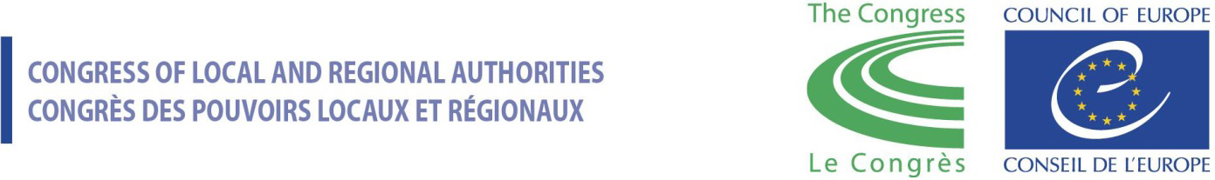

CALL FOR APPLICATIONS

Training of Trainers on Local Democracy and Human Rights
17-20 October 2023, Tbilisi, Georgia
Description
The Congress of Local and Regional Authorities of the Council of Europe is organising a Training of Trainers (ToT) on Local Democracy and Human Rights on 17-20 October 2023 in Tbilisi, Georgia.
The objective of the training of trainers is to create a pool of youth educators to address issues of local democracy and human rights at local level, with experience on human rights, local democracy, and citizen engagement. Their future activities and engagement will in turn contribute to building capacities of young people in Georgia, raising their awareness on their rights and freedoms and motivating them to be more engaged in local decision-making.
The training of trainers will:
- equip participants with comprehensive understanding of the relationship between human rights and local democracy, up to date knowledge of existing standards, and good practice examples from Georgia and other European countries;
- enhance capacities of participants to carry out educational activities on human rights and local democracy independently;
- equip participants with necessary methodological tools to develop a training curriculum based on the needs of young people, corresponding to the Georgian context.
The training of trainers is an initial step within a series of activities targeted at developing capacities of young local leaders in Georgia organised as part of the project “Strengthening Participatory Democracy and Human Rights at Local Level in Georgia” implemented with the financial contribution of the Austrian Development Cooperation. The pool of educators trained as a result of the ToT may be further engaged in the youth-centred activities within the Council of Europe Action Plan for Georgia 2024-2027.
The main thematic areas of the activities for youth will be human rights and participatory democracy. They will focus, inter alia, on developing youth capacities on human rights advocacy, countering disinformation and socio-economic and cultural stereotypes, combating hate speech and discrimination, promoting and protecting the right to healthy environment – all in cooperation with local authorities.
Finally, youth groups from pilot municipalities will be supported to actively participate in decision making processes and advocate for their rights in dialogue with local authorities. Close co-operation with community-based, civil society organisations and regional media outlets will be mainstreamed throughout the youth-led activities.
METHODOLOGY
The training will be based on the principles of non-formal education: other than the formal educational curriculum, it will have a planned programme of personal and social education designed to improve a wide range of transversal skills and competencies.
Up to 25 participants will be selected to take part in the training course. The selection will strive to ensure a fair gender balance. Trainers working at local level in Georgia are highly encouraged to apply.
WHO CAN APPLY?
Eligibility criteria
- At least 2 years of experience in conducting formal/non-formal trainings;
- Demonstrated knowledge and interest in the topics of training: human rights and local democracy, including transparency, ethics, youth participation as cross-cutting topics;
- Fluency in Georgian.
Preferences
- Good knowledge of English is desirable;
- Experience in working with young people and/or local elected representatives will be considered an advantage;
- Personal and professional commitment to follow-up activities, namely developing the training curriculum and implementing trainings with young people living in rural areas in Georgia.
Costs
All costs related to participation, including travel within Georgia, meals and accommodation, will be covered by the Council of Europe.
How to apply
All interested candidates should submit the fully filled application form, together with a Curriculum Vitae (CV), in English, before 29 September 2023, 23:59 CET to the email address: Georgia.localgov@coe.int with the subject: Youth Training of Trainers Application Form.

Should you encounter difficulties with the application form, please contact the project assistant Diana Endeladze via email: diana.endeladze@coe.int

Training of Trainers on Local Democracy and Human Rights

17-20 October 2023, Tbilisi, Georgia
APPLICATION FORM
Name
Surname
Date of birth
Postal address
E-mail
Contact phone
Current position

Please tick the boxes below and answer fully the questions from 1 to 5.

Eligibility and preference check:
Do you have at least 2 years of experience in conducting formal/non-formal trainings?
☐ Yes ☐ No
Do you have knowledge of and interest in the topics of the training?
☐ Yes ☐ No
☐ human rights
☐ local democracy
☐ citizen participation

Have you previously worked with young people and/or local elected representatives?
☐ Yes ☐ No If “yes”, please specify (max 50 words):
___________________________________________________________________________________________________________________________________________________________________________________________________________________________________________________________________________________________________

Are you fluent in Georgian?
☐ Yes ☐ No
What is you level of English?
☐ Basic ☐ Fair ☐ Good ☐ Advanced ☐ Fluent

Expression of interest:
- What is your motivation to participate in the Training of Trainers on Local Democracy and Human Rights? (max 250 words)

- Please briefly describe your grassroot expertise in providing formal and/or non-formal education to young people on human rights, equality, local democracy, youth participation and peaceful dialogue. (max 250 words)

- In your opinion, what are the most prevailing human rights issues affecting young people in Georgia? (max 250 words)

- In your opinion, what are the main challenges that hinder the participation of young people in Georgia in local affairs? (max 250 words)

- How do you plan to use the experience gained after the training? (max 250 words)

