APPENDIX I

Technical specification for development of the second phase of the Software for the Bar Association in North Macedonia on appointing of ex officio lawyers

Author:
Nikola Cacanoski, IT expert

Skopje, May 2023

Table of Contents
1 Foreword 3
2 Introduction 4
3 Key principles 4
4 Objectives 4
4.1 Solution for appointment of ex-officio lawyers 5
4.1.1 First finished phase of the Solution 5
4.1.2 Development of a Call Centre Software 6
4.1.3 Detailed technical specification for development of a Call Centre Software 7
4.1.4 Integration with other systems 10
4.2 Bar members register 10
4.2.1 Central database 11
4.2.2 Document production 16
4.2.3 Document storage 17
4.2.4 Integration with other systems 17
4.3 Specific requirements 18
4.3.1 Reporting system 19
4.3.2 Logs of changes 19
4.3.3 Data access 20
4.3.4 Training 20
4.3.5 Deadline and payment 20
4.3.6 Warranty and maintenance 20
4.3.7 Source code 20
4.3.8 Backup 21
5 Qualifications and experience 21

Foreword
The Council of Europe is currently implementing the joint Council of Europe/European Union Project HF III 9 Towards a Consolidated and More Efficient Free Legal Aid (FLA) System in North Macedonia, which aims at completing the development of the regulatory framework and of the capacities of the main actors to ensure that FLA system of North Macedonia becomes entirely efficient, of high quality, suited to address the legal needs of the population providing an improved and wider access to justice in a professional, transparent and self-sustainable way. More concretely, it proposes to consolidate, institutionalise and sustain the progress achieved so far through an overall reform of a strengthened FLA Central Unit of the Ministry of Justice, the establishment of a quality control system, more effective provision of FLA also in criminal proceedings and a stronger role of the Bar Association in the education of FLA lawyers. The Council of Europe’s Project Team requested to develop a concise Paper containing proposals for an IT based system (software solution) concerning appointment of the ex officio lawyers for the Bar Association of North Macedonia that provides an overview of the key principles, objectives, functions, requirements and structure of the software and will serve as starting point for developing terms of reference for potential software solution to embed the proposed system.
This document builds upon the recommendations from the Assessment report on legal aid in criminal proceedings and of the Report on the on-line coordination meetings to tackle shortcomings on legal aid provision in criminal proceedings in North Macedonia developed previously under the project and the online meeting held with the executive director of the BAR Association that took place on December 02, 2021.
The need for an efficient case management system in processing the data related to the appointment of ex-officio and FLA lawyers is self-evident. Until now, the provisions of the Law on Criminal proceeding (LCP) do not foresee a clear practical mechanism for appointing lawyers in cases under the articles 74 and 75 of LCP and the courts use different practices for appointment of ex-officio and FLA lawyers, i.e. there is no unified system in this regard, subsequently the modality of appointment of ex-officio lawyers is perceived to be unclear and lacking transparency.
With the new draft of the LCP (planned to be adopted in 2022), two key amendments were proposed to the Working Group by the CoE consultants which stipulate the engagement of an innovatory software solution as a mechanism for appointing lawyers that will finally unify the system of appointment of lawyers.
It is a Process tool for regulating the mechanism of appointment of ex-officio and FLA lawyers, but also for regulating the modality of payment of fees to lawyers by the courts (respecting the level of the fees) and correspondingly will increase the interest of lawyers to participate in the system of delivery of legal aid in criminal proceedings. Subsequently, it will contribute to a better quality of provided legal aid in criminal proceedings.
In developing the model for appointment of ex-officio lawyers, there were taken into the consideration some challenges that can impede introducing an IT based software system. The software solution implies costs and resources, and the Bar will need continuous support in implementing the software solution.
The first phase of the Software for the Bar Association in North Macedonia on appointing of ex officio lawyers successfully finished in December 2022.
This document shall serve as a Technical specification for development of the second phase of the Software for the Bar Association in North Macedonia on appointing of ex officio lawyers in accordance with the CoE procurement rules.

Introduction
The BAR’s final goal is a fully integrated IT solution to effectively manage all of the data related to the lawyers, the expert associates, the trainees and the law firms – all the members of the Bar regarding the main items on the status/membership (e.g. active, dormant) of the chamber and the relevant changes such as changes of individual lawyers in law firms, changes of employed lawyers in law firms, enrolment of trainees, transfer of trainees to lawyers or professional associates, transfer of professional associates to lawyers, disciplinary proceedings (including violations and fines), payment of membership fees, trainings (participation in seminars), payment of licenses, changes of address, etc. The Bar’s ambition is to include Bar members management, billing, document producing, document storage and reporting.
This shall be done through requesting offers from software vendors for design, development, supply/installation, implementation, training and maintenance.
This project is one step toward the fully integrated IT solution which will fulfil the needs of the Bar association.

Key principles
The software solution shall be developed on the following key principles:
- High security level of accessibility of data based on confidentiality of personal, as applicable other sensitive data and clear determination of the level of accessibility (the BAR to adopt a specific regulation on software use and maintenance);
- Integrity of the system by safety protection levels and backup safeguards.

Objectives
The project shall deliver two objectives:
- Solution for appointment of ex-officio lawyers
- Bar members register, web application for Bar members management

Solution for appointment of ex-officio lawyers
Different institutions defined by the law (police, prosecution offices, courts, centres of social affairs, ministries etc.) have cases which require legal aid from ex officio lawyers. This system shall function as Call centre i.e., fully automated mechanism for appointment of ex officio lawyers to any subject who needs legal aid.
The software solution shall ensure a uniform and transparent process of appointment of ex-officio lawyers, subsequently the institutions role is to determine the eligibility and to call the centre for appointment of a lawyer, while none of the institutions will have any access to the software operations.

First finished phase of the Solution
First phase of the Software for the Bar Association in North Macedonia on appointing of ex officio lawyers successfully finished in December 2022.
Hardware equipment that is installed meets the requested requirements having in mind system redundancy, to ensure system availability and reliability. Two IP-PBX are connected to work in cluster mode together with one failover controller. Configuration like this ensures that both PBX have same configuration all the time and in case one of them breaks down, the other will take over all functionalities within seconds. To avoid failover in case of power supply shortage, the company installed unlimited power supply (UPS) device with 4 battery banks with total 64 batteries 12V-9Ah.
All offered hardware is installed in Bar association premises in appropriate rack. The following pictures presents the rack including the equipment as installed in Bar association premises:
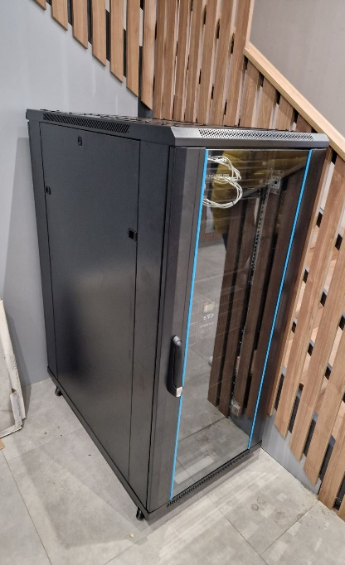 | 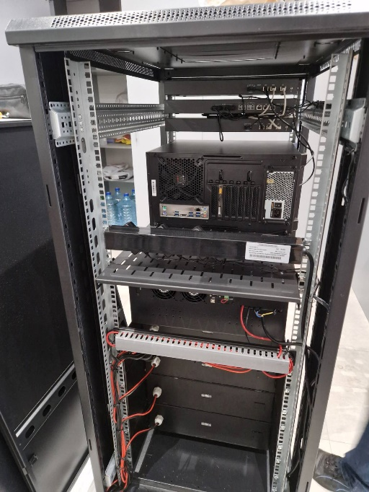 | 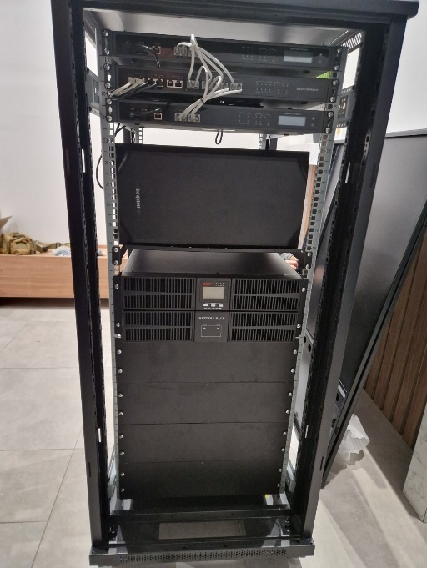
Side view | Rear view | Front view

Starting from the top, rack contains:
- Grandstream UCM6510IP-PBX telephone exchange hardware
- Grandstream HA100 failover controller for UCM6510
- Grandstream UCM6510IP-PBX telephone exchange hardware (for redundancy purposes)
- Server - CPU Intel Xeon, mem. 32GB, HDD 2 x 4TB
- UPS System-EAST 6000VA/6000W19"-2U/lower online supercharger Long Backup-EA906H-G4-RT-including 4 x Battery Bank

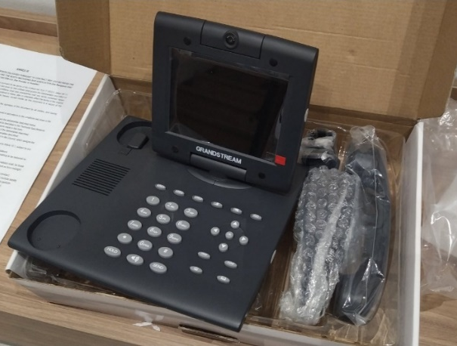
The company also delivered Video Phones, model Grandstream GXV-3000, which is SIP video phone with a large adjustable color display LCD screen, camera, and real-time bandwidth-efficient H.264/H.263 video codec that renders stunning picture quality over public Internet, as presented on the picture.

The Bar association and the company agreed to postpone realization the company’s obligation to provide telecom services “SIP trunk service from telecommunication operator for at least 10 phone channels with 4 phone numbers (for each appellate district), with included traffic toward all national networks in Republic of North Macedonia, for 12 months in total”. This postponing is agreed until the start of the realization of second phase of the development of Call centre software for ex-officio lawyers for the Bar Association, since this subscription is not needed prior to second phase of the project.
Delivered PBX were configured, ready to be connected to telecom operator, as well as the Grandstream HA100 failover controller for UCM6510.

Development of a Call Centre Software
The economic operator obligations are to provide:
- Call centre software with functions provided in these document
- Populate the initial data given from Bar association (ex-officio lawyers list by districts, potential callers list with names and institutions)
- Provide warranty and maintenance for the system, as described in the Specific requirements section of this document
- Provide training for the system, as described in the Specific requirements section of this document
Call center – the final system shall be able to redirect automatically the incoming phone calls for appointment of lawyers received on a specific phone number from different sources defined by the law (police, prosecution offices, courts, centres of social affairs, ministries etc.) towards individual phone numbers of the ex-officio lawyers.

Detailed technical specification for development of a Call Centre Software
The following part describes the detailed technical specification for the development of the final Software for the Bar Association in North Macedonia on appointing ex officio lawyers, which is one of the objectives of this procurement. The economic operator shall have in mind that second phase of development shall be fully compatible with the first phase, described above.
Overall, the call center shall cover 4 appellate districts:
- For appellate district Bitola, there shall be at least 2 lines/channels (one for every basic court district as follows Bitola, Krusevo, Ohrid, Prilep, Resen and Struga).
- For appellate court district Gostivar there shall be at least 2 lines/channels (one for every basic court district as follows Gostivar, Tetovo, Kicevo and Debar).
- For appellate court district Skopje, there shall be at least 3 lines/channels (one for every basic court district, as follows Skopje, Veles, Gevgelija, Kavadarci, Kratovo, Kriva Palanka, Kumanovo, Negotino).
- For appellate court district Stip, there shall be at least 3 lines/channels (one for every basic court district, as follows Stip, Berovo, Vinica, Delcevo, Kocani, Radovis, Sveti Nikole, Strumica).
The Call Centre shall accept only the incoming calls from predefined list of incoming phone numbers (whitelist). This list will be delivered by the Bar and will consist of:
- Phone number
- Institution
- Basic court district
- Appellate court district
The lists of basic courts, appellate courts, and lawyers shall be records in the database and controlled only by the database.
These lists will be delivered by the Bar and will consist of:
- Name
- Surname
- Phone number
- Email address
- Ex-officio eligibility (yes/no)
- On duty eligibility (yes/no)
- Justice for children eligibility (yes/no)
- Gender based violence eligibility (yes/no)
- Basic court district
- Appellate court district
Based on the lawyer records each basic court district shall have its predefined lists of:
- ex-officio lawyers
- on duty lawyers
- justice for children lawyers
Each incoming call shall initiate the call center software to:
- Initiate the IVR asking the caller to enter to enter the ordinal number of the list for ex-officio lawyers, on-duty lawyers or justice-for-children lawyers (three options), offering the ordinal numbers for all lists. In the future more options (lists) might be added. Incoming caller shall be already defined from whitelist, and its basic court shall be already known by incoming call number. That way, the call center automatically and unequivocally knows the list (ex-officio, on-duty or justice-for-children) of lawyers from basic court (defined by the caller whitelist number)
- After the caller’s input, to start trying to redirect the incoming call to one of the individual phone numbers of the lawyers, in the sequence of the predefined order from the lawyers’ phone numbers included in the chosen basic court district
If a lawyer does not answer a complete call of 8 rings, the software will automatically transfer the call to the next lawyer on the list and so on (without interruption of the incoming call). The lawyers who were being dialled (eighter busy, not answered or answered) shall be moved to the bottom of the list in the next call. The next call shall start from be the first undialed lawyer’s phone number on the list.
For example, the first call tries to get first phone number on the list. If unsuccessful, then tries to get the second phone number on the list etc. until finally established a call with the third phone number on the list. The second call shall start the sequence with the fourth phone number on the list, then fifth phone number, than first phone number (in this example where there are five total phone numbers on the list).
The graphic below shows the cyclical sequence for dialling through the phone list of single basic court list:

In case the lawyer picks up the call, but does not accept to represent the case, then the caller (judge, prosecutor, police etc.) will have to dial again; and the software will continue with the calling the next number from the list.
The system shall also include the possibility when a phone call to a particular phone number (i.e. from a particular basic court district) is not overtaken by the lawyers in that basic court district (e.g. in case none of the lawyers is available from this basic court district) to extend the redirection to the lawyer lists of reserve basic court districts defined be the Bar association.
Similarly, if the particular basic court district list has no lawyers at all, the system shall extend the redirection to the lawyers list of reserve basic court districts in the same appellate district defined be the Bar association. The graphic below shows the cyclical sequence for dialing through the phone lists in case none of the lawyers answers within the requested basic court list:

For example, Bar association defines for basic court Gevgelija the following list of reserve basic courts lists (districts in the same appellate district) by priority defined by geographic proximity: Negotino, Kavadarci, Veles, Kumanovo, Kratovo, Kriva Palanka, Skopje. The order lists for each basic court will be defined be the Bar association.
After the established call, after the end of conversation between caller and lawyer, the lawyer should wait for the caller to hang up, and automatically the second IVR will ask for confirmation giving two options:
- If lawyer accepts engagement, press 1
- If lawyer rejects engagement, press 2
That way the lawyer can instantly set the status of the call. If lawyer press 1, the call gets status accepted, and email is sent to lawyer, bar and caller that the lawyer is engaged for the case. If lawyer press 2, email is sent to lawyer, bar and caller that the lawyer has rejected the case and system continues to connect the next call with new lawyer according to the rules explained above.
If lawyer does not press anything, due because he is not following procedure or call is dropped, email is sent to lawyer, bar and caller that the lawyer has rejected the case and system continues to connect the next call with new lawyer according to the rules explained above.
The phone number (one phone number by appellate district) for specific appellate district will be made available and known to the relevant stakeholders in advance and they have the possibility to call this number whenever legal aid is necessary.
Each call center action (redirection, call busy, call hang up, call establishment etc.) shall keep records about the following data:
- Date and time
- Calling number
- Calling name
- Calling surname
- Calling institution
- Called lawyer number
- Status of call:
  - not answered,
  - busy/no network,
  - accepted by lawyer,
  - rejected by lawyer
  - not chosen option (nor accepted, nor rejected) by the lawyer
- Call duration
During the implementation of this call center software, the whitelist, lawyers’ lists and reserve basic courts shall be imported by the economic operator, from data given by the Bar.
Each list of records (basic court lawyer’s list, reserve basic courts lists for each basic court etc.) shall have an option for:
- Advanced filter by each field (by value), ordering (descending/ascending) etc.
- Add, edit, delete a specific record
- Change the priority order by click on an arrow
- Download as excel file and print of the list
The phone call redirected from the call center (incoming call for lawyers) shall be easily identifiable i.e. the lawyer should see the Bar association phone number, one for each appellate district.
The economic operator shall describe in its technical offer any deviations from the algorithm described above (if any), which might be considered as not acceptable, or confirm it in its entirety.

Integration with other systems
The Call center software shall use lawyer data (lists) and whitelist from Bar register software (second objective of the call), because the lawyers lists are to be regularly updated only in the Bar register software.
The Call center software data from its call history will be used by Bar register software.

Bar members register
The entire solution (Bar members register) shall be delivered through a web browser, be compatible with the latest and most used browsers and be accessible on a number of different operating systems. In addition, the solution must be able to integrate with the future Bar’s web page and the future Educational centre software, with the call centre software.
The system shall be hosted on the existing hardware provided in the first phase of the procurement, described above, which is located in the premisses of the Bar association.
The software solution shall achieve the following objectives for the BAR:
- Document Production - Fast and effortless document production.
- Document Management - Fully searchable and fully automated central document library (by lawyer and by type of document).
- Monitor - To monitor the members connected activities that the Bar is managing.
- Backup solution – a primary and secondary backup option for data recovery in case of system failure.
The economic operator obligations are to:
- Provide Bar members register software as a web application with functions provided in this document
- Import the data given from Bar association (members data, legal entities data etc.)
- Provide warranty and maintenance for the system, as described in the Specific requirements section of this document
- Provide training for the system, as described in the Specific requirements section of this document
The software for Bar members register shall be capable to perform the following core functions:

Central database
It shall be powerful central database (register) storing information items related to all Bar members.
The main menu shall contain options for:
- accessing the list of lawyers
- accessing the list of expert associates
- accessing the list of trainees
- accessing the list of law firms
- accessing the lists (including mechanism for data update) for:
  - Ex-officio eligibility
  - On duty eligibility
  - FLA eligibility
  - Justice for children eligibility (ordinal number
  - Gender-based violence eligibility
- Search option for members by name, by Bar registration number, by National personal unique ID number
- Search option for law firms by name, by Bar registration number, by National unique ID number
- Bar membership fees (mechanism for data update and reports)
- Call centre reports
- Codebooks (mechanism for data update):
  - Cities
  - Communities
  - Municipalities
  - Bar presidents
  - insurance companies
  - disciplinary prosecutors (members and deputies)
  - disciplinary court members (president, 2 members and deputies)
  - appellate council members (president, 4 members and deputies)
  - basic courts
- Professional insurances (mechanism for data update, reports, and option for delivery warning)
- Disciplinary procedures list (mechanism for data update and reports)
- Disciplinary measures list (mechanism for data update, and option for debt warning)
- Bar membership fees (mechanism for data update, reports, option for debt warning)
- Payment exemptions (mechanism for data update, reports)
- Membership dormancy (mechanism for data update)
- Erase status change (mechanism for data update)
- Confirmations generations (according to templates)

Each member (physical person) shall have its record, consisting of the personal (sensitive) data and work-related data (but not limited only to list below):
 | lawyer | expert associate | trainee
Name | √ | √ | √
Surname | √ | √ | √
National personal unique ID number | √ | √ | √
Bar registration number (example: 4124/23) | √ | √ | √
Date of enrolment | √ | √ | √
Legal status (employed lawyer, self-employed lawyers, expert associate, trainee) | √ | √ | √
Legal entity employer (law firm, self-employed lawyers) | √ | √ | √
City | √ | √ | √
Municipality | √ | √ | √
Law community | √ | √ | √
Ex-officio eligibility (yes/no) | √ | x | x
On duty eligibility (yes/no) | √ | x | x
FLA eligibility (yes/no) | √ | x | x
Justice for children eligibility (ordinal number (yes/no) | √ | x | x
Gender-based violence eligibility (yes/no) | √ | x | x
Current status (active, dormant, erased), including history of status changes | √ | √ | √
Email | √ | √ | √
Phone | √ | √ | √
Gender | √ | √ | √
Address | √ | √ | √
Nationality | √ | √ | √
Attached documents (unlimited number of documents associated with the member) | √ | √ | √
History of Bar membership fees, including: mechanism for data management; pending payments report according to template by member and by city; option for sending warning for debt to all members on the lists. The reports and warnings shall be calculated having in mind the periods of dormancy, periods of status “erased”, disciplinary procedures, payment exemptions etc. | √ | x | x
History of professional insurance policies, including mechanism for data management and option for sending warning for policy delivery | √ | x | x
History of payment exemptions, including mechanism for data management | √ | x | x
History of payment releases, including mechanism for data management | √ | x | x
History of procedures and fines, including mechanism for data management | √ | x | x
History of Disciplinary procedures and fines, including mechanism for data management | √ | x | x

Some of the data above is relevant to different member groups, according to the table above, marked by √. The others member groups shall not have those fields.
Option for new adding new member has to be provided, which provides automatic generation of several documents (with templates) from initial member data input (depending of the member legal status).
Each law firm shall have its record, consisting of the following data (but not limited only to list below):
- Status (active, dormant, erased)
- Address
- Municipality
- EMBS number (unique registration number)
- Tax number
- Email
- Phone
- Lawyer community (city)
- List of founders (members), for law firms only, including mechanism for data management
- List of employees (one or many members), including mechanism for data management
- History of professional insurance policies, including mechanism for data management
Each self-employed lawyer shall have its record, consisting of the following data (but not limited only to list below):
- Status (active, dormant, erased)
- Address
- Municipality
- EMBS number (unique registration number)
- Tax number
- Email
- Phone
- Lawyer community (city)
- List of employees (one or many members), including mechanism for data management
- History of professional insurance policies, including mechanism for data management
Disciplinary procedure is set of records, consisting of the following data (but not limited only to list below):
- One or more members or law firm (connected to an existing records from the database)
- Description
- History of complaints, including mechanism for data management. It shall include all phases:
  - submitting complaint (registration number EVBR, complainer, date, attached documents, etc.)
  - disciplinary prosecutor
    - name
    - date
    - attached documents
    - decision with options
      - rejected
      - accusation
    - generation of some documents by template
  - disciplinary court sessions:
    - registration number DSBR,
    - court members,
    - attached documents
    - generation of some documents by template
    - decision with options:
      - measure (public warning; fine; membership erase)
      - suspended procedure
      - delay
  - appellate council sessions
    - registration number ZSBR
    - members
    - attached documents
    - generation of some documents by template
    - decision with options
      - rejected
      - refused
      - accepted
  - Administrative Court sessions
    - Date
    - decision with options
      - Back to disciplinary court
      - Confirm decision
Disciplinary measures is set of records, consisting of the following data (but not limited only to list below):
- Member or law firm (connected to an existing record from the database)
- Connection to Disciplinary procedure by registration number EVBR
- Measure
  - public warning;
  - fine with amount;
  - membership erase
Membership dormancy is set of records, consisting of the following data (but not limited only to list below):
- Member, lawyers only (connected to an existing record from the database of physical persons)
- Dormancy reason (education, function election, employment, health reasons etc.)
- Description
- Set of documents connected to the procedure
- Period (from date; to date), which sets the member status to “dormant”, except in case of maternity leave when the status is “active”
- Generate some decision document according to templates (continuation of dormancy, new dormancy etc.)
Erase status change is set of records, consisting of the following data (but not limited only to list below):
- Member or law firm (connected to an existing record from the database)
- Erasing reason (predefined list: not paying, cancelling lawyer activity, disciplinary measure etc.)
- Description
- Date of erasing, which sets the member status to “erased”
- Generate decision document according to templates
Professional insurance policy is set of records, consisting of the following data (but not limited only to list below):
- Lawyers and law firms (including their founders) (connected to an existing record from the database)
- Insurance company (select from insurance companies list). There has to be an option for regular update of this list.
- Policy number
- Period (from date; to date)
Payment exemption is set of records, consisting of the following data (but not limited only to list below):
- Member (connected to an existing record from the database of physical persons)
- GB decision number
- Period (from date; to date)
BAR membership fee is set of records, consisting of the following data (but not limited only to list below):
- Lawyer (connected to an existing record from the database of physical persons)
- Sum paid
- Date of payment
- Membership fee year
Mechanism for membership fees updates, shall provide option for import of bulk data from bank format (for example excel, by template given by the Bar association).
Yearly fee is set of records, which allow report generation, consisting of the following data (but not limited only to list below):
- Year
- Sum
Call centre lists are set of records, which will be used by Call centre software:
- Ex-officio lists by basic court, with mechanism for list update
- On duty lists by basic court, with mechanism for list update
- FLA lists by basic court, with mechanism for list update
- Justice for children lists by basic court, with mechanism for list update
- Gender-based violence lists by basic court, with mechanism for list update
- Whitelist of callers toward Call Centre (explained in Call Centre section of this document), with mechanism for list update
Call centre logs are set of records, which will be delivered from external system (Call centre), consisting of the following data (but not limited only to list below):
- Date and time
- Calling number
- Calling name
- Calling surname
- Calling institution
- Called ex-officio lawyer
- Status of call (not answered, busy/no network, accepted, etc)
- Call duration
All value inputs which have limited values shall be forced (if possible) to be entered as dropdown (selection from pre-defined lists) in order to exclude input errors. The system shall allow administrator to be able to edit these lists. Such lists are:
- Status field in physical person with values: active, dormant, erased
- Status field in legal entities with values: active, dormant, erased
- Dormancy reason in Membership dormancy with values: maternity leave, education, function election, test work
- Etc.
Some of the data shall be changed only by decision generation.
The software shall process, store and export (in word or pdf format) all kind of data related to every member of the Bar chamber such as personal data, work related data and activity related data (history of: maternity leave, insurance policies, disciplinary procedure, BAR membership fees etc.).
Additionally, every member record shall contain the history of every change (included in the database) made for the chosen member (such as: change of surname, change of address, change of status, history of: maternity leave, insurance policies, disciplinary procedure, BAR membership fees etc.). Administrator shall be able to export those data (in word or pdf format) by click of a button.
Changing of legal status of a physical person shall keep record of each stage of person’s status, having in mind history of each stage records (fees, fines, dormancies etc.).
Similarly, every legal entity record shall contain the history of every change (included in the database) made for the chosen legal entity.

Document production
The solution shall provide fast and effortless document production. The software shall automatically generate and store a variety of documents (e.g. confirmations, decisions etc.) on a click of a button (e.g. confirmation for lawyers licence, confirmation for trainings etc.).
Documents connected to legal entities (law firm, self-employed lawyers) (but not limited only to list below):
- Letter of confirmation for stamp
- Decision for central registry
- Decision for enrollment of law firm in Bar register
- Decision for address change
Documents connected to physical person (but not limited only to list below):
- Decision for change of surname
- Decision for change of e-mail
- Decision for enrollment of lawyer in Bar register
- Decision for enrollment of trainee in Bar register
- Decision for enrollment of expert associate in Bar register
- Decision for deleting from register due to cancelation
- Decision for deleting from register due to death
- Decision for dormancy due to sickness
- Decision for dormancy of employment (permanent)
- Decision for dormancy of employment (temporary)
- Decision for dormancy of employment (test work)
- Decision for dormancy due to education
- Decision for dormancy due to function election
- Decision for dormancy continuation
- Decision for dormancy stoppage
- Decision for status transfer (to self-employed lawyer)
- Decision for status transfer (to law firm)
- Decision for central registry
- Oath document
- Decision for address change
- Decision for employment transfer (to another self-employed lawyer)
- Decision for employment transfer (to another law firm)
- Letter of confirmation for training
Different decisions shall be generated for different member statuses.
Some of the decisions need additional data to be entered such as: decision number, decision date, president of the commission, how member status is changed, etc.
Some of the decisions shall also execute the automatic database update. For example: transfers (between legal entities, changes (email, address, surname etc.), dormancy shall change status value etc. Therefore, each document generation shall not only generate document in word or pdf format and store it in a file format, but also create change the lawyer/legal entity record in the database.
Changes in the records can be made eighter through decision generation or through edit record option (on chosen member/legal entity).
Documents shall be generated using pre-delivered MS Word templates from Bar association, by automatic filling in the documents data.
Document generation requires the current president/signer of the documents, thus there has to be an option for administrator for regular update of the list of presidents with period they are authorized (date from and date to).

Document storage
The system shall permit easy finding, identification and ordering of the generated documents based on specific search/given criteria. The software shall automatically update all the relevant data from the central database when any data input/change is made.

Integration with other systems
The Bar register software shall be capable to deliver some members data (which will be defined later) to other systems such as:
- Chamber’s website, for the information that shall be published on the website, such as lawyers lists (on-duty lawyers by cities, ex-officio lawyers by cities, active lawyers by cities, lawyers on dormancy by months and years, deleted lawyers etc.). The economic operator shall suggest the method for automatic website lists update, through read-only web services, RSS (Really Simple Syndication) or other.
- Future educational centre software, for the synchronization of current active members lists because the system shall be capable to update data for participation in trainings of its members, on demand initiated by future educational centre software. To be defined as soon as the future educational centre software starts with implementation.
The Call center software and future educational training centre software shall use lawyer data (lists) from Bar register software (second objective of the call), because the lawyers lists are to be regularly updated only in the Bar register software.
The Call center software data from its call history will be used by Bar register software.

Specific requirements
Application language interface shall be Macedonian.
The Application shall be unique evidence (database) of static and dynamic aspects of the activity of members of the BAR (one central location for all information).
Since the working on application, subject to this document, depend on power supply and internet connection, it is assumed that Bar association provides these utilities.
The application shall be as user-friendly as possible, so the user can easily understand and navigate through the application in an efficient way. Thus, the user decreases search time, fulfilling his needs in a fast and efficient way.
Data input fields shall be processed with data validation prior to update the database. It will ensure data has undergone data cleansing to ensure they have data quality, that is, that they are both correct and useful. It can use routines, such as "validation rules", "validation constraints", or "check routines", that check for correctness, meaningfulness, and security of data that are input to the system.
Database architecture shall follow the principles of:
- “Data integrity”, referring to the accuracy and consistency of data stored in a database
- “Referential integrity” referring to relational database, which requires that if a value of one attribute of a relation references a value of another attribute, then the referenced value must exist
Principle of Soft deletion shall be used, because it marks records as deleted without actual erasure from the database.
HTTPS protocol is preferable, because it protects all communication to the systems by uses the SSL/TLS protocol to encrypt communications so adds an extra level of security and allows authentication of the website application.
It is recommended all web services to satisfy the following key security requirements: authentication, authorization, data protection.
Every update of data shall be stored and recorded (old data, new data, date of update, logged in user who made the update). Updates such as changes and transfers shall be visible on each concerning record. For example: transfer of a lawyer from law firm A to another law firm B with the date of transfer, shall be listed:
- on the record of the lawyer;
- on the record of the law firm A;
- on the record of the law firm B.
Each list of records (lawyers, associate experts, trainees, law firms, list of documents, list of records in reports, etc.) shall have an option for:
- Advanced filter by each field (by value), order (descending/ascending) etc.
- Add, edit, delete a specific record
- download as excel file and print of the list
The application shall be planned and implemented having in mind the scalability of the systems. So, the application shall be able to handle a growing number of users and features, without compromising on performance and causing disruptions to user experience.
The economic operator shall be in constant consultation with the Bar representative during the development of the software in order to be developed be beneficiary needs.

Reporting system
The system shall be able to provide generalised and desegregated statistics or other synthesis information on specific items, based on request criteria, and export (in excel or pdf format) option.
For example, the list of lawyers shall allow the administrator, by setting the filters (order, contain etc.), to generate all the relevant lists of lawyers according:
- By provisions of the relevant laws, such as lists on duty lawyers, on ex-officio lawyers, on FLA lawyers, on lawyers for justice for children, on lawyers for gender-based violence etc. based on the data from the central database.
- by legal entity
- by status
- etc.
Every list (legal entities, documents, Disciplinary procedure, membership fee etc.) shall have the same filtering and export options.
It is preferable the system to allow combination of filters in order to get the refined results with advanced search.
The data shall be presented, when applicable, in pre-established formats of reports (e.g. on specific subject – lawyer, i.e. appeal council, disciplinary court, reports on membership fees payments, professional incurrence policy; categories such as number of lawyers trained in specific area).
The call centre data shall be presented, while applicable, in pre-established formats of reports (e.g. on specific time period, subject – lawyer, appeal district, basic court district, caller etc.) with advanced filter by each field (by value), order by each field (descending/ascending) and export option.
The current debt shall be generated as a difference between the yearly fee and sum of year-to-date payments minus the periods when the specific lawyer has a valid decision for membership dormancy. Such reports, by specific lawyer, by city and for all lawyers shall be generated on demand.

Logs of changes
Each change in the database should be recorded and previewed in the separate section of the application. There should be search options by name, by license number, by date range, by user who made the change etc.

Data access
The Bar members register shall be accessed and managed only by the Bar association and its employees within Bar association LAN network. User management system shall enable administrators to add/edit/remove/reset password to the other editor role users. Only the relevant employees of the Bar shall have specific usernames and, depending on the authorizations given by the administrators, be able to:
- Update the system data permissions by each field (list eligibility status change; personal data; history of payments; history of dormancies; history of insurance policies; history of disciplinary procedures; etc)
- View the system data permissions by each field (list eligibility status change; personal data; history of payments; history of dormancies; history of insurance policies; history of disciplinary procedures; etc)
- generate variety of documents through the system
- generate statistics reports when needed
- access system logs of changes

Training
The economic operator shall deliver electronic user manual on Macedonian language for the application and provide training. The manual shall also contain the restoring backup procedure. Bar association employees (several persons) shall get training on all activities provided by the software. At the end of training, each participant shall be able to independently perform all activities.
Council of Europe shall organize trainings for all stakeholders in order to train them for the call centre usage.

Deadline
Deliverable 1: Economic operator shall develop and implement the two objectives (Solution for appointment of ex-officio lawyers and Bar members register) in the period of 6 months starting from the contract award.
Deliverable 2: During the next 3 months (following the completion of Deliverable 1) as test period the economic operator shall provide the corrections in interface or functionalities of the software upon Bar association suggestions.
Bar association, as the beneficiary of the system, shall have to approve each phase, prior the remuneration of Deliverable 1 and Deliverable 2.

Warranty and maintenance
The economic operator shall provide warranty and maintenance service (during working hours) for a period of 12 months, including bug removals and fixing errors in functioning, after the official acceptance of the product.
Additional features and functionalities are not subject to this warranty. Restoring back‐up on demand, not more than once a month, shall be included.

Source code
In case of custom developed software, upon finalisation of the implementation the Economic operator shall transfer the ownership of the product including the source code to the end user, the Bar association. The source code must be properly documented and packed in a form which, for the contracting authority and the beneficiary, will enable easy maintenance and further development or upgrade of the software application. The economic operator shall deliver all the necessary credentials for initial implementation, upgrade the functionalities and update the system data.

Backup
Backup solution – a primary database backup made on the same server and secondary database backup made on other cloud hosting for data recovery in case of system failure. Backup interval shall be made in consultation with responsible person in Bar association. The economic operator shall describe in its technical offer which methods will be used for backup system and data security.

Please see: https://rm.coe.int/provision-of-legal-aid-in-criminal-proceedings-in-north-macedonia-mkd-/16809fcd83 and https://rm.coe.int/provision-of-legal-aid-in-criminal-proceedings-in-north-macedonia/16809fcd82
Prepared under the Project on supporting enhanced access to higher quality Free Legal Aid (FLA) services in North Macedonia.
Similar model is already successfully developed and implemented in the Republic of Serbia. The experiences from Serbia in using the call center are positive and with maximum results. Please see the following link: https://aks.org.rs/aks/wp-content/uploads/2019/02/SAJT-PO%C4%8CETAK-RADA-KOL-CENTRA-AKS.pdf Additionally, the functionality of the Call Centre of the Bar association of Serbia depends on a human factor, meaning that the Bar chose a specialized agency that provides information exchange services through call centres and trained the operators who were hired to work in the Call Centre. The Serbian model is generating additional costs on a long-term which impacts on the sustainability of the whole system. A fully automated call center integrated into the software and guided by the software might imply lower costs. It is to underline that the proposed software solution derives from the actual context of management of the legal aid system in criminal proceedings in North Macedonia, where the Bar has an active role. In the case a Legal Aid management entity will be created (feasibility of which for North Macedonia to be yet determined), the function of appointment of lawyers (and corresponding the software solution) might be overtaken by the Legal Aid Management entity.
Interactive voice response is a technology that allows humans to interact with a computer-operated phone system through the use of voice and DTMF tones input via a keypad
Interactive voice response is a technology that allows humans to interact with a computer-operated phone system through the use of voice and DTMF tones input via a keypad

