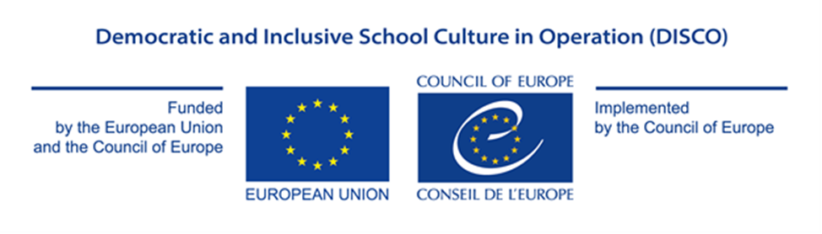

Appendix I

PROJECT PROPOSAL FORM

GRANT AWARD PROCEDURE

Democratic and Inclusive School Culture in Operation (DISCO)

EU/CoE Joint Programme for international co-operation projects

REF 2020/2021 DISCO

Micro-Grants

HOW TO COMPLETE THE PROJECT PROPOSAL FORM?

Complete each box with the information requested. The size of the box will adapt to the volume of text typed.

Once all fields are completed, upload the Project Proposal Form in Word format to the online system in accordance with the requirements of the Call for Proposals.

PROPOSED ACTION

Please, describe clearly and distinctively under each section the role and relevance
of each applicant in the project implementation process

- Project overview: Please provide a description of the project:
Title ►
Overall aim ►
Outcomes (Specific Objectives) ►
Partner countries (NB: from 2 to 3, with at least half of the countries being a member of the EU) ►
Participating organisations/institutions in each country and their roles (i.e. leading partner, implementing partner) ►
Outputs (Expected results) ►
The resource/publication to be used (select only one):► | 1. Travel pass to democracy:supporting teachers for active citizenship ☐  2. Education for democratic citizenship and human rights:diversity of approaches ☐  3.Three country audit of the lower secondary curriculum ☐  4. Teaching controversial issues-developing effective training for teachers and school leaders ☐  5. Teacher training in EDC/HRE-how to develop the ability of students to assess information from media  and social networks? ☐  6. Addressing violence in schools through education for democratic citizenship and  human rights education ☐  7. Managing controversy ☐  8. Developing democratic competences in the digital era ☐  9. Democratic school governance for inclusion: a whole community approach ☐  10. coLAB toolkit - inclusive practices towards refugees in higher education ☐  11. Digital resistance - an empowering handbook for teachers ☐

- Project concept and the description of activities (At least 1 page)

Please present the main ideas of your projects. Please describe the main project activities and indicate how they will lead to the foreseen outputs and outcomes of the project. ▼

- Appropriateness and relevance of the action in accordance with the Charter, the Council of Europe Framework of Competences for Democratic Culture and with the Paris Declaration

Please explain how the project will contribute to the implementation of the Council of Europe Charter on EDC/HRE, the Reference Framework of Competences for Democratic Culture and the provisions of the Paris Declaration. Please note in particular that the grants will fund projects designed to contribute to the sustainable development and promotion of education for democratic citizenship and human rights education. ▼

This micro-grant call focuses on the further development and/or dissemination of the resources and publications produced in the previous cycles of the Programme. Please also explain how you plan to make use of the selected resource (Section A).

- Potential impact on educational policy and practice in the participating countries

Please describe how the project will impact the educational policies and practices in the participating countries, including possible ways of evaluating such impact (1-2 years after the project), how will you ensure the sustainability of the action. ▼

- Potential for awareness raising at national and/or international level
Please describe how the project will contribute to increased visibility and awareness of the role of citizenship and human rights education for the future of democratic societies and specify what visibility material is expected to be produced (ex. video and/or audio products, coverage on relevant websites, the use of social media, coverage in specialised magazines, other publications) ▼

- Implementation plan and co-operation between partners
Please present your implementation approach, indicating each partner’s role in the project. Please also describe the planning of activities and how you will ensure timely delivery of the main outputs. Please refer to the workplan under section I. ▼

- Human Rights Approach
Please indicate:
- how gender equality is relevant to your project and explain how men and women will be included in the project, and whether the project will affect men and women differently.
- what vulnerable groups can be identified in relation to the project? what factors potentially contribute to inequalities for these groups (power, status, resources)? and explain in what ways the project will include these groups and have an impact on them.▼

- Participation of the States party to the European Cultural Convention, which had not previously taken part in this Programme
Please indicate whether one or more of the following countries are among the partners for the present project proposal:
1. Azerbaijan 2. Denmark 3. Iceland 4. Holy See 5. Kazakhstan 6. Liechtenstein 7. Luxembourg 8. Malta 9. Monaco 10. San Marino 11. Slovenia 12. Switzerland ▼

 | - Workplan
 | Briefly present your plan for the implementation of activities until 31 October 2021 ▼
Activity |  | 2021
Month |  | 1 | 2 |  | 3 |  | 4 |  | 5 |  | 6 |  | 7 | 8 |  | 9 | 10 | 11

