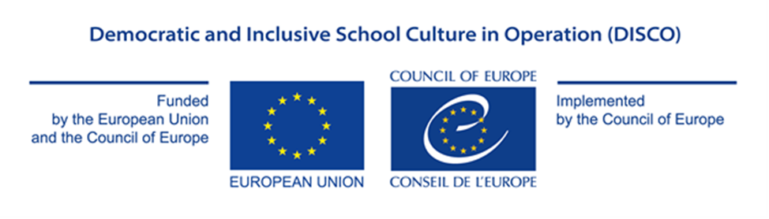

Appendix I

PROJECT PROPOSAL FORM

GRANT AWARD PROCEDURE

Democratic and Inclusive School Culture in Operation (DISCO)

EU/CoE Joint Programme for international cooperation projects

REF 2017 EDC/HRE DISCO

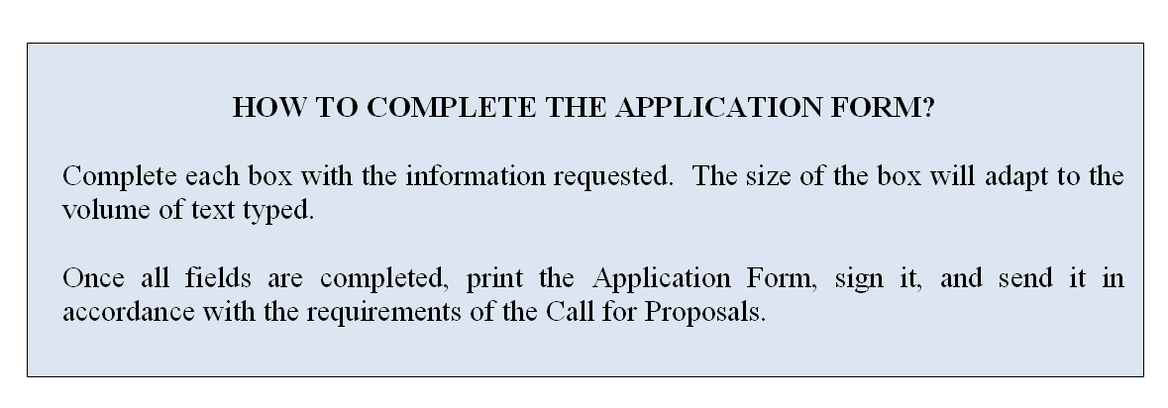

PROPOSED ACTION

Please, describe clearly and distinctively under each section the role and relevance
of each applicant in the project implementation process

- Project overview: Please provide a description of the project:
Title ►
Overall aim ►
Outcomes (Specific Objectives) ►
Partner countries (NB: from 3 to 6, with at least half of the countries being a member of the EU) ►
Participating organisations/institutions in each country and their roles (ex. coordinator, participant, implementing agency) ►
Outputs (Expected results) ►
The Council of Europe Tool to be used (select only one of two options):► | Thematic Priority 1: Digital citizenship education in relation to the implementation of the Council of Europe reference Framework of Competences for Democratic Culture and its guiding documents ☐  OR  Thematic Priority 2: Building democratic and inclusive school culture by embedding the learning environment in the local community (whole school/community approach) ☐  Choose an item.

- Detailed description of Activities (At least 1 page)

Please explain how project activities will be implemented in participating countries. ▼

- Appropriateness and relevance of the action in accordance with the Charter

Please explain how the project will contribute to the aims and objectives agreed by the Council of Europe member states in the Charter on citizenship and human rights education (in the primary, secondary (lower and higher) and initial vocational education and training levels), in accordance with the present Call for Proposals. Please note in particular that the grants will fund projects designed to contribute to the sustainable development and promotion of education for democratic citizenship and human rights education. ▼

This programme cycle will focus on:

Thematic Priority 1: Digital citizenship education in relation to the implementation of the Council of Europe reference Framework of Competences for Democratic Culture and its guiding documents

Participating countries are invited to support teachers in teaching and testing competences for digital citizenship for the promotion of democratic values and fundamental rights, non-discrimination, as well as active citizenship, and facilitate the acquisition of these competences based on the Council of Europe Framework of Competences for Democratic Culture. Information on the Framework is available at the following address: www.coe.int/competences.

The Scheme also supports activities aiming at enhancing critical thinking and media literacy, particularly in the use of the Internet and social media, so as to develop resistance to all forms of discrimination and indoctrination and foster digital citizenship education. In this field, participating countries are invited to develop project ideas with a specific focus and tangible outcomes based on the conceptual model and ten key domains presented by the Council of Europe Conceptual Model of Digital Citizenship Education.

Thematic Priority 2: Building democratic and inclusive school culture by embedding the learning environment in the local community (whole school/community approach).

The participating countries are invited to develop mechanisms to foster inclusion and a sense of belonging to a community for groups which face a high risk of exclusion, such as migrants, refugees, minorities and other vulnerable groups by creating opportunities to embed the learning environment in the local community based on a whole school/community approach.
.

- Potential impact on educational policy and practice in the participation countries

Please describe how the project will impact the educational policies and practices in the participating countries, including possible ways of evaluating such impact (1-2 years after the project) ▼

- Potential for awareness raising at national and/or international level
Please describe how the project will contribute to increased visibility and awareness of the role of citizenship and human rights education for the future of democratic societies and specify what visibility material is expected to be produced (ex. video and/or audio products, coverage on relevant websites, the use of social media, coverage in specialised magazines, other publications) ▼

- Participation of NGOs, youth organisations/associations, parents associations in the project design and implementation
Please describe how non-governmental organisations (national or international), youth organisations/associations and parents associations will contribute to the project design and implementation. In particular, you might wish to provide an indicative list of organisations, number of organisations, methodology for cooperation, your previous experience with respect to cooperation and potential for sustainability for such cooperation. ▼

- Human Rights Approach
Please indicate:
- how gender equality is relevant to your project and explain how men and women will be included in the project, and whether the project will affect men and women differently.
- What vulnerable groups can be identified in relation to the project? What factors potentially contribute to inequalities for these groups (power, status, resources)? and explain in what ways the project will include these groups and have an impact on them.▼

- Participation of the States party to the European Cultural Convention, which had not previously taken part in this Programme
Please indicate whether one or more of the following countries are among the partners for the present project proposal:
1. Azerbaijan 2. Belgium 3. Bosnia and Herzegovina 4. Denmark 5. Germany 6. Holy See 7. Iceland 8. Italy 9. Kazakhstan 10. Liechtenstein 11. Luxembourg 12. Malta 13. Monaco 14. Netherlands 15. Norway 16. Portugal 17. Republic of Moldova 18. San Marino 19. Slovenia 20. Switzerland 21. “the former Yugoslav Republic of Macedonia” 22. Turkey 23. Ukraine ▼

 | - Action plan
 | Briefly present your plan for the implementation of activities until 31 October 2019 ▼
Activity |  | 2018 |  |  |  |  |  |  |  |  |  |  |  |  |  |  |  |  | 2019
Month |  | 3 | 4 |  | 5 |  | 6 |  | 7 |  | 8 |  | 9 |  | 10 | 11 |  | 12 | 1 |  | 2 |  | 3 |  | 4 |  | 5 |  | 6 |  | 7 |  | 8 |  | 9 | 10

- SIGNATURE OF THE IMPLEMENTION PARTNER IN CHARGE
Name / First name of the Signatory ►
Title of position in the organisation of the implementing partner submitting the proposal ►
Place of signature ►
Date of signature ►
Signature and official stamp of the implementing partner submitting the proposal ►

