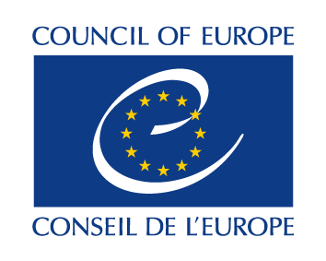
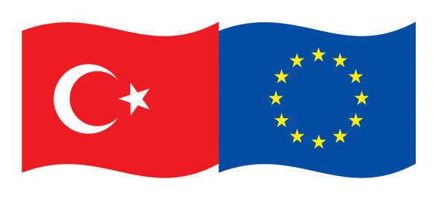

This project is co-funded by the European Union and the Council of Europe,
and implemented by the Council of Europe.

“PROMOTING ALTERNATIVE DISPUTE RESOLUTION (ADR) IN TURKEY”
EUROPEAN UNION-COUNCIL OF EUROPE JOINT PROJECT

FIELD VISIT TO ISTANBUL BAKIRKOY COURTHOUSE

Activity 2.1 Conducting a detailed needs assessment analysis and expert review of the legal framework and European best practices

11-12 OCTOBER 2021

Venue: Istanbul Bakırköy Courthouse

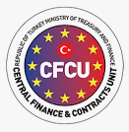

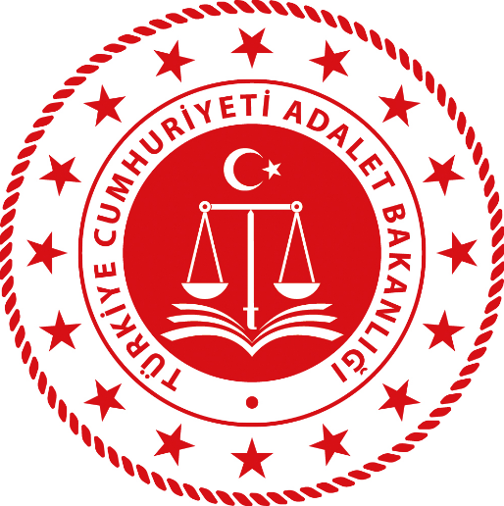

AGENDA

- Oct | 1st Day/Monday: Istanbul Bakırköy Courthouse
9.30 | Visiting the courthouse facilities  General review of the project and the activity  Ms Dicle Okan, Senior Project Officer, Council of Europe Programme Office in Ankara  (Chief Public Prosecutor, pilot court judges, court staff, mediators, representatives of the Ministry of Justice (MoJ) Mediation Department)
10.00- 11.00 | The conceptual framework and models related to the disputes to be included in Mandatory Mediation in Turkey and EU best practices.  Ms Nina Betetto, Council of Europe expert
11.00-11.20 | Break
11.20-12.30 | Discussions on the evaluation and expansion of the Mandatory Mediation in Turkey and the needs of the mediators, judges and other relevant stakeholders.  Ms Nina Betetto, Council of Europe expert  Ms Maria Oliveira, Council of Europe expert,  Mr Mustafa Erkan, Professor at Faculty of Law, Marmara University
12.30-14.00 | Lunch
14.00-15.20 | The conceptual framework and different models in Family Mediation and EU best practices.  Ms Maria Oliveira, Council of Europe expert
15.20-15.40 | Break
15.40-16.50 | Discussions on the conceptual framework and different models in Family Mediation in Turkey and the perspective of the mediators, judges and other relevant stakeholders.  Ms Maria Oliveira, Council of Europe expert  Ms Nina Betetto, Council of Europe expert  Mr Mustafa Erkan, Professor at Faculty of Law, Marmara University
16.50-17.00 | Wrap up and closing

- Oct | 2nd Day/Tuesday: Istanbul Ataköy Sheraton Hotel
9.30 | General review of the project and the activity  Ms Dicle Okan, Senior Project Officer, Council of Europe Programme Office in Ankara  (Staff of the mediation bureaux, mediators, representatives of the mediation centres, mediation associations, representatives of the MoJ)
10.00- 11.00 | The conceptual framework on the legal status and institutionalisation of the Mediation Centres and EU best practices.  Mr Mustafa Erkan, Professor at Faculty of Law, Marmara University  Ms Nina Betetto, Council of Europe expert  (Staff of the mediation bureaux, mediators, representatives of the mediation centres, mediation associations, representatives of the MoJ)
11.00-11.20 | Break
11.20-12.30 | Discussions on the revision and proposals related to the legal status and institutionalisation of the Mediation Centres in Turkey and different perspectives of the stakeholders.  Ms Maria Oliveira, Council of Europe expert  Ms Nina Betetto, Council of Europe expert  Mr Mustafa Erkan, Professor at Faculty of Law, Marmara University
12.30-14.00 | Lunch
14.00-15.20 | Meeting with the arbitrators, mediators, representatives of the Istanbul Arbitration Centre (ISTAC), the Istanbul Chamber of Commerce (ICOC), and representatives of the MoJ;  The status quo of arbitration (discussing voluntary/mandatory arbitration) in Turkey:  - sufficiency of legislation, the role and perception of the judiciary and other legal professionals, institutional capacity, and proficiency of arbitrators, the issue of competence, the needs, obstacles, and remedies;  - suggestions for the capacity building for arbitrators, and how to increase the awareness among the target groups and beneficiaries of the arbitration in Turkey.  Mr Mustafa Erkan, Professor at Faculty of Law, Marmara University
15.20-15.40 | Break
15.40-16.50 | Discussions on the status quo and the design of arbitration, capacity building for arbitrators, and raising awareness in Turkey.  Ms. Maria Oliveira, Council of Europe expert  Ms Nina Betetto, Council of Europe expert  Mr Mustafa Erkan, Professor at Faculty of Law, Marmara University
16.50-17.00 | Wrap up and closing

