EUROPEAN YOUTH FOUNDATION

|  |  |
| --- | --- |
|  |  |

Grant management system of the European Youth Foundation

Business Requirements

This document is the property of the Council of Europe. It's a part of a consultation launched by the Directorate of Information Technology (DIT) of the Council of Europe. The supplier will treat this document as strictly confidential. It may not be reproduced or communicated without the author's prior agreement. The content of this document will be disclosed to potential business partners in good faith by the supplier. No part of this document may, in itself, constitute a commitment of the Council of Europe or its staff.

Contents

1 Introduction 5

1.1 Objectives of the document 5

1.2 Document references 5

1.3 Lexicon / Glossary 5

2 Executive summary 7

3 Background Information 9

3.1 Project scope and Objectives 9

3.2 Presentation of any other relevant directorates / departments 10

3.3 Business processes 10

3.3.1 Existing (AS IS) processes 10

3.3.2 Future (TO BE) processes 13

3.4 Identified stakeholders, users, roles & responsibilities 16

3.5 Interaction with other systems 18

3.6 Replacement of existing / older systems 18

3.7 Production rollout considerations 18

4 Business Requirements 19

4.1 Detailed business requirements 19

4.1.1 BR1 – General and parameter management 19

4.1.4 BR2 - Access to public data form reports, NGO data and automated extraction of data in the map 20

4.1.5 BR3 – NGO registration and data change management 20

4.1.6 BR4 – Grant application forms and the assessment process (communication with NGO) 22

4.1.7 BR5 – Decision making on a grant 23

4.1.8 BR6 – Contracting a granted project 24

4.1.9 BR7 - Management of changes in a grant and communication with the grantee organisation 24

4.1.10 BR8 - Filling in reports by NGO and validation of reports by the EYF 25

4.1.11 BR9 - Cancellation of projects, refund requests 25

4.1.12 BR 10 – Search for and production of data and statistics, including complex statistics 26

4.1.13 BR 11 - Possibility for the EYF secretariat to develop new grant applications within the same granting process 27

4.1.14 BR 12 – Snapshot of historical relations with the NGO 28

4.2 Interface requirements 28

5 Technical Requirements 29

5.1 Operational environment Standards 29

5.2 Hardware and infrastructure requirements 29

5.3 Access modes and security requirements 29

5.4 Business Continuity plan (Disaster recovery) 29

5.5 Backup and Archiving 30

5.6 Service level: availability, performance and support 30

5.7 System Documentation 30

6 Critical considerations 31

6.1 Assumptions 31

6.2 Constraints 31

6.3 Risks 31

7 Data Requirements 32

7.1 Data outputs and reporting requirements 32

7.2 Data migration 32

8 User Documentation and Training Requirements 32

9 Regulatory requirements 32

9.1 Privacy Requirements 32

9.2 Audit Requirements 33

9.3 Legislation 33

10 Appendices 34

10.1 Current Functional Mapping 34

10.2 Middleware NetDocument 34

10.3 Database diagram 35

10.4 Public interface 35

10.5 Report interface 36

10.6 Public report interface 37

10.7 Interface once connected 37

10.8 Example of grant application form 38

# Introduction

## Objectives of the document

This document aims to provide a comprehensive overview of the business requirements for the European Youth Foundation – Online system / platform. The document serves as a crucial starting point for implementing a solution that meets the organisation's specific needs.

By clearly defining the minimum business requirements, this document acts as a roadmap for the development and deployment of the EYF Platform. It outlines the functionalities, features, and technical specifications that are essential for the successful operation of the system.

However, it's important to note that this document does not delve into the detailed analysis of potential solutions implementations. Instead, its primary focus is capturing the core business requirements that will guide the selection and development process, ensuring that the resulting solution aligns with the Council of Europe's objectives and needs.

## Document references

|  |  |
| --- | --- |
| **Document** | **Link** |
| Current online system | [Home Page (coe.int)](https://fej.coe.int/) |
| System specifications of the current online system | <https://mycloud.coe.int/s/eSb2cFwKacESPPZ> |
| Descriptions of the grants of the EYF and other relevant information about the EYF | [Funding and grants Council of Europe EYF - European Youth Foundation (coe.int)](https://www.coe.int/en/web/european-youth-foundation) |
| Statute of the EYF | <http://rm.coe.int/CoERMPublicCommonSearchServices/DisplayDCTMContent?documentId=090000168008f622> |
| Regulations of the EYF | <http://rm.coe.int/CoERMPublicCommonSearchServices/DisplayDCTMContent?documentId=090000168008f611> |
| COE Developer Toolkit | <https://mycloud.coe.int/s/C4HbcSkF7y6ZZaa> |

## Lexicon / Glossary

|  |  |
| --- | --- |
| **Term** | **Definition** |
| DIT | Directorate of Information Technology |
| SLA | Service Level Agreement |
| EYF | European Youth Foundation, also referred to as the Secretariat |
| CPJ | **The Programming Committee on Youth** is a co-managed statutory body of the youth sector, comprised of representatives of 8 youth NGOs and 8 governmental bodies. It takes decision on the EYF budget and grants awarded by the EYF, as well as of the programme and activities of the EYCs in Strasbourg and Budapest. |
| NGO / ONG | Non-governmental organisation, used in the text as abbreviation for youth organisation |
| PA | Pilot Activity, a type of grant awarded by the EYF |
| IA | International Activity, a type of grant awarded by the EYF |
| WP | Annual work plan, a type of grant awarded by the EYF |
| SG | Structural grant, a type of grant awarded by the EYF |
| GAF | Grant Acceptance Form – the contract between the NGO and the EYF on the Grant |
| DMS | Document Management System (NetDocument) |
| IAG | Identity Access Governance (UserCube) |

# Executive summary

The European Youth Foundation (EYF) is a fund established in 1972 by the Council of Europe to provide grants to youth organisations (NGOs) for their projects and for their operations. Every year, the EYF supports about 200 youth projects through grants, for a total sum of approx. 4 million euros. The working languages of the EYF are English and French.

The granting process as a whole is managed through an online system, whose updating, and modernization are the purpose of this document. This online system is used by beneficiary NGOs to register, to apply and report on their grants. It is also used by the EYF secretariat to manage the granting process from the registration of an NGO to the assessment of its application, the decision to give grants, and ultimately the reporting (narrative and financial) on the project.

The EYF provides four types of grants on a regular basis:

* **pilot activities** to support local or national projects (PA)
* **international activities**, open to international youth NGOs and networks and to national youth NGOs with partners (IA)
* **annual work plans** of international youth NGOs and networks (WP)
* **structural grants** to support international youth NGOs and networks (SG).

A specific **integrated grant** is awarded to the European Youth Forum (European platform of youth organisations) each year which also requires an assessment process of their application and executing the decision in the online system.

On specific occasions, there may be also **special calls** for projects, that have different specifications in relation to the four mentioned types of grants.

The EYF online system is the only platform for communication, assessment and reporting on grant applications and reports, with partners and beneficiaries, and for the management of the EYF budget and grants. It is essential as it is the main working tool of the EYF secretariat and the CPJ.

The current online grant management system has the following major functions:

1. **NGO Registration:** NGOs create an account and fill a registration form to submit a registration request in the online system. NGOs need to choose under which category they want to register national / local / international / international networks of youth NGOs / regional networks of youth NGOs. The EYF secretariat may get in touch with the NGO through a message system in the online system. The NGO can respond and re-submit their registration. Once the NGO registration is accepted, they can submit grant applications. Forms are only accessible if logged in with a unique username and password for each NGO.
2. **Grant application:** Registered NGOs submit grant applications at specific deadlines and depending on their category (local NGOs can only apply to Pilot Activities for example). A different application form is available for each grant.
3. **Application assessment:** The application is then assessed by the EYF Secretariat. The process can involve communication between the EYF secretariat and the applicant NGO to clarify their proposal. During this, specific sections of the application form can be reopened with a comment for the NGO to modify different fields.
4. **Assessment sent to the CPJ**: The EYF processes the applications and inserts a technical assessment of the applications that is then forwarded in the system to the members of the CPJ.
5. **CPJ Vote:** The CPJ has access to parts of the applications and the EYF assessment and votes on the decision for each application.There are 3 potential decisions that can be taken: an application can be **rejected**, **resubmitted** or **accepted**.
6. **Letters of approval or rejections:** Based on the decision taken by the CPJ, the EYF will processes the decisions and launch in the system the **letters of grant approval, conditions for resubmission of the application or grant rejection**. Similarly, then the awarded project will be issued a grant acceptance form, using specific templates generated from the online system.
7. **Grant management (for accepted application):** The online system allows the secretariat to manage all the steps related to grant giving and project reports, such as the contract for the grant, the payments, modifications of data of the granted application, the cancellation of a grant, or the refund requests.
8. **Reporting:** The NGOs use the online system for reporting on their projects and to provide a financial report.

The current online system was launched in 2013, it is outdated and requires frequent maintenance and development with high costs and risks. Users often experience recurring bugs. The user-friendliness of the interface is under standards and does not reflect the technology of today. In general, all processes on the online system need to be streamlined for efficiency.

The current online system does not allow for youth organisations to apply for study sessions offered by the youth sector of the CoE (a different support scheme for youth organisations than the grants of the EYF, managed also by the Youth Department of the Council of Europe). It is commonly agreed that including this additional functionality in the new EYF online system would facilitate applications by youth NGOs, decision making by the CPJ, and it would also facilitate work of and support internal coordination, within the youth sector secretariat.

Further, the EYF is increasingly required to report to its donors on results and impact on granted projects. For its reports, the EYF secretariat needs to be able to count on, and extract reliable data easily from the online system, which is not the case at present. The current system has limitations in navigation, statistics extraction and generally more and more technical bugs. For example, opening it in two different tabs in the same browser can result in permanent errors in information. A new online system must allow for the above-mentioned tasks to be carried out with major improvements, and a **higher level of autonomy of the EYF secretariat to operate developments**, for example in application or reporting forms or the creation of grant approval/rejection letters, etc. A new system could also incorporate a grant workflow that would record the task division and deadlines for projects more easily.

The need for an updated online system is also highlighted in the EYF risk assessment for 2023.

# Background Information

## Project scope and Objectives

The objectives of this project are multiple:

1. to develop a new modern and functional tool to receive, communicate on, assess and manage grant applications and reports on awarded projects that saves the EYF secretariat time and allows for changes and adaptations when needed rapidly, and a simplified and clear workflow;
2. to replace obsolete technology, as the current system dates back from 2013;
3. to have a clear, easy to navigate interface of the online system for all users, including beneficiaries, members of the Programming Committee on Youth and the EYF secretariat;
4. to make the decision-making process (consultation and voting) for the CPJ members more accessible and efficient;
5. to allow to the EYF secretariat to extract reliable statistics from the system;
6. to reduce maintenance costs for the online system and the number of tickets made to solve problems in the system;
7. to ensure security and data protection settings;
8. to establish an efficient system of (re-)registration of youth NGOs to confirm their interest to stay in the database of NGOs and that they still fulfil all criteria;
9. to provide a tool for youth organisations to apply for study sessions offered by the youth sector.

**This project is of absolute urgency** as we are using an outdated system that creates a lot of issues and additional labour-intensive work to the EYF secretariat, the CPJ, and to the youth NGOs. Bugs occur daily, sometimes preventing the secretariat to process applications. In addition, for quality and reputational considerations, a new system is needed to ensure we use current technology in the best ways to make our work effective and attractive.

It should also be noted that the EYF is currently in a process of reform of its grants, so there may be new grant types appearing in the future, that would require specific application forms, reporting forms etc. **The new online system should allow for the EYF secretariat to create new grant types that follow the same process as the current grant types** but have specific application and reporting forms. For this reason, it is important that the new system enables the secretariat to create, update, and in general manage every section of each form (the current system only enables the secretariat to modify text, but not to create a new box or a new form for instance).

The following stakeholders will benefit from this project:

1. youth NGOs as they will gain a modern, user friendly and efficient tool to apply and manage their grants and communicate with the EYF;
2. the CPJ, as they will gain a modern, user friendly and efficient system to facilitate their decision making on the grants and reliable data and statistics for monitoring purposes;
3. the EYF secretariat, as the team will be able to assess an increased number of applications efficiently and the quality of their work will increase;
4. the EYF as a financial instrument of the youth sector of the Organisation, to have a new system to improve its grant management and reporting processes, as well as communication with beneficiaries, partners, and donors.

## Presentation of any other relevant directorates / departments

The main internal stakeholders are the Youth Department, namely the EYF secretariat receiving and assessing applications and reports, and preparing recommendations on grants, and the CPJ, as decision-makers on the grants. The EYF secretariat is currently comprised of 9 staff members using the online system on a daily basis and as the main working tool for managing the grant system.

Youth organisations are the external stakeholders, as they use the system as beneficiaries of the grants. The current online system counts almost 2000 accounts of youth organisations registered, along with other thousands of organisations whose applications for registration were rejected.

The EYF is part of the Youth Department of the Council of Europe, which has another division – the Education and Training Division - that process applications for study sessions from youth organisations on which the CPJ take decisions. The development of a new online system should also address the possibility to incorporate the application process for study sessions and enlarging the access to the online system to certain colleagues in the Education and Training division (to manage the study session applications primarily). This integrated approach would allow for better data and statistic related to the individual NGOs applying for both EYF grants and study session. This dimension would though be of a second priority in the development of the new system.

## Business processes

### Existing (AS IS) processes

See also Current Functional Mapping, Database diagram, Public interface, Report interface, Public report interface, Interface once connected, Example of grant application form.

**Process 1: NGO registration**

1. A registration form, including EYF criteria, is made available for new youth NGOs to apply for registration with the EYF.
2. The youth NGO creates an account in the online system and fills in the registration form with some questions and attaches the required documents (e.g. statutes).
3. The EYF secretariat assesses the registration form. If the form is complete, the registration is validated or rejected, based on the fulfilment of the criteria for registration. If the registration form is not complete, the EYF asks the NGO for additional information or documents and the registration form moves to resubmission status in the system and the NGO can add information. Subsequently, the NGO can complete what is requested and resubmit the form. The EYF will then finalise the assessment and either approve or reject the application.
4. The NGO can apply and be registered as either local NGO, national NGO, regional network, international youth NGO or an international youth network. The European Youth Forum is registered under a separate category. The categorisation is important as it conditions the types of grants the registered NGO can apply for. Once registered, the NGO will be able to access the application forms for the grants to which it can apply for.
5. Based on the information provided during registration, a geographical map of the registered NGOs is produced automatically and made available on the EYF website. Also, the list of NGOs in the system has a function that allows to search and extract different data about the registered organisations. A list of registered NGOs is also available in the public section which is accessible to all organisations that have registered in the online system (with limited data).
6. Registered NGOs may update their profile, for instance in case their contact details change, or if they want to be changed their status to a different type of NGO (for example, local NGOs start working nationally, and request to change to the category of a national NGO). Depending on the requested change, some request will require the validation of the EYF secretariat to ensure that the NGO still meets all the eligibility criteria.

**Process 2: Grant application and decision**

1. Depending on the type of NGO, they can apply for specific grants, among the four available. Each grant has specific deadlines each year, specific application forms and specific criteria. All this information is found online where the NGO completes the information about the project, uploads attachments and completes a budget.
2. The NGO submits their grant proposal in the online system.
3. In some cases where the information is not sufficient, the EYF ask the NGO to add more information or to modify data. To do so, the secretariat must reopen specific sections of the grant proposal in the online system. After completing the missing information in the system, the NGO can resubmit the proposal.
4. The EYF secretariat carries out (in writing) 2 assessments of each application and summarises the full assessment with a draft comment to the NGO.
5. The EYF secretariat fills in the assessment and recommendation for each application in separate forms/text boxes in the online system. These are then made available for consultation, analysis and final decisions of the Programming Committee on Youth (CPJ).
6. The CPJ votes on each application to be approved, resubmitted or rejected, and can leave a comment about their own vote.
7. Based on the comments and votes of the CPJ members in the online system, and subsequent CPJ decisions during plenary meetings or online, the EYF secretariat finalises the formulation of the CPJ decisions to the NGOs. The results of the CPJ decisions (grants awarded, rejected or resubmitted) are communicated to the applicant NGOs then through the online system.

**Process 3: Grant management after approval, reporting and closing of grants**

1. Once an EYF grant is awarded, a grant approval letter is generated by the online system and the beneficiary NGO can print and sign their grant acceptance form and send the signed and scanned document to the EYF secretariat by email. At the moment, this step is not fully automated, as the letters need to be partly manually processed by the EYF secretariat and the NGO needs to use emailing to send back the signed and scanned letter, instead of using the system to upload it.
2. The approved project moves to different “status types” (contract sent to NGO, first payment done etc), depending on where the grant contract is at, or later on, when the NGO sends the report.
3. The current system allows the EYF secretariat to make changes in the project dates and venue, for example.
4. Once the NGO has implemented and finalised the project, they must submit a narrative and financial report. There is a reporting form (with guiding questions) available in the online system which the NGO can initiate to start their reporting in the system.
5. All grantees are asked to submit a narrative report on the project’s results and a financial report how they have spent the funds two months after the end of the projects. For WP and SG grants which are longer in time, there is a requirement for the grantee to submit an interim report half time through the implementation of the projects in the online system. The online system sends two automatic reminders when a report is late.
6. The financial report must include proof of expenditures, such as receipts, invoices, contracts, purchases, etc. Currently, the financial proofs are sent to the EYF secretariat on paper, or on a USB stick for some grant categories or under special calls.
7. The EYF assesses the report received and then moves the project to the validation phase, which consists of approving the narrative report and the final amount (balance) of the grant. Depending on the final balance, some beneficiaries are requests to refund transferred amounts back to the EYF.
8. In case of WP and SG grants which have also an interim report, the second payment is made once the interim narrative report is approved.

**Supporting processes**

1. All projects and NGOs are fully searchable in the online system. This means that the EYF secretariat has a way to search data in the system by a number of parameters and extract specific lists.
2. A number of parameters for the grants may be defined each year, which means that at the beginning of a year, the EYF secretariat has the power to create new parameters. For example, every year the priorities for grants need to be inserted in the online system.
3. The system has a dashboard interface where a number of projects are inserted in boxes for fast visualisation (so, on the dashboard, the numbers of NGOs with late reports is indicated, or the number of new comments, etc). For example, it can categorise in this interface the projects with very late reports, etc.
4. The NGOs can contact the EYF secretariat through the online system, sending messages in the Comment page of the relevant grant application/project
5. In some cases, the CPJ can take the decision to cancel grants, also the NGO that has been granted a project can request to cancel it due to certain reasons.

### Future (TO BE) processes

The aim is to have a new online system that can manage coherently (as a minimum) the above-mentioned processes. It is expected that the new online system uses modern and fast technology, is efficient and accessible for all users, is an easy and intuitive tool for navigation to manage the grants, automates information to limit labour intensive work, provides easy to get and reliable data and statistics, and is flexible and adaptable for new grant schemes and other novelties in the future.

To ease the navigation, the structure of the online system should be improved. The current division of sections: NGO / Projects / Reports should be reviewed to facilitate the navigation between application / registration / project page / report / changes to projects, as these are all currently accessed separately with no links between the pages.

**Process 1: NGO registration**

**Reminder to NGOs**: An automated way of asking the NGO to reconfirm their data on a regular basis, to check if the NGO is still active, if it is relevant to keep them in our database, or if their profile page need to be updated for instance. For now, once they are validated in the system, they are in for good and there is no technical solution to check that their data is updated and confirm this. The new system could record the day when the NGO registration was validated and at a given interval (for example every 5 years), automatically put the NGO in the status of needing to resubmit their form and update their data, with the possibility for the EYF secretariat to recheck whether that NGO still fulfils the criteria for remaining in the database. NGOs also have the possibility to make changes in fields for which the EYF approval is not needed and of which the EYF is not informed. The new system should include the function that the EYF receives a notification each time a registration form is modified.

**Deleting inactive NGOs:** As a follow-up, the EYF should be able to delete NGOs from the database after a certain (defined) period of inaction.

**Removing NGOs that were either disactivated or that asked to be taken of the list**: at the moment, NGOs in this situation are still included in the list of validated NGOs in the system that can be extracted.

**Each NGO should have a profile page** **that can be linked or tagged.** Everywhere in the system names of NGOs would appear as hyperlink leading to the NGO profile page in the online system. This profile page could highlight recent projects, submissions, the history with the EYF, etc.

**Process 2: Grant application**

**Backoffice autonomy:** In the Backoffice, the EYF secretariat should be autonomous in modifying and creating new application and reporting forms, not only in the tags used for questions, but also at a structural level, creating new fields, boxes, new forms/templates, new NGO categories etc.

**Deadline management:** the EYF secretariat should have the possibility to close/turn off specific grant forms, according to deadlines, available funding, special calls or other variables. In the current form, eligible NGOs can apply to grants at all times.

**Process 3: Grant assessment and decision**

**Streamlined assessment:** Each application form currently includes an assessment tab to be used by the secretariat in preparation for the CPJ decision. This section should be modified according to needs and include the possibility to automatically generate information from the applicant’s profile, such as the number of applications received in the past and their decisions.

**Improved data, presentation of assessment and recommendations for the decision-making process of the CPJ:** The process of assessment should have fewer manual and labour-intensive steps, and the system should extract and organise data for the decision of the CPJ in a more coherent and navigable manner. For example, at the moment, the EYF secretariat needs to extract manually an Excel file with all the applications from a given deadline and format it to make it readable. However, when two deadlines overlap, there is no possibility to separate the applications when exporting the data and it has to be done manually. This also means that any modification must be inputted manually in the system. An easier way would be for the online system to have a system of visualising a category of applications and include links to each application within this category/group.

**Regroup information in one place to streamline decision process:** The final steps, after decisions, involve several manual and labour-intensive steps to validate the results. A key improvement is to improve the administration of the online system for the execution of the decisions on grants, the new system must streamline the information which is typed in so that it automatically appears in all places as needed. Currently, in the process of assessing an application, providing a recommendation to the CPJ, processing the CPJ decision and informing the applicant NGO of the results, the EYF secretariat needs to type the same information in 2 or 3 places in the online system, which makes is cumbersome and time inefficient.

**Improve online forms to ensure data protection (of project applicants / managers / owners) :** One example: currently, the CPJ members who consult and vote on grant applications can see and read all the data provided in a project/grant application. This includes some information and data of applicant NGOs (staff) that can be sensitive and must be protected. At the same time, the navigation for the CPJ members between applications must be reviewed to make it easier and more coherent for them to consult the grant proposals and vote on them.

**Process 4: Grant management after approval, reporting and closing of grants**

**Letter templates:** The contractual letters issued need to be fully automated and the EYF secretariat must be able to adapt the letter templates without further (or if not possible, with less) intervention of the DIT/developers. There need to be fewer manual steps than now.

**Better visualisation of key info for each project**: In the new online system, there is a need to record better the key communication with the grantee NGOs and the points of attention to each grant. For example, the conditions upon which the grant was awarded could be highlighted in some way, so it is easily detectable on the project page, to ensure that the conditions are clearly seen by anyone reading the project page.

**Internal project management tools:** There needs to be more information on the project page regarding the status of the project within the EYF team. There is a need for the secretariat to be able to record the EYF team members in charge of following a certain project. On the project page, it should be clear who within the team is in charge of the different steps (1st assessment, 2nd, reporting etc.). A text field is also needed where an EYF team member can leave a comment regarding the status of the project / application, which should be visible from the dashboard or home interface.

**Reporting on results of EYF funded projects and other supporting processes**

A **statistical extraction** procedure must be included in the system so that the extraction of statistics based on different parameters is easy to do. This should also be aligned to the EYF indicators that are in the Budget and Programming document of the Organisation.

Once an NGO is registered in the system, communication between the NGO and the EYF secretariat is done through a system of messages, with generic notifications being sent by e-mail about new messages. These should remain and be improved to ensure that the content of the message is visible in the generated e-mail and/or that it is possible to link directly to each individual message. The system should ideally also register if the NGOs has read the message sent by the secretariat, especially when it concerns reminders and delays.

For NGOs applying, the system must have an easy interface so that they can navigate more easily between their grant proposals and reports.

For special calls for projects, the EYF secretariat must be able to develop and use new application and reporting forms that NGOs can access in the same manner as they do now with the 4 existing grants.

Historical tracking of an NGO’s previous projects should be possible in an easy way, indicating for example the chronology of their grants and any major issues therein.

Navigation among projects, reports, registrations, should be improved. At the moment, some of these processes require to go back to the main menu and then restart the search. The new system should allow to open new pages in different tabs.

The new online system should be user-friendly for users who are not necessarily computer literate.

The online system must continue to be available in French and English.

The online system should also facilitate administrative processing by the EYF secretariat and the various stakeholders in the decision-making system.

A simple dashboard should enable the basic user to know at what stage their application is. It must also allow the NGOs to consult the history of their previous files.

A more detailed dashboard should enable the EYF secretariat to have a synthetic view of all the files in progress in a cycle as well as the requests for registration, etc. There should be an additional functionality (workflow) in the system that would allow the secretariat to assign/view and work on assigned tasks and files within the EYF secretariat team.

All the specifications for the current online system must be reviewed in order to ensure that the new system has in place also the current processes, in some cases with some modifications, and also the improvements. The current system specifications are available.

## Identified stakeholders, users, roles & responsibilities

1. **Anonymous user:** does not have an account on the online system and has only access to public information. UA
2. **NGO in the process of registering** has an account, requested to be registered, they cannot apply yet for grants as the process is not over yet, ONG Tmp
3. **Registered NGO:** can apply for grants, then fill in their reports, etc. ONG
4. **CPJ members**: can access certain grant applications to take the decision on the grants. PC
5. **EYF secretariat:** manages the online system back office. SEC
6. **Director of EYF:** more powers that the previous role in the back office. DIR

*This table comes from the current specifications of the current online system and was copied here to clarify the settings and access of different profiles.*

|  |  |  |  |  |  |  |
| --- | --- | --- | --- | --- | --- | --- |
| ***Functions*** | ***UA*** | ***ONG Tmp*** | ***ONG*** | ***PC*** | ***SEC*** | ***DIR*** |
| Access to public data of reports and NGOs | X | X | X | X | X | X |
| Create a new login profile | X |  |  |  | X | X |
| Log into the system |  | X | X | X | X | X |
| Submit an NGO registration | X | X |  |  | X | X |
| Change the account details of an NGO |  |  | X |  | X | X |
| Manage NGOs |  |  |  |  | X | X |
| Ask for a grant through a grant application form |  |  | X |  |  |  |
| Consult the projects of one NGO |  |  | X | X | X | X |
| Validate a grant request |  |  |  |  | X | X |
| Recommend a grant |  |  |  |  |  | X |
| Evaluate a grant request |  |  |  | X |  |  |
| Adopt a grant request |  |  |  |  |  | X |
| Issue the contract for a project granted |  |  |  |  | X | X |
| Fill in and submit a report |  |  | X |  |  |  |
| Validate a report |  |  |  |  | X | X |
| Evaluate a report |  |  |  |  |  | X |
| Cancel a project |  |  |  |  | X | X |
| Assess a refund |  |  |  | X |  |  |
| Confirm a refund |  |  |  |  |  | X |
| Produce statistics |  |  |  |  | X | X |
| Manage all users except DIR |  |  |  |  | X | X |
| Mange DIR |  |  |  |  |  | X |
| Configure system settings |  |  |  |  | X | X |

## Interaction with other systems

**Office suite / adobe**: The online system must be able to generate different kinds of documents, in CSV, Excel, Word, plain text, PDF or image formats.

It should also be able to convert uploaded documents in a specific format such as excel or word, if formatted correctly, to avoid having to copy-paste from offline files.

**EYF Website:** Some NGO and project data is exported to a map on the EYF website, showing the NGOs registered in real time on a map and similarly showing the ongoing projects on a map.

On the online system external interface, there is data about NGO and project reports available to anyone.

The new online system should make it easier also to extract project summaries when needed.

**DMS:** NetDocument will serve as the central repository for storing various types of documents provided by platform users, including Word, PDF, Excel, CSV, and more.

The primary objective of this integration is to enhance document management capabilities within the European Youth Foundation platform by utilizing NetDocument as the dedicated DMS. This will ensure secure storage, efficient retrieval, and streamlined collaboration on diverse document formats.

The integration will be facilitated through the utilization of the API provided by the Council of Europe (COE) for NetDocument.

## Replacement of existing / older systems

The current online system was set up in 2013 and has outdated technology. The new system will replace it, ensuring the functions it has now, with adding improvements, new functionalities, coherence, navigation, statistics extraction etc. Corrections of current system limitations should also be made. The new online system should also comply with the Council of Europe current security and privacy rules.

## Production rollout considerations

**No discontinuity:** The EYF has applications open on a rolling basis, throughout the year. This means that there cannot be a discontinuity in the online system to ensure NGOs can continue to apply at any time. Hence, the date of activation of the new online system, and deactivation of the former system must be thoughtfully considered.

**No loss of data:** Data of NGOs implementing projects at the time of rollout of the new system need to be either secured in the old, or transferred to the new one, to allow the EYF to continue the grant management without loss of data or discontinuity. This should be thoughtfully considered.

**Not all data should be transferred:** clean information that is no longer relevant. For example, in the list of NGOs, some have been in drafts for several years and are no longer relevant.

# Business Requirements

## Detailed business requirements

### BR1 – General and parameter management

|  |  |
| --- | --- |
| **Description** | This is where all the general parameters of the application are grouped, such as cycle management, evaluation periods, etc., as well as the general rules for the entire application. |
| **Priority** | MUST |
| **Perimeter** | General |
| **Benefits** | Allows to centralise all the parameters of the online system |
| **Test method and acceptance criteria** | The implemented solution will be tested by the business team in a validation environment. |
| **Business Rules** | The EYF secretariat should have the permissions and capacity to update and upscale all the parameters (including criteria, requirements and guiding questions) in the application, registration and report forms, as well as to introduce new ones. Some parameters need to be reviewed every year, such as annual priorities for grants or special calls.  Selecting “NGO comments” from an assessment page in an application leads to a server error.  In the NGO section, be able to search by acronym. |

**4.2.2 BR2 – Account management**

|  |  |
| --- | --- |
| **Description** | Access to the online system is open to everyone. Anyone can open an account, and once an NGO is validated, they have access to the EYF grants. The EYF should have access to NGO lists and be able to modify them. |
| **Priority** | MUST |
| **Perimeter** | Users |
| **Benefits** | Allows for management of users in agile ways. |
| **Test method and acceptance criteria** | The implemented solution will be tested by the business team in a validation environment. |
| **Business Rules** | Users must be able to create an account and then register an NGO.  Permissions for each type of user are described earlier in the document.  In addition, the EYF secretariat must have the rights to close accounts of NGOs. |

**4.2.3 BR3 – Simple dashboard and workflow**

|  |  |
| --- | --- |
| **Description** | The tool must allow users to visualise the elements/sections on which they have to take action and there is a system of workflow, with tasks and deadlines indicated. Allows for each user, according to their privileges, to follow the workflow they must be involved in. |
| **Priority** | MUST |
| **Perimeter** |  |
| **Benefits** | Allows for users to know what they need to do and when. |
| **Test method and acceptance criteria** | The implemented solution will be tested by the business team in a validation environment. |
| **Business Rules** | A centralized dashboard is accessible to the EYF secretariat.  This will allow to follow the status of applications, latest comments, reports that are late etc.  For each member of the EYF secretariat the online system should have a workflow function and allow them to see their tasks and when they are due (assessment / reply to comment / report, etc.). A task assignment function must be hence foreseen in the system. |

### BR2 - Access to public data form reports, NGO data and automated extraction of data in the map

|  |  |
| --- | --- |
| **Description** | The system allows for the publication of the public part of the system and in a map of key data on NGOs, applications and reports |
| **Priority** | MUST |
| **Perimeter** | Website, general |
| **Benefits** | Allows for updated public data about NGOs and projects supported |
| **Test method and acceptance criteria** | The implemented solution will be tested by the business team in a validation environment. |
| **Business Rules** | Once an NGO is validated, some of its data from the registration should appear in the public part of the online system and be searchable. The same applies for the NGO data to appear on a map of Europe, on the basis of its GPS coordinates or the address indicated.  Once a project is approved, during its implementation period, its data should appear on a map of Europe on the EYF website. |

### BR3 – NGO registration and data change management

|  |  |
| --- | --- |
| **Description** | This requirement covers the functions of NGO registering in the EYF online system, the possibility for them to update their data, and the renewal of EYF registration regularly. |
| **Priority** | MUST |
| **Perimeter** | NGOs registered in the online system |
| **Benefits** | Allows for having an updated list of NGOs |
| **Test method and acceptance criteria** | The implemented solution will be tested by the business team in a validation environment. |
| **Business Rules** | There needs to be a form for registration of NGOs, that any NGO with a newly created account in the online system fills in and submits for registering.  The EYF secretariat must be able to ask questions for clarification and the NGO must be able to complete their form and submit it.  NGO can have different statuses in the system: Draft / validated / rejected / resubmit / New / Archive.  Once an NGO is validated, the system sends upon validation an automated message. The EYF secretariat must be able to reconfigure this automated message whenever needed, and the message should be different according to the NGO category and should contain hyperlinks.  The system must keep track of the date on which the NGO is validated. At a given interval of time, the NGO must go back to the status of not validated, in order for the NGO to reconfirm its data, statute, mission, and all the registration criteria.  The interval could be of 5 years, starting at the moment when the NGO was registered. The NGO could be asked to reconfirm their information within a number of months, and if they do not do this, the system should not allow them to apply for new grants, while they should still be able to access past or ongoing projects.  Currently, a number of inactive NGOs are registered in our database – these NGOs could go in an “archive file” so maybe some sort of record could be kept, but they would not take up space anymore next to active NGOs (they would not be considered in statistics generated, or the map, etc.)  The EYF secretariat must have high privileges on the NGOs and in some cases be able to close NGO accounts or temporarily suspend part of their access.  There must also be a system to assign the registration assessment to specific members of the EYF secretariat, so that this appears as a task in their personal dashboard.  Each NGO should have a profile page that can be linked or tagged. Everywhere in the system names of NGOs would appear as hyperlink leading to the NGO profile page in the online system. This profile page could highlight recent projects, submissions, the history with the EYF, etc.  The NGO registration page should also contain a system of “tags”, so that it would be possible to search the NGO by those tags. For example, “HRE” or defined target groups could be a tag, and then in the statistical module the tags should be searchable.  Add a mandatory field in the “bank account” tab of the registration form where the NGO confirms if the bank account is in EUR or not.  On the "Banking Details" tab, change "I do not have a bank account" to "The NGO does not have a bank account."  For pilot activities, could we integrate a "focus themes" section: to be selected like ER or sub-programs (which we could adapt for each new vote ourselves). This would also mean that it would be mandatory for NGOs to link their project to a focus theme.  It will be beneficial to integrate the program template into the online system so that there are no other choices but to use this template.  Have the possibility to delete NGOs under registration (for longer than three years). |

### BR4 – Grant application forms and the assessment process (communication with NGO)

|  |  |
| --- | --- |
| **Description** | This requirement is about NGOs submitted grant proposals to the EYF within at least 5 grant categories, and the assessment process of those grant proposals by the EYF secretariat. |
| **Priority** | MUST |
| **Perimeter** | Project applications |
| **Benefits** | Allows for NGOs to propose their projects in an adequate format, and for the EYF to enter in communication with the NGOs during assessment |
| **Test method and acceptance criteria** | The implemented solution will be tested by the business team in a validation environment. |
| **Business Rules** | 1. **Grant Application:**   Once an NGO is registered, according to its category (local / international…), it can apply at different deadlines to different grants.  Each grant type has a specific application form that the NGO needs to fill in and submit. The EYF needs to be able to create new application forms in case new types of grants are created in the future.  The date and time when an application form is submitted must be visible.  Application forms are accessible based on deadlines for the specific category.  Add a "last update date" on the registration forms and on the grant application forms.   1. **Grant assessment by the EYF and communication with the NGO**   Once submitted, the EYF secretariat can reopen certain sections of the application for the NGO to complete and resubmit.  There must be a comments sections for communication between the EYF the NGO.  There must be a space in each application visible only to the EYF where the EYF secretariat must indicate its assessment of the grant in writing. This section should be fully modifiable in terms of boxes and fields.  There must also be a system to assign the assessment of an application to specific members of the EYF secretariat, so that this then appears in their personal dashboard and workflow of tasks to do.  This should also include a workflow system, for example if several EYF secretariat members are involved.  NGOs must be able to see their past applications and reports.  The online system should indicate automatically in a space on the new application how many applications the NGO submitted in the past and their status, as well as ongoing other projects awarded by the EYF.  In the online system, the EYF secretariat should be able to indicate the available budget for the specific grant type at the given deadline, and the system should be able to automatically filter projects that the EYF secretariat indicates for funding or to be rejected and make calculations on the total amounts of projects to be supported. This function could also be visible to the CPJ members when they do their assessment.  On the dashboard, in the list of received reports, add a "date of submission" column instead of "last action date", so that they can be sorted in chronological order of receipt.  Add a link to export internal comments from NGOs (from the NGO registration page) to the request evaluation page, similar to the "exported comments made during the finalization of previous grants." Currently, we can access the NGO page and read them, but exporting directly to .doc format would be easier.  Have the ability to delete grant request drafts (we can only disable them).  Indication on "projects supported" – to add in project status? (after decision of the PC)  Export all attachments from a group of grants (downloadable).  Add space (box) on the assessment page for a short description of the objectives of the project and its results; and comments on follow-up. |

### BR5 – Decision making on a grant

|  |  |
| --- | --- |
| **Description** | Procedures are in place for the CPJ to vote on project proposals and for the final decisions to be inserted in the online system, so that then grantees get the replies for their project proposals. |
| **Priority** | MUST |
| **Perimeter** | Project applications |
| **Benefits** | The CPJ members have a user-friendly interface and vote on the selection of projects. |
| **Test method and acceptance criteria** | The implemented solution will be tested by the business team in a validation environment. |
| **Business Rules** | Once the assessment of project proposals is finalised, the project proposals need to be visible by the CPJ members, where they have an easy to navigate interface to read the project proposals and can then vote on each proposal.  The interface must also include the technical assessment and recommendations made by the EYF secretariat.  At the end of the decision-making process, the final comments and decisions made by the CPJ will be inserted in the system (approved / resubmission possible / rejected) and the applicant organisations informed of the results.  If a grant is approved, the application can move into contract phase, see below.  The EYF secretariat should keep the possibility to ‘reject’ (deselect) an application during its first (initial) reading. Such a rejection is decided by the secretariat if the application does not meet the core EYF grant application criteria.  Be able to separate batches of requests to be sent to the PC when deadlines overlap.  Be able to sort requests by deadline. |

### BR6 – Contracting a granted project

|  |  |
| --- | --- |
| **Description** | For approved project applications, the EYF secretariat must be able to automatically issue a contract for the NGO to sign and upload back in the system. |
| **Priority** | MUST |
| **Perimeter** | Projects approved |
| **Benefits** | This allows for a rapid contracting of the projects approved. |
| **Test method and acceptance criteria** | The implemented solution will be tested by the business team in a validation environment. |
| **Business Rules** | Once a project is approved, the EYF secretariat should be able to press a button for the system to issue the grant acceptance form (GAF), which is the contract for a given approved project and an approval letter. The template for these 2 documents must be modifiable by the EYF secretariat. The system then needs to issue these letters and grant agreement forms automatically and send them by email and within the online system to grantee organisations. The grantee organization must be able to download the files, sign them and upload them again the online system.  At the same time, the EYF secretariat must be able to unblock in the system the first grant instalment. |

### BR7 - Management of changes in a grant and communication with the grantee organisation

|  |  |
| --- | --- |
| **Description** | For any project, there must be a page of comments between the EYF and the NGO related to the specific project. The EYF secretariat must have the possibility to update project details. |
| **Priority** | MUST |
| **Perimeter** | Project applications |
| **Benefits** | Allows for an agile management of changes and communication between the EYF secretariat and the grantee organisations |
| **Test method and acceptance criteria** | The implemented solution will be tested by the business team in a validation environment. |
| **Business Rules** | At any time since registration, communication between the NGO and the EYF is done through a system of messages, with generic notifications being sent by e-mail about new messages.  For the EYF secretariat, the comments appear in the home dashboard under “latest comments” and grouped in each grant/registration form.  These should remain and be improved to ensure that the content of the message is visible in the generated e-mail and/or that it is possible to link directly to each individual message.  The EYF secretariat must have the permissions necessary to modify project details, such as venue, dates etc. in an accessible and practical way, directly in the concerned project form (without exiting the form and go to another section of the online system). It should also be possible to select/deselect these comments to appear in the main table from the project.  Have a list of pending payments and/or an alert for payment deadlines. |

### BR8 - Filling in reports by NGO and validation of reports by the EYF

|  |  |
| --- | --- |
| **Description** | Grantee NGOs are able to fill in and submit their reports and the EYF can assess and validate them. |
| **Priority** | MUST |
| **Perimeter** | Approved projects. |
| **Benefits** | Allows for the management of grant reports. |
| **Test method and acceptance criteria** | The implemented solution will be tested by the business team in a validation environment. |
| **Business Rules** | For approved project proposals, the grantee NGO should be able to access a report form for their grants, to do the reporting on the project. The report forms are specific for each grant and consist of a narrative part and a financial part, plus a space to store documents.  For WP, there is also an additional step of interim reports, midway through the project the NGO has to do a narrative report.  SGs have a report after the first year and a final report.  For all reports, the NGO must be able to fill in the specific forms and submit the report.  The EYF secretariat must have a page where to fill in the report assessment. If there are questions, the report may be sent back to the NGO to complete it.  Once completed and resubmitted, then the EYF secretariat will fill in the report assessment, both narrative and financial and issue information to the NGO that the reports are validated. If there is a second instalment to pay to the NGO, or additional instalment as for WP and SG, then the validation process will allow to unblock the instalment. If the NGO expenditure are lower than the first instalment of the grant, the EYF secretariat must be able to issue a request for reimbursement of part of the money sent earlier. |

### BR9 - Cancellation of projects, refund requests

|  |  |
| --- | --- |
| **Description** | This includes a procedure for cancelling projects in the online system and also ask for refunds. |
| **Priority** | MUST |
| **Perimeter** | Approved projects. |
| **Benefits** | Allows for grant management specific actions. |
| **Test method and acceptance criteria** | The implemented solution will be tested by the business team in a validation environment. |
| **Business Rules** | In some cases, approved projects can be cancelled.  In this case, the EYF secretariat must have the tools online to place the project in a category of cancelled grants and to issue a letter of request of the reimbursement of the grant.  The list of NGOs or projects pending refunds should be easily accessible. |

### BR 10 – Search for and production of data and statistics, including complex statistics

|  |  |
| --- | --- |
| **Description** | Includes the possibility to search for data in the online system and produce complex statistics |
| **Priority** | MUST |
| **Perimeter** | NGO and project data |
| **Benefits** | Allows for a rapid possibility to extract data from the system according to defined criteria |
| **Test method and acceptance criteria** | The implemented solution will be tested by the business team in a validation environment. |
| **Business Rules** | The EYF secretariat must have access to NGO and project search windows in the system from where to look for NGOs or projects according to different criteria such as year, country, etc.  The system should also allow to extract complex data in Excel, at any given moment.  For example, statistics could be extracted for:   1. Number of grants per category per year/ per multiple years/ per deadline 2. Total number of grants per year/ per multiple years/ per deadline 3. Number and Type of Grants per Youth Sector priority/ focus theme per year/ multiple years / per deadline 4. Number of applications received and granted per grant type per year/ per multiple years/ per deadline 5. Number of beneficiary NGOs per country (including from international activities), per year/ per deadline 6. Ratio received applications and awarded applications per grant type per year/ per multiple years/ per deadline 7. NGOs per country 8. Activities per country per type of grant 9. Nb of projects supported per topic /theme/ priority per year/ per deadline 10. Nb of projects per type of grant per year/ per deadline 11. Projects supported per NGO / per type of grant / in a country/ per deadline 12. Nb of beneficiaries = 1) number of people trained (directly involved); 2) estimated number of people reached throughout the implementation of the project; add a possibility to indicate a) female, b) male, c) other? 13. Within WP, make it possible to distinguish between a) international activities, b) international online activities, campaigns, etc, c) national activities, d) other (report on) 14. Grants per organisations, according to their status (awarded, closed, ongoing)   These are just some examples. The EYF secretariat should be able in the new online system to configure the data according to which statistics should be created.  The EYF secretariat must be able to use in application, NGO, and report forms a system of “tags”, and then search the NGO or project by those tags. For example, “NGO working on HRE” could be a tag, and then in the statistical module the tags should be searchable.  Front table:   1. Include a number for each row (to avoid counting). 2. Include the option to “mark comment as new” in the new comments section (after it’s been deleted from the list by mistake, for example). 3. c. Include the possibility to add a comment box (to be used by us) visible to the front table. |

### BR 11 - Possibility for the EYF secretariat to develop new grant applications within the same granting process

|  |  |
| --- | --- |
| **Description** | The EYF secretariat creates new application and reporting forms independently and modifies existing forms structurally. |
| **Priority** | MUST |
| **Perimeter** | Project and report forms. |
| **Benefits** | Allows for an agile adaptation and upgrading of the system, in case application and report forms need to be created anew or updated in their structure. |
| **Test method and acceptance criteria** | The implemented solution will be tested by the business team in a validation environment. |
| **Business Rules** | The EYF should be able to add fields or delete fields in existing application and reports forms, and the changes must be active from a given date onwards, without affecting past projects submitted with old forms.  The EYF should also be able to create a new grant application and report form and set it in place for the same assessment process and other processes as mentioned earlier.  The EYF secretariat must be able to make the application forms accessible based on each specific deadline.  The EYF secretariat must be able to use in application, NGO, and report forms a system of “tags”, and then search the NGO or project by those tags. For example, “NGO working on HRE” could be a tag, and then in the statistical module the tags should be searchable. |

### BR 12 – Snapshot of historical relations with the NGO

|  |  |
| --- | --- |
| **Description** | Snapshot of historical relations with the NGO |
| **Priority** | SHOULD |
| **Perimeter** | Back office |
| **Benefits** | Allows EYF secretariat to keep track of its relations to the NGO in an easy way, and also record any key aspects of this relation. |
| **Test method and acceptance criteria** | The implemented solution will be tested by the business team in a validation environment. |
| **Business Rules** | The EYF secretariat must have access to a historical overview of relations with an NGO where past grant applications can be consulted, and also any comments from the EYF on past reports, any comments on the registration etc. This should be part of the back office. This space should also allow for the EYF to add new comments and milestones in this historical overview. |

## Interface requirements

The interface should be simple and clear. It must be user-friendly for young people and for committee members in CPJ that are not so familiar with such IT online systems, so the graphic elements should also be of quality.

The front office must be modern and provide a user experience that facilitates acceptance and adoption by all users. To achieve this, it must:

* guide the user effectively through these operations;
* avoiding information overload through concise pages limited to the essentials, brief information with only relevant features present, and aids to facilitate reading;
* empowering the user to retain control over their actions and tasks;
* display actions and their results explicitly;
* allow flexibility of the interface according to user profiles;
* consider the needs of the user;
* manage the quality of error messages that may appear;
* provide a consistent and coherent interface;
* avoid technical or specialist jargon, i.e. make it easy to understand while remaining precise;
* comply with the accessibility standards described in the Developer's Toolkit (DTP).

The back office should also include an interface that allows the EYF secretariat to navigate through the current processes of the online system, similarly, as it is the case now.

The online system should work in user friendly ways and adapt to other devices, PC, tablet, phone.

The new online system must allow for several windows of the online system to be opened at the same time, with different data.

# Technical Requirements

See COE Developer Toolkit which describe the Process and IT Norms and Standards of the Council of Europe as well as the up-to-date Developers Standards and Good Practices Set.

## Operational environment Standards

At the CoE we are hosting 3 environments:

* The live environment;
* the validation environment for testing purpose (UAT);
* the test environment for training purpose.

## Hardware and infrastructure requirements

See COE Developer Toolkit.

## Access modes and security requirements

The internal users will be authenticated via COE’s Identification system with the protocol OIDC.

External user and their identity (name, email, password) will have to be managed by our IAG system (UserCube). This system will manage identity and manage access rights - based on contract & roles defined for the application. The IAG system is fully connected to the COE system, in particular IAG manage AD groups and fill authentication system. Note that business need, like account validation process or specific business field will remain on the application database, link with IAG using unique ID.

## Business Continuity plan (Disaster recovery)

Will be managed by the global rules defined by DiT. To be discussed during workshops.

## Backup and Archiving

Will be managed by the global rules defined by DiT. To be discussed during workshops.

## Service level: availability, performance and support

The Service Level Agreement (SLA) for the support of the platform should include the following elements:

* **Acknowledgment of a Demand:** The SLA should specify the maximum response time for acknowledging a support request from the EYF team. This ensures that the provider acknowledges the demand promptly and begins the resolution process.
* **Minor Issue:** The SLA should define the response time for resolving minor issues, which are non-critical incidents that have a limited impact on the system or its users. The provider should commit to resolving these issues within a specified timeframe during business days and hours.
* **Major Issue:** The SLA should outline the response time for addressing major issues, which are incidents that significantly impact the system's functionality or user experience. The provider should prioritise and allocate resources to resolve these issues within a defined timeframe during business days and hours.
* **Critical Incident:** The SLA should establish the response time for critical incidents, which are severe disruptions or failures that cause a significant impact on the system's availability or security. The provider should prioritise these incidents and provide immediate attention and resolution during business days and hours.

The SLA should also specify that support is provided in English and/or French, ensuring effective communication between the provider and the EYF team. Additionally, the provider or the bug tracking tool should grant the EYF team access to monitor the SLA's progress, either through direct access or by providing monthly reports on the status of support requests.

It is important to note that the SLA may evolve as the project grows and new requirements emerge. Any changes to the SLA should be agreed upon by both parties, ensuring that the support agreement remains aligned with the project's needs and objectives.

## System Documentation

Documentation should cover:

* Specifications (functional and technical)
* Installation and Operation files
* Sources code of the platform

# Critical considerations

## Assumptions

* Modern technology can cover all our needs.
* Security of the new online system can be duly set to reflect the CoE regulations.
* The EYF secretariat and the CPJ will keep their political will up during the project.
* Youth NGOs will adapt to the new system fast and without too many problems.

## Constraints

* Solution design constraints (can the new online system be up to the task?)
* Time
* Budget
* Security and Governance

## Risks

|  |  |  |  |  |  |  |  |
| --- | --- | --- | --- | --- | --- | --- | --- |
| **Category** | **RISK** | **Impact** | **Probability** | **Overall gravity** | **Proximity** | **Current Mitigation** | **Assigned to** |
| *What type of risk this is?* | *RISK TITLE in capitals followed by the risk description (Risk is a specific situation in the future which is undesirable, can be avoided or mitigated and is measurable)* | *Severity of the risk occurring (from 1=Low to 4=High)* | *Likelihood of the risk occurring (from 1=Low to 4=High)* | *Overall rating reflects the combination of Probability and Impact* | *When is the risk likely to occur (in X months)* | *Specific measures in place to counter the risk* | *The person appointed to keep an eye on the risk* |
| Financial | Costs of the new online system are higher than what we can afford and we only realise this during the process. | 4 | 1 | 3 |  | Have clear BR and good tender selection, plus clear contractual terms with the selected provider. |  |
| HR | The EYF secretariat is under pressure and does not have sufficient resources/capacity to follow up with the deadlines of this project | 4 | 2 | 3 |  | Assign clear roles, free time in specific staff working hours for following up on this project, have clear division of tasks and acceptance of task |  |
| Reputational | The project takes longer than expected and this creates a reputational risk for the EYF. Similarly, the final result is seen by external stakeholders as not worth the investment. | 2 | 2 | 2 |  | Clear contractual terms with the provider, and strong EYF staff engagement in making sure the final result reflects the agreed terms. |  |
| Programmatic | The final product is not functional as expected and the EYF cannot do its work anymore. | 2 | 2 | 2 |  | Time to test the product in depth is foreseen, the whole EYF staff and other stakeholders are involved in testing it. |  |

# Data Requirements

## Data outputs and reporting requirements

Have the ability to export the list of NGOs, regardless of status, in Excel format.

Projects by theme – be able to export results based on the sub-themes that already exist in the evaluation tab.

Export NGOs with a summary of grants (x supported, x rejected, etc.)

Add the option to identify/divide/export applications by batch, which is not possible now.

Add the option to identify/divide/export applications by supported/not supported/resubmission, especially if together with the option above.

## Data migration

All working dropdowns lists, such as NGO list have to be migrated. also, all projects which will not be finalized when the platform is put into production.

Historical data should be migrated in an appropriate format covering all files that are closed and be saved into DMS for consultation.

# User Documentation and Training Requirements

One of the aims of this project is to improve the user experience and ergonomics, we wish user document will not be necessary if the interface is sufficient self-explanatory.

# Regulatory requirements

## Privacy Requirements

The solution must respect the laws in force to protect the privacy of the people whose information it stores. Thus, it is important to take into account:

* Personal data of contacts
* Confidential data contained in the documents

The new solution must comply with the legislation related to this data - in particular the GDPR - and must guarantee security, manage limited access to the data and respect the legal retention period of the data.

A specific consideration is that the CPJ members should not be able to access the private data of project coordinators and NGOs during the assessment process of grant applications.

## Audit Requirements

A security audit can be conducted before scaling up to a larger production environment, subject to agreement with the provider. The security audit aims to assess the platform's security measures, identify potential vulnerabilities, and ensure compliance with security standards and best practices.

Conducting a security audit, including a brute force test entry, before the platform goes live can help identify and address any vulnerabilities or weaknesses. This audit should be carried out with the agreement of the provider to ensure the platform's security and integrity.

Data protection is a critical aspect, and the platform must comply with GDPR (General Data Protection Regulation) requirements. This includes ensuring that personal data is handled in a secure and compliant manner, with appropriate safeguards in place.

As part of security and compliance measures, the provider should be able to supply the EYF and DiT team with access to the necessary logs upon request. These logs should include relevant information such as IP addresses, date and time of access, and other pertinent details.

## Legislation

GDPR and all rules that DIT applies within the Council of Europe.

# Appendices

## Current Functional Mapping



## Middleware NetDocument

## Database diagram

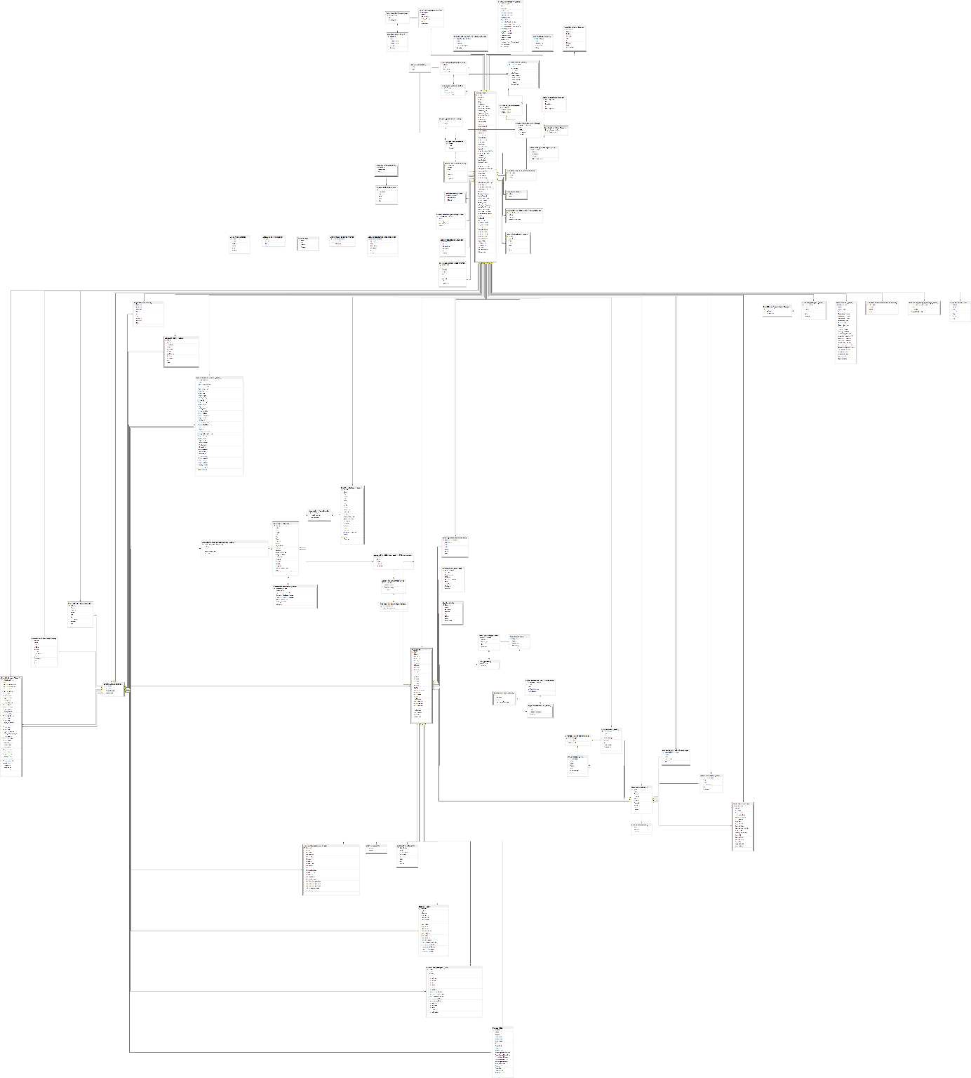

## Public interface

<https://fej.coe.int/>

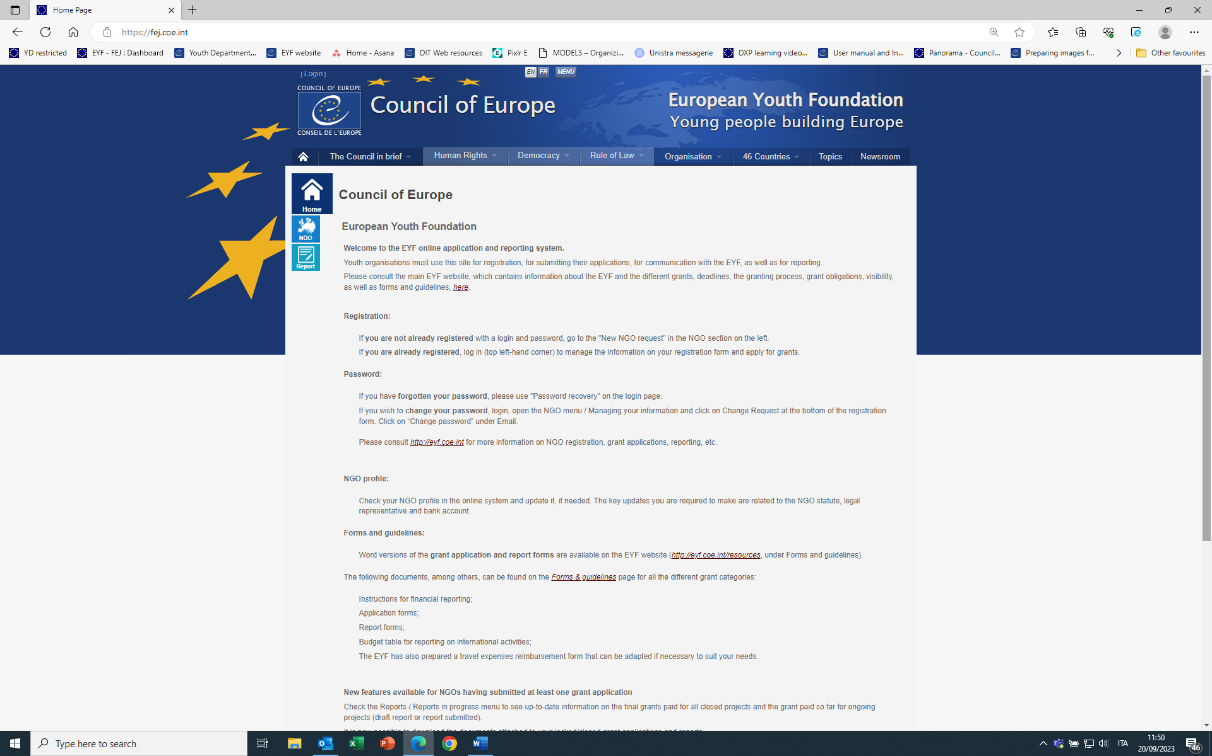

## Report interface

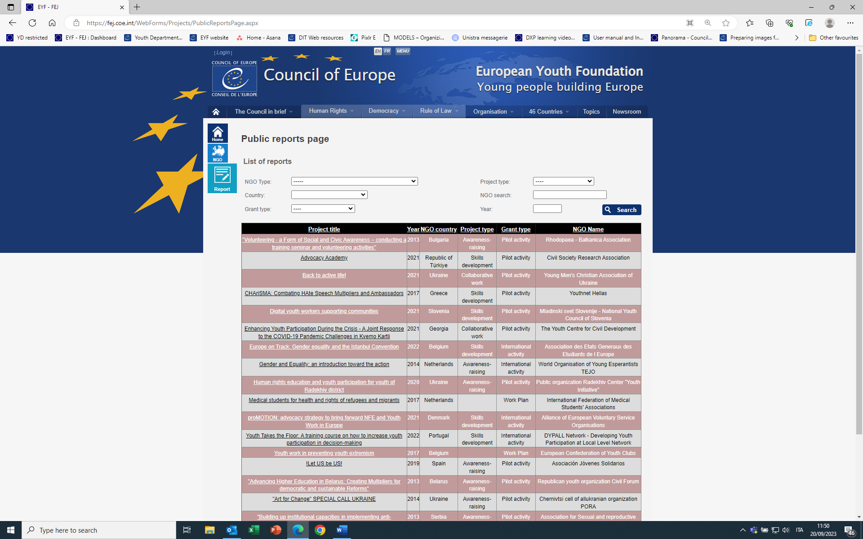

## Public report interface

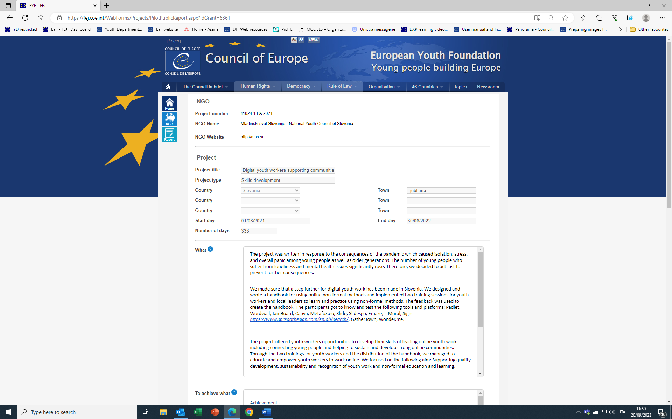

## Interface once connected

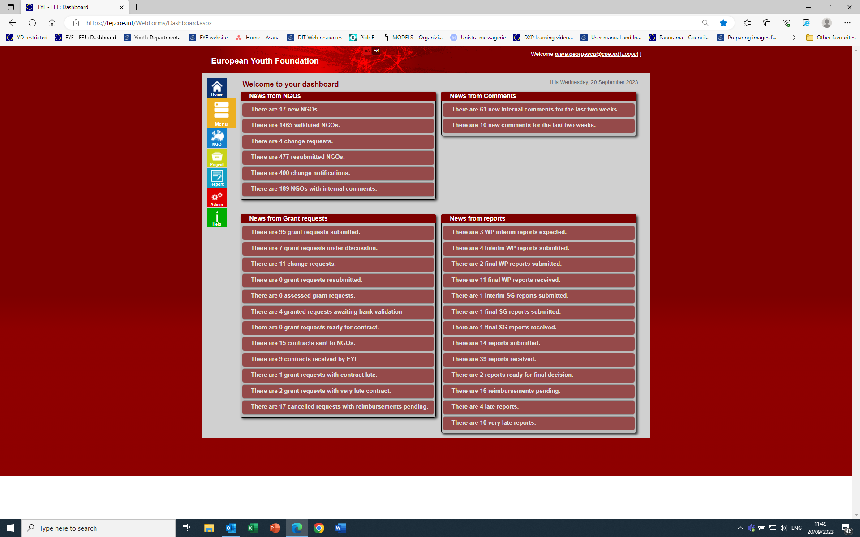

## Example of grant application form

