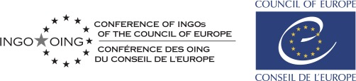

APPLICATION FORM

“Youth Delegate for a year 2021”
Please return completed application form to rares.craiut@ingo-coe.org by 20 March at the latest. Successful applicants will be contacted by the 25 March.
Personal details:
First name
Last name
Date and place of birth
Gender (M/F/other)
Nationality
Address where you will be residing at the time of the sessions If you are selected, the Conference of INGOs will cover your cost of travel from this address and return, no other.
E-mail
Mobile number
Working language(s)
Do you have any special needs or requirements, for example dietary, medical, allergies, disability, etc?
If you are invited to take part in the sessions, will you require assistance in obtaining a visa for France?

Experience and motivation (no more than 200 words for each reply: longer answers will be disregarded)
Name of the NGO, member of the Conference of INGOs, that you will be representing.
What is your personal motivation to take part in the Conference of INGOs 2020 sessions?
What do you expect to be able to contribute to the sessions?
What do you expect to learn from this experience?
How will you disseminate the information obtained during the session on your return home?
Why do you think Non-Governmental Organisations play a significant role in today’s society?
What would be the added value of young people contributing to the work of the INGO Conference?
If selected, would you be available for a youth volunteer project in between the two sessions with support from the Conference of INGOs?

Name of the nominating organization

Name and signature of the official representative of the nominating organisation

Candidate’s signature

