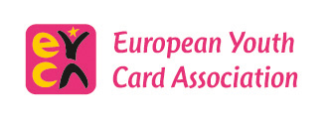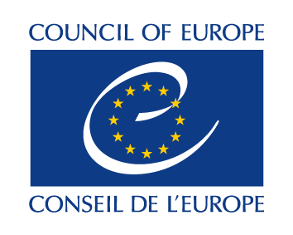

AP/Carte-J (2016)PV36

Partial Agreement on Youth Mobility through the Youth Card

36th meeting of the Board of Co-ordination

Monday, 21 March 2016

European Youth Centre
Budapest

REPORT

1. Welcome and opening of the meeting

The meeting was opened by Jarkko Lehikoinen, Chair of the Board of Co-ordination. The list of participants appears in Appendix II. The Board welcomed the newly elected Advisory Council’s representative to the Board of Co-ordination, Valentin DUPOUEY (Erasmus Students’ Network). The Board voiced its condolences to the families of victims – Erasmus students on a trip - of the accident which just happened in Spain.

2. Adoption of the agenda

AP/Carte-J (2016) OJ 36

Agenda was adopted as set out in document AP/Carte-J (2016)OJ 36 (pl. also see Appendix I).

3. Adoption of the report of the 35th meeting of the Board of Co-ordination

AP/Carte-J (2015)PV35 prov

The report of the 35th meeting of the Board of Co-ordination was adopted as it appears in AP/Carte-J(2015)PV35. The Board thanked the Secretariat for the useful financial information appearing in the appended tables. The Secretariat was asked to make a simulation of the percentages and actual contributions by member states with a hypothesis that the PA’s budget will be increased by 10 000€. Then a decision could be taken by the Board of Co-ordination on whether to ask the Committee of Ministers to allow for such an increase.

4. Up-dates in the programme of activities 2016

AP/Carte-J (2015)3

Manel Sanchez, EYCA’s Director, up-dated the Board on the Seminar “Mobility towards inclusion: EYC supporting young migrants &refugees” which is the first seminar in the 2016 programme of activities of the Partial Agreement on Youth Mobility and will take place in Samobor, Croatia, on 10-11 May 2016. The next events are foreseen early September in Italy or Turkey, a promotional seminar in Barcelona, Spain, and finally a seminar in Cyprus as part of the Cypriot Chairmanship of the Committee of Ministers. The Secretariat mentioned the interest shown by Albania to join the Partial Agreement.

5. Developments in the European Youth Card Association (EYCA)

EYCA has been joined by a new member – in Turkey, and the Turkish youth card representative made a short presentation of their organisation and the work they have been doing since July 2016, planning to start distributing the cards in April/May. A new – strong and active - organisation has taken over youth cards in Ireland - “Ireland Youth Work”, which is eager to re-join the European dimension.

The Moldovan governmental representative informed the Board that the national youth council will probably be the sole organisation coordinating the work of the youth card in Moldova. The Hungarian youth card member made an agreement with the Hungarian government (Ministry of Education) which led to the increase of the European youth cards’ distribution from 5.2mln to 6.2mln. The French card which already has over 1000 discounts in Paris should be launched end of April possibly in co-operation with the city of Strasbourg.

EYCA’s Director mentioned that EYCA, ERYICA and National Youth Agency/EURODESK continue to reinforce co-operation and common actions. A Memorandum of Understanding will be soon signed between the three and joint Board meetings will be held. A Memorandum of Understanding has been also signed with the European Youth Forum. A renewed Memorandum of Understanding has been signed with the Ibero-American youth organization.

EYCA was invited to participate in the Summer University of the Cultural Routes Partial Agreement in June. It will also take part in the next EPLM meeting in Tbilisi also in June.

EYCA strives to achieve its re-branding process in time for its next General Assembly in Gdansk, Poland, early June.

6. Presentation of the desk research on youth mobility in Europe

The Board heard an outline presentation of the desk research on youth mobility in Europe, had an exchange of views on it and suggested directions for the finalisation of the study.

7. Any other business

None.

8. Date and place of the next meetings

The next meeting of the Board of Co-ordination will take place in the framework of the statutory bodies on 17-19 October 2016 in Strasbourg.

Appendix I

AGENDA

1. Welcome and opening of the meeting

2. Adoption of the agenda

AP/Carte-J (2015) OJ 36

3. Adoption of the report of the 35th meeting of the Board of Co-ordination

AP/Carte-J (2015)PV35 prov

4. Up-dates in the programme of activities 2016

AP/Carte-J (2015)3

5. Developments in the European Youth Card Association (EYCA)

6. Presentation of the desk research on youth mobility in Europe

7. Any other business

8. Date and place of the next meetings

Appendix II

