56 - Planning language support activities in the community
Aims: To offer guidance on setting up activities which take refugees out into the community.
Note: the refugees that you are dealing with may not be able to leave the area of their accommodation centre. This should be checked before any activities are planned.
1. Deciding where to go
Make a list of places you typically go to in your everyday life, e.g.:
 |  |  | 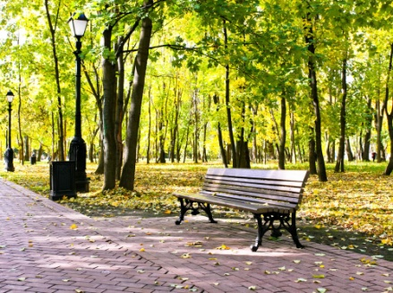
pharmacy | supermarket | market | park
Use the internet and local newspapers to look for free events in the neighbourhood or city. Look for information on posters and notices in the street. Make a list, including times and places. For example:
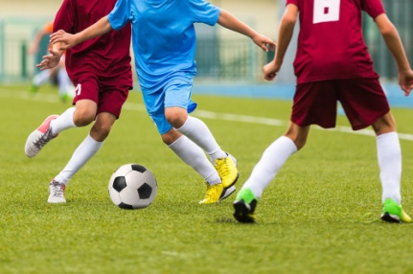 | 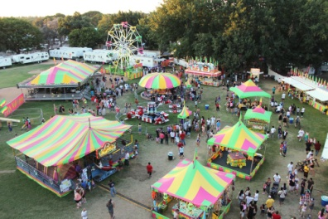 | 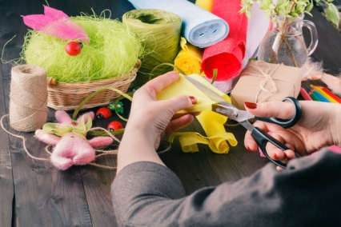 | 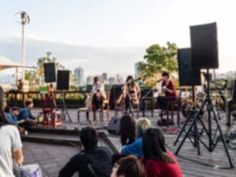
sports | fairs | crafts | music
2. Organizing the trip
Discuss the following questions with your refugee group:
Where shall we go? | Where shall we meet? | What time shall we meet?

How will we get there?
 | 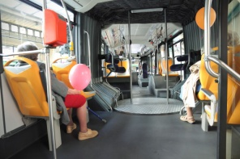 | 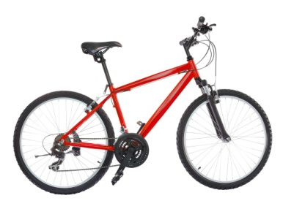 | ?
on foot | by bus, tram, metro | by bicycle
Useful phrases for planning a trip:
- Let’s go to... Can we go to…?
- Good idea! / Let’s do that!
- Let’s walk/go by bus/... Shall we go on foot…?
- Where shall we meet? When shall we meet?
- I will bring my phone/a bottle of water/a map/ an umbrella/...
3. Getting ready - preparing language (see section “Scenarios” for language supports)
Example: useful phrases for a trip to the market.
- What is this called?
- Can I have half a kilo of…?
- How much is it?
- Have you got... / Where can I get...
- Can I take a picture?
- Yes please/No thank you.
- Prices (1 Euro 10).
- Names of fruit, vegetables.
- Fresh.
- Cheap.
- Home-made, organic.
- Would you like to try this?
Talking to people, here are some suggestions:
- We are doing a project in our language class.
- Can we ask you some questions?
- Can we record this?
- How often do you come here?
- What is your favourite place in the city?
- What do you like about the market?
4. After the trip: writing about the experience. Pictures or other items could be added.
- For those refugees who can write they could write a short text giving an account of the trip or giving their impressions of what they have seen.
- For those refugees who are developing literacy in the target language they could make notes on the basis of prompts like these:
Date and place:
- New words and expressions you heard:
- Things you said/wanted to say:
- Describe the place: what was new/different? What was familiar?
- Would you like to go there again? Why? Why not?

