52 - Using postal and banking services
Aims: - Inform refugees about postal and banking services.
- Enable refugees to use postal and banking services.
Communicative situations
- Understand the signs related to postal and banking services.
- Understand simple information about postal and banking services.
- Use a cash machine (ATM).
Materials
- Pictures of places and signs related to postal and banking services.
- Leaflet or information sheet about a bank or the post office.
Language activities
Activity 1
Use the pictures to:
- Elicit some basic information and vocabulary about postal and banking services asking e.g. Where do you have to go to send a letter to another country? And where can you change money?
- Refugees may be able to talk about these services in their own country.
Activity 2
Use the pictures to explain relevant signs. Refugees can:
- Write the key words and expressions on cards. Read the same signs in other photos (e.g. a photo of a street with the same signs).
- Check their understanding by asking them to match words with pictures and signs.
Activity 3
Hand out an illustrated sheet with information about the location and the opening times of the nearest post office or bank.
- Check refugees’ comprehension by asking questions such as: Where is the bank? Is it open on Saturdays? When is the post office open? What time does the bank close? Refugees can practise times of the day and days of the week, (e.g. The bank is open from 9.00 to 4.30 from Monday to Friday).
- Then, ask them to work in pairs and to exchange information about the information sheet
- Ask refugees to share their information with the group.

Activity 4
Refugees imagine they are outside a bank – or, better, organise a visit to a bank or post office, or to an office specialised in international money transfer with a group of refugees. If this is not possible:
- Show photos of a cash machine and ask: How do you use a cash machine or ATM?
- If possible, show photos of some cash machine screens that explain the procedure for using a debit/credit card to withdraw cash. Ask refugees to explain the procedure in simple language, e.g.:
- First you put in your card.
- Then you have to choose whether you want to withdraw cash, buy credit for your mobile phone etc.
- Next you have to key in your pin code and choose how much cash you want, etc.
- You have to take back your card before receiving your cash etc.
Activity 5
Refugees practice language they may need in a post office:
A. How can I help you?
B. I want to send this letter to Iraq please.
A. OK put it on the scales – that’s 3 euros 50.
B. Right. Here you are. Where can I post it?
A. Put it in the box marked ‘overseas’.
B. OK. Thanks. Goodbye.
Activity 6
Refugees practice language they may need for sending money abroad by international money transfer
A. Hello. I would like to send some money to ****** (name of place)
B. OK, first you need to fill in this form.
A. How long will it take for the money to arrive in ****** (name of place)?
B. It is more-or-less immediate
A. How do I pay you?
B. With cash or a debit card from a bank.
A. How will my friend collect the money?
B. You must get this tracking number to your friend and that is used for collecting the money in one of our offices.
A. That’s good. Thank you.
Ideas for learners with low literacy
- Ask refugees with low literacy to copy onto cards some of the words used in the activities above.
- Ask them to choose easy words from the leaflet or pictures of signs to copy.
- Ask them to read signs and notices found in post offices and banks.

Sample materials
Pictures of places and signs related to postal and banking services.
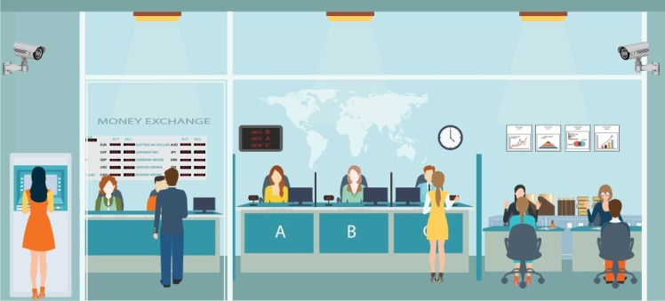 | 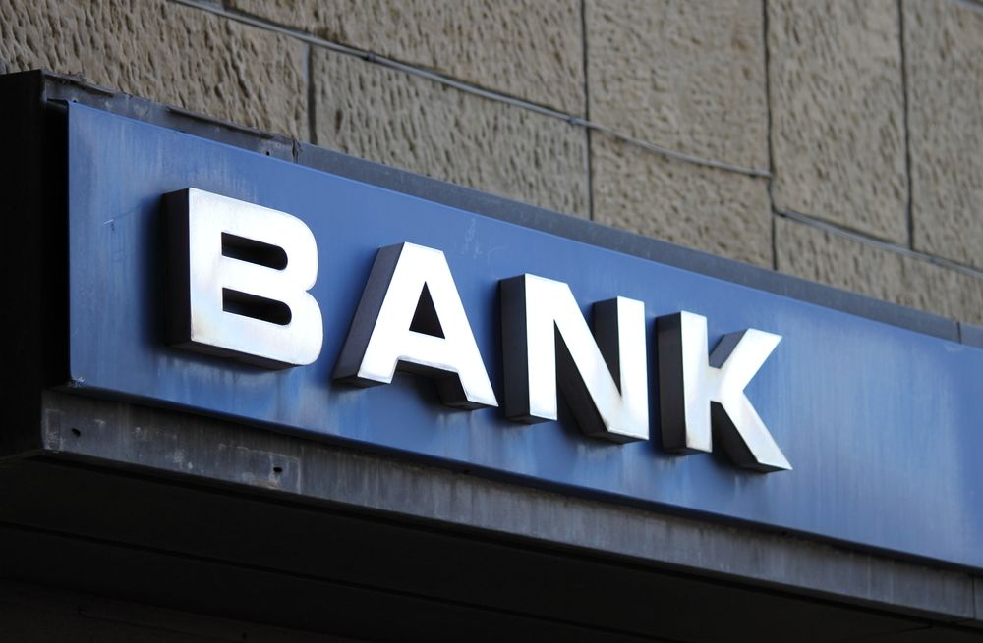
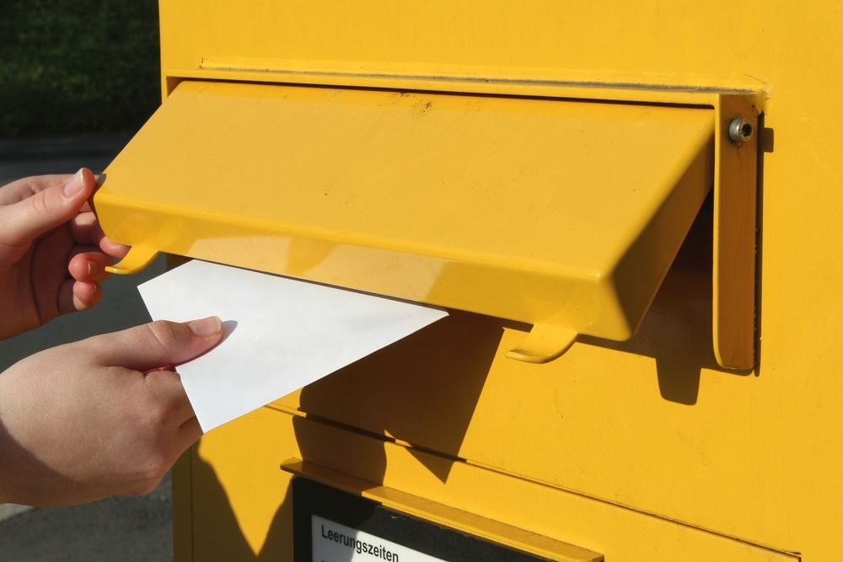 | 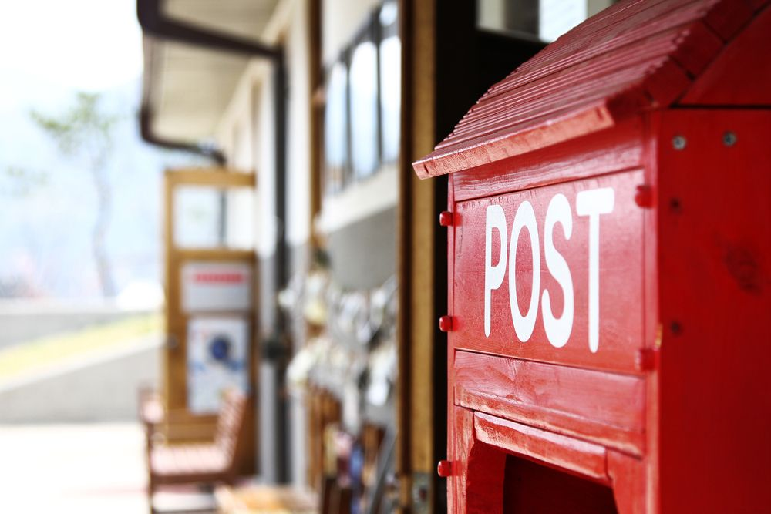
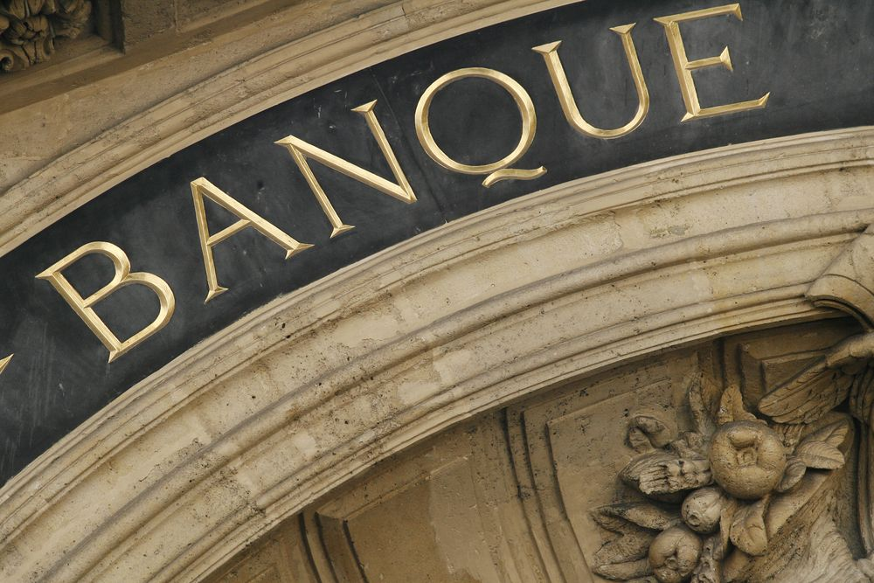 | 