51 - Finding accommodation
Aims: - Inform refugees about housing in the host country.
- Enable refugees to communicate about accommodation.
Communicative situations
- Understand advertisements for apartments and houses to let.
- Understand and be able to give simple information.
Materials
- Pictures related to housing.
- Floorplans of apartments.
- Pictures of items of furniture.
- Advertisements for flats or houses to let (with pictures).
Language activities
Activity 1
Use the pictures related to housing to get refugees to talk about:
- Accommodation and housing in their own country.
- Similarities and difference between homes in the host country and in their own countries.
Activity 2
Use the pictures to introduce some key-words related to housing (e.g. flat, apartment, house, bedroom etc.).
- Ask refugees to write these words on cards.
- Check comprehension by asking them to match the words with pictures.
Activity 3
Show refugees one of the floorplans and introduce or check their knowledge of keywords by asking e.g. Where is the kitchen? And the bathroom? Then ask them to point to these rooms on the floorplan.
Activity 4
Ask refugees to draw a floorplan by following simple instructions, e.g. an apartment with one large bedroom, a kitchen, a big living room, and a very small bathroom. (This activity is suitable for use with refugees with low levels of literacy.)
Activity 5
- Hand out the two floorplans and describe one of the apartments.
- Ask refugees to indicate which is the apartment you described.
- Then, allowing time for preparation, ask them to describe the other floorplan in a simple way.
Activity 6
Find some advertisements (with pictures) of flats or houses to let in the area.
- Ask questions such as: Have you ever tried to find an apartment or house to rent? Where did you look for advertisements? Was it hard/easy to find one? Why? etc.
- Invite refugees to exchange information in pairs about the advertisements: the price, the location, the description of the apartment etc., recycling language from the previous activities.
Activity 7
Refugees practice language they may need for speaking to an estate agent or a letting agent
A. Hello, I’m looking for a house/apartment to rent. Do you have anything suitable for me?
B. Where do you want to live and what sort of accommodation do you need?
A. I’d like an apartment near the centre with two bedrooms.
B. We have a number of properties that might suit you – have a look at these details.
A. I’ll take these away and look at them. I’ll come back tomorrow. Thank you.
(Use expressions linked to facilities in Tool 35 - Ideas for learning basic vocabulary: everyday life)
Ideas for learners with low literacy
- Cut out pictures of furniture and of the most important rooms in a house. Ask refugees to match the pictures of furniture with the pictures of rooms. Invite learners with low literacy to copy down the names of the rooms and items of furniture.
- Invite them to write lists of furniture which they could find in the different rooms.

Sample materials
Pictures related to housing
 | 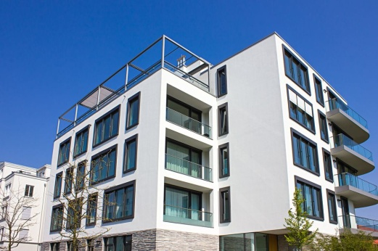 | 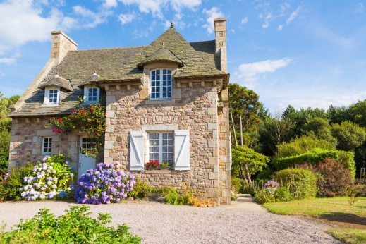
Floorplans of apartments
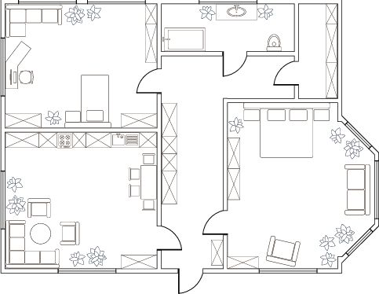 | 