50 - Looking for a job
Aims: - Find out more about jobs and job opportunities.
- Introduce key words and simple sentences that can be used in CVs, job applications and interviews.
Communicative activities
- Exchange information about jobs.
- Introduce oneself.
- Communicate with employers.
Materials
- Pictures related to jobs.
- A simple curriculum vitae (CV) form.
- Pictures of job interviews.
Languages activities
Activity 1
Use the pictures related to jobs to brainstorm different areas of work which are of interest to the group e.g. health, retail, education, catering, care or manual work.
- Ask refugees about their previous professional experience (commenting on the value of these experiences).
- Then ask them about jobs they would like to do in the future.
Activity 2
Divide refugees into groups of those interested in similar jobs.
- In groups, refugees discuss the jobs they would like to do and try to find out more, e.g. What skills do catering staff need? Do they need/have qualifications? If so, which qualifications?
- Give each group a large sheet of paper and pens and ask them to create their own spider-gram of different jobs they can think of in this area of work (see the example below).
- Each group then presents their spider gram and the other participants can ask questions and offer suggestions.
Activity 3
Show refugees a simple CV.
- Ask what’s this called? Do you have one in your language? How does it work? Are there any words you don’t know in this form? And so on.
- Refugees then fill in the form with your help, focusing on previous work and training experience.
Activity 4
Use the pictures to talk about job interviews:
- Describe the pictures in a simple way.
- What do they say in their own languages in similar situations?
Activity 5
Refugees imagine they are attending an interview related to the type of work they discussed in the second activity. Introduce a sample dialogue like the following, using a recording if possible:
A. Good morning.
B. Good morning and welcome. First, what is your name and where do you come from?
A. My name is Farooq and I’m from Pakistan.
B. How old are you?
A. I’m 27.
B. What type of work experiences do you have?
A. I worked as a driver in Pakistan. In Italy I worked as a waiter for short periods.
B. What kind of job would you like to do?
A. Well, I’d like to continue in catering.
Check refugees’ comprehension and then organise role plays: A is an employer and B is the interviewee and can refer to the CV prepared in activity 3. First, take the role of A yourself. Then refugees work in pairs, following the example (allow time for preparation).
Ideas for learners with low literacy
- Invite refugees with low literacy to copy the job(s) they choose on cards.
- Ask them to fill in only the first part of the CV containing basic information.
Sample materials
Pictures related to jobs
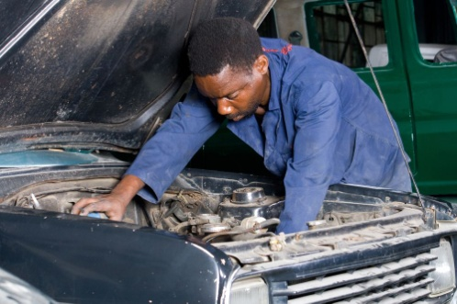
A simple curriculum vitae (CV) form
1 | First name and family name
2 | Place and date of birth
3 | Nationality
4 | Address in the host country
5 | Contact details (e-mail, mobile, …)
6 | Education
7 | Work and training experience

Pictures of job interviews
Example of a spider gram

