5 - Arabic : some information
Aim: To provide a brief overview of one of the languages spoken by large numbers of refugees.
Having an insight into how the Arabic language works may be helpful in understanding the challenges speakers of this language face when learning a new one and what, on the other hand, might be relatively easy for them. Also, refugees may appreciate it if you ask them to help you to pronounce the names of persons and places correctly and if you at least try to use some words or phrases of their language (see "Language of Origin"). Standard Arabic is the official language of 25 countries in the Middle East and North Africa, and is one of six official languages of the United Nations. In addition, there are several regional variants, for example daridscha maghribijja (colloquial Moroccan), and ammijja misrijja (colloquial Egyptian).
Where the language is spoken
About 280 million people speak Arabic as their first language. In the Arabic-speaking countries different dialects are spoken. Geographically, the Arabic language extends from North/Sub-Saharan Africa, to the Middle East, including Iraq and Syria. Furthermore, there are many Arabic language communities and Arabic-speaking minorities outside this region.
Art, media and literature
Of particular importance is the fact that classical Arabic is the language of the Koran, the holy book of Islam. The classical Arabic of the Koran is still considered as standard for written Arabic but spoken Arabic often differs from it, since the spoken language is constantly changing.
There is an enormous variety of poetry and prose in Arabic, but there are rather few translations, which are not representative of the diversity of Arabic literature. Very well-known (in Europe) Arab writers and poets include the Nobel laureate Nagib Mahfuz (1911–2006) and the author Khalil Gibran (1883–1931).
Borrowings from Arabic
Common words in English (and other languages) that originate from Arabic include:
- algebra (al-jabr).
- cotton (koton).
- sugar (succar).
- guitar (qithara).
- lemon (laymoon).
- alcohol (al-kuħuul).
European numerals are also derived from Arabic.
Some features of Arabic script
The Arabic script is cursive, and is written and read from right to left. The Arabic alphabet has 28 characters and essentially only consonants are written, unlike languages with Latin characters, in which vowels are written too.
The Arabic alphabet
Numbers
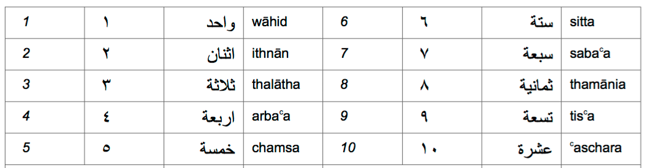
Some phrases
Hello (first meeting) | السلام عليكم | assalamu a’alaikum (peace be upon you)
Goodbye | مع السلامة | maʕ as-salaama! (Say goodbye to a person)
Goodbye! | الله يسلمك، الله يسلمكم | allaah jusallimuka (m.)! allaah jusallimuki (f.)! allaah jusallimkum (pl.)! (As an answer)
How are you? | كيف الحال؟ | kayf il-ħaal?
Yes | نعم | naʕm
No | لا | la
Please | من فضلك، من فضلكم | min fadʕlika (m.), min fadʕliki (f.), min fadʕlikum (pl.)
Thank you | شكرا | šukran
You are welcome | عفوا | ʕafwan
I am sorry! | أنا آسف | ana asif
Source: "Sprachensteckbrief Arabisch", Schule Mehrsprachig, Eine Information des Bundesministeriums für Unterricht, Kunst und Kultur – © Dina el Zarka (translated in English and adapted) www.worldatlas.com/articles/arabic-speaking-countries.html

