47 - Food – inviting someone to a meal
Aims: - To enable refugees to communicate about food.
- To activate vocabulary to do with food and eating.
- To introduce some relevant expressions.
Communicative situations
- Ask for information and understand the answer.
- Understand simple instructions.
Materials
Flashcards related to food, and pictures of typical host country dishes.
Language activities
Activity 1
Ask refugees to talk about popular dishes in their countries and traditions related to food. Acknowledge their contributions.
Activity 2
Use the materials to get refugees to talk about:
- What they already know about dishes in the host country.
- Similarities and differences between food in the host country and in their own countries, and also meal times (e.g. breakfast, lunch, and dinner).
Activity 3
Write on the board some food categories such as meat; fish; vegetables; fruit; dessert. Then, using the pictures/flashcards or, if possible, real items of food, ask individual participants to put the pictures/items in the right category, and to say whether they like the food in question and what other food they enjoy. Focus on key expressions such as: I like/ I don’t like/ I like…very much. This activity is suitable for use with refugees with low literacy.
Activity 4
Ask participants to write down (for example, on cards) the common words related to food that came up the previous activities. Then check comprehension by asking them to match the words with the relevant pictures.
Activity 5
Participants work in pairs to talk about good practice related to food, for example how to store food, the need to check the use-by date, respecting the seasonality of food, food hygiene etc.

Activity 6
Give an example of a dialogue like the following:
A. Hello Amir.
B. Hello Jane. How are you?
A. Fine thanks. Do you want to come to lunch? I would like to prepare a traditional dish from my country.
B. Fantastic! So, what will you cook for me?
A. My favourite dish, which is….
Check comprehension, then organize role-plays between refugees based on the model dialogue, inviting them to describe their favourite dish. Allow some time for preparation.
Activity 7
Ask participants to imagine they are setting the table for the meal planned in the previous activity. Show them some items (or pictures) of cutlery and crockery (i.e. fork, knife, glass, plate etc.), Then, ask individual participants to follow your instructions, e.g. put the glass on the right of the plate, put the fork on the left etc. Focus their attention on the words for position and orientation (left, right, next to, near, below, above etc.). Then ask them to talk about how the table is set for a meal in their countries. Acknowledge their contributions.
Activity 8
Hand out a short text, preferably with illustrations, containing a recipe for a traditional host country dish, preferably a dish from the region where refugees are living. Participants talk in pairs about the text: the ingredients, the key steps in the recipe, etc. Then, if permitted, work with the group to actually prepare the dish described in the recipe, for example using the kitchen facilities in the reception centre.
Activity 9
Prepare to taste the dish just prepared: introduce expressions like: enjoy your meal, I hope you like it, it looks delicious etc.
Ideas for learners with low literacy (see activity 4)
Invite participants to copy onto cards the main food vocabulary which occurs in the activities. Then ask them to match the cards with the pictures of food and the pictures with the meals of the day. Finally, ask them to write down a list of their favourite food or ingredients – say three or four items.
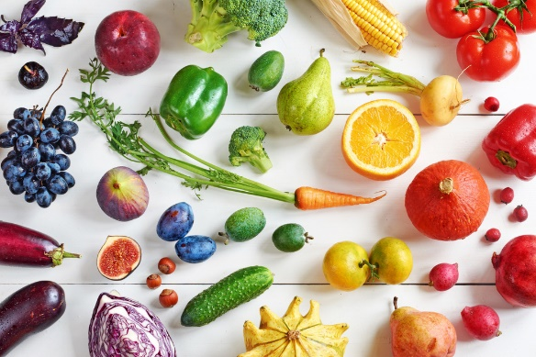
Sample materials

