45 - Shopping: buying clothes
Aims: - Activate vocabulary and key expressions related to clothing.
- Enable refugees to speak about clothes.
Communicative situations
- Express a need and understand the answer.
- Talk about clothing.
Materials
- Pictures related to clothes.
- Pictures of the host country in different seasons.
Language activities
Activity 1
Use the pictures related to clothes to talk about:
- clothes in their own country (traditional clothes, most common clothes, etc.)
- similarities and difference between the way people dress in the host country and in their own countries.
Activity 2
Use the pictures or better, real clothes to
- introduce some key vocabulary related to clothes.
- ask refugees to write these words on cards.
- Check their comprehension of words by asking them to match words with pictures or items of clothing.
Activity 3
Show refugees the pictures of seasons (if possible, using pictures of the nearest city/town/village) and check their understanding of the four seasons asking e.g. What season is shown in this picture? How do you know?
- Then ask them to describe these pictures in more detail.
- Next ask refugees to talk about the four seasons in their own countries (temperature, rainfall and the clothes needed).
Activity 4
Use both sets of pictures together. Spread out the pictures of the four seasons. Then ask refugees to put the various pictures of clothing that they consider most appropriate for each season in the right place. This activity is suitable for use with refugees with low levels of literacy.
While doing this, refugees explain their choices in a very simple way, e.g. this jacket is warm. It’s good for winter.
Activity 5
Introduce a dialogue like the following:
- A. Good morning.
- B. Good morning, how can I help you?
- A. It is very cold. I need a coat for the winter.
- B. What size are you?
- A. Medium.
- B. Ok, come this way. The coats are over here.
- A. Can I try this one on?
- B. Yes, the fitting room is over there.
Check comprehension, especially of:
- the key expression I need.
- the word size (write on the board the various sizes: small, medium, large etc.).
Refugees then do a role play adapting and extending the model dialogue. Allow time for preparation and repeat the activity using the different pictures of seasons to contextualize the role play.
Ideas for learners with low literacy
Invite refugees with low literacy to write or copy the names of the clothes.

Sample material
- Pictures related to clothes.
 | 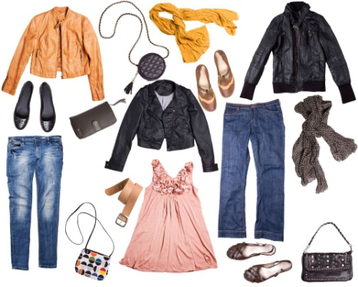 | 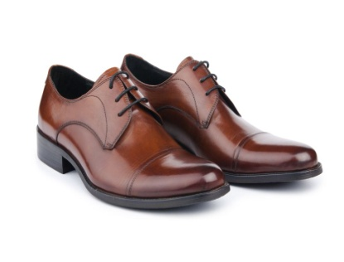
 | 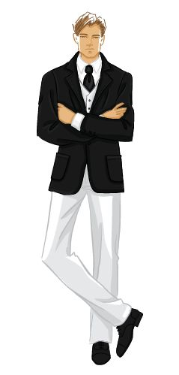 | 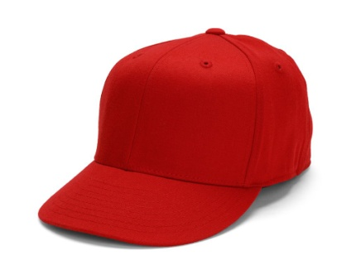
- Pictures of the host country in different seasons.
*