42 - Using apps like Google Maps
Aims: - Present some relevant key words and expressions.
- Inform refugees about services offered by apps.
Communicative situations
- Understand and be able to give simple information.
- Understand simple instructions.
Materials
- Pictures, icons and logos relating to wifi and apps.
- Screenshot of apps (e.g. Google Maps).
- Pictures of traffic lights.
- Pictures and a map of the nearest town.
Language activities
Activity 1
Use the pictures of icons etc. to ask refugees some questions such as:
- In addition to phoning, what else can you use your mobile phone for?
- Is there wifi access here?
- Which apps do you find useful? Why? How do you use them?
Activity 2
Show refugees how to use Google Maps to view a route from one place to another (or get one of them to show the group).
- Show a screenshot of where to insert the place of departure, the destination, the type of transport (car, public transport, on foot, etc.).
- Then ask refugees to write on a printed copy of the screenshot the information needed to display the route to the place of their choice (e.g. the train station or the main square of the nearest town).
- Then ask them to type the words on their mobile phones (if these are connected to the internet).
Activity 3
Play an audio clip from Google Maps giving details of the route, e.g. After 150 metres turn left and go straight on for 500 metres until you get to the traffic light.
- Then check refugees’ understanding by asking them to describe the route.
- Present pictures to involve learners with low literacy, asking for the meaning of the colours of the traffic light.

Activity 4
Refugees work in pairs to exchange information:
A chooses a destination where he/she would like to go and B finds the way using Google Maps and explains it, mentioning the time needed to reach the destination. Then refugees reverse roles and do the activity again.
Activity 5
Use the pictures and a (paper) map of the nearest town.
- Ask refugees to find the route they have identified using Google Maps and draw it on the paper map.
- Then ask them to describe pictures of places along the route they have just drawn (e.g. the station, the main square, the most important monuments etc.).
- Then ask the group to work together to put the pictures in the right places on the map.
Ideas for learners with low literacy
- Invite refugees with low literacy to copy the main words used in the language activities on cards.
- Ask them to find the logos of apps and social networks among the pictures.
- Ask them to write down the destination they chose in activity 4.
Sample materials
Pictures, icons and logos relating to wifi and apps.
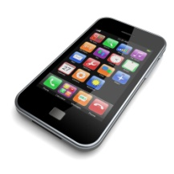 |  | 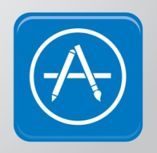
Screenshot of apps (e.g. Google Maps).
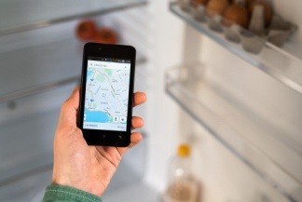
Pictures of traffic lights.
