41 - Using a mobile phone
Aims: - Introduce some key-words and expressions related to phone calls.
- Enable refugees to cope with simple telephone conversations in the target language.
Communicative situations
- Understand a name or telephone number they hear on the telephone.
- Receive and understand simple SMS messages in the target language.
- Send a simple message.
Materials
- Picture of a mobile phone keypad.
- Picture of SMS.
- Recordings of phone calls.
Language activities
Activity 1
Refugees listen to a recording of a phone call between two friends, then read a dialogue like this.
- A. Hello?
- B. Hi Tom, it’s Samira. I’m calling to ask for help: I’m looking for a job. Do you know anyone who needs a babysitter?
- A. You can ask my friend Patricia: I know she is looking for a babysitter.
- B. Great. What’s her phone number?
- A. 356789225.
- B. OK. Thank you. Bye!
- A. Good luck! Bye.
Use simple questions to check refugees’ understanding of key words and expressions, e.g. Who is speaking? Why is Samira phoning Tom? Does Tom help her? Check refugees’ understanding of numbers: e.g. What is Patricia’s phone number? Invite refugees to write down the number they hear and to read it aloud.
Activity 2
Refugees with low literacy can take it in turns to type their own numbers on the picture of a mobile phone keypad or on a real mobile phone. Then they can write down their own telephone number.

Activity 3
Refugees imagine that Samira is calling Patricia and listen to another recording:
- A. This is 356789225. I am not available to take your call at the moment. Please, call later or leave a message after the BEEP.
- B. Hallo Patricia. This is Samira, a friend of Tom’s. He gave me your number because I am looking for a job as a baby sitter. My number is: 328965200. Please, call me back or send me a text. Thanks. Goodbye.
To check comprehension, ask questions like: Was Samira able to speak with Patricia? Why not? What is Samira’s phone number? What did Samira ask Patricia to do?
Activity 4
- Ask refugees to read the text message from Patricia.
- Check comprehension, and then ask refugees to write a reply to confirm the meeting.
Ideas for learners with low literacy
Refugees with low literacy can copy a simple text message provided by you before replying to confirm an appointment.
- Write the message clearly on a strip of card.
- Read it aloud several times pointing to each word as you read.
- Invite refugees to read it aloud with you and then alone.
Cut up the sentences of the first dialogue and ask them to put the pieces back in the correct order and read the sentences aloud again.
Sample materials
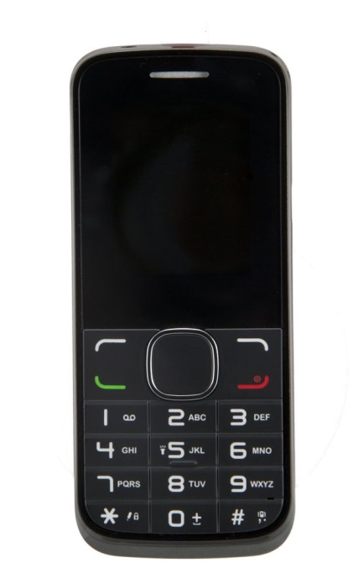 | Hallo Samira, I am going for a coffee with Tom at Kings Cafe. If you want, we can meet there at 5 p.m. Patricia
Picture of a mobile phone keypad. | Picture of SMS.

