35 - Ideas for learning basic vocabulary: everyday life
Aim: To provide resources for activities to teach everyday vocabulary.
Using images to support basic vocabulary learning
Pictures, as well as real-life objects (realia), are an excellent resource for very low-level language learning. When you have a good bank of pictures you can use them for a number of different but basic activities. The pictures below provide examples of the type of images that are suitable for basic language learning. For more information about selecting pictures and realia see Tool 22 Selecting pictures and ‘realia’ for language activities. Pictures can be used to support many different language-learning activities as well as providing support when there are communication difficulties.
Some suggested activities for using pictures
1. Flashcards to learn new words
Make flashcards with the word on one side and the picture on the other side. Focus on a particular theme related to a scenario. For example, ‘shopping’ or ‘health’. The theme should be relevant to the group.
Place the cards with the word down and the picture visible.
Learners must pick a card and say the word in the target language. Then they check on the back to see if they are correct.
The card is then put to one side.
This activity can be organized as a team-based competition. The team with the most correct items of vocabulary wins the competition.
Learners could write or copy the words into their vocabulary files, providing a translation in their mother tongue.
The words could be revisited in a later session to see how many words have been remembered.
2. Using a mix of flashcards to organize words
Place a number of flashcards from different thematic areas with the pictures down and the words visible.
First the cards must be sorted by the refugees into the themes represented only by looking at the word and without looking at the picture.
Then the refugees read a word and say what it is. For example ‘apple’ is fruit/food, ‘inhaler’ is medicine or doctor.
Then the refugee looks at the back to check the picture. If the answer is not correct, the card is mixed in with the other cards again with the picture down and the word visible. Another refugee can try to identify the correct word.
3. Using pictures to create spoken (or written) text
Place flashcards on the table with the pictures visible.
Check that everybody knows what the words are and what the pictures relate to. They should belong to the same theme.
Learners work as a single group or in smaller sub-groups to create some phrases or sentences based on the pictures. For example, ‘I go to the market and I buy vegetables’. They can speak their sentences or, if possible, one member of the group could write them.
Food
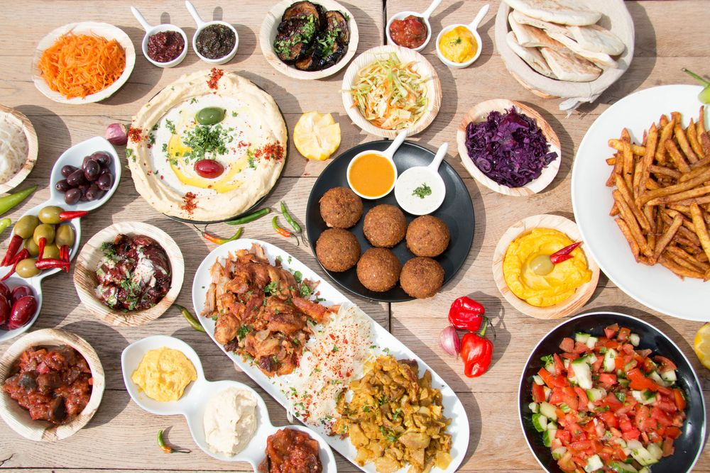 | 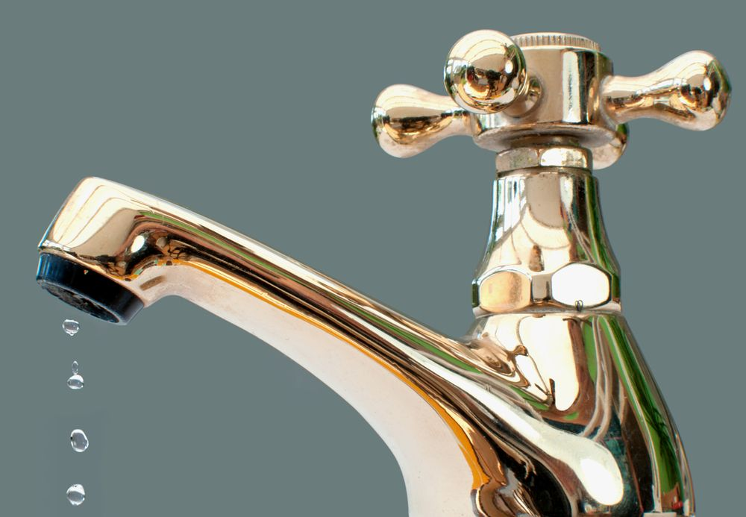
food | water
Expand: milk, coffee, tea, etc.
Health
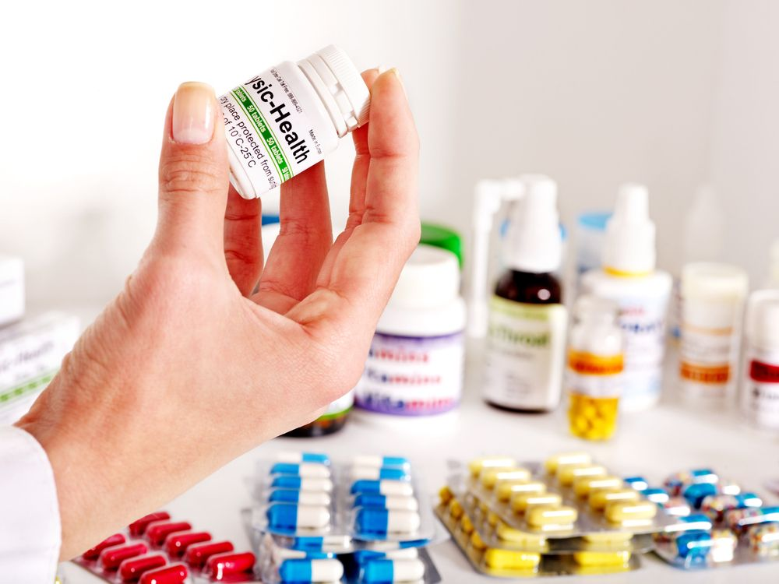
medicine | injection
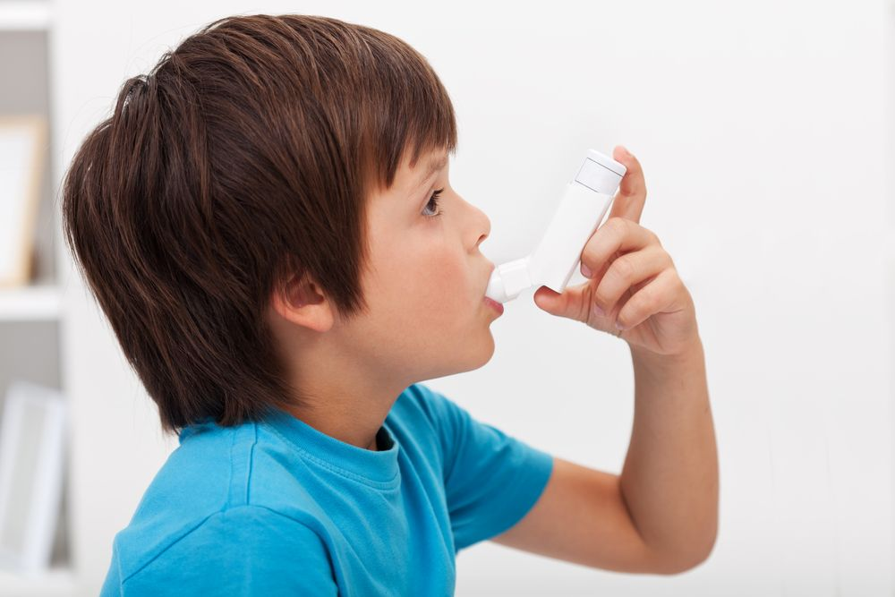
inhaler | doctor
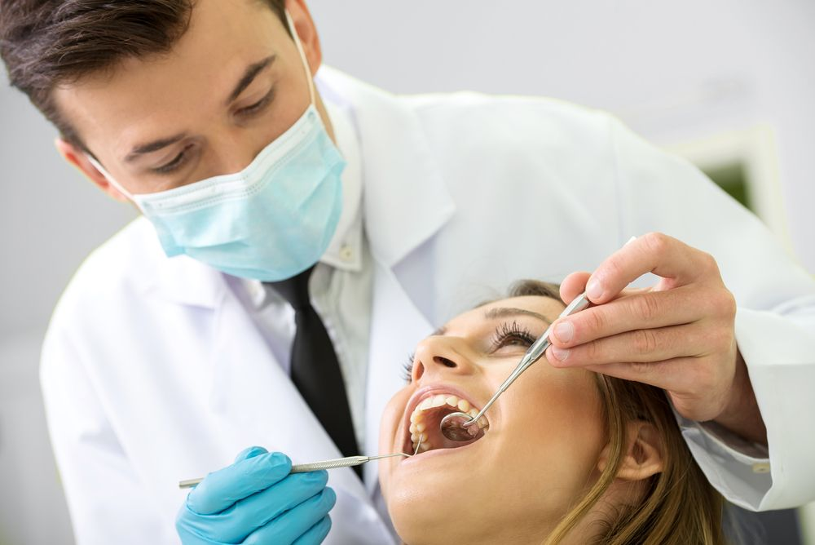 | 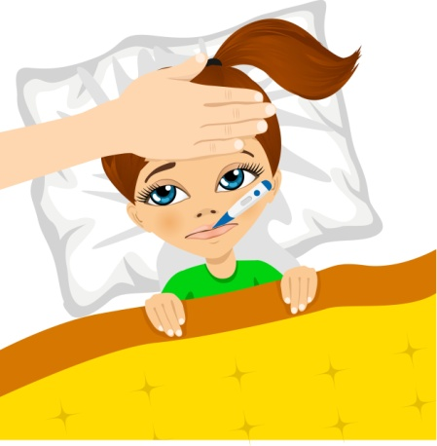
dentist | temperature /fever

Clothes
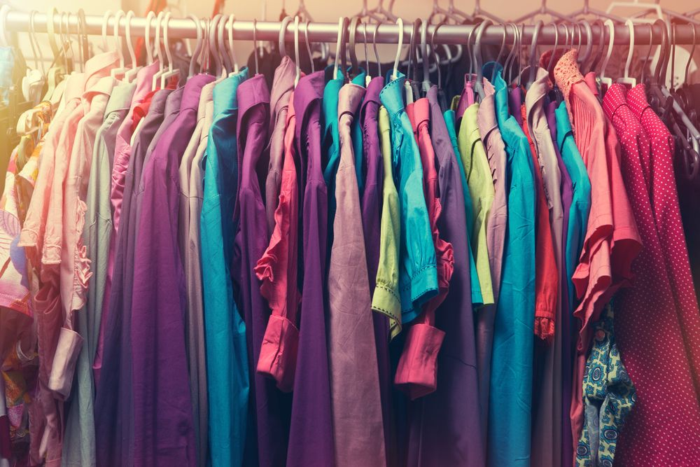 | 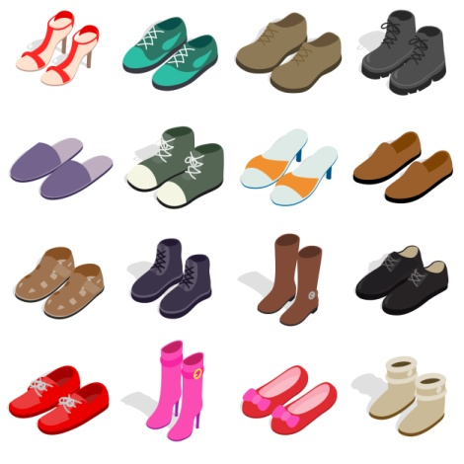
clothes | shoes
Expand: trousers; jumper; skirt; jacket, …
Hygiene
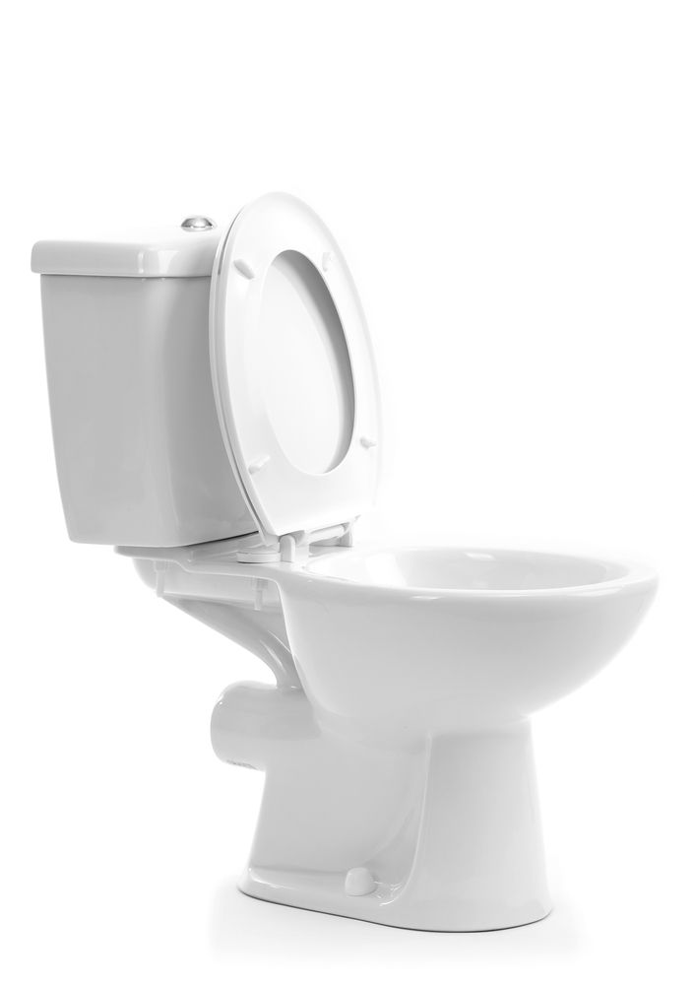 | 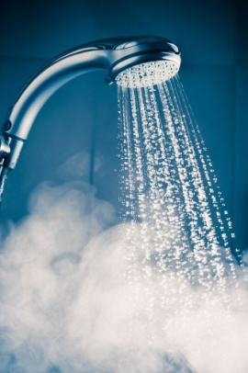
toilet | shower
 | 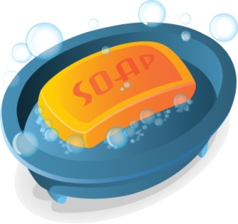
nappy/diaper | soap
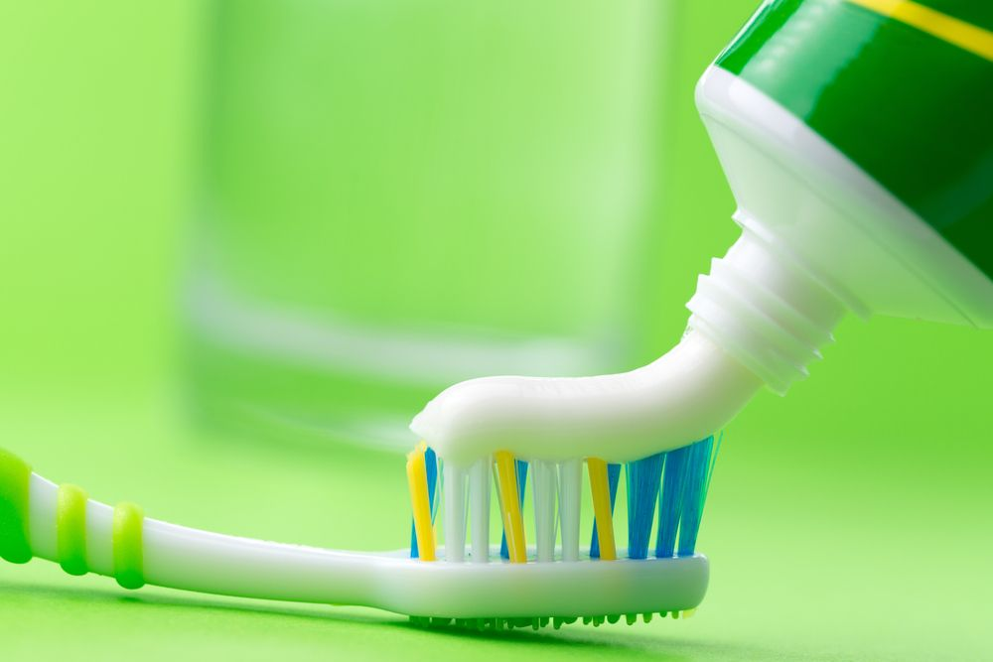
toothbrush /toothpaste

Telephone
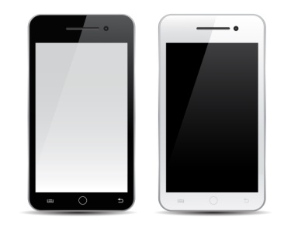
mobile phone | internet
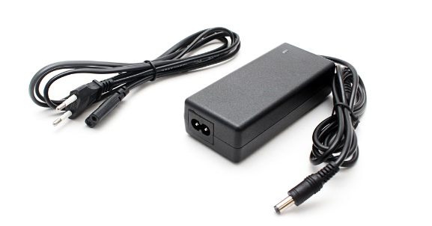
charger | WiFi
Furniture / Home
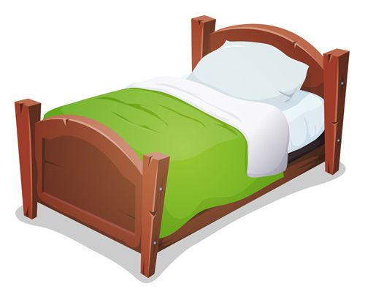 | 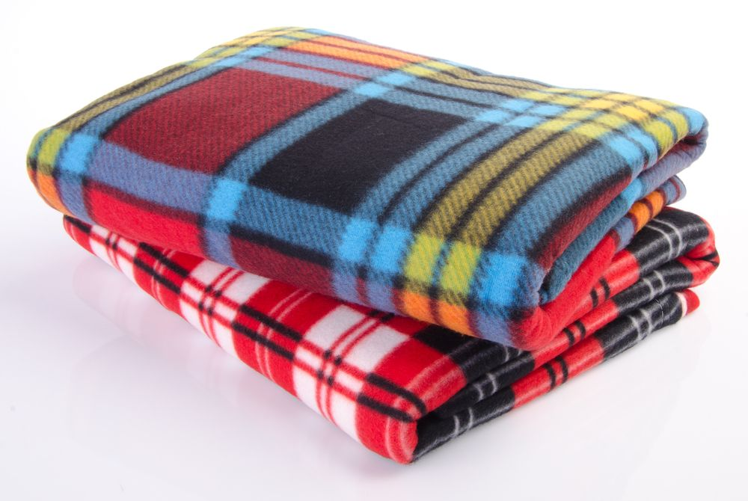
bed | blanket
pillow

Family
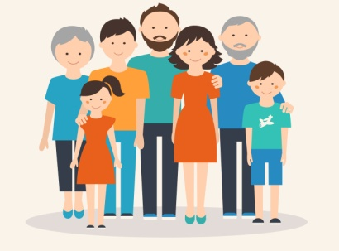 | 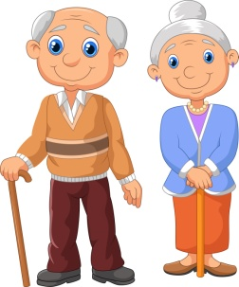
family | grandfather / grandmother
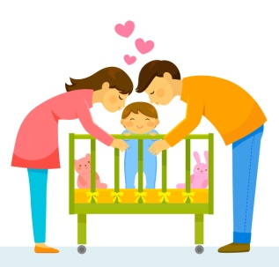 | 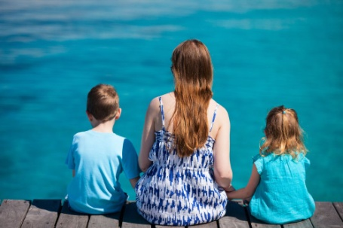
father / mother | son / daughter
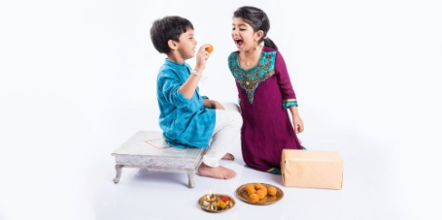 | 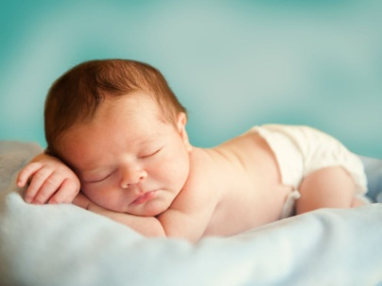
brother / sister | baby

Other important words
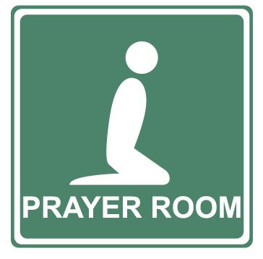
prayer room | documents
interpreter | legal advice
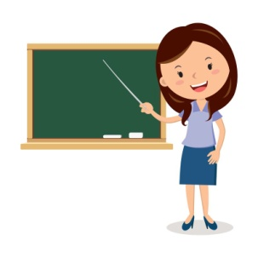 | 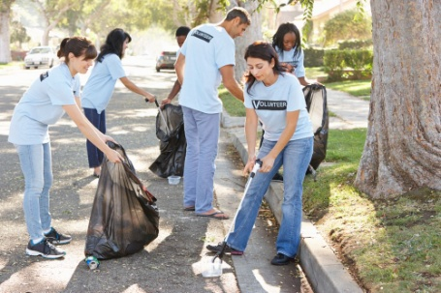
teacher | volunteer

