28 - Finding out more about refugees’ own linguistic resources
and capacities
Aim: To help volunteers to decide what language activities to plan with refugees by finding out what they are already able to do in the language.
Information about refugees’ own resources and capacities can be gathered during individual or group interviews using questions like those below. Refugees can also be asked to write this information down in a personal document (on paper or in electronic form) similar to the language biography in a European Language Portfolio.
Please answer these questions about the languages you know and your other competences. This will help us to plan and organise our language activities.
Your name: _____________________________________________________________________________
What language do you normally use with your family? ___________________________________________
Could we hear some examples of it? Say some words (a proverb, greetings, a short poem, a song …)
Could you show us how it is written? Write a few words (your name, your surname, the name of the place you come from, or where you were born….).
_______________________________________________________________________________________
_______________________________________________________________________________________
_______________________________________________________________________________________
Could you explain how to pronounce your name and the names of your children?
_______________________________________________________________________________________
_______________________________________________________________________________________
What other languages do you know? How and in what circumstances did you learn them?
LANGUAGE | Do you speak them...
 | A little | Quite well | Well

Draw a wheel like this indicating the main taste or feel of each language that you know:
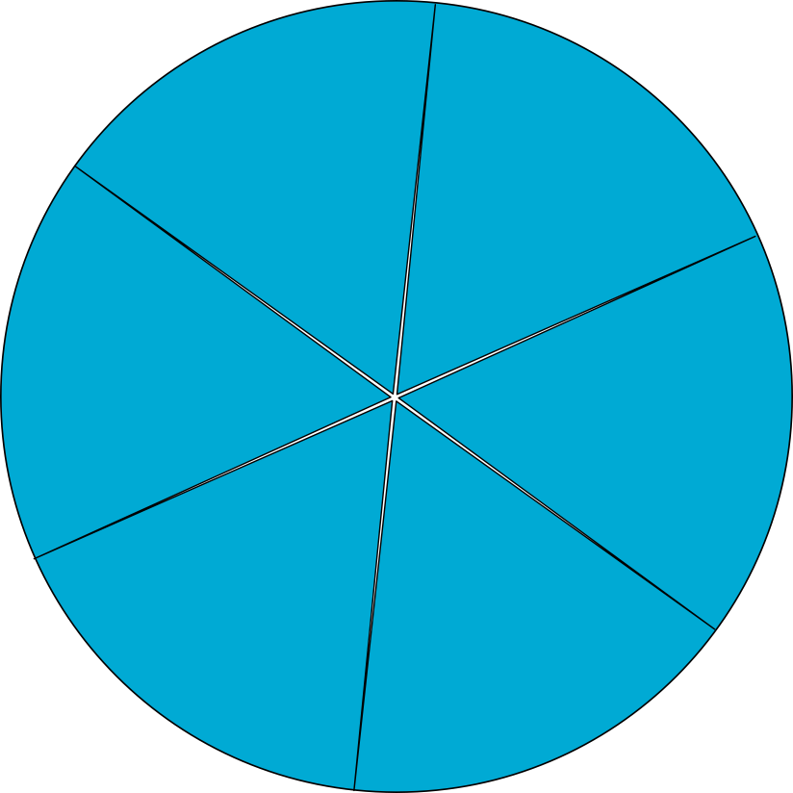
Place your languages on the wheel
Example:
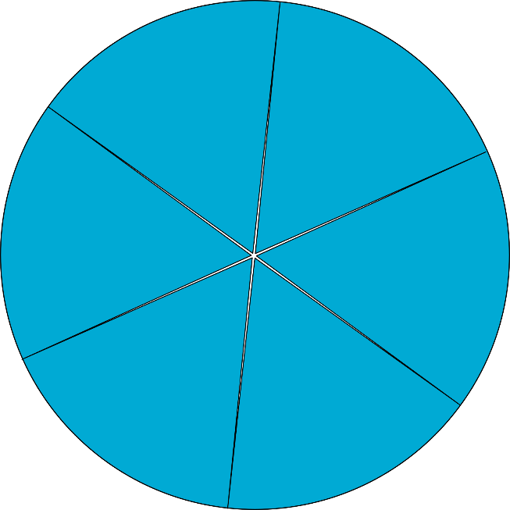
SUN
WIND
HONEY
LEMON
SILK
CHILE

 | Very little | A little | Quite well | Not at all
Do you know the language spoken here?
Can you speak it?
Can you read it?
Can you understand it on TV (on the radio, in a film)?
Can you write it?
In this language, how easily can you: | Not easily |  | Quite easily
Talk on the phone.
Answer questions people ask you.
Give explanations.
Express your opinion or feelings.
Fill in forms or questionnaires.
Write short messages (e.g. SMS).
Do you like this language? _________________________________________________________________
Is there a word in the language that you really like? _____________________________________________
Is there a word in the language that you don’t like at all? _________________________________________
Do you like learning on your own? ___________________________________________________________
When learning a language: | Yes | No
Do you read?
Do you watch TV (the news, sport, soap operas)?
Do you learn words by heart (e.g. using a dictionary)?
Do you learn songs or poems?
Do you copy out texts?
Do you study using a grammar book?
Do you learn the language with friends or neighbours?
Do you learn it with other people from your country who have been here for some time?
Do you ask people questions or ask for explanations?
Do you translate into your own language?
Do you write notes in a notebook or on your smartphone?
Did you attend school as a child? ____________________________________________________________
How many years did you attend school? ______________________________________________________
Did you work in your country? ______________________________________________________________
What kind of job(s) or profession were you in? _________________________________________________
Have you done professional training? For how long? ____________________________________________
For what profession or job? ________________________________________________________________
What professional area(s) were you trained in? ________________________________________________
Did you go on studying after leaving school? If so, please tell me about it. _______________________________________________________________________________________
_______________________________________________________________________________________
_______________________________________________________________________________________
_______________________________________________________________________________________

