25 - Finding out what refugees can already do in the target language and what they need to be able to do
Aim: To enable refugees, with the help of volunteers, to describe their current language competence in the target language, and indicate their most urgent communicative needs.
How to use this tool
Part 1. “What I can do now”
In the first part of the grid on page 3, “What I can do now”, individual refugees can use the symbols to indicate their overall competence in the target language in terms of listening, reading, interactive communication and conversation, and writing.
They use the smiley-faces to express the following:
I cannot do this in the target language
I can do this with a lot of help
I can do this without any help
The refugee should just tick () the relevant column.
The grid on pages 3 and 4 presents language situations in which refugees will typically find themselves in a new country. These situations, which are illustrated by images, include face-to-face socialising, speaking on the telephone, using the media – newspapers, television news/sport etc. – understanding instructions that have visual support (pictures, diagrams etc.), reading and understanding public information, completing forms with basic information, and sending and reading text messages.
Refugees tick the column under the relevant smiley face to show how well they feel they can manage each situation.

Part 2. “What I need now”
Individual refugees use the following symbols to indicate which situations are urgent for them to do
The second grid ‘What I need now’ helps you find out what individual refugees think they need to learn. The images indicate typical everyday situations including going to the doctor or hospital, shopping, school, managing money at a bank or post office, filling in forms, accommodation, choosing and ordering food, travelling, and the workplace.
By marking the relevant column ‘’, individual refugees indicate which of these situations are important for them to be able to communicate in using the target language.
Urgent
Very important
Important
Putting the information together
By combining the information from self-assessment (What I can do now) with the participant’s priorities (What I need now) you can identify the immediate language learning needs of an individual participant. For example, a refugee who finds interactive communication difficult in part 1. What I can do now, and who sees medical treatment as a priority in part 2. What I need now will need to be able to talk to medical personnel. This highlights a priority for the language support offered to this individual and others with similar needs.
See also
For participants who can read some text in the target language please see European Language Portfolio (ELP) pages for Adult Migrants learning the language of the host community www.coe.int/lang-migrants [ Instruments]. Pages LP3, LP4, LP5 and LB (1) 2 provide instruments for self-assessment of language proficiency. LB (2)6 and LB (2)7 provide means for identifying and specifying personal priorities and targets for language learning.

What I can do now
I can do this in the language of the host country (tick the relevant column)
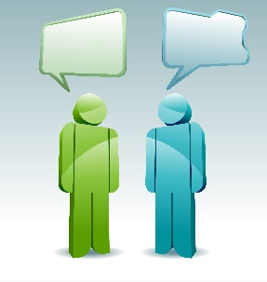
I can do this in the language of the host country (tick the relevant column)
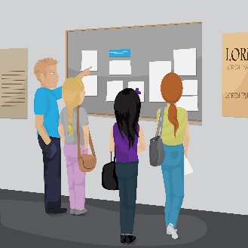

What I need now
You could ask a number of simple questions, if necessary by using pictures, and get the refugees in the group to indicate a positive or negative reaction.
It is important to ensure that everybody in the group understands that:
means urgent ;
means very important;
means important
When you are sure that each person knows how to use this system, then introduce the grids.
 | Doctor, hospital, medical, dental etc.
 | Shopping
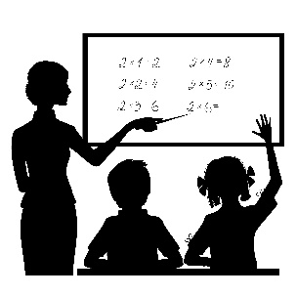 | School, education
 | Bank, money ATM etc.
 | Post office
 | Filling in forms
 | Accommodation
 | Choosing and ordering food
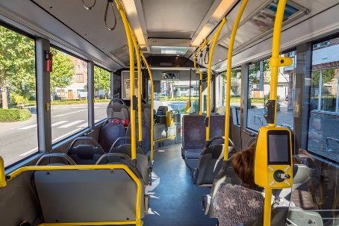 | Transport and travel
 | The workplace

