21 - Selecting and using texts for listening and reading at elementary level
Aim: To suggest how volunteers can find suitable texts for elementary listening and reading practice, and how they can use them in their language support activities
Introduction
Refugees need to understand as much as possible of what people say to them and certain announcements in public places, e.g. in stations, on public transport, in supermarkets etc. They may also wish to watch television, for example the news or sporting events. Using simple dialogues and other texts in listening activities helps them to get used to understanding spoken language and reinforces their developing language competence.
Refugees also need to be able to read certain kinds of text in the target language such as notices, instructions, leaflets, SMS messages, and e-mails. Apart from these practical needs, reading the language can help with learning because reading texts are ‘visual’ and can be looked at again and again, unlike language that is spoken. If, however, any refugees in your group have a very low level of literacy in their first language or are not familiar with the Roman alphabet they will need special help (see Tool 15 – Supporting refugees with low literacy).
LISTENING ACTIVITIES
Types of listening text that may be suitable:
- announcements heard in public places, such as stations, stores and hospitals
- recorded messages, for example voicemail messages on a mobile phone
- dialogues between people asking for and offering information or services, such as bank services, ticket offices, doctors’ surgeries etc.
- short news items on television, especially if they are about a topic known to refugees
- brief conversations between people communicating for different purposes, such as greetings, invitations, suggestions, asking for meaning to be clarified etc.
Questions to consider:
Is the listening activity suitable for your group?
- Is the topic and situation at least partly familiar to them? Does the text contain some familiar vocabulary and expressions?
- If the listening text or dialogue is recorded, is it clear? Can refugees hear it where they are sitting?
- Do the speakers have unfamiliar accents, or speak very quickly?
- If the text is read aloud does it sound natural? For example, does an ‘announcement’ sound like a real announcement?
- Can refugees listen to it more than once?
Is the listening activity related to topics you are dealing with in other areas of language support?
It is often useful to select texts that are related to topics and situations that have already been featured in your language support. For example, if refugees are working on a scenario about using health services (see, for example, Tool 44 - Using health services), select a related dialogue or text. Refugees can help here: they may have or mention texts that they want to understand for practical reasons or because they find them interesting, or they may have been asked questions by a receptionist or medical staff or heard an announcement somewhere.
Is the listening activity relevant and/or interesting for your group?
Listening and understanding what you hear can be difficult because of time pressure, unknown vocabulary or the speakers’ pronunciation. If the information is useful or interesting to them, refugees will be more motivated to participate in listening activities. If one refugee suggests a listening situation, decide whether it is useful for the whole group:
- Does it contain relevant information for their everyday lives (e.g. food, health services, leisure activities)?
- Is it about something they can identify with or have experienced? Is it about something topical, e.g. international news, famous people, or a local event?
- Does it have an interesting or amusing angle?
- Is it about how people feel, think and do things in the host country?
- Is it free of topics that might be considered offensive by your group or individuals in it?
Using listening activities in language support
Step 1: if possible, record the text (announcement, dialogue, news item etc.) on a mobile device, or find a short recording or a video on the internet. Make sure the recording is audible to refugees (one or more loudspeakers may be needed in the room).
If you cannot record the text or cannot play it back to refugees so that it is easily audible, prepare to read the text aloud to them. If it is a dialogue, try to use different voices for the participants, or ask a refugee or another volunteer to read with you.
Step 2: before refugees at low level listen to the text for the first time, orientate them to it by introducing the situation. For example, if it is a station announcement, ask who has been to a station, why they were there, what they did at the station, what they heard at the station etc. You can also check their understanding of one or two of the more difficult words in the text, and repeat them.
With more confident refugees, you could play the recording or read the text first, and then ask them to identify the situation if they can.
Step 3: after they have listened for the first time, ask refugees some simple questions: ‘where can you hear this?’, ‘how many people are speaking?’, ‘what is he/she saying?’ etc. Do not correct their answers at this time: let them guess.
Step 4: let them listen to the text a second time. If necessary, stop half way through and ask questions again to check understanding, then continue to the end before asking more questions. Then let them listen to the text a third time.
Step 5: if the text is a dialogue, it can be used as an example for a role play with refugees: they could take the roles of the different people in the dialogue. If the text is an announcement or a news item, it would be good to play or read a similar text to them so that they can listen to something similar and try to understand it.
Example
Step 1: write a simple dialogue, for example about finding the way to the station: For example:
- Excuse me, can you tell me how to get to the station?
- Yes, turn left at the end of this street, then cross the road at the lights.
- Sorry, I don’t understand: where should I turn left?
- At the end of this street, where that supermarket is.
- And then I cross the road?
- Yes, cross the road and go straight ahead for about 200 metres. You’ll see the station on the right.
- Thank you. What’s the time?
- It’s 10.15.
- Oh dear, my train is at 10.30!
Include expressions and vocabulary useful to refugees in your dialogue.
Step 2: if possible, record the dialogue with a friend or colleague using natural voices, for example on a mobile phone. Then listen to it to make sure that it is clear.
Step 3: in the language support session, ask refugees for simple expressions and vocabulary relevant to directions, e.g. go straight on, turn left, turn right (see tool 48 Finding your way in town). Then, connect the phone to a loudspeaker if possible, and ask them to listen carefully while you play the recording. If it is not audible, read the dialogue in a natural voice.
Step 4: ask refugees simple questions about the dialogue: where is the woman/man going? At the end of the street, should he/she turn right or left? etc.
Step 5: if necessary, introduce words or expressions refugees aren’t sure about, e.g. cross the road, where should I turn, I’m late etc. Then play or read the dialogue again, but stop half way through to check understanding. Then continue to the end.
Step 6: get refugees to prepare similar simple dialogues in pairs. Help them with vocabulary, then ask some of them to ‘act out’ their dialogues in front of the group. If necessary, help then with expressions and pronunciation.
Step 7: give refugees another situation, for example, helping someone to find the post office or bank (see activity 55 Mapping the local area). One refugee asks the way, another gives directions. Move round the room listening to the dialogues and encouraging and helping refugees.

READING ACTIVITIES
Types of reading text that might be suitable
- Notices that refugees may see in buildings or in the street. For example: Exit, Private, No entry, Open from 9.00 - 18.00, Closed, Bus stop, No smoking and so on, as well as longer safety messages, e.g. Fire door - keep closed, Wet surface - take care, Stand behind the yellow line, Keep this door locked etc.
- SMS messages, e-mails etc.: refugees may be used to dealing with these in their first language, and they can be useful for elementary writing practice (see Tool 20 - Organising writing practice at elementary level);
- Information leaflets they might need to understand, e.g. information about accommodation, library leaflets, health-related information (such as that found on medicine packaging, prescriptions, at the doctor’s surgery), and so on.
- Publicity, such as advertising in the street, on the internet, or in magazines and newspapers.
- Headings and instructions on internet pages.
- Newspaper headlines etc.
- Simple stories or ‘graded readers’ (books with simplified versions of well-known stories).
- Texts written by you specially for the group, or by language textbook writers for students at elementary level.
Questions to consider:
Is the reading text related to topics you are dealing with in other areas of language support?
It is often useful to select texts that are related to topics and situations that have already been featured in your language support. For example, if refugees are working on a scenario about using health services (see, for example, Tool 44 - Using health services), select a related text. Refugees can help here: they may have or mention texts that they want to understand for practical reasons or because they find them interesting, such as leaflets or information about medication.
Is the reading text relevant and/or interesting for your group?
Reading in a new language is hard work. If the information is useful or interesting to them, readers will be more motivated to read. If one refugee brings a text, decide whether it is useful for the whole group:
- Does it contain relevant information for their everyday lives (e.g. food, health services, leisure activities)?
- Is it about something they can identify with or have experienced? Is it about something topical, e.g. international news, famous people, or a local event?
- Does it have an interesting or amusing angle?
- Is it about how people feel, think and do things in the host country?
- Is it free of topics that might be considered offensive by your group or individuals in it?

Is the linguistic level of the reading text suitable for your group?
Will they be able to understand it without necessarily having to understand every single word or using a dictionary?
- Are the contents already partly familiar to the refugees, e.g. because they have read about the topic in their first language?
- Is the vocabulary basic and non-technical? Does it contain some international words? Are some words repeated in the text?
- Are the sentences quite short and mostly in the active rather than the passive voice?
- Are pictures, diagrams, photographs etc. used to illustrate meaning?
- Are longer texts divided into paragraphs with headings and subheadings?
Using reading texts in language support activities
Step 1: Once a text has been found (or written by you) you need to decide how to share it with the group:
- If it is a printed or handwritten text, can it be photocopied and given to each person?
- If it is a text found on the internet, in an e-mail etc., can each person read it on a mobile phone, should it be printed and copied, or can it be projected onto a screen or board?
- If it is a photograph of a sign or notice, can it be shared on mobile devices or should it be printed and copied or projected?
Step 2: Decide whether to ‘prepare the ground’ by, for example, mentioning the topic, asking refugees some questions about it, introducing some key words, showing a picture or two etc. Alternatively, you may wish to show them the text straight away and ask questions about it.
Step 3: Get refugees to read the text. If it is short, they can read it all; if it is longer it can be divided into sentences or sections.
- Tell them not to worry if they don’t understand every word.
- Ask simple questions about where they might see such a text, what the topic is, the meaning of certain words, which some might know (let them use a shared language to explain to fellow refugees, or the dictionary on their phones)
- Don’t ask anyone to read the text aloud. Instead, ask simple questions about the information the text contains, or tell them to ask questions (practise ‘what does xx mean?’, ‘How do you pronounce this word?’ etc.)
Step 4: Get refugees to read the whole text again or a very similar text. This time, decide whether it would be good for them to hear the text while reading to enable them to link the spoken and written versions. You can read it yourself, or record yourself or someone reading it.
Step 5: Move on to an activity such as a scenario or a role-play about a related topic (see Introduction to scenarios).
Example:
 | Operate nearest fire alarm. |  |  | DO NOT stop to collect personal belongings.
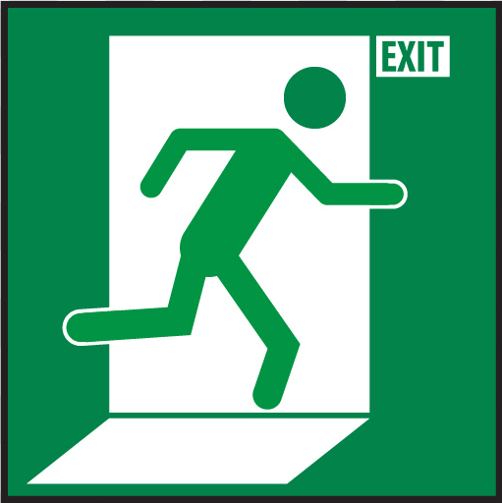 | Leave building by the nearest exit. |  |  | DO NOT re-enter until told it is safe to do so.
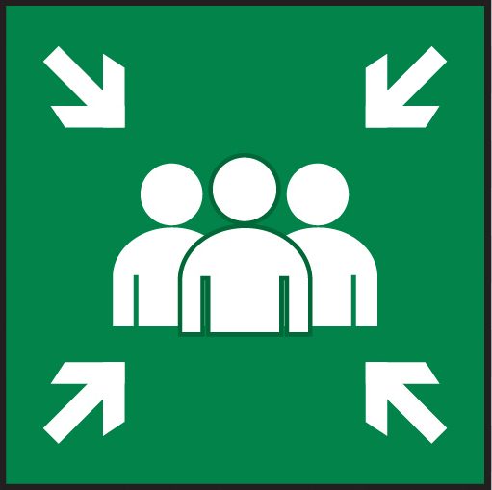 | Report to the assembly point. |  |  | In case of fire break glass.
Step 1: There might be a similar sign in the building where you work. Show it to refugees, photograph it or print the image from a website and photocopy it (colour is not necessary), project it on a wall or board, or show it on a device.
Step 2: Before showing the notice to refugees, ask them to explain or translate the word ‘fire’. Where have they seen fires? (be sensitive to any cases where a refugee might have been involved in fires caused by warfare). Depending on the language level of refugees, you could also teach ‘what would you do…?’ as a phrase. Remind refugees of one or two other words and expressions e.g. ‘exit’, ‘belongings’, ‘do not’; alternatively, get them to explain them.
Step 3: Show them the notice. Ask them to read the first three instructions (the symbols may help). Guide them in acting out the instructions (maybe you can find a fire alarm – don’t let them operate it!). They may help each other using actions, drawings, their phone dictionaries or a shared language etc. Then ask them to read the next three instructions and act out the meaning. You may need to explain ‘assembly point’. If there isn’t one near the building, invent a suitable location for it.
Step 4: Get refugees to read the whole notice again. This time, you may want to read each instruction aloud (or play a recording of yourself or someone else reading it). If so, read at natural speed with clear emphasis on the key words. If refugees want to practice pronouncing certain words themselves, help them with repetition practice.
Step 5: Plan a simple role play with refugees, starting with an imaginary fire in the building. You could practise questions such as ‘where’s the fire alarm?’, ‘what should we do?’, ‘where is the nearest exit?’, ’can I get my bag?’, ‘where should we go?’ etc. Refugees take turns to play the role of ‘fire officer’ and office workers or customers in a shop.

