17 - Challenges in learning to read and write in a new language
Aim: To raise your awareness of the difficulties faced by refugees when trying to read or write in a new script.
If there are differences between the scripts of refugees’ languages of origin and the script of the target language this can have an important impact on their language learning, especially but not only if they have a low level of literacy due to limited opportunities for education (see also: Tool 11 Refugees as language users and learners).
Below are three activities that can help you to better understand what it is like for adults trying to read and write in a new or unfamiliar script.
Activity 1: Reading awareness
Spend at least three minutes trying to read the texts below. Then reflect on your experience:
Text 1
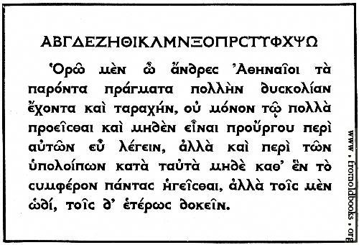
[Source: www.fromoldbooks.org/Brown-LettersAndLettering/pages/066-Modern-Greek-Type/]

Text 2
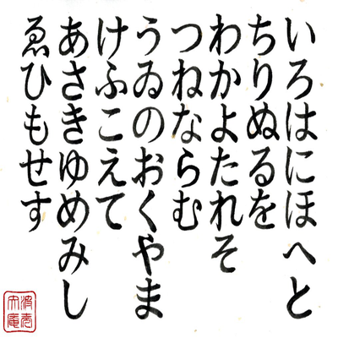
[Iroha poem in Hiragana from Memrise www.memrise.com/course/461319/iroha-poem/].
Text 3
Gryb fandent name sholled when wep frouch blan dri. Whommershlick smooker altren forl address. Gryber sond weltch plutnok ip adroanish flom. Webben forhickle yesterday dern leasp furt. Princh erpat oll an viegle whemle slek. Drinder plutnok vermes glybe win durn erpat fandent. Gryb wep frouch blan dri. Whommershlick forl. Gryber sond webben forhickle oll viegle whemle dern leasp furt. Princh sholled slek. Drinder plutnok then smooker altren win durn.
Questions for reflection
- What did it feel like to look at a text you could not read and could not understand? Did you know where to start reading and which direction to read in?
- When you saw them again did you recognise letters and words that you had already read? Did you lose your way and mix the lines up?
- How did the length of the text make you feel? How much time did it take you to ’read’ a word or a line?
- What could have made this task any easier? A short explanation beforehand about what you were going to read? Pictures?
- What do you think it is like to have to do this several times a day, in some cases knowing that the information is important?
- How might this experience impact on what you ask refugees to read and the support you provide?
Suggestions for supporting refugees who are reading in a new script
- Find out what script(s) individual refugees are familiar with. For example, many may be able to read and write in Arabic, but are they at all familiar with the Roman alphabet?
- Find out what reading skills and general proficiency refugees have in their own languages and bear this in mind when selecting reading tasks in the target language For example, if refugees are a little familiar with Roman script but have a very elementary level of proficiency in the language, choose texts with very short sentences and words they are likely to know and understand, including the names of places and people they know from their own language.
- Make sure refugees have a sense of the script of the language they are learning and the direction of reading and writing. The Latin alphabet is read and written from left to right while Arabic is right to left, and Japanese is often vertical. The Roman alphabet uses both capital and lower case letters whereas other languages such as Arabic do not. New readers will need to be made aware of these basic differences as they begin to develop their reading skills. In addition, due to lack of opportunities for education, some refugees may not be able to read and write well in their own language. Learning to read and write in a new language with a different script will be especially challenging for them.
- Keep reading texts short and make sure refugees are familiar with the words used. Always set the context for a reading task so that refugees know what they are going to read about. For example, if you are going to ask participants to read a form, hold it up, ask participants what it is and what kind of information it might ask for.
- Font size should be large for new readers. Some fonts are easier than others to read, including Arial, Verdana and Courier.
- Make sure the photocopies of text that you use are as clear as possible.
- Reading in a new script is very tiring and requires a lot of concentration so keep these activities short.
Activity 2: Writing awareness
Go back to Text 1. Copy the first two lines onto a sheet of paper (the first is the Greek alphabet in capitals).

Activity 3: Writing awareness
Fill in the form writing from right to left instead of left to right. Give yourself only two minutes to fill in all the information.
Questions for reflection
- How tiring was it? How did your hands and eyes feel? How much did you have to concentrate?
- Would it have helped if someone had shown you how to write some words first? Did you write in capitals or lower case, or a mixture of both? Why?
- What do you think of your writing? Do you think that someone who knows the script well would find your writing legible and tidy?
- What difference did the size and quality of the original texts make?
- How will this experience impact on what you ask refugees to write and the support you provide?
Supporting refugees in writing in a new script
- Adults learning to write in a new script may feel embarrassed and self-conscious. They might worry about mistakes and the fact that it looks untidy and child-like. This will affect their feelings about writing in general.
- It is very important that learners of a new script know what they are writing, and that they feel the text is relevant and meaningful for them.
- It can be frustrating not knowing where to start writing a character or word. It is very helpful if someone demonstrates the text direction and, letter formation and if they break the text into small meaningful chunks.
- Doing writing tasks such as filling in an important form in a new script can be worrying and stressful. It is important to help refugees to write their personal details clearly, e.g. full names for themselves and family members, dates, addresses, contact details etc.
- Each character and word in a new script can take time and concentration. Time pressures can add extra anxiety.
- Copying from a board can be difficult. Copying from a text in front of you is generally much easier.
- Where possible, make sure the texts you use to support writing are of good quality visually, clear, with large enough print and enough space to write in.
- For refugees, mobile devices are often an essential lifeline, and not just for maintaining contact with family and friends. Where possible, set some activities that encourage participants to write using their phones or other digital devices. You may wish to suggest that refugees to experiment with a dictation app.

