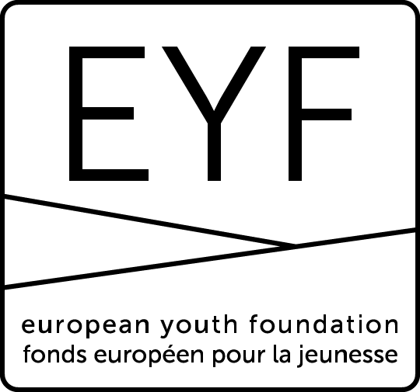
19/01/2018
EUROPEAN YOUTH FOUNDATION
REPORT FORM
STRUCTURAL GRANT (SG2)
FIRST YEAR REPORT
to be submitted at the end of 2016 and validated by the EYF before confirmation of the SG2 grant for 2017
This form is for drafting purposes only and must not be sent to the EYF.
It reproduces the information contained in the online form
to help you prepare your report.
All reports must be submitted online.

PRESENTATION
NGO Name | Information taken from registration form
NGO Responsible | Information taken from registration form
NGO Number | Information taken from registration form
NGO Type | Information taken from registration form

N.B. If any information on your organisation needs to be updated, this must be done on the registration form (NGO section: Managing your information).

Person responsible
Who was in charge of this structural grant application?
This person will be the contact person for all questions and comments concerning this report.

First name | Taken from application (can be modified)
Surname | Taken from application (can be modified)
Function | Taken from application (can be modified)
Email | Taken from application (can be modified)
Telephone | Taken from application (can be modified)

Strategy
Strategic approach for 2016-2017

Is everything going according to plan?

Comment

Compared to what you indicated in the application form, please explain any modifications that have been made to your strategic approach for 2016-2017 and the effect these changes have had.

Links with the Council of Europe

Compared to what you indicated in the application form, have there been any developments affecting the way in which your strategic approach is linked to the priorities of the Council of Europe’s youth sector for 2016-2017?

Report of activities
Please attach your annual report of activities for 2016 (obligatory), including an analysis on the way the activities were carried out. The report must acknowledge the EYF support (Council of Europe logo and EYF visual identity - see http://eyf.coe.int).

Comment

Please explain if there were any modifications to your programme of activities in 2016 and, if this was the case, how these affected your planning/working methods.

BUDGET
Please update the estimated figures for your expenditure and income in 2016 in the online table (in Euros) when submitting your first year report. When submitting the final report, update the figures for 2016 and 2017. Please make sure that the figures concerning EYF grants appear clearly and that they correspond to the amounts transferred to your bank account. The figures in the online budget must correspond to those in the certified/audited accounts.

You are not obliged to attach your certified/audited accounts for 2016 (these will be requested with the final report), but you can attach your draft accounts if available.

VALIDATION
Before submitting your report, you will be asked to confirm that you have taken note of the EYF operational regulations (see link on EYF website – paragraph 1.B on structural grants) and that the information you provide in the application is true and correct.

STRUCTURAL GRANT (SG2)
SECOND YEAR REPORT
to be submitted before the end of June 2018

Strategy
Strategic approach for 2016-2017

Did everything go according to plan?

Comment

Compared to what you indicated in the first year report, please explain any modifications that have been made to your strategic approach for 2016-2017 and the effect these changes have had.

Links with the Council of Europe

Compared to what you indicated in the first year report, were there any developments affecting the way in which your strategic approach was linked to the priorities of the Council of Europe’s youth sector for 2016-2017?

Annual report of activities
Please attach your annual report of activities for 2017 (obligatory). We do not expect you to create a new document, but to provide the report approved by your Board or General Assembly. This should not be just a list of activities, but should include an analysis on the way the activities were carried out. The report must acknowledge the EYF support (Council of Europe logo and EYF visual identity - see http://eyf.coe.int).

Comment

Please explain if there were any modifications to your programme of activities in 2017 and, if this was the case, how these affected your planning/working methods.

BUDGET
Please update the estimated figures for your expenditure and income in 2016 and 2017 in the online table (in Euros). Please make sure that the figures concerning EYF grants appear clearly and that they correspond to the amounts transferred to your bank account (i.e. identify the grants received for international activities, work plans and the structural grant). The figures in the online budget must correspond to those in the certified/audited accounts.

You are obliged to attach your certified/audited accounts for 2016 and 2017 to the online form and to send by post to the EYF a signed original or a copy certified conform to the original, signed by a person who can take legal responsibility for your organisation.

VALIDATION
Before submitting your report, you will be asked to confirm that you have taken note of the EYF operational regulations (see link on EYF website – paragraph 1.B on structural grants) and that the information you provide in the report is true and correct.

