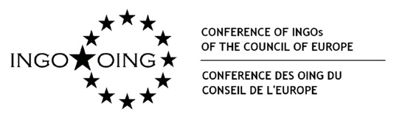

CONSULTATION OF THE CONFERENCE OF INGOs
Proposals to modify
Please send your proposals using this form to the Secretariat
NGO-unit@coe.int
by 29 November 2019

During this first consultative process the members of the Conference of INGOs are welcome to submit specific proposals to the articles presented.

The proposals are made by: ______________________________

Kindly enter modifications as follows: a) Enter the existing number of the article; b) Formulate the proposed modification, and c) Explain the reason why in italics.
Continue any further proposals in consecutive order of numbering on the same form.

Article Nr. | Modification  Reasoning of the modification (in italics, please)

Please note that the drafting group will review all proposals, but your proposal may overlap with another proposal or may not be accepted.

