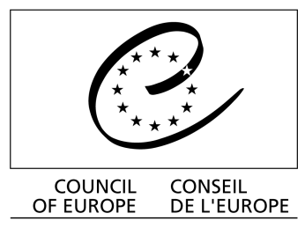

Convention on the Conservation
of European Wildlife and Natural Habitats

Standing Committee

Recommendation No. 193 (2017) of the Standing Committee, adopted on 8 December 2017, on the European Code of Conduct for Invasive Alien Trees
The Standing Committee to the Convention on the Conservation of European Wildlife and Natural Habitats, acting under the terms of Article 14 of the Convention,
Having regard to the aim of the Convention which is notably to ensure the conservation of wild flora and fauna, by giving particular attention to species, including migratory species, which are threatened with extinction and vulnerable;
Recalling that under Article 11, paragraph 2.b of the Convention, each Contracting Party undertakes to strictly control the introduction of non-native species;
Recalling its Recommendation No. 99 (2003) on the European Strategy on Invasive Alien Species;
Recalling Decision VI/23 of the 6th Conference of the Parties of the Convention on Biological Diversity, on Alien species that threaten ecosystems, habitats or species, and the definitions used in that text;
Recalling that the 10th Conference of the Parties of the Convention on Biological Diversity adopted the Strategic Plan for Biodiversity 2011-2020 with its 20 headline Aichi targets for 2020, in particular Target 9 devoted to invasive alien species (IAS): “By 2020, invasive alien species and pathways are identified and prioritised, priority species are controlled or eradicated, and measures are in place to manage pathways to prevent their introduction and establishment”;
Welcoming the EU Biodiversity Strategy to 2020, endorsed by the Council of the European Union in June 2011, and in particular its Target 5, calling on Member States to combat IAS so that by 2020 IAS and their pathways are identified and prioritised, priority species are controlled or eradicated, and pathways are managed to prevent the introduction and establishment of new IAS;
Welcoming the EU Regulation No. 1143/2014 of the European Parliament and of the Council of 22 October 2014 on the prevention and management of the introduction and spread of invasive alien species;
Noting the need to co-operate with all the actors involved in forestry activities in the prevention and management of the introduction and spread of IAS into the territory of the Convention;
Referring to the European Code of Conduct for Invasive Alien Trees [document T-PVS/Inf (2017) 8],
Recommends that Contracting Parties:
1. Take the European Code of Conduct mentioned above into account while drawing up other relevant codes - or where appropriate - draw up national codes of conduct on invasive alien trees;
2. Collaborate as appropriate with the actors involved in forestry activities in implementing and helping disseminate good practices and codes of conduct aimed at preventing and managing of introduction, release and spread of invasive alien trees;
3. Keep the Standing Committee informed of measures taken to implement this recommendation.
Invites Observer States to take note of this recommendation and implement it as appropriate.

