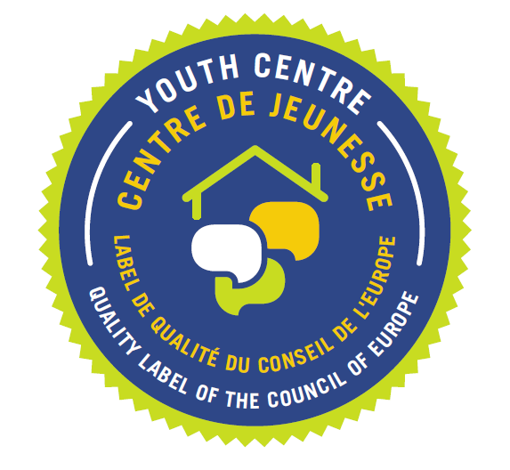
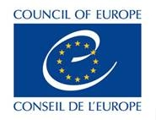

1/ Details of the candidate centre
Council of Europe Quality Label for Youth Centres

EXPRESSION OF INTEREST IN ACQUIRING THE QUALITY LABEL

Name of the Centre:

Full Address:

City:

Country:

Website:

Weblink to location map:

2/ Details of the responsible contact person (Director, Manager, etc)

Name:

Email:

Daytime telephone:

3/ Why do you want to associate your youth centre to the Council of Europe by acquiring the Council of Europe Quality Label for Youth Centres?

4/ Eligibility criteria:

Eligibility criterion 1
“The centre has, as its primary mission, the aim to serve the youth sector and young people.”

Condition | Self-evaluation
1.1 The primary focus of the centre's programme is young people and those working with and for young people.
1.2 The majority of the educational activities in the centre correspond to the profile of non-formal education.
1.3 The centre is involved in training multipliers engaged in non-formal education with young people.

Eligibility criterion 2
“The centre promotes international co-operation within the youth sector.”

Condition | Self-evaluation
2.1 The centre hosts and promotes international and multi-lateral activities.
2.2 The centre can demonstrate that it is involved in wider European/international co-operation frameworks of the youth sector.
2.3 The centre makes efforts to multiply good practices from the international level (Council of Europe, European Union, United Nations, specific networks) and spread the knowledge and values through training and promotional activities at national, regional and local levels.

Eligibility criterion 3
“The centre has a clear mandate from public authorities.”

Condition | Self-evaluation
3.1 The centre is supported by public authorities.
3.2 The centre has / could have a mandate from public authorities to apply for this Council of Europe Quality Label for Youth Centres.
3.3 The centre has structured links and communication mechanisms with the public authorities responsible for youth policy.

Eligibility criterion 4
“The centre has in-house educational staff working to support the activities.”

Condition | Self-evaluation
4.1 The centre has at least one internal educational staff member responsible for ensuring conceptual coherence, quality assurance, and support for activities, including those run by external educational staff.
4.2 The centre's educational staff team is adequately large for the number and volume of activities run.
4.3 The centre can demonstrate the competence of its educational staff for value-based, non-formal educational activities with an international dimension.

Eligibility criterion 5
“The centre has accommodation facilities within one campus with the working facilities.”

Condition | Self-evaluation
5.1 The centre has the capacity to provide board and lodging on one campus. Living together is an integral part of the educational concept/process.
5.2 The centre's facilities are such that the group does not have to move to another venue outside the campus for social activities, sleeping, and so on:
- Accommodation is provided indoors with suitable basic hygiene facilities
- Accommodation in tents and campsites is not eligible
- Rented space does not qualify
5.3 The centre's accommodation capacity is adapted to the organisation of international study sessions or similar activities (i.e. to accommodating
approximately 35 participants).

5/a/ Please describe your relationship with public authorities (for example: recognition, contracts, …)

5/b/ Please describe your relationship with civil society

5/c/ Please describe how your centre reaches out to multipliers in the youth sector

5/d/ Please describe how your centre could contribute to the development of youth work on local, regional, national or European level.

6/ Please indicate your agreement to the terms and conditions of participation by checking the boxes:

We undertake to provide all the information required by the assessment procedure as outlined in the brochure entitled ‘The Council of Europe Quality Label for Youth Centres’ and to cooperate fully with the expert group appointed by the European Steering Committee for Youth (CDEJ), should an exploratory visit to our centre be undertaken.

We have taken note of and agree to the financial conditions of acquiring the Council of Europe Quality Label for Youth Centres as laid out on page 23 of the brochure entitled ‘The Council of Europe Quality Label for Youth Centres’:
http://www.coe.int/t/dg4/eycb/Source/Quality_Label_brochure_EN_2015.pdf

We consider that a monitoring visit of the Council of Europe group of experts could take place in our Centre as from:
☐ autumn 2017
☐ spring 2018

Date: Signature:

Please submit this form, along with not more than 6 representative photos of your centre (e.g. dining area, bedrooms, working rooms, outdoor spaces, etc), in electronic format (scan of signed copy) to:

Council of Europe Quality Label for Youth Centres

email: youthcentres.quality@coe.int

