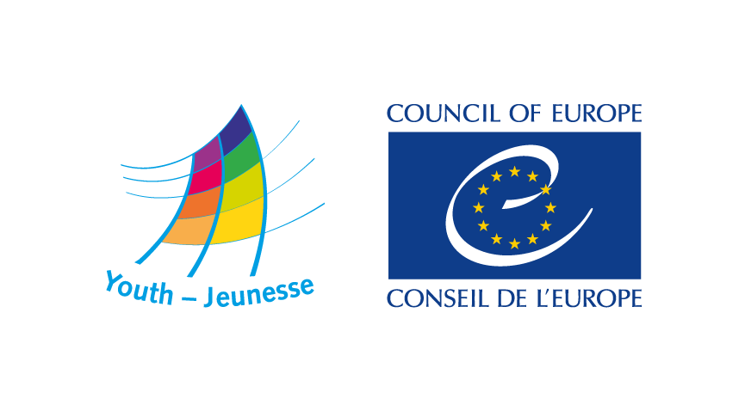

DDCP-YD/ETD(2017) 3 3 1 March 2017

Guidelines for reports

of study sessions

held at the European Youth Centres

of Strasbourg and Budapest

I. Introduction

The Council of Europe requires the youth organisations, partners running study sessions held in cooperation with the European Youth Centre to produce a report of the study session. This activity report must be submitted to the educational advisor assigned to the session, no later than two months after the end of the activity. The submission of study session reports in the previous 2 years is an eligibility criterion for organisations applying for study sessions.

This document contains guidelines on the content and form of the report of study sessions, and also specifications to be followed by all organisations. They are meant to facilitate the work of those in charge of writing and publishing the report. Reports that do not conform to the specifications outlined in the document will be returned to the organisations to be revised, improved and finalised. All these guidelines admit exceptions whenever justified. Reference to numbers of page refers to text only (i.e. not taking into account pictures of graphics). These guidelines also apply to reports of double study sessions and special projects.

II. Function of the report

Providing a report of the study session is an important formal and quality criterion for the activities of the Council of Europe: they provide visibility to the activity’s results and participants, they support the multiplying role of the participants and they inform the Council of Europe and other stakeholders in youth policy of the conclusions/perspectives of young people. Providing a report is also part of good governance and sound usage of public money.

The reports of study sessions provide valuable reference material on the issues discussed, project ideas, recommendations and follow-up by and for the participants. The report should serve as both as a resource for the organisation in question and for teams of other study sessions and as a reference for the Council of Europe and particularly its Youth Department, other youth organisations and institutions interested in the subject of the study session.

The content of the report should reflect the issues addressed, results and conclusions reached by participants during the sessions. More than an account of the daily programme, the reports should reflect the most relevant proceedings, the innovative elements and the aspects that can inspire or inform future study sessions or youth activities. The report must document fairly on the activity:
- why it was held
- who the participants were
- which issues were discussed in the programme
- what was learnt
- what were the conclusions, main findings and contributions to the “knowledge” and the expertise in the theme(s)
- what were the main outputs and outcomes for the organisers
- how it will be followed up.

The report may also reflect the methods and methodology used if relevant to potential multipliers in the organisation or elsewhere. It may also, where relevant, include evaluation material collected from participants. But none of these are essential. Youth organisations have thus a large margin of manoeuvre to decide what should and what should not be in the report. An important indicator is that it should still make sense when read three years after publication.

Readers and users of the report

The envisaged readers and users of the report are:
- the participants of the study session
- other young people interested in the topic
- the youth organisation(s) running the study session and other youth organisations co-operating with the Council of Europe or interested in the same issues
- Staff members and experts of the Council of Europe and members of the statutory bodies of the Youth Department.

III. Formats

Reports can have different formats. The most usual is a document that will be published online or, in exceptional circumstances, printed. But it may also take the form of:
- A video clip or a podcast;
- A blog open to external comments or contributions on the topic;
- A webpage;
- A multimedia report;
- A graphic report.

Other formats are possible, or a combination of the above provided that it remains a complete report and that is public. When choosing the format, the organisers should make sure they have the capacity and expertise to produce it in that specific format and that feedback from the Council of Europe will be possible.

All reports must:
- Contain an executive summary no longer than one page
- Acknowledge the cooperation with the Council of Europe and carry its logos
- Be publicly accessible, also from the Council of Europe websites.

The choice of the report format and how it will be produced must be discussed in the preparatory meetings for the session.

Size

Written reports should be between 6 and 20 pages long, without appendices (exceptions are possible if agreed with the educational advisor). The final report should be provided in both MS Word or another editable text format. It should use type font Calibri, Times New Roman (size 11 or 12) or Arial (size 10 or 11) for the main text and formatted for A4 paper size. The cover pages should respect the elements provided in appendix 1 to this document. The organiser(s) may find useful to consult the Council of Europe visual identity guidelines.

If the report is in video or audio format it should be between 7 and 15 minutes for video and 10 to 45 minutes for audio. The video or audio reports should also follow the suggested structure described below.

IV. Suggested structure for reports of study sessions

Table of Contents

- Executive summary
The executive summary highlights the most important facts, issues, conclusions and recommendations of the study session. It should be possible to get from the executive summary a complete overview of the information in the report about the study session. The executive summary is often easy to prepare after having finalised the rest of report. The summary should not exceed 1½ page.

- Introduction
The introduction presents the report and the activity in a synoptic but complete manner. It should normally include:
- An introduction to the report (what the reader can find there)
- The background to the session (why was the session needed for the organisation/s)
- The aims and objectives
- A description of the profile of participants number and anything else about the group that may be relevant to understand the report
- A presentation of the organisation/s
- A presentation of the topic and list the main contents/issues discussed
- The link between the session’s theme and the Council of Europe.
The introduction should fit in 3 pages.

- Results and conclusions
Present the outcomes and main results of the study session that are relevant for the organisation, participants and the Council of Europe, including where applicable:
- Mains findings and conclusions on the issues discussed
- recommendations or statements on issues that require particular attention and which could be addressed in the context of the European youth policy
- suggestions or proposals for the Council of Europe (including for the work of the Youth Department)
- learning points for participants
- follow-up foreseen by the organisation
- Overall evaluation (if relevant)
- Contribution of the session to the programme/mission of the Youth Department of the Council of Europe.
This section should not exceed 2 pages.

- Programme – inputs and discussions
This is the main body of the report in relation to the themes of the study session. It presents a summary of the main issues / thematic blocks, findings and presentations in relation to the theme(s). Please consider the following:
- There is no need of a detailed description of the daily programme. It is more useful to give a description of the flow of the session in 2 or 3 paragraphs. This can be followed by a more detailed account of the most important sessions and their outcomes grouped by focus, theme or otherwise
- Outline of the content of the discussions that took place during the study session, including where possible the main conclusions, definitions and concepts developed and the inputs of team members, Council of Europe staff or lecturers
- Highlight new ideas, conclusions and projects emerging from the discussions or working groups
- Present, even if briefly, connections between the study session and the Council of Europe’s programme or instruments
- Point to remaining questions
- Explain proposals for action
- Avoid long lists of bullet points
This section can include from 3 to 10 pages

- Follow-up activities
Give an overview of follow-up activities developed or to be developed by participants and/or organisers.
This section should fit in 2 pages.

Appendices
- Final Programme, as executed
- List of participants: names, organisations and countries (no personal contact details!)
- List of references (books, web-sites, hand-outs, articles, pictures) used
- List of links where information about the study session was posted online to ensure visibility

Note: The focus on the areas outlined above is by no means exhaustive. The content of the report should attempt to be analytical, informative and useful to the future readers. It is, therefore, useful to define the target group first. Everything that seems unnecessary and makes the report too long should go in Appendices or left out.

V. Rights of third parties

It is the organisation’s responsibility that copyrighted material is not reproduced without written agreement of the copyright holder. The Council of Europe reserves the right not to publish reports (fully or partly) wherever this rule is not respected.

VI. Process

- The reports are produced by the organiser(s) and sent to the educational advisor assigned by the Council of Europe no later than 2 months after the study session.
- The educational advisor controls the quality of the report and provides comments and feedback on form and content to the organiser(s), including a reference number.
- The organiser(s) finalises the report by integrating comments provided by the educational advisor. This should be done within two weeks.
- The Council of Europe Youth Department publishes the report in its website/s and sends the final approved PDF version of the report to the organisation.

VII. Printing and translation

Organisations can request printed copies of the report (black and white, A4 size). The Council of Europe reserves the right to decide on the printing.

If justified, an organisation can request a translation of the report into the second language used in the study session; this provision depends on availability of financial resources and the quality of the text.

VIII. Quality of the texts

The written reports are to be delivered in English (United Kingdom) or French (France). The texts are expected to be of good quality in grammar, spelling and style. Report writers are strongly advised to make use of the Council of Europe Style Guide for common questions about English language and terminology commonly used in the Council of Europe.

LOGO OF ORGANISATION (s) Logo of the Council of Europe
Appendix 1 - Sessions report cover layout mask
(OPTIONAL)

Reference number of the report Budapest/Strasbourg, date

TITLE

Report of the study session held by
(name of organisation)

in co-operation with the
European Youth Centre of the Council of Europe

European Youth Centre Budapest / Strasbourg
Dates

This report gives an account of various aspects of the study session. It has been produced by and is the responsibility of the educational team of the study session. It does not represent the official point of view of the Council of Europe.

