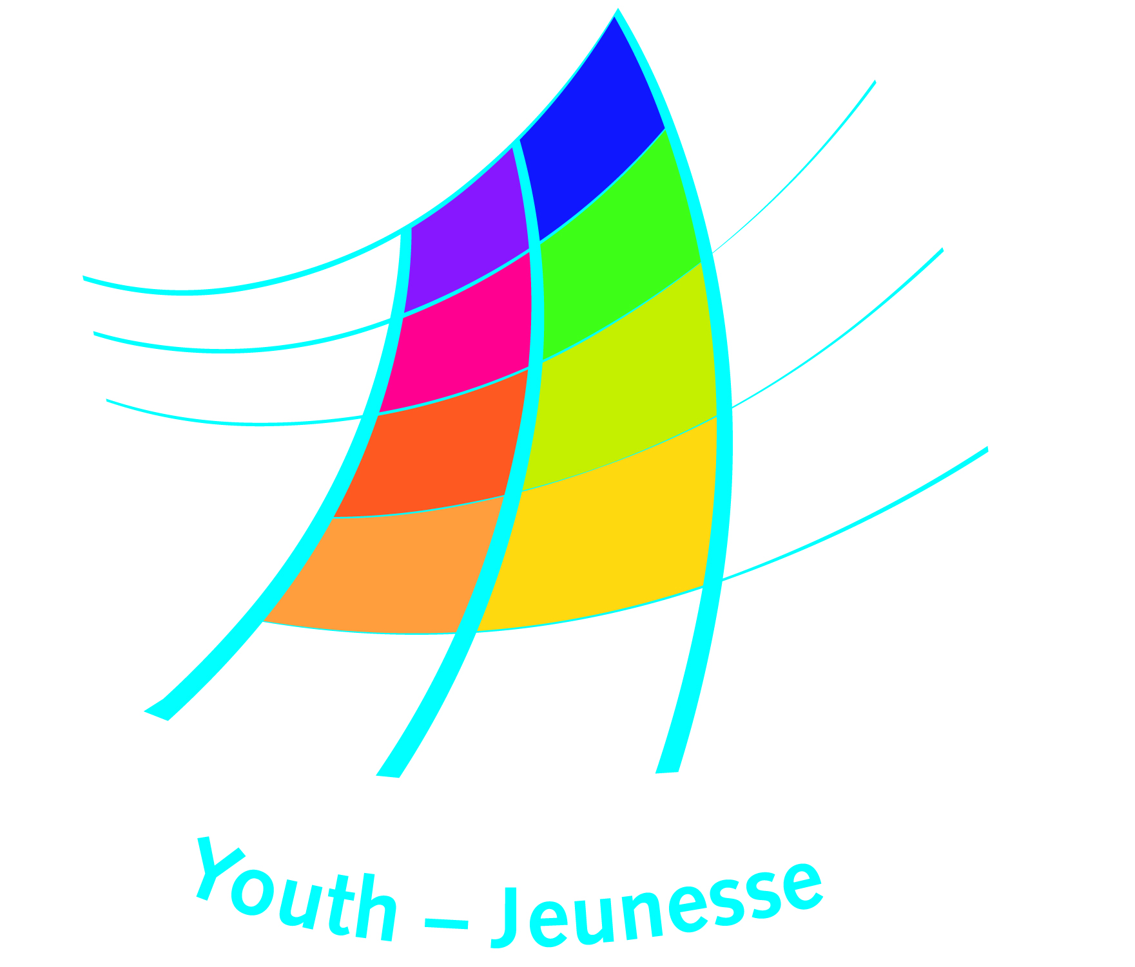
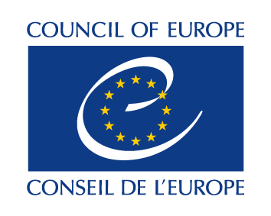
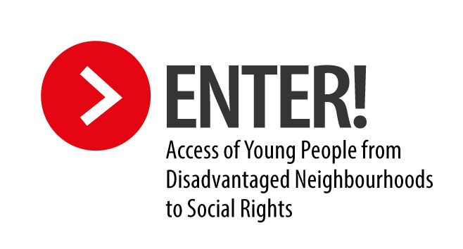

Support to local and regional authorities for the implementation of the
Enter! Recommendation

Form for expression of interest

Information about the local partner(s)

Name of the local or regional authority, institution or organisation:
Country:
Address (include city, postal code, and country):
Telephone (include international dialling code):
Email:
Website:
Your organisation is:
☐A local authority
☐A regional authority
☐A youth centre
☐The regional office of a national institution
☐A youth work institution
☐An education institution
☐Other (please provide details)Click here to enter text.

Partners – if you have partners for the action proposed, please provide their names and type of organisation Click here to enter text.

Contact person(s)
Please provide the name and contact details of the contact person for this expression of interest:
Name:
Position:
Address:
Telephone number:
Email:

Needs identification
What is the challenge that young people are facing in their access to social rights which you would like to work on?

Proposed activities
What do you want to achieve in relations to the challenge described above? What would you like to change?

How will the activity of project integrate support the implementation of the Enter! Recommendation?

What do you intend to do or undertake with your project or activity in order to improve access to social rights for young people from disadvantaged neighbourhoods?

Requested support or partnership

What type of involvement or support would you like to have from the Council of Europe?
☐Sharing expertise and experience
☐Institutional or educational support
☐Capacity-building
☐Networking and peer-learning
☐Other (please specify)

Please describe more in details the target beneficiaries of the support activity and the expected outcomes:

How would like the support of the Council of Europe to be provided?

Please provide a proposed date and location for the support activity (if applicable)

Please provide any other information which will help us better understand your idea assess the possibilities for support

To submit your expression of interest, please send this form to youth_enter@coe.int before 31 August 2018. In addition to the form you can enclose any relevant examples, reports, or links to the Internet which can support the Council of Europe to understand better the type of support that you are requesting.

