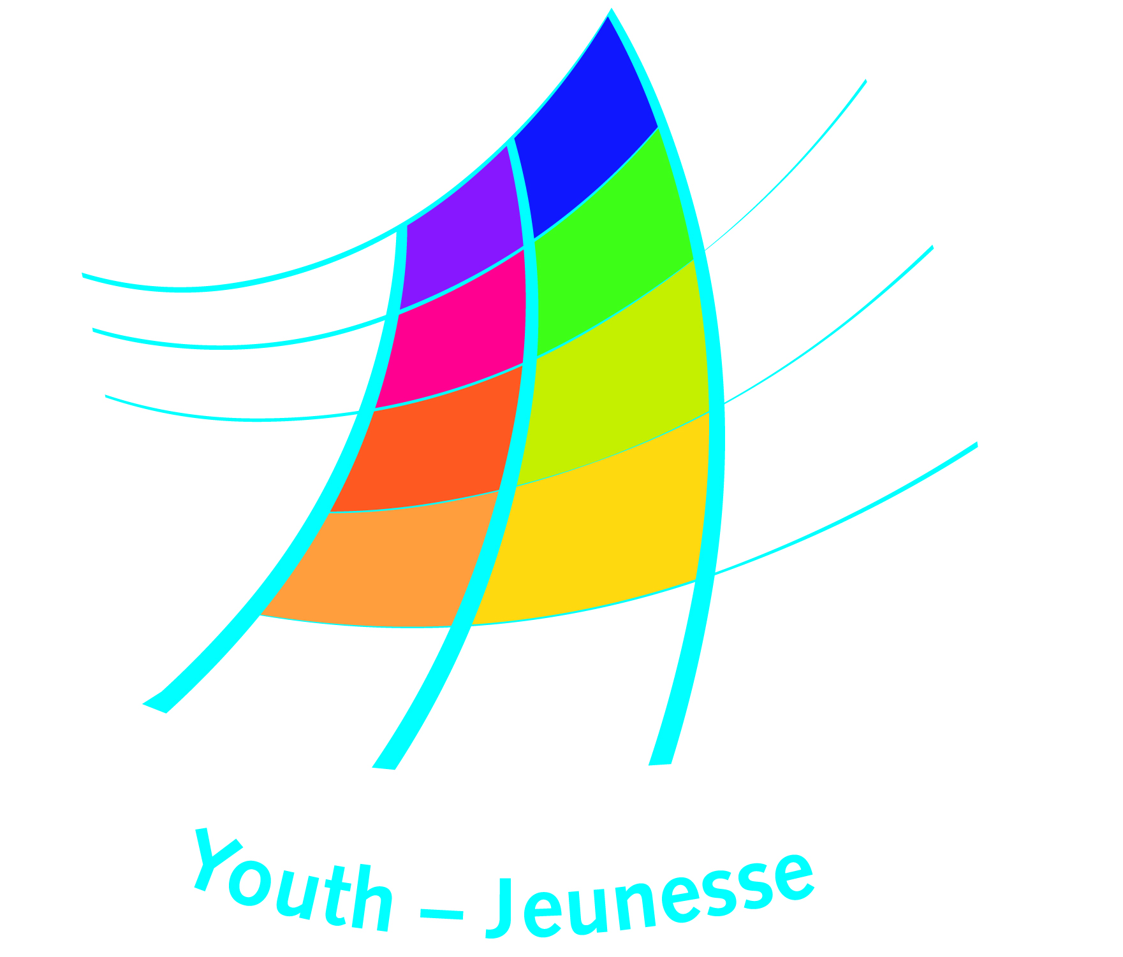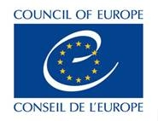

DDCP/EYCB/Compass2012/2013/003

Expression of intent to translate COMPASS

A manual for human rights education with young people
(2012 edition, updated in 2016)

- Name of the applicant organisation(s)

- Address and contact details (including, fax, e-mail and web site, if available)

- Contact person for the project (name and contact details)

- Language into which you propose to translate “COMPASS 2012”

- Please indicate your experience in translation and/or publishing and provide a list
of publications, if available

- Please indicate the name(s) and the profile(s) of the translator(s) who will translate
“COMPASS 2012”, specifying their expertise in translating publications on human rights and training materials

- How will the translation and publishing be financed? (Please indicate details of sponsors and funders, including contribution in kind)

- How do you intend to disseminate the translated version of ‘COMPASS’...
- In print form?

- Online?

- Please provide the time-line of the planned translation and printing of ‘COMPASS’ containing:

  - translation (ready within xx months)
  - quality control by the Council of Europe (takes three months)
  - implementation of changes of the quality controller (xx months)
  - design and printing (ready within xx months of the date of agreement of the Council of Europe)

10. How do you intend to cooperate or liaise with the publishers of the translation of the 2002 version in [language], notably in respect of the rights of the holders of that first version to the language in question?

We have taken note of the conditions of the Memorandum of agreement on copyrights.
We are ready and committed to undertake the translation of “COMPASS 2012” under the
conditions outlined in the memorandum, once approval from the Council of Europe has
been received.

Date: Signature:

Please submit this form to:

Erzsébet Bánki
Council of Europe
Directorate of Democratic Citizenship and Participation
European Youth Centre Budapest
H- 1024 Budapest, Zivatar utca 1-3.
Tel + 36 1 4381036
Fax + 36 1 2124076
E-mail: erzsebet.banki@coe.int

