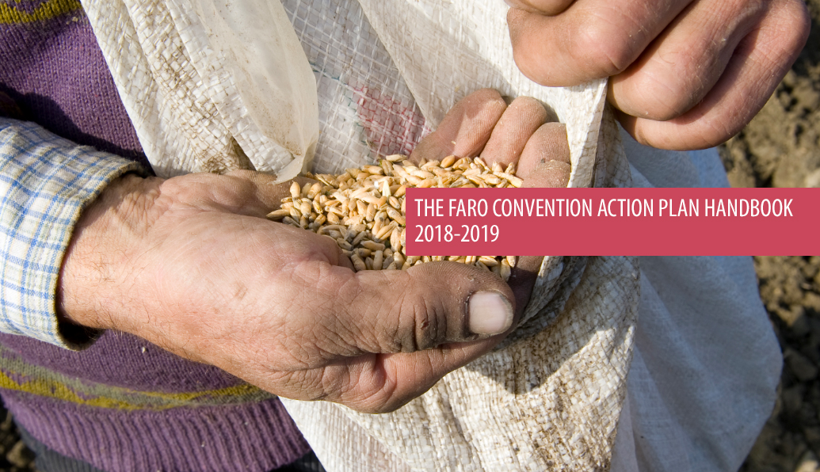

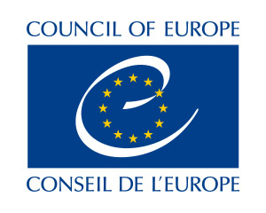 | THE COUNCIL OF EUROPE FRAMEWORK CONVENTION ON THE VALUE OF CULTURAL HERITAGE FOR SOCIETY

The opinions expressed in this work are the responsibility of the authors and do not necessarily reflect the official policy of the Council of Europe.

Photographs are kindly provided by members of the Faro Convention Network.
Table of Contents

Introduction 4
1. The Faro Convention 4
2. The Faro Convention Action Plan 7
2.1. Faro Convention Promotion 7
2.1.1. The Faro Convention Talks 7
2.1.2. The Faro Convention Meetings 7
2.1.3. The Faro Convention Labs 8
2.1.4. The Faro Convention Visibility 8
2.1.5. Testimonies from the field 8
2.2 The Faro Convention Network (FCN) 9
2.2.1. The Faro Convention Network (FCN) process 10
2.2.2. Self-management process 12
2.2.2.1. Step 1 – Self-Assessment / Baseline Measure 12
2.2.2.2. Step 2: Feedback including recommendations 15
2.2.2.3. Step 3: Preparation of a Plan of Action / A monitoring tool 15
2.2.2.4. Step 4: Self-evaluation 16
2.2.2.5. Documentation 18
2.3. The Faro Convention in Action 18
2.3.1. The Faro Convention methodology 18
2.3.2. Good practices: 19
2.3.3. Facilitators: 19
2.3.4. Practitioners: 19
2.3.5. Workshops: 19
2.4. The Faro Convention Spotlights 19
2.4.1 Narratives 19
2.4.2 Shared Vision 20
2.4.3 Common Points for Action - Projects 20
2.5 The Faro Convention Research 20
3. Faro Convention Action Plan and Synergies with other Council of Europe Programmes 21
3.1. The European Heritage Days (EHD) Programme, 21
3.2. Strategy 21: the European Cultural Heritage Strategy for the 21st century, 21
3.3. The Cultural Routes programme 21
3.4. The EUR-OPA Major Hazards Agreement 21
3.5. The Intercultural Cities Programme 21
4. Plan of Action 2018-2019 22
5. Annexs 23
ANNEX I - Faro Convention Action Plan Glossary 23
ANNEX II - Suggested draft outline of the biennial report 25
ANNEX III - Participation vs. Cooperation 26
ANNEX IV - Definitions of the concepts as per the Convention articles 27
ANNEX V - The Austrian experience 28
ANNEX VI - Towards the ratification of the Faro Convention - The Finnish experience 29

Introduction

The Faro Convention Action Plan Handbook has been developed by the Council of Europe Secretariat in consultation with the Faro Convention Network (FCN) members. It seeks to offer guidance for heritage communities that are interested in aligning their initiatives with the Faro Convention principles and take part in a pan-European network.

The handbook primarily targets civil society and heritage communities, while local and national authorities are considered essential actors in the process where they can benefit from the content and methodology that are offered. The handbook is specifically designed to explain the basic information and steps to be taken to implement the Faro Convention. In this regard, it also provides member states with a resource to take further steps in the ratification and implementation of the Convention.

Considering their crucial role in the Faro Convention process, the handbook will assist the facilitators to work independently in their respective contexts and feel part of a pan-European network that they can rely on to expand their activities.
The handbook will be revised by the FCN members and the CoE Secretariat every two years, in line with changing conditions and needs. It lays out the general idea behind the Faro Convention Action Plan, its brief background, vision and structure, setting the groundwork for future development. The FCN annual gatherings are good opportunities to work on this manual to improve it with the members of the FCN, as well as incorporate input from the stakeholders.
The FCN is meant to build upon the communities’ existing knowledge and experiences in heritage and cultural diversity, as well as explore new concepts and community based initiatives focusing on:
- heritage governance;
- the role of heritage in addressing societal challenges;
- setting a framework for cooperation and inclusive policies.
The Faro Convention Action Plans are developed biennially and a report is envisaged in order to share the results with a wider audience. This will allow self-evaluation of progress in a transparent manner.
The Council of Europe has long been committed to the idea that cultural heritage and its value to societies is essential for human rights and democracy to help ensure positive social, political, cultural and economic development. The Faro Convention offers a sound framework to address these issues at the heart of the communities.
We encourage heritage communities to look carefully at this handbook, and to use and adapt it with ingenuity and creativity as an important contribution to the building of a cohesive understanding between all members of society.
Faro Convention Action Plan Team

1. The Faro Convention
The Council of Europe, with an integrated and cross-disciplinary approach to cultural heritage and diversity, encourages societies to assert the principle of every person’s right of access to the cultural heritage of his or her choice, while respecting the rights and freedoms of others.
The Framework Convention on the Value of Cultural Heritage for Society (the Faro Convention) was adopted by the Council of Europe’s Committee of Ministers on 13 October 2005 and it entered into force on 1 June 2011. To date it has been ratified by 18 states and signed by 5 additional states. The implementation of the Convention is coordinated through the Faro Convention Action Plan, which is reviewed and adjusted biennially, based on specific societal challenges and set Organisational priorities.
Why the Faro Convention?
Ongoing efforts towards sustainable development, shared prosperity, peaceful, just and inclusive societies, require sound and innovative perspectives on human rights and democratic governance. With the consideration of heritage as a social, economic and political resource, the Council of Europe’s Faro Convention suggests a vision and a new way of looking at heritage by setting the ground to reframe relations between all involved stakeholders, highlighting the essential role of inhabitants and as suggested by the Convention, heritage communities.
In this regard, the Faro Convention Action Plan promotes heritage-led and people-centred actions around a defined common interest. It argues that when heritage is considered as a source and resource, everyone’s opinion, interests and aspirations count. It further acknowledges that the presence of diversity of peoples, places and narratives may lead to conflictual situations. Consequently, the Action Plan presents a distinctive approach and a set of tools in order to examine such situations, and together with the communities, identify good practices to contribute to inclusive societies with respect for dignity and multiple identities. By making the invisible visible, the Faro Convention approach empowers communities to take an active role in decision-making towards direct democracy and contributing to policy and strategy making regarding their local resources.
Increased numbers of signatory member States to the Convention will further encourage the European institutions to pay more attention to the communities, and be aware of their active role in the development of innovative approaches to heritage and democratisation processes. Through the Faro Convention, the Council of Europe continues to assume its role in launching and guiding a pan-European debate on societal challenges, with particular attention to human rights, democracy and the rule of law.
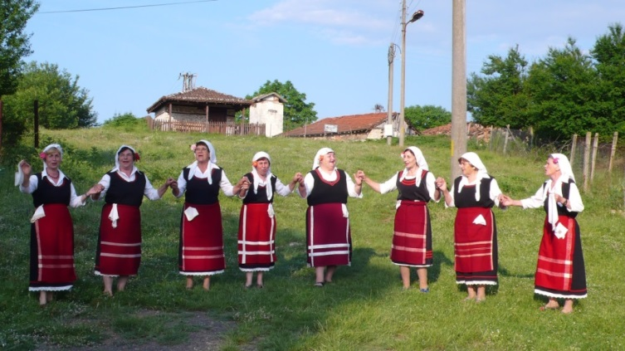
The Faro Convention Action Plan – a distinctive approach
The Faro Convention Action Plan aims to illustrate the richness and novelty of the principles of the Faro Convention, as well as providing possibilities for interpretation in relation to current societal challenges. It further generates common references, and creates mechanisms and tools in order to encourage initiatives in line with the Faro Convention’s principles and criteria.
Based on the Faro Convention Action Plan motto “Peoples, Places and Stories”, the Council of Europe’s ongoing reflection on the Faro Convention draws on three main ideas:

- Prioritising inhabitants in their relationship with cultural heritage;
- Reaching out to heritage communities and groups;
- Strengthening linkages between all the local, regional and national heritage stakeholders, through synergetic action.

The approach focuses on an “action-research-reflection”, particularly aimed at issues aligned with Council of Europe priorities. It offers a platform for dialogue, seeking alternative heritage-led solutions to the increasingly complex societal challenges of our times. It also seeks to include the various distinctive civic initiatives carried out at local level and to draw on these specific experiences. It allows a better consideration of contributions from the field and understanding of the government entities and institutions in order to develop common references for all member States of the Organisation.
A distinctive approach of the Action Plan is embodied in the identification of common ground; increased mutual understanding; restored respect for dignity and multiple identities; and redefining and redesigning relationships.
The Faro Convention Network and Heritage Communities
Heritage communities are self-organised, self-managed groups of individuals who are interested in progressive social transformation of relationships between peoples, places and stories, with an inclusive approach based on an enhanced definition of heritage.
Heritage communities go beyond the classic concept of heritage experts, putting the community at the centre of the heritage work and democratic governance. With the consideration of heritage as a resource, they work for direct democratic engagement in support of diversity and sustainable heritage-led local development, seeking economic and social conditions favourable to the survival and well-being of diverse communities. With their people-centred initiatives and distinctive approach which involves working through the different layers of society, heritage communities create a platform to revisit and redefine relationships in order to manage their heritage assets and address the societal challenges faced today.
An ever growing Faro Convention Network (FCN) is based on the idea of self-management where heritage communities are able to self-assess, monitor and evaluate their position against the Faro Convention principles and criteria. Interconnection of this network is also strengthened through a series of actions, developing solidarity and allowing mutual exchange among its members. This approach acknowledges and values the existing wisdom, knowledge and capacities in each heritage community. Consequently, it supports the internal dynamics of sustainable development processes with real consideration for human rights and democracy.
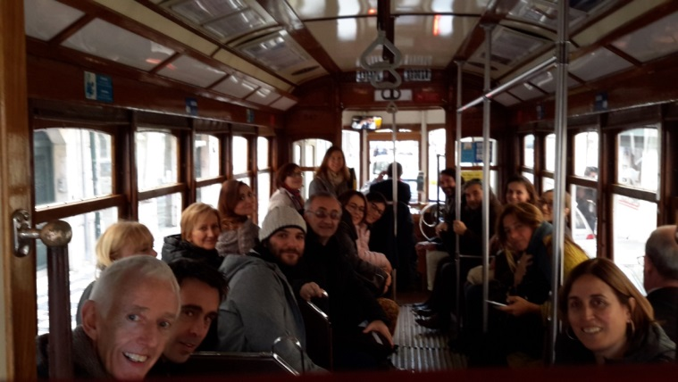
The Faro Convention Promotion
Promotion of the Faro Convention takes place at community, national and international levels through Faro Convention Talks, Faro Convention Meetings and Faro Convention Labs.
Faro Convention Talks are presentations of good practices, inspirational talks at high political level as well as local level (in person and multimedia) to introduce the spirit and impact of the Faro Convention.

Faro Convention Meetings – at the invitation of a country, these are stakeholders’ meetings to introduce the Convention, its principles and possible actions for implementation.

Faro Convention Labs are a series of events organised in relation to specific aspects of the Convention in order to exhibit, analyse and reflect on the Faro principles and criteria.
The principles:

- Connection to a community and territory determines a sense of belonging;
- Social cohesion is founded on various levels of cooperation and commitment;
- Democracy is practised by engagement of civil society in dialogue and action, through shared responsibilities based on capacities.

The criteria:

Who?

- Presence of an active civil society (heritage community) that has a common interest in a specific heritage;
- Presence of people who can convey the message (facilitators);
- Engaged and supportive political players in the public sector (local, regional, national institutes and authorities);
- Engaged and supportive stakeholders in the private sector (businesses, non-profit entities, academia, CSOs, NGOs, etc.).

How?

- Consensus on an expanded common vision of heritage;
- Willingness of all stakeholders to cooperate (local authorities and civil society);
- A defined common interest of a heritage-led action;
- Commitment and capacity for resource mobilisation.

What?

- Readiness of the group to engage in the process of developing diverse narratives based on the people and places;
- Aspirations towards a more democratic socio-economic model;
- Commitment to human rights principles in local development processes (respect for dignity and multiple identities);
- Improved democratic participation and social inclusion of all inhabitants.
Member States can contact the Secretariat for assistance in promoting the Convention.

The Faro Convention in Action

The Faro Convention in Action is an active learning platform where the Faro Convention Network builds on its good practices, and generates dynamic dialogue among practitioners, facilitators and heritage stakeholders. Through ongoing action-process-reflection, the FCN seeks to identify the changing needs of the societies and build on the pan-European know-how in order to address challenges at local, national and international levels.
The Faro Convention Spotlights
Faro Convention Spotlights focus on specific heritage-led actions in line with the political priorities of the Organisation. These actions actively investigate the possible role of heritage in addressing societal challenges. Every year, the Secretariat identifies specific areas and practices in order to analyse and make subsequent recommendations to promote these actions in the member States.
The Faro Convention Research
The Faro Convention is open to interpretation, as its guiding principles encourage periodic review of set criteria as the Faro Convention Network expands. Consequently, its implementation should be flexible and creative, inspiring new initiatives to demonstrate the role of heritage in addressing societal challenges. This requires an extended network of civil society involvement and academic study to be able to assess the progress and impact of the Faro Action Plan, as well as making sound recommendations. In this regard, the Secretariat establishes partnerships with civil society organisations and academia in order to study various aspects of the Faro Action Plan, produce research papers, articles and documentaries, and provoke further discussion in the field of heritage.

The principles:
- Connection to a community and territory determines a sense of belonging;
- Social cohesion is founded on various levels of cooperation and commitment;
- Democracy is practised by engagement of civil society in dialogue and action, through shared responsibilities based on capacities.
The criteria:
Who?
- Presence of an active civil society (heritage community) that has a common interest in a specific heritage;
- Presence of people who can convey the message (facilitators);
- Engaged and supportive political players in the public sector (local, regional, national institutes and authorities);
- Engaged and supportive stakeholders in the private sector (businesses, non-profit entities, academia, CSOs, NGOs, etc.).

How?
- Consensus on an expanded common vision of heritage;
- Willingness of all stakeholders to cooperate (local authorities and civil society);
- A defined common interest of a heritage-led action;
- Commitment and capacity for resource mobilisation.

What?
- Readiness of the group to engage in the process of developing diverse narratives based on the people and places;
- Aspirations towards a more democratic socio-economic model;
- Commitment to human rights principles in local development processes (respect for dignity and multiple identities);
- Improved democratic participation and social inclusion of all inhabitants.

FARO CONVENTION ACTION PLAN OPERATIONAL STRUCTURE
FARO CONVENTION PROMOTION

FARO CONVENTION NETWORK
FARO CONVENTION RESEARCH
FARO CONVENTION IN ACTION

FARO CONVENTION SPOTLIGHTS

The operational structure is conceived to promote the Faro Convention and Action Plan at local, national and international level, encouraging civil society based initiatives (heritage communities) to work with the Faro Convention Network members. Through this process, local community initiatives align themselves with the Faro Convention principles, gradually becoming part of the Faro Convention Network. The Secretariat, through lessons learnt, focuses on some of the actions in line with the political priorities of the Organisation, putting them in the spotlight through projects. All the efforts are documented and studied to understand the impact of the work done, offering recommendations for further actions, and feeding into the promotion of the Convention. Faro Convention in Action, symbolically located in the centre, plays the crucial role of learning platform, offering knowledge, examples and expertise that are utilized by all aspects of the Faro Convention Action Plan.

2. The Faro Convention Action Plan
The Faro Convention Action Plan is designed to translate the Faro Convention principles into practice. It provides field based knowledge and expertise for member States to better understand the potential of the Convention, as it gives life, shape and meaning to the concepts expressed in the Convention. It helps the Secretariat to highlight and study specific cases in line with the political priorities of the Organisation, offers a platform for analysis and recommendations for further steps, and encourages member States to ratify the Convention.
While the Faro Convention is an exercise in participatory democracy and offers a framework on how heritage is viewed and governed, the Action Plan attempts to provoke a reconsideration of heritage as a concept, as an asset, as a set of processes, and as a dynamic force to deal with heritage governance as well as identifying the role of heritage in addressing societal challenges. The Action Plan is reviewed and adjusted biennially, based on the Organisation’s priorities and the feedback received from the Faro Convention Network.
Working with all relevant stakeholders from community level to civil society organisations, schools, academia, local and national authorities and institutions, the Action Plan ultimately aims at creating a space for multiple narratives, perspectives and a better quality of life through heritage.
The operational structure of the Action Plan encourages a dynamic process of action-research-reflection where the concepts on heritage governance, various initiatives for community engagement and cooperation, economic dimension and relationships between heritage and other fields are explored with a synergetic approach. While many member States may consider that they have already been implementing many aspects of the Faro Convention, the sense of solidarity developed through the Faro Convention Network is considered a large pan-European workshop and a learning platform that seeks solutions to challenges based on local knowledge, wisdom and experiences, offering an impetus to the critical questions that societies face today.

Synergies sought through the Faro Action Plan aim to demonstrate the organic links between various aspects of human rights and democracy as they relate to human dignity, identity and cultural survival of all communities, particularly the marginalised ones.

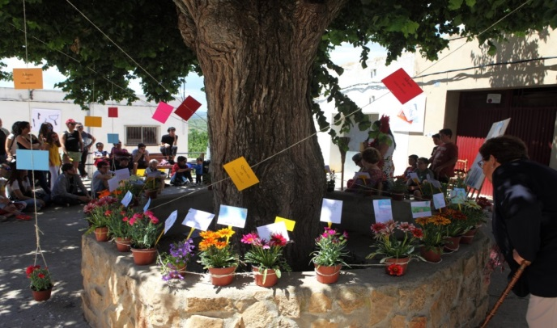

2.1. Faro Convention Promotion

Promotion of the Faro Convention takes place at community, national and international levels through various means, in order to inform authorities and public about the Convention and its implementation. Involvement of all layers of society through promotional efforts is expected to encourage member States to sign and ratify the Convention to enhance their heritage governance practices in a pan-European network in the field of cultural heritage.
2.1.1. The Faro Convention Talks
are presentations of good practices and inspirational talks in person or through multimedia to introduce the spirit of the Faro Convention. These talks provide testimonies of individuals who have been involved in the Faro Convention implementation in diverse areas. The Faro Convention Network members, experts and the Secretariat attend events at the invitation of the member States and heritage communities.
2.1.2. The Faro Convention Meetings
are a step further than the Talks where already informed stakeholders search for possibilities to further engage in the Faro Convention and Action Plan. While such meetings could be coordinated by a member State, at the invitation of a country, the Secretariat could also play a role in assisting a member State in their process of looking into the Convention for clarification on the way to possible ratification and implementation. At the heritage community level, this could also be considered in convening essential stakeholders for further action.

2.1.3. The Faro Convention Labs
are organised with the participation of interested member States and communities to further explore the Faro Convention principles and their effective implementation. The Labs include a series of events for a period of 2-3 days based on the availability of the host community, and involve stakeholders at national, local and community levels. The labs aim to expand a group of participants from each country so they can work together on their return to promote and implement the Faro Convention. While the specific topic of each Lab is decided together with the host community, overall objectives include:
- Promotion of the Faro Convention with local and national stakeholders;
- Becoming familiar with the Faro Convention approach;
- Enhancing the Faro Convention Network;
- Skill building for the implementation of the Faro Convention principles and criteria.
Through experiential learning, participants gain first-hand experience of the implementation of the Convention. The Labs include various techniques including introduction of good practices, discussion groups, promotional events, heritage walks and workshop modules. With the inspiration of the Faro Convention Labs, participants are expected to follow up the implementation of the Faro Convention principles through local initiatives by heritage communities and preferably at the national level by further promoting the ratification. During the workshop, a specific session is dedicated to work on action points to take place after the Lab.
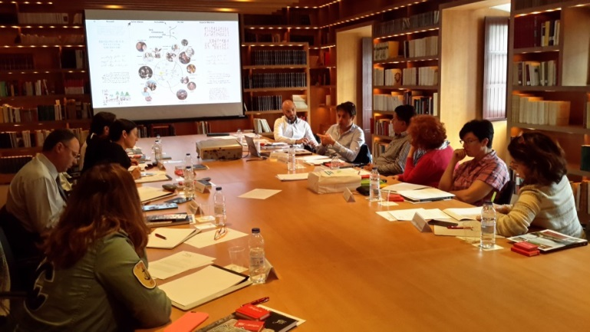
2.1.4. The Faro Convention Visibility
is a series of actions that heritage communities, local, regional and national authorities can organise to raise awareness about their heritage resources and introduce the Faro Convention and Action Plan as a useful framework. In this regard, the following actions are suggested, which would not have significant financial implications:
- Reading the Faro Convention, available at http://www.coe.int/en/web/culture-and-heritage/faro-convention and discussing the meaning and implications for any given place;
- Visiting the Faro Convention Action Plan website http://www.coe.int/en/web/culture-and-heritage/faro-action-plan and following on Facebook Faro Convention Network to follow the developments and possibly take part in it;
- Translating the Convention into the local language and generating discussions on heritage topics.

At national, regional and local levels:
- Mapping of the actions in line with the Faro Convention principles;
- Involvement of academia and NGOs for research activities;
- Assessment on the legislative and political challenges preventing ratification.

Heritage Communities / groups level:
- Organise community-based meetings to discuss the interpretation of the Convention in the specific context;
- Check with local and national authorities whether the Convention was ratified by national authorities and if there are heritage communities that have already been involved with the Faro Convention Network;
- If there is interest in getting involved, discuss the linkage between the initiative and the Faro Convention, and consult the CoE website for further actions.

2.1.5. Testimonies from the field
are short scripts or videos prepared to document the changes that were recorded having applied the Faro Convention approach. This documentation can be shared with the Secretariat to be circulated through the Faro Convention Network. Some of these testimonies can be viewed at http://www.coe.int/en/web/culture-and-heritage/faro-testimonies
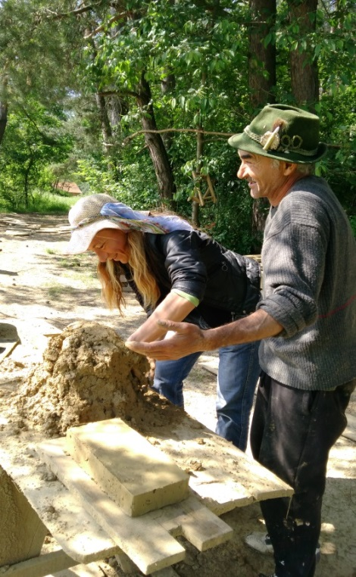
2.2 The Faro Convention Network (FCN)

The Faro Convention Network consists of groups of practitioners and facilitators of heritage-led and people centred actions in towns and territories in the Council of Europe member States and non-member States who go through a process of valuing their local heritage assets in line with the principles and criteria of the Faro Convention. The Faro Convention Network is made up of a growing number of “local communities” participating in a dynamic pan-European platform, offering extensive knowledge, expertise and tools, within a framework for constructive dialogue and cooperation.
The Network works towards identifying good practices and practitioners, it conducts workshops and supports members’ efforts in addressing challenges related to field of heritage. Furthermore, the Network aims to demonstrate the role of heritage in addressing the societal challenges faced today.
The Faro Convention acknowledges and promotes the internal dynamics and issues of each society in relation to its heritage and identity in a dignified manner. It acknowledges that diversity of people, places and their stories are essential to the positive interaction between and within societies as well as their surroundings. The FCN is thus conceived as a self-managed, dynamic and transformative platform with its members freely associated and guided by the principles and criteria based on human rights, democracy and the rule of law.
Becoming part of the FCN is a self-assessed process. Interested heritage communities are encouraged to go through a self-assessment exercise based on the Faro Convention principles and criteria. The Faro Convention Action Plan advocates that each heritage community has its own wisdom, knowledge and potential, and is capable of managing this process. Therefore, self-assessment, monitoring and evaluation are considered parts of a self-management process. The guidance and support of the Council of Europe (CoE) secretariat and the FCN members contributes to pan-European dimension, creating a space for dialogue and exchange. While the principles and criteria are the products of an on-going reflection, they are revisited on a regular basis and adjusted according to feedback and a learning process embedded in the Faro Convention Action Plan. Lessons learned from the Action Plan, together with the tested good practices, are included in the recommendations for Strategy 21 implementation, as well as policy making for the members States of the CoE. Based on the principles and criteria, each heritage community initiative should conduct a self-assessment, responding to the points indicated in twelve criteria. It is expected that a heritage community may not meet all the criteria. In such cases, the heritage community, as an active member of the FCN, is expected to work with the Network to optimize its position. A self-assessment tool provides an opportunity to visualise the baseline measure vs. desired level, and to assist in the drawing up of a plan of action for each heritage community.
Affiliation with the FCN is a free association, based on the Faro Convention principles and criteria. Once a heritage community establishes an affiliation with the network, continuation is sustained through active dialogue and continued interest and action between members as well as the CoE Secretariat. If such progress is not assessed and demonstrated through the initiative, the heritage community might be considered a passive member until they are ready to be actively involved, and their CV would not appear on the CoE website among active members. In this regard, an active member:
-becomes part of a pan-European Network and has access to the resources that the Network offers;
-has the opportunity to make their ‘invisible’ case ‘visible’ across 47 CoE member States;
-takes part in the assessment and spotlight visits, as appropriate;
-participates in the annual FCN meeting;
-contributes to the Faro Labs and tests the good practices to verify their cross-cultural validity;
-engages in joint actions, projects with other programmes and initiatives;
-maintains its visibility on the CoE website and promoted through the CoE activities;
-promotes the Faro Convention and Action Plan in their respective countries.
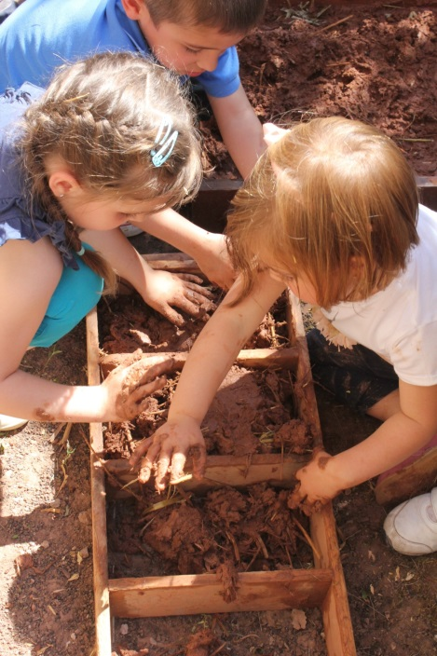

2.2.1. The Faro Convention Network (FCN) process

1 – PROMOTION
INTRODUCTION TO THE FARO CONVENTION
AND ACTION PLAN
13 – FARO CONVENTION METHODOLOGY
(Projects + impact assessment + link to Strategy 21)
14 – SELF-EVALUATION
(Lessons learned + recommendations)

12 – DOCUMENTATION OF GOOD PRACTICES
(Workshop + Test + Verify)
8 – SELF-MONITORING and EVALUATION
(every two years)
10 – APPRECIATION VISIT
11 – FARO CONVENTION SPOTLIGHTS
9 – DISTINCTIVE INITIATIVES IDENTIFIED
7 – INCLUSION OF THE CV ON THE CoE WEBSITE
15 – PROMOTION / VISIBILITY OF GOOD PRACTICES & CONTRIBUTION TO STRATEGY 21
6 – COMMITMENT LETTER
4 – SELF-ASSESSMENT
3 – FEEDBACK FROM THE SECRETARIAT
5 – REVIEW BY THE SECRETARIAT AND THE FCN
2 – INTEREST IN THE FARO CONVENTION NETWORK
The Faro Convention Network (FCN) process - explanatory note
Please note that the numbered explanations below correspond to the numbers on the chart
- Introduction to the Faro Convention and Faro Action Plan
Information on the Faro Convention and Faro Action Plan is available on the CoE website – www.coe.int/heritage
Promotional events organised by the CoE Secretariat include,
Faro Convention Talks: inspirational talks at the invitation of member States as well as testimonies from the member States presented in Strasbourg to introduce the Convention and examples of its implementation.
Faro Meetings: at the invitation of member States or local authorities in order to become familiar with the Faro Convention approach and seek ways for involvement in the process.
Faro Labs: a series of events organised with the participation of interested member States and communities to further explore the Faro Convention principles and their effective implementation.

- Interest in the Faro Convention Network (FCN)
The FCN is a platform made up of the heritage communities working together in line with the Faro Convention principles and criteria. The Network works towards identifying good practices and practitioners, conducting workshops and supporting members’ efforts in addressing challenges related to field of heritage. Furthermore, the Network aims to demonstrate the role of heritage in addressing societal challenges faced today.
If interested in the FCN, please click on “Interested in the FCN” and insert a short note (300 words max.) answering the question after reviewing the Faro Convention and Action Plan.

- Feedback from the CoE Secretariat
Your short note explaining the relationship between your initiative and the Faro Convention will be reviewed by the Secretariat and responded to within three weeks upon receipt of your note.

- Self-assessment process
Based on the principles and criteria, each heritage community should conduct a self-assessment, responding the points indicated in 12 criteria. Please refer to the self-assessment guide for details. It is expected that a heritage community may not meet all the criteria. In such cases, the heritage community, as an active member the FCN, is expected to work with the Network to optimize its position. A self-assessment tool provides an opportunity to visualise the baseline measure vs. desired level and assist in the drawing up of a plan of action for each heritage community. Please send your assessment to faro.convention@coe.int. If you have any questions, you may also send these to the same email address.

- Review of the application and self-assessment by the FCN members and the Secretariat
Feedback to the applicant (a baseline report with recommendations)
Your self-assessment will be provided with feedback within four to six weeks. You will receive a letter with feedback and recommendations, which should contribute to your plan of action.

- Commitment letter
Following the receipt of the feedback, the local initiative should provide the Secretariat with a letter with a plan of action, indicating their commitment to be actively involved in the FCN.

- Inclusion of the initiative CV on the CoE website as an active member
Upon receipt of the commitment letter, the CV of the initiative will be included on the CoE website as an active member. Please see the active member profile.

- Self-monitoring by heritage communities every 2 years. Based on the progress made, the CV is maintained on the CoE website. If not, the initiative is considered a passive member.
The initial recommendation by the FCN and the Secretariat and Plan of Action presented by the initiative set the baseline measure. The FCN members are encouraged to self-monitor and share the results with the FCN members every two years.

- Distinctive initiatives are identified for further assessment visits or Faro Convention Spotlights.
Following the inclusion of the CV on the website, some of the initiatives might be considered for further study, in line with the organisational priorities as well as the role of heritage they present in addressing societal challenges. This interest will be communicated to the respective heritage communities and details will be clarified together.

- An assessment (appreciation) mission carried out for distinctive initiatives
An assessment mission is often conducted by the FCN members and the Secretariat to verify the details of the initiative and aims at identifying good practices and practitioners.

- Faro Convention Spotlights visits are conducted
Spotlights are visits that focus on organisational priorities and seeking solutions through heritage-led initiatives. These visits are conducted by the Secretariat and experts.

- Development and documentation of Good Practices
Good practices are actions that are carried out by heritage communities in various settings and that show effective results. Once a practice is identified through the assessment visit, a heritage community may be asked to further study and document it to be introduced to other FCN members in a workshop setting. This process is supported by the CoE experts. At the workshops, these practices are introduced to the network and interested communities are asked to test and verify the validity of the practice in their respective communities. Once a practice is tested and verified (self-evaluated) in different settings, based on the results, it might be considered a good practice and included in the pool of good practices of the CoE.

- Use of the Faro Convention methodology
The Faro Convention methodology is applied to work with conflictual situations following specific steps to transform conflict through heritage-led initiatives. This methodology works around the main concepts of narratives, commons and cooperation. While the methodology might be used in various aspects of the Faro Action Plan, the full process is often used through spotlight actions based on the organisational priorities.

- Self-evaluation of the good practices and Faro Convention Action Plan carried out by the heritage community
Both the works on the good practices and actions through the Faro Convention methodology are encouraged to carry on self-evaluation and provide the FCN and the secretariat with results. Support by the experts is provided, as needed.

- Promotion of the good practices and contribution to the Strategy 21
All the results attained throughout the Faro Convention Action Plan feed into the Strategy 21 implementation, offering an approach, a platform for intercultural dialogue and tested good practices.

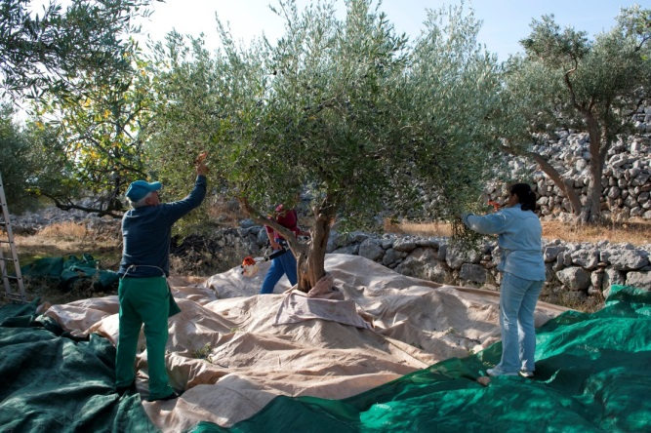
2.2.2. Self-management process

Following adoption by the Committee of Ministers of the Council of Europe in 2005, the Convention entered into force in 2011. Since then, the issue of how to implement the Convention and monitor the impact has gone through a series of reflections, and evolved through Action Plans 2014-15 and 2016-17. With the increasing numbers and significant involvement of the communities and experts in the process, the Faro Convention principles and criteria were amended. In addition, the Faro Convention Network members expressed their interest in a distinctive approach to the implementation and impact assessment, remaining loyal to the spirit of the Convention. Consequently, a self-management process was introduced where Faro Convention initiatives and heritage communities are encouraged to go through a process of self-assessment, self-monitoring and self-evaluation of their activities in line with the Faro Convention principles and criteria. This process is considered to be essential for the organic nature of the Faro Convention and empowering the network through strengthening solidarity and cooperation among its members, offering a variety of good practices and recommendations to enable member States to expand their involvement.
The Faro Convention initiatives and heritage communities who decide to be involved in the Faro Convention Network are encouraged to pursue the following self-assessment process and go through the principles and twelve criteria; discuss the existing situation among heritage community members and mark as appropriate.
2.2.2.1. Step 1 – Self-Assessment / Baseline Measure
The assessment process should be inclusive and there should be a safe environment where everyone can voice their opinions, regardless of the size of the representation. Table 1 should be completed, based on a thorough discussion among heritage community members. The numerical value of each criterion is scaled in Table 2. An example of the completed table is shown in Table 3, which can be illustrated either through words or numbers.

Table 1
 | Criteria | Heritage Community | Public Institutions | Private Sector | Facilitator
Who? | 1,2,3,4 - Presence and engagement | 1 | 2 | 3 | 4
How? | 5 - Consensus on an expanded common vision of heritage
 | 6 - Willingness of all stakeholders to cooperate (local authorities and civil society)
 | 7 - A defined common interest in a heritage-led action
 | 8 - Commitment and capacity for resource mobilisation
What ? | 9 - Readiness of the group to engage in the process of developing diverse narratives based on the people and places
 | 10 - Aspirations towards a more democratic socio-economic model
 | 11 - Commitment to human rights principles in local development processes (respect for dignity and multiple identities)
 | 12 - Improved democratic participation and social inclusion of all inhabitants

Table 2
Assessment / criteria | inexistent | fair | medium | good | excellent
Scale | 1 | 2 | 3 | 4 | 5

Table 3
Criteria - EXAMPLE | Heritage Community | Public Institutions | Private Sector | Facilitator
Presence and engagement | good | medium | fair | good
5 - Consensus on an expanded common vision of heritage | excellent | medium | fair
6 - Willingness of all stakeholders to cooperate (local authorities and civil society) | medium | good | inexistent
7 - A defined common interest of a heritage-led action | excellent | good | good
8 - Commitment and capacity for resource mobilisation | fair | fair | fair
9 - Readiness of the group to engage in the process of developing diverse narratives based on the people and places | excellent | medium | inexistent
10 - Aspirations towards a more democratic socio-economic model | fair | inexistent | fair
11 - Commitment to human rights principles in local development processes (respect for dignity and multiple identities) | medium | good | inexistent
12 - Improved democratic participation and social inclusion of all inhabitants | fair | medium | inexistent

Self-assessment can be translated into graphic representation based on five grades of assessment of the situation, as described by the criteria. Based on the data provided in Table 1, three separate graphic representations (who, how, what) will provide each heritage community and initiative with visual illustrations of the current situation per criterion. It is essential to mark as precisely as possible in order to identify the areas to be worked on. The box below each graphic allows for a brief explanation and comments on the current situation.

Criteria for presence and engagement (WHO? - 1 à 4)
Brief comment:

Criteria for implementation (HOW? 5 à 8)
Baseline measure:
Brief comment:
Brief comment:

Brief comment: Baseline measure

Criteria for outcome (WHAT? 9 à 12)

Criteria for outcome (WHAT? 9 à 12)
Baseline measure:

Brief comment:

Brief comment: Baseline measure

2.2.2.2. Step 2: Feedback including recommendations
The baseline measure of the self-assessed initiative should be sent to the Council of Europe secretariat for review and feedback, including recommendations for implementation. This feedback will assist heritage communities with their plan of action. Furthermore, the Secretariat may conduct a good practice assessment and / or spotlight visit to better understand and analyse the situation on the ground for further actions and cooperation.
Recommendations | Priorities | Progress | New priorities
Recommendation by the CoE 1
Recommendation by the CoE 2
2.2.2.3. Step 3: Preparation of a Plan of Action / A monitoring tool
The initiative (heritage community) prepares a plan of action based on realistic objectives. While this plan has a self-monitoring tool, with its timeline of two years, it will allow the FCN member to self-evaluate the progress. Therefore the points of self-evaluation should be well described including the objectives for the initiative as well as contribution to the Faro Convention action plan.
Plan of Action for the local initiative (Faro Convention) | Achieved
Faro Convention Network (appreciation, good practice, etc.)
Faro Convention promotion (Talks, Meetings, Labs, etc.)
Faro Convention Research (Studies, camps, etc.)
Faro Convention in Action (Cooperation, workshops, etc.)
Faro Convention Spotlights (Migration, marginalised groups, etc)

2.2.2.4. Step 4: Self-evaluation
Brief comment:

Self-evaluation - two years after baseline measure
Brief comment:

Brief comment: Baseline measure

Self-evaluation - two years after baseline measure
Brief comment:

Brief comment: Baseline measure

OBSERVED PROGRESS ON IMPLEMENTATION – 2 YEAR-CYCLE
Through on-going active membership of the FCN and communication with the Secretariat, the initiative receives feedback from the FCN in order to expand its work and further promote its actions within the Faro Convention Action Plan.
The objectives of self-management and a biennial evaluation cycle are to:
• Find out: whether the initiative is still active and has an impact at the local and national levels;
• Draw lessons: to know the results obtained with regard to the priorities set, the problems encountered which could be the subject of a referral to the FCN;
• To assess the contribution of the initiative in relation to the Faro Action Plan (promotion, research, implementation) and the priorities of the Council of Europe;
• Share knowledge with the Council of Europe and the FCN;
2.2.2.5. Documentation
As multimedia plays a crucial role in documentation, heritage communities are encouraged to document their initiatives every two year in order to record the change and share with the FCN members as an effective learning tool. This is also important for visibility and advocacy work. In this regard, the facilitator of the initiative is encouraged to make a simple video of 8 minutes, addressing the questions as follows;
- What are the major events that have occurred in your initiative? - 1 minute
- What are the priorities of your action plan that you have achieved? - 1 minute
- What is the major obstacle to the implementation of this action plan? - 1 minute
- What are the results achieved so far? - 1 minute
- What is the main issue that leads you to pursue your initiative? - 1 minute
- Are other projects of the same nature or have they been launched? - 1 minute
- How are the Faro Convention Network and / or the Faro Action Plan useful for your initiative? - 1 minute
- On a personal level, what is the importance of the Faro Convention approach? - 1 minute
This video will not be publicised and will remain within the FCN unless the author indicates otherwise.
2.3. The Faro Convention in Action

The Faro Convention in Action is an active learning platform where the Faro Convention Network builds on its good practices, and generates dynamic dialogue among practitioners, facilitators and heritage stakeholders. Through ongoing action-research reflection, the Convention keeps its dynamic elements of redefining its principles and contributing to a better understanding of the Faro Convention spirit and its implications at local, national and international levels.
2.3.1. The Faro Convention methodology
offers a distinctive approach to address the challenges generated by dynamic interactions between peoples, places and their stories. The methodology bases its work on the premise that diversity is fundamental to survival, and in some cases, it may lead to conflictual situations, which are considered natural. It argues that such conflictual situations can be transformed through a constructive intercultural dialogue with an active engagement of stakeholders involved, and heritage plays an important role in this process. The contextual structure of this methodology is embodied in the identification of a common ground; working towards a mutual understanding; attempting to restore respect for dignity and multiple identities; and redefining and redesigning relationships.
The methodology focuses on the main ingredients of commons, narratives and cooperation, considering heritage as a social, economic and political resource. It works with the local dynamics and pace, in line with the Faro Convention spirit, and the principles of social inclusion, human rights and community well-being.
Common Ground Mutual Understanding
(Defined common interest) (Narratives)
Re-humanising Reframing
(Restored respect for (Redefine and redesign dignity and multiple relationships) identities)

Re-humanising Reframing
(Restored respect for (Redefine and redesign dignity and multiple relationships)
identities)

This methodology is used for the specific actions identified by the Faro Convention Spotlights.

2.3.2. Good practices:
Community-based and heritage-led initiatives in line with the Faro Convention’s principles are identified, studied and promoted, bringing these experiences from local level to European level. The Faro Convention Action Plan plays a crucial role as a platform (workshop) for learning and reflection, encompassing accumulated knowledge, experience, wisdom and expertise across the CoE members States and beyond in order to offer a pool of good practices, particularly for the implementation of Strategy 21. For an initiative to be considered a good practice, it goes through a process, including

-identification of the potential good practice
-observation of the good practice by FCN members (appreciation visit)
-documentation of the practice
-introduction of the practice to FCN members
-testing of the practice in diverse settings to verify the validity
-declaration of a good practice to be included in the CoE good practices pool
-promotion of the good practice and its use through workshops, Faro Convention Labs, etc.

2.3.3. Facilitators:
Locally based individuals with natural leadership skills who have a good understanding of the Faro Convention and its principles, and play a pivotal role in bringing relevant stakeholders together for Faro Convention Process. These individuals are essential focal points between the heritage communities and the CoE Secretariat, and are considered as the driving force for the implementation of the Faro Convention in their respective settings. Regardless of their positions in their communities, the facilitators act as a catalyst to ensure synergetic work between all stakeholders as suggested by the Faro Convention criteria.

2.3.4. Practitioners:
Locally based individuals and groups that produce and apply good practices. The practitioners are the authors of the good practices and are requested to demonstrate and share their practices with the other members of the Faro Convention network members. As each practice might be applied differently based on the local conditions, these diverse experiences and knowledge shape the pool of practitioners where the Secretariat works in designing and delivering workshops as well as promotional activities.

2.3.5. Workshops:
The Faro Convention Network offers periodic workshops to introduce potential good practices, awareness raising on specific issues related to the Convention and its implantation, and skill building on specific good practices. Various workshop modules are produced and made available on the Faro Convention Action Plan website and could be made available at the request of member States, local and regional administrations as well as the heritage communities.

2.4. The Faro Convention Spotlights
The Faro Convention Spotlights focus on specific heritage-led actions in line with the political priorities of the Organisation, examining the role of heritage in addressing some of the societal challenges. Every year, the Secretariat identifies specific areas and practices in order to analyse and make subsequent recommendations to promote these actions in the member States. The methodology that was introduced on page 20 is used for the specific actions of the spotlights. While it may go through a cycle of common ground – mutual understanding – re-humanising – reframing, a heritage community might find itself in a specific stage. Depending on the local dynamics and needs, the duration of the stages may vary for each community. Through the process, willingness to engage in dialogue is essential, and this allows participants to be exposed to diverse narratives, regardless of whether they may present a drastically opposing view. The essential point here is to try to understand different narratives (stories) about the same heritage item, and acknowledge their existence. By making an effort to understand other viewpoints and recognition of the existence of multiple stories, a number of actions take place to restore confidence and respect for the other.
Based on the readiness and willingness of the involved stakeholders, the spotlight process goes through the following steps;
2.4.1 Narratives

Objective:
Acknowledgment and understanding of the existence of diverse narratives on a given heritage asset
Process:
- Collection of information on the heritage asset in focus
- Identification / mapping of existing groups and individuals relevant to specific heritage asset
- Establishment of a Project Implementation Unit (PIU)
- Orientation of the PIU
- Consultation meetings / structured dialogue sessions with each group
- Documentation of narratives
- Consultation meetings / structured dialogue session between groups
- Confirmed acknowledgment and understanding of diverse narratives
- Demonstrated willingness to work towards a common vision

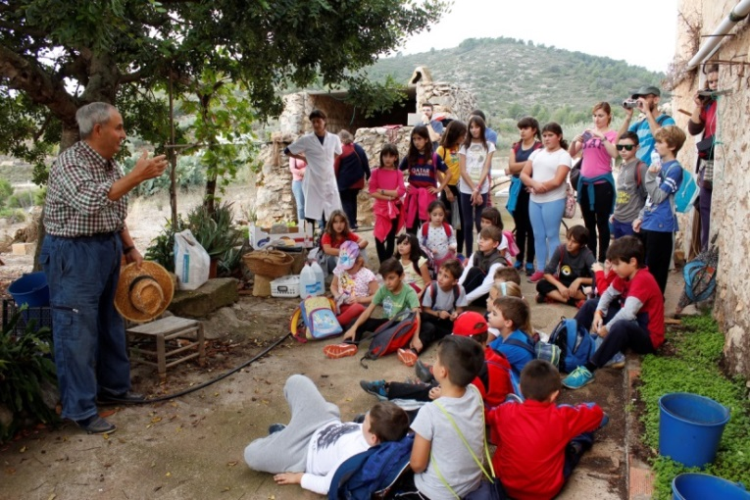
2.4.2 Shared Vision

Objective:
With particular attention to narratives, search for a common thread and develop a shared vision on the heritage asset in focus
Process:
- Consultation meetings / structured dialogue session between groups
- Considerations on integrated approach to heritage with clear demands of each group (immoveable, moveable, intangible heritage and landscape)
- Laying out specific benefits of a shared vision to each group involved
- Laying out a marketing / branding strategy for the shared vision (local, regional, national and international level) with a social message

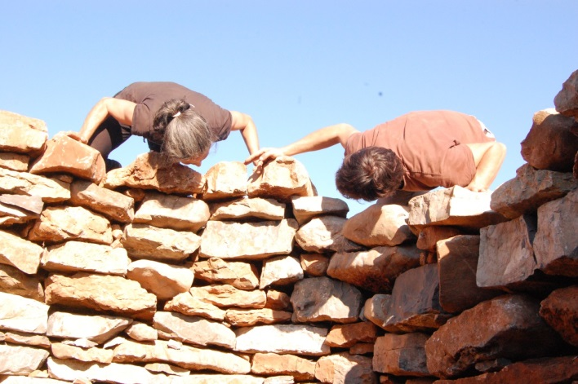

2.4.3 Common Points for Action - Projects

Objective:
Together with the community members, elaborate specific projects to be implemented by the community members with specific considerations of social inclusion, education, local economic development, anti-discrimination measures.
Process:
- Creation of working groups with specific focus on project elaboration
- Carry on needs assessment
- Project design and planning including activities on social inclusion, education, local economic development, anti-discrimination measures
- Funding and communication strategy
- Reflection and feedback to Faro Community
- Input / cooperation with Faro Research

Throughout these steps, Faro Convention good practices, workshops, practitioners and facilitators are used as resources while specialised expert assistance is sought as per the assessed needs.

2.5 The Faro Convention Research

Each year, the Faro Convention Network (FCN) proposes a specific issue for the Secretariat to use as an occasion to organise a research study and visibility event in order to draw attention to the use of the Faro Convention approach and the role of heritage in addressing societal challenges. The study aims to develop partnerships with academia, civil society and research centres (universities) to carry out case studies on multi-scale territories (rural, urban), heritage communities (local actors, museums, NGOs, etc.) and European heritage (culture, nature) on Faro Convention values and principles.
Participants from different academic circles and interested civil society organisations analyse the situation in the selected area from various Faro Convention related angles (also recommended by Strategy 21: territorial/economic development, knowledge/education, social development) and make recommendations for community based actions.
Main activities include:
- development of partnerships with academia and research organisations that carry out studies on Faro Convention related topics;
- production and promotion of academic research papers, articles, documentaries to be shared with a wider audience;
- organisation of periodic impact assessment of the outcomes of the Faro Convention Action Plan and projects.

Accordingly:
- Each group of academics carries out an assessment of the situation during research study;
- As a result, a number of vision/opinion papers are produced to generate discussion in the field, as well as providing recommendations for the local and national stakeholders;

In line with the Faro Convention approach, research-action workshops are hosted by local communities. Collective work and dialogue among community members, experts, academics, NGOs is considered to be crucial in this process. Depending on the topic, cooperation with different programmes and departments of the CoE is established.
More specifically, research action workshops
- increase visibility and highlight the efforts made by local communities for the selected issue, in line with the Faro Convention principles (with media coverage);
- gradually bring the local experience into a larger context as a good practice, after going through the Faro Convention process;
- set an example of an inclusive annual event for the Faro Convention Network;
- ensure academia and NGO involvement in the Faro Action Plan;
- provide decision-makers with sound recommendations.

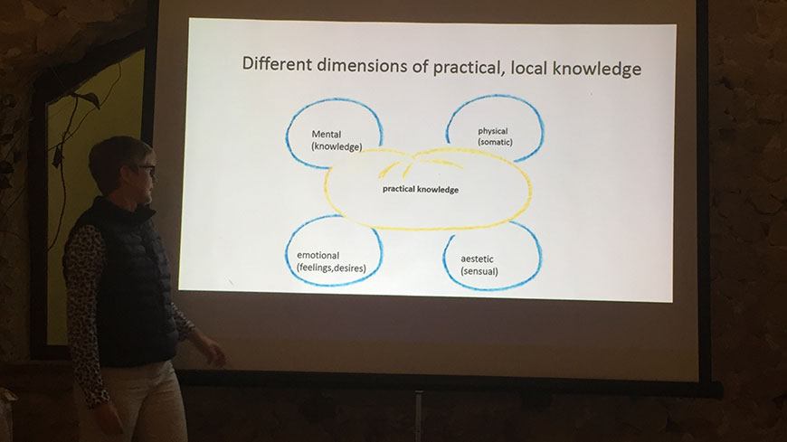
3. Faro Convention Action Plan and Synergies with other Council of Europe Programmes
3.1. The European Heritage Days (EHD) Programme,
with its extensive network and ever growing outreach capacity to over seventy thousand initiatives and thirty million people across member States, plays a crucial role in informing heritage communities, identifying distinctive initiatives and using the potentials of its network for further action. The EHD national coordinators and communities are considered complementary and a great resource for the Faro Action Plan, carrying local stories of heritage communities to the pan-European level.
3.2. Strategy 21: the European Cultural Heritage Strategy for the 21st century,
with the goal of transmitting the Council of Europe principles on participatory governance and integrated approach to heritage, works with the national authorities, policy makers as well as professional associations. It advocates the utilisation of a sound self-evaluation process during its implementation. In addition to consultation and advice provided by the Secretariat, Strategy 21 offers member States good practices in its three main domains. As the Faro Convention constitutes one of the important frameworks of Strategy 21, the Faro Action Plan plays a pivotal role in analysing and processing potential good practices and ensuring that they are in line with the Council of Europe’s core values.
3.3. The Cultural Routes programme
demonstrates, by means of a journey through space and time, how the heritage of the different countries and cultures of Europe contributes to a shared cultural heritage. As the principles of the Faro Convention are closely linked with the Cultural Routes Programme, synergies have been sought between two programmes, where the Faro Convention Action Plan has been cooperating with the ATRIUM - Architecture of Totalitarian Regimes of the 20th Century since 2016.
3.4. The EUR-OPA Major Hazards Agreement
is a platform for co-operation in the field of major natural and technological disasters. Its field of competence covers the major natural and technological disasters - knowledge, prevention, risk management, post-crisis analysis and rehabilitation. With increasing concerns about major disasters and how they affect cultural heritage, community based preventative and recovery work is being explored through the Faro Convention approach. Synergies between the two programmes have been explored since 2016 and being put into practice in 2017 through a joint research study based on a case study in Fontecchio, Italy with the involvement of academia and civil society organisations.
3.5. The Intercultural Cities Programme
supports cities in reviewing their policies through an intercultural lens and developing comprehensive intercultural strategies to help them manage diversity positively and realise the diversity advantage. Based on the previous experiences gained in the field of heritage through its technical assistance programmes, a joint project idea was developed and adjusted to the intercultural cities programme. STEPS is a EU-CoE Joint pilot project which aims at building and strengthening community cohesion, promoting trust, dialogue and mutual understanding across diverse societies, through the participatory heritage-based action plans. While the project is implemented by the ICC, programme and technical advice is provided by the Faro Action Plan, as needed.

4. Plan of Action 2018-2019
The following activities are planned for the next biennial for the Faro Action Plan.
Components | Actions | 2018 | 2019
Faro Convention Promotion | Seminars | 4 | 4
 | Promotion materials (posters, films, logo, joint campaigns with other sectors) | 1 | 1
 | Biennial report (Faro Convention Network) |  | 1
 | Meetings, Labs, Talks | 4 | 4
Faro Convention Network | Annual gathering | 1 | 1
 | Joint Project with the EU | 1 | 1
 | Appreciation visits | 2 | 3
Faro Convention Spotlights | Spotlight visits | 2 | 3
Faro Convention Research | Research study | 1 | 1
 | Cooperation on Research with the Gran Sasso Scientific Institute
 | Vision opinion papers | 5 | 5
Faro Convention In Action | Handbook | 1
 | Faro Convention legal advisory team and perspectives from the governments who signed it | 1
 | Good practices and workshops | 3 | 3
Communication Strategy | Internal, governmental, FCN | 1

5. Annexes
ANNEX I - Faro Convention Action Plan Glossary

Action-research is a reflective process of problem solving led by academics working with others in teams and local communities to assess, exchange, study and extract lessons learned to produce opinion papers and make recommendations for further actions to address issues and solve problems.
Assessment visits are often conducted by the FCN members in peer review a format in order to assess the distinctive initiatives, identify good practices and opportunities for exchange as well as providing feedback to heritage communities.
Civil society is made up of groups or organizations working in the interest of the inhabitants, outside of the governmental sectors.
Commons are the cultural and natural resources accessible to all members of a society, including natural materials such as air, water, and a habitable earth. In the context of the Action plan, commons further refer to significant places, unique practices and traditions, relationships and life styles that are rediscovered or revealed and brought to public attention.
Co-operation is the action of working together to same goal, beginning from the first steps and gradually constructing together. A special distinction is made here between participation and co-operation as participating in something denotes lesser influence in decision making and may exclude certain groups in taking active role in the processes.
Defined common interest is an agreed upon heritage asset that brings all interested stakeholders together as a common ground for a joint action. This common interest can be defined by local heritage communities as per the significance of the specific asset.
Facilitators are locally based individuals with a good understanding of the Faro Convention and its principles, and who play a pivotal role in bringing relevant stakeholders together for Faro Action.
Faro Convention Action Plan is a biennial plan that translates the Faro Convention principles into practice by generating common references, creating mechanisms and tools in order to encourage initiatives in line with the Faro Convention’s principles and criteria. It is prepared by the CoE Secretariat in line with the organisational priorities and in consultation with the Faro Convention Network.
Faro Convention Network is a network of heritage communities represented by groups of practitioners and facilitators of heritage-led and people centred actions in towns and territories in the Council of Europe member States and non-member States.
Good practices are defined as identified and verified initiatives in line with the Faro Convention principles and criteria. For an initiative to be considered a good practice and included in the website, it needs to go through a FCN verification process.
Heritage communities: as defined by the Faro Convention, a heritage community consists of “people who value specific aspects of cultural heritage which they wish, within the framework of public action, to sustain and transmit to future generations”. In the context of the Action Plan the definition is enhanced as self-organised, self-managed groups of individuals who are interested in progressive social transformation of relationships between peoples, places and stories, with an inclusive approach based on an enhanced definition of heritage.
Heritage education refers to development and implementation of diverse and creative formal and non-formal educational activities, curricula, games for children under 18 years old, in line with the principles of the Faro Convention. Such action is developed through active involvement and cooperation between the community members, artisans, children, parents, educators and administrators.
Heritage-led means cultural and natural heritage are considered as political, economic, social and cultural resource and is a driving force in local development processes. Therefore, the heritage-led actions should have the issues around heritage as the main topic of their initiative in relation to all other issues of relevance to the community.
Inclusive societies are “where individuals maintain their own identities while respecting each other’s differences, united by a set of shared, democratic values” (Council of Europe Action Plan on Building Inclusive Societies).
Inhabitant is the preferred term used in the context of the Faro Convention Action Plan for every individual to be valued regardless of their legal status. This terminology allows adopting an inclusive approach and focuses on human rights and community well-being.
Local heritage stakeholders include community members, civil society organisations, local businesses, schools, students, teachers, academics, unions, workers, farmers, artists, municipalities, migrants, local institutions, etc.
Narratives are unique stories of individuals and groups or emblematic places that nurture the very essence of heritage communities. These narratives, and the way they are revealed and disseminated, make up an important part of the extraordinary wealth of our shared history. Acknowledging that there is more than one story to any issue, and regardless of whether we agree with it or not, having the opportunity to be heard is fundamental to the ‘narratives’ question. It allows the inhabitants themselves to take possession of places and of their history.
Pan-European Network is a network of heritage communities across 47 member states and beyond for those who are interested in the Faro Convention principles and criteria.
People-centred refers to individuals and communities that play a direct and an active role in their development processes with increased decision-making, inclusiveness and equal access to resources for improved quality of life.
Practitioner is someone who is the actual implementer of the initiative. A practitioner is considered as the holder of the knowledge and skills of the practice and a resource person who is able to transmit its significance to others.
Regional and national stakeholders are regional and national institutions including ministries and specialised departments, civil society organisations, informal stakeholders or interest groups.
Spotlight visits focus on the areas where the ongoing actions are interest of the Secretariat in line with the organisational priorities.

ANNEX II - Suggested draft outline of the biennial report

Key concepts
Foreword
Introduction
Background

Faro Action Plan Review 2018-19
Highlights
Challenges and potential solutions

Good practices:
Heritage governance
Role of heritage in addressing societal challenges
Framework for cooperation and inclusive policies

Conclusions and Recommendations for 2020-21

Faro Community Network projects and Partners

ANNEX III - Participation vs. Cooperation

Participation | Cooperation / Faro

WHO?
Ordinary citizen: users, beneficiaries, daily experts | Heritage communities: active citizens
Difficulty to mobilize beyond citizens who are aware | Mobilization of marginalized citizens

WHY?
Public responsibility: a better understanding of public decision | Public responsibility: a rebalancing of powers
Strengthen citizen trust in the implementation of the public politics | Strengthen the sense of shared responsibility on the quality of life
Improve the public action and accept it | Adapt the public action and contribute to it
Depoliticize the public debate | Re politicize the public debate
Dissemination of knowledge | Production of knowledge
Institutional | Bottom-up
Functional action | Cultural process
Strengthen empowerment | New empowerment

WHAT?
Predefined and confined challenges | Expression and management of conflicts
Efficacy of the public decision | Quality of the democratic debate
Research of the better solution | Plurality of answers
Procedures of public decision | Democratic governance
Citizen control | Citizen initiative

HOW?
Rules of participation | Common framework
Rules | Principals
Agreement on the procedures | Agreement on the objectives
Procedure is fundamental | Involvement is fundamental
Expression of opinions | Sharing responsibilities
Access to information and transparency | Strengthen of citizen initiatives
Public policy | Service policy
Integrated standards | Shared framework
Public institution produces information for the citizen | Citizens produce information for public policy
Delimited intervention | Sustainable process
ANNEX IV - Definitions of the concepts as per the Convention articles

Links between the criteria and the Faro Convention articles

The criteria could be established based on excerpts from articles of the Faro Convention:
Heritage group | They value specific aspects of cultural heritage which they wish, within the framework of public action, to preserve and pass on to future generations. | Article 2 – Definitions
Facilitator | Seeks greater synergy of competencies among all the public, institutional and private actors concerned. | Article 1 – Aims of the Convention
Public institutions | Encourage everyone to participate in the process of identifying, studying, interpreting, protecting, conserving and presenting cultural heritage, as well as in public reflection and debate on the opportunities and challenges which cultural heritage represents. | Article 12 – Access to cultural heritage and democratic participation
Private sector | Takes into account the specific character and interests of cultural heritage when devising economic policies. | Article 10 – Cultural heritage and economic activity
Adherence to the Faro principles | Cultural heritage plays a role in the construction of a peaceful and democratic society and in the processes of sustainable development and the promotion of cultural diversity. | Article 1 – Aims of the Convention
Willingness to co-operate | Recognising individual and collective responsibility towards cultural heritage and developing innovative ways for public authorities to co-operate with other actors. | Article 1 and Article 11 – The organisation of public responsibilities
Interest in a common heritage | Valuing specific aspects of cultural heritage which they wish, within the framework of public action, to preserve and pass on to future generations. | Article 2 – Definitions
Ability to act | Legal, financial and professional frameworks making possible joint action by public authorities, experts, owners, investors, businesses, non-governmental organisations and civil society. | Article 11 – The organisation of public responsibilities
Creation of narratives | Respect for a diversity of interpretations and establishment of processes for conciliation. | Article 7 – Cultural heritage and dialogue
Social and economic innovation | Utilising all heritage aspects of the cultural environment to enrich the processes of economic, political, social and cultural development and land-use planning. | Article 8 – Environment, heritage and quality of life
Protection of human rights | The conservation of cultural heritage and its sustainable use have human development and quality of life as their goal. | Article 1 – Aims of the Convention
Active co-operation | Joint action by public authorities, experts, owners, investors, businesses, non-governmental organisations and civil society. | Article 11 – The organisation of public responsibilities
Narratives | Developing knowledge of cultural heritage as a resource to facilitate peaceful co-existence by promoting trust and mutual understanding with a view to resolution and prevention of conflicts. | Article 7 – Cultural heritage and dialogue
Resources | The conservation of cultural heritage and its sustainable use have human development and quality of life as their goal. | Article 1 – Aims of the Convention
Co-operation | Recognising individual and collective responsibility towards cultural heritage. | Article 1 – Aims of the Convention

ANNEX V - The Austrian experience

Austria ratified the Faro Convention in 2015 and has since been very active in identifying and cooperating with initiatives and heritage communities in line with the principles the Convention. As awareness-raising and the mapping of civil society heritage initiatives are the first steps towards this implementation, the Austrian experience has been exemplary in illustrating how the Convention can be implemented.
This experience suggests the following steps:
Step 1: identification of an appropriate institute to carry out the study
The Federal Chancellery of Austria commissioned the Österreichische kulturdokumentation internationales archiv für kulturanalysen – an institute for applied cultural research and cultural documentation – to carry out an exploratory study that describes and summarizes the basic content and aims of the Faro Convention.
Step 2: analysis of the current situation
The Institute analysed the role and importance of the Faro Convention in the European and international context. The study/mapping aimed to answer the following questions: What is the Faro Convention? What does the Convention seek to do? What aims are the Council of Europe pursuing? What is the situation in Austria?
Current measures and activities were explored with regard to the importance of cultural heritage for society in Austria and good-practice examples were described.
Step 3: selection of good practices in line with the Faro Convention
The mapping of involved institutions and the relevant stakeholders at national, regional and local levels identified six good-practice examples. These examples of civil society initiatives illustrated some preliminary activities for the implementation of the Faro Convention in Austria.
Step 4: organisation of a Workshop on the Value of Cultural Heritage for Society
The Federal Chancellery in co-operation with the Österreichische kulturdokumentation organised a workshop on the value of cultural heritage for society, addressed to interested stakeholders from relevant ministries, the Federal States, artists, members of NGOs and interest groups, as well as experts from arts, culture and cultural heritage. The workshop provided a starting point for further steps of implementation, and the results and recommendations of the workshop were incorporated into the survey.
Step 5: follow-up actions
On the basis of the Austrian projects from the survey, the importance of cultural heritage was illustrated as a resource for cultural diversity, sustainability, contemporary art and digitization. It was recommended that further structural measures and projects be developed in order to take the implementation of the Convention in Austria forward. Follow-up workshops should be planned to monitor progress.
Step 6: networking
Good practices were identified and presented at the plenary meetings of the Steering Committee for Culture, Heritage and Landscape (CDCPP).

ANNEX VI - Towards the ratification of the Faro Convention - The Finnish experience

Finland signed the Faro Convention in June 2017. Currently, the ratification process is under way and the Convention is in parliamentary proceedings.
Joining the Faro Convention seemed a logical step for the Finnish heritage administration, also from a wider perspective, as the Convention reflects well the topical developments of the past decades as well as recent challenges in both heritage policies and the Finnish society in general.
Ground for joining the Convention was carefully prepared in Finland. Ratification of the Convention was included in the national Cultural Environment strategy 2014–2020 as one of the measures to promote joint responsibility for heritage and good governance. Prior to the decision to sign and join the Convention, the Ministry of Education and Culture tasked the heritage authority, the National Board of Antiquities, to draw up a background report. In the project executed in 2014, we chose to use a participatory approach in line with the spirit of the Faro Convention.
The purpose of the exercise was to map and assess the citizens’ and stakeholders’ views regarding the topical challenges in fostering cultural heritage and promote discussion on the value of heritage for society, communities and individual citizens. Another aim was to make the Convention and its content better known in Finland. Identification of existing good practice was an additional goal.
The project was a joint effort of the National Board of Antiquities and the Finnish Local Heritage Federation. In addition to a project group, a larger support group with representatives from the ministries, heritage administration and the civil society was created. Three prominent figures representing developers of open government and heritage research acted as sponsors or patrons of the project.
In order to secure an interactive preparation process, an open Internet survey was executed and three discussion fora were organised in different parts of the country. Social media and traditional media were actively used as well. The dialogue was structured under three themes: first, cultural heritage as part of everyday life of communities and individuals, second, heritage as a resource for sustainable development, and third, open, fair and people-oriented heritage governance.
The Internet survey mapped what kind of heritage and environment were regarded as significant and valuable by the respondents. It contained questions such as: what kind of heritage do you wish to sustain and transmit to future generations? Do you expect and need support in fostering heritage, and, if yes, what kind of support and advice and from whom? What kind of new, innovative ways to utilize and use heritage you can name, e.g. in your neighbourhood? Should heritage be included in childhood education, primary and secondary school and adult education and how? If and how does heritage affect your quality of life? In what ways should the heritage administration be developed, what kind of new channels and methods of cooperation are needed? Also the value of heritage to society was touched upon.
The final report presented the Convention and its main principles. It contained an analysis of the findings of the project and outlined a number of conclusions on the consequences of the ratification. Based on these, the report also gave recommendations on how to develop heritage practices and procedures in the spirit of the Faro Convention.
The report recommended the ratification of the Faro Convention. It was officially published in the spring of 2015. Parts of the report were translated into Swedish, Sami, plain Finnish and English. Formal steps towards the ratification were then prepared in the Ministry of Culture and Education in 2016–2017.
Currently, the Government proposal for the ratification is under the proceedings of the Parliament.
After the ratification of the Convention, we first need to inform the public and all relevant stakeholders about the content, aims and implementation of this Convention. Communicating the essence of an abstract international convention, such as Faro, in a concrete and captivating way is a challenge, but an interesting one. In the implementation, we need to take a closer look at heritage communities, explore and share existing good practice and create new procedures for cooperation between administration and diverse actors, new innovative and sustainable heritage partnerships. Administration should act more and more as a facilitator, whereas the role of the civil society, with its changing new forms including heritage communities, will grow stronger. Participation and sustainability are among the key words of the implementation. Ratification will also open the door to participating in and contributing to the European cooperation connected with the Faro Convention.
The aim is to encourage and promote the implementation of the Convention and its spirit across sectors, in various fields of the society and also on different levels of society ranging from the administration to the civil society and heritage communities.

Additional information:
- http://www.nba.fi/en/about_us/international_activities/international-cultural-heritage-conventions/thefaro-convention
- http://www.nba.fi/fi/ajankohtaista/kansainvalinen_toiminta/kansainvalisia_sopimuksia/faronpuiteyleissopimus
Prepared by Ms Ulla SALMELA, Chief Intendant National Board of Antiquities, 29 September 2017
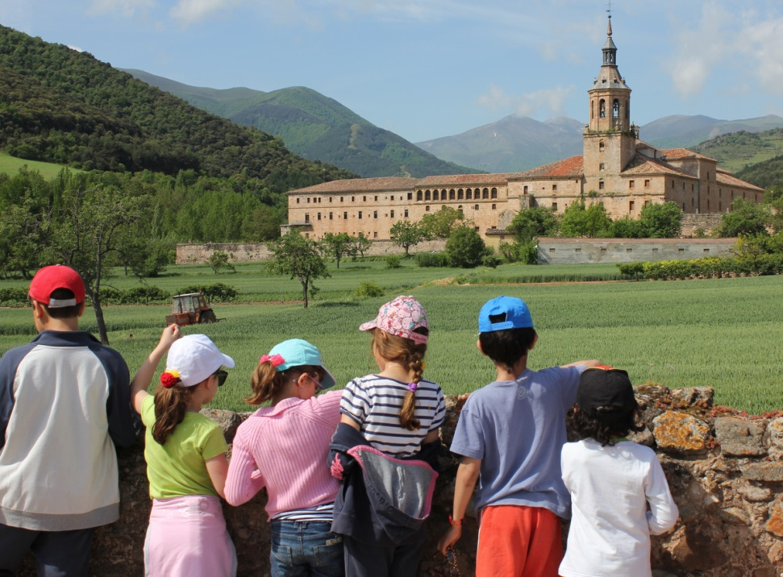

http://www.coe.int/en/web/culture-and-heritage/faro-convention
While the term heritage communities is explicitly indicated in the Convention, based on the local context, alterations including heritage groups, heritage teams, etc. could be used.
Member States can contact the Secretariat for assistance in promoting the Convention and for promotional materials.
Please find the steps developed by the Austrian experience in Annex V.
While the term heritage communities is explicitly used in the Convention, based on the local context, different terms, including heritage groups, heritage teams, etc. could be used.
Yates, G. 2004.
Please note that Wikipedia was also consulted for some of the definitions.
As per the purpose of the Action Plan but not limited to this definition.

