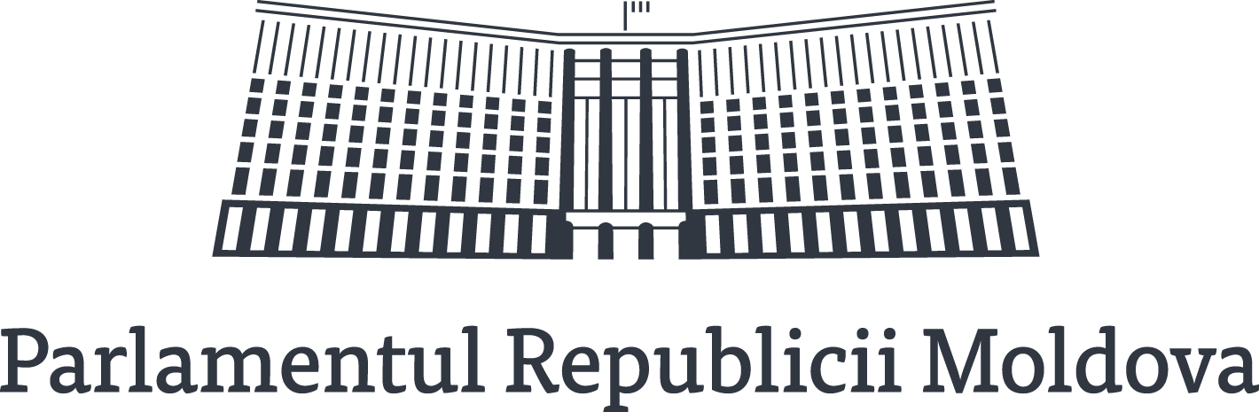
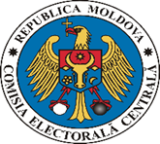
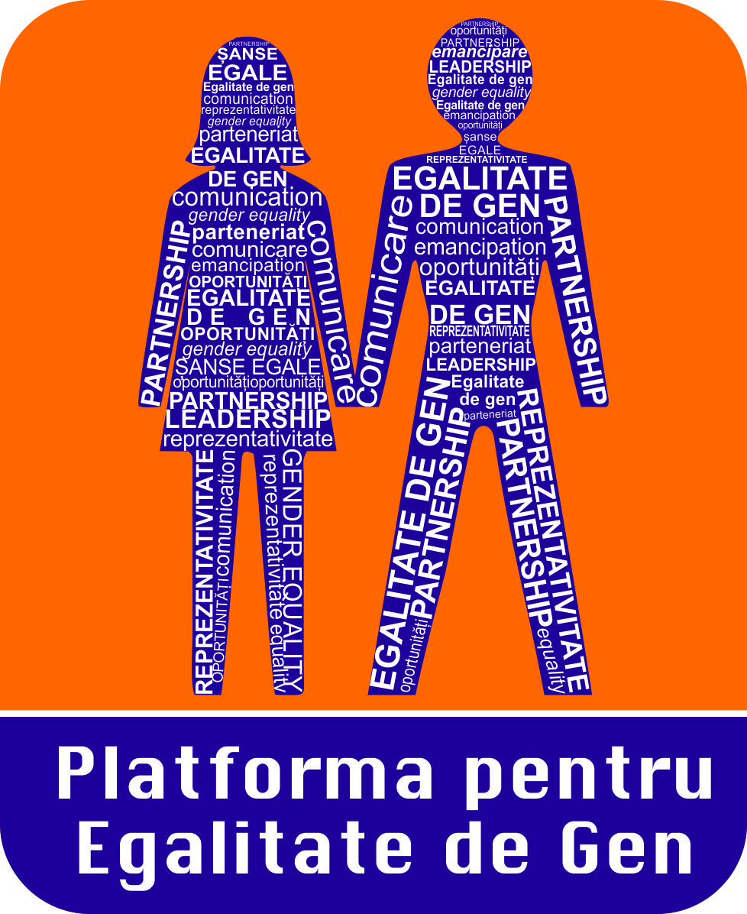

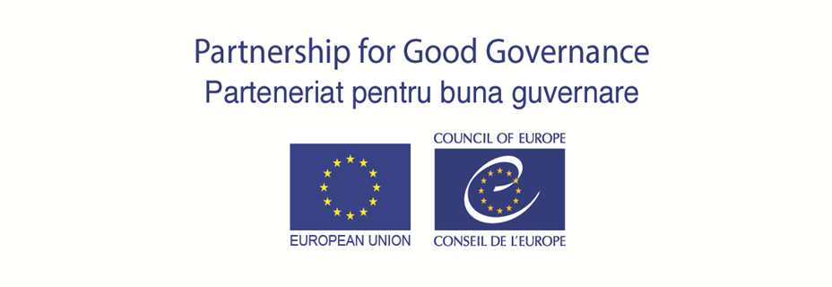

PRESENTATION OF THE REGIONAL GENDER STUDY
“WOMEN’S POLITICAL REPRESENTATION IN THE EASTERN PARTNERSHIP COUNTRIES”

DRAFT AGENDA
26 September 2017, 13:00 – 17:00
Chisinau, Republic of Moldova
Venue: Parliament of the Republic of Moldova, Europe Hall
(the access will be through main entrance)

13:00 – 13:15  13:15 – 13:30 | Registration of the participants  Opening remarks  Ms. Violeta Ivanov, Chairperson of the Permanent Parliamentary Commission “Committee on Foreign Policy and European Integration” of the Parliament of the Republic of Moldova  Ms. Alina Russu, Chairperson of the Central Election Commission of the Republic of Moldova
 | Ms. Eva Gutjahr, Deputy Head of the Council of Europe Office in Chisinau
13:30 – 14:15 | Presentation of the Council of Europe regional gender study “Women’s political representation in the Eastern Partnership countries”  Ms. Cornelia Perle, Programme Adviser, Division of Electoral Assistance, Council of Europe  Mr. Doru Petruti, Director of the Institute of Marketing and Surveys (IMAS)
14:15 – 15:00  15:00 – 15:15  15:15 – 16:00 | National mechanisms to enhance women’s participation in elections  Experience of the CEC and the in promotion of gender equality and empowerment of women  Ms. Alina Russu, Chairperson of the Central Election Commission of the Republic of Moldova  Ms. Cristina Cucurudza, Deputy Director of the Centre for Continuous Electoral Trainings by the Central Election Commission  Coffee break  Presentation of the Gender Equality Platform report on “Monitoring of the respect of the gender quota by the political parties of the Republic of Moldova”  Ms. Valentina Buliga, Chairperson of the Permanent Parliamentary Commission “Committee for social protection, health and family"  Ms. Ecaterina Mardarovici, President of the Gender Equality Platform  Ms. Cornelia Calin, member of the Permanent Bureau, Gender Equality Platform  Ms. Valentina Bodrug-Lungu, vice-president of the Gender Equality Platform
16:00 – 16:45  16:45 – 17:00 | Roundtable discussion  Final remarks  Ms. Violeta Ivanov , Chairperson of the Permanent Parliamentary Commission “Committee on Foreign Policy and European Integration” of the Parliament of the Republic of Moldova  Ms. Alina Russu, Chairperson of the Central Election Commission of the Republic of Moldova  Ms. Cornelia Perle, Programme Adviser, Division of Electoral Assistance, Council of Europe

