DDCP-YD/ ETD (2017) 67 Strasbourg, 26 April 2017

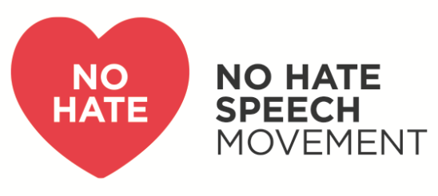

Youth Campaign for human rights online

Call for Tenders:
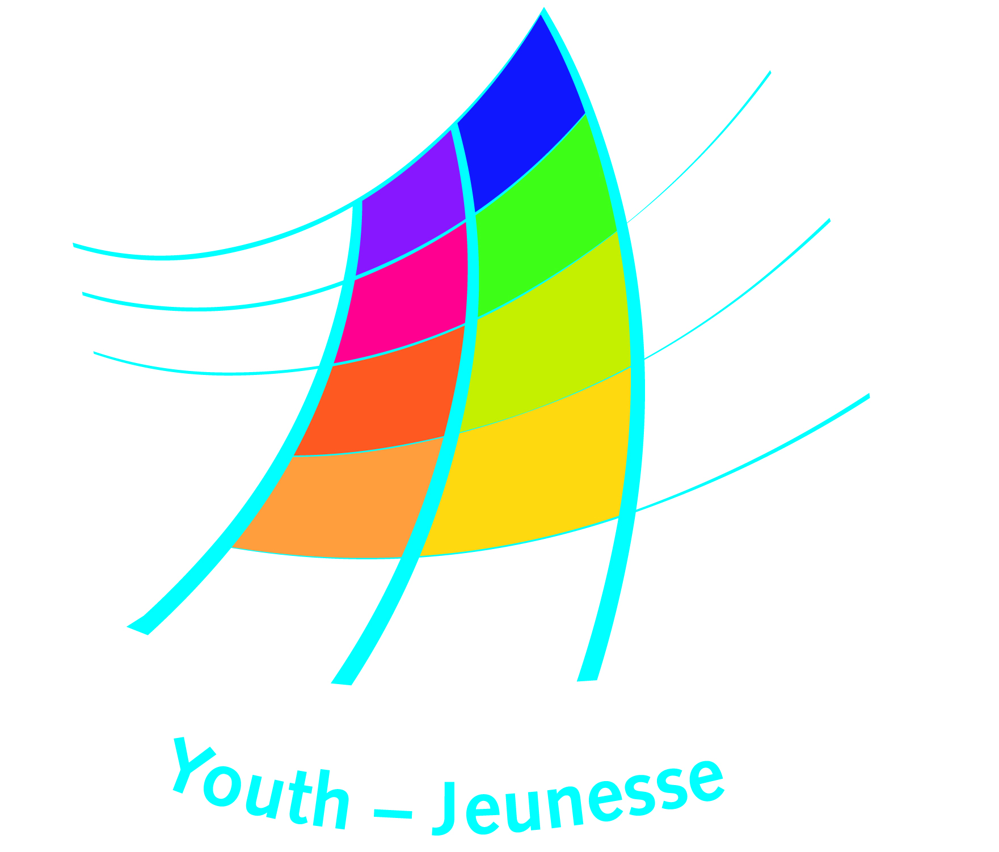
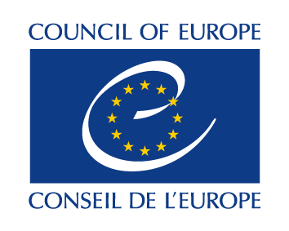
Evaluation of the No Hate Speech Movement
for the period 2016-2017

The Youth Department of the Council of Europe is seeking a consultant/s to conduct the evaluation of the No Hate Speech Movement (NHSM) youth campaign, according to the guidelines, requirements and criteria outlined below.

The Council of Europe welcomes applications from all candidates who fulfil the profile of this tender, irrespective of gender, disability, marital or parental status, racial, ethnic or social origin, colour, religion, belief or sexual orientation.

Interested candidates should submit their expression of interest by 22 May 2017, comprising of CV(s), experience and motivation, understanding of the Terms of Reference, proposed outline of approach, price and availability during the desired period.

All the services, material and reports related to this contract will have to be provided in English.

The duration of the contract will be from June 2017 to March 2018. The maximum budget available for the contract is 10.000 Euros.

- Introduction and background

The No Hate Speech Movement is a youth campaign of the Council of Europe for Human Rights online and against hate speech. The campaign was launched on 22 March 2013 on the initiative of the Youth representatives in the Joint Council on Youth. The Campaign was planned to run until the spring of 2015; an evaluation was conducted by a team of consultants for that period.

In May 2015, in the framework of the ‘Action Plan on the fight against violent extremism and radicalisation leading to terrorism’, the Committee of Ministers decided to continue the campaign until the end of 2017. The second phase of the campaign covers 2016 and 2017 as part of the Youth for Democracy programme. The campaign also contributes to the Council of Europe’s Action Plan for Building Inclusive Societies’ as the Strategy on Internet Governance.

The Joint Council of Youth (CMJ) adopted a concept note for the campaign 2016-2017 identifying 4 main objectives and actions.
The campaign remains based upon human rights education, youth participation and media literacy. Following the announced prolongation, the campaign platform was updated, new thematic focuses have been identified, namely sexist hate speech, antisemitic hate speech, and radicalisation leading to extremist violence. Greater emphasis is also placed on counter and alternative narratives to hate speech and reporting of hate speech.

The national campaigns of the No Hate Speech Movement are implemented with the active involvement of non-governmental and governmental youth representatives, organisations and partners, through national campaign committees or campaign support groups. National campaigns are adapted to the national contexts and languages. The online European campaign is implemented by an open community of 80 online activists. The campaign is also supported by over 60 European and International partners.

- Scope, purpose and objectives of the campaign evaluation

Scope of the evaluation
The evaluation of the NHSM-campaign 2013-2015 is well documented in an evaluation report. The evaluation conference in May 2015 together with other assessments has produced even more understanding of the results of the campaign that far. A proposal for evaluation indicators and means for verification were defined in 2016 and shared with the campaign partners. The current evaluation should not duplicate this work, but take it as a starting point for evaluating the years 2016-2017, including the preparation stage during 2015.

Goal

The evaluation should answer the following questions:
To what extent has the NHSM-campaign 2016-2017:
- changed the awareness amongst young people, their educators and policy makers, of the risk of hate speech and intolerance, online and offline
- mobilised activists and young people at large to act by reporting or denouncing it
- contributed to defending the rights of groups targeted by hate speech in a sustainable way?

The specific objectives of the evaluation are:
- To determine the level to which the campaign has achieved the objectives and expected results identified in the concept note adopted by the Joint Council on Youth
- To assess the programme against the 7 OECD-DAC criteria and associated detailed questions (see below)
- To identify key learning from the different stakeholders within the 5 different groups of actors in the campaign (see below). The evaluation should draw attention to lessons learned for campaigns of the Youth Department of the Council of Europe on European level stretching out to national levels, the learning strategy in the campaign, activities that went different than planned, challenges to the Theory of Change, success factors, good practices, challenges etc.
- To identify good practices and examples to build on after the completion of the campaign in the future work of the Council of Europe on Hate Speech.

The main actors of the campaign include 5 important groups:
- The campaign management, including the Youth Department of the Council of Europe (and the European campaign secretariat), the European Steering Committee on Youth and the Advisory Council on Youth of the Joint Council on Youth and its Follow-up Group of the campaign
- The online activists of the European campaign
- Institutional partners, such as other Council of Europe institutions and departments and European institutions
- National campaign committees and coordinators
- European campaign partners.

- Criteria and questions
In this evaluation the OECD-DAC criteria are applied: Relevance, Effectiveness, Efficiency, Impact and Sustainability. Since this is a complex campaign, it is also helpful to consider Coordination and Coherence.

Criteria Definitions:
- Relevance: The extent to which the campaign is suited to the priorities and policies of the target groups/ recipients, 5 different groups of actors and member states
- Effectiveness: A measure of the extent to which the campaign attains its objectives.
- Efficiency: Efficiency measures the outputs -- qualitative and quantitative -- in relation to the inputs. It is an economic term which signifies that the campaign uses the least costly resources possible in order to achieve the desired results. This generally requires comparing alternative approaches to achieving the same outputs, to see whether the most efficient process has been adopted.
- Impact: The positive and negative changes produced by a campaign intervention, directly or indirectly, intended or unintended. This involves the main impacts and effects resulting from the activity on the local, social, educational, political level and other progress indicators. The examination should be concerned with both intended and unintended results and must also include the positive and negative impact of external factors, such as changes in terms of governmental conditions.
- Sustainability: Sustainability is concerned with measuring whether the benefits of an activity are likely to continue after withdrawing the campaign. Coordination: The extent to which different actors’ interventions are harmonised, promote synergy, and avoid gaps, duplication, and resource conflicts.
- Coherence: The extent to which there is consistency across policies and actions towards a shared goal of objective, and to which all policies take into account human-rights considerations.

Criteria Questions:

Questions |  | Criteria for evaluation
1. | - What is the validity of the Theory of Change for the implementation of the campaign?  - To what extend did cross country campaigning contribute in reaching the outcomes?  - What is the result of the cooperation between the 5 different groups of actors?  - Which context situations provide a good basis for improved awareness of hate speech and taking action on it, and in what situations the NHSM-approach is less or non-effective? | Relevance
2. | - How effective is the campaign in achieving the stated outcomes in the member states and its contribution to adoption of the policy framework regarding hate speech? Where the outcomes have changed in priority, determine the validity of this.  - What is the progress made in the campaign themes Sexist Hate Speech, Antisemitic Hate Speech, and Hate Speech targeting Refugees in the campaign period and the contribution to improved prevention and counter hate speech and intolerance online and offline targeting these groups?  - What is the contribution of the results of other hate speech thematic actions to achieving the outcomes?  - To what extent has the approach been gender sensitive and/or gender transformative?  - What was the quality of the data collected through the web-based data collection system used in the reporting? What was the take-up of this system for stakeholders involved? What is the potential of the continuation of the Hate Speech Watch?  - What quality and effect did the counter and alternative narratives to counter hate speech developed by the campaign actors have?  - What is the quality and effect of the communication tools (flashnews, newsletter, social media, blog) to raise awareness of hate speech, counter and alternative narratives, and campaign actions and developments? | Effectiveness
3. | - What have been the benefits and challenges of using volunteer young online activists to nurture the Action Days and other parts of the central online campaign, which has been a key strategy from the beginning in 2013?  - How efficient and effective has the capacity-building of NCC’s and European level stakeholders been in strengthening quality of the campaign? To what extent has the capacity-building gone beyond European partners?  - To what extent has the pre-existing capacity of Council of Europe Youth Department / Secretariat of the Campaign at the start of the prolongation of the campaign in 2015, contributed to an efficient achievement of outcomes? | Efficiency
4. | - What elements of action against hate speech have been strengthened by the NHSM campaign approach, and how can these linkages been shown?  - What level of increase in capacity to recognise and counter-act hate speech has been achieved among target groups (entities, individuals, participants)? Distinguish online and offline. Taking into account the quality of educational tools and activities, online and offline; what factors have contributed to this increase?  - What learning has taken place within the existing partnerships and with other partners? How has the learning led to adaptations of the campaign? | Impact
5. | - In what ways have national and European level NHSM structures become sustainable for the cause of action against hate speech and intolerance online and offline, what ownership is taken and what aspects still need external support (financial, institutional, political, technological, social aspects)?  - What has been the level of accountability in the campaign on how resources are used?  - What can be observed as the most significant change due to the campaign? | Sustainability
6. | - What type of partnerships and collaboration has developed during the campaign with other stakeholders in the European context, and in the national / regional context, what were the (de-) motivating factors and what have been the results?  - What key lessons can be identified regarding the structure of the campaign and the interaction between stakeholders, based on successes achieved and obstacles encountered during the implementation period? | Coordination
7. | - To what extent has an adequate response been given to several and different crisis situations in this period (like terrorist attacks, sudden influx of refugees, populism, national elections or other events, and fake news for example) in the campaign context, as facilitated by the flexibility of the partners?  - How that response was linked to the general campaign approach?  - Was there a sufficient connection and interlink between initiatives from the central and de-central level within the campaign to provide common framework, that is to say one campaign with a shared common goal? | Coherence

Scoring the assessment criteria
For this evaluation a common scoring system is used to assess the contribution to campaign performance against the OECD-DAC , scoring as follows:

0 | 1 | 2 | 3 | 4
Low or no visible contribution to this criteria | Some evidence of contribution to this criteria but significant improvement required | Evidence of satisfactory contribution to this criteria but requirement for continued improvement | Evidence of good contribution to this criteria but with some areas for improvement remaining | Evidence that the contribution is strong and/or exceeding that which was expected of the intervention

- Methodology of the final evaluation

The selected evaluator(s) will develop a detailed plan for the evaluation in discussion with the European Campaign Coordinator. It should include:
- Desk review of key documents.
- In-depth interviews with key-representatives from all 5 groups of actors.
- Online questionnaires involving as many implementers as possible.
- Focus group discussions using open dialogue approaches to assess changes or verify indicated progress
- Direct observation of actions where possible.
- Analysis of central and national websites of the campaign
- Analysis of tools and instruments used in the NHSM campaign
- Analysis of stories of change (applying the Most Significant Change method)

- Sources of information

The evaluation should be based on the information available or to be gathered from the following sources:
- Online activists
- European partners of the campaign
- Council of Europe Youth Department staff and other bodies and services directly involved in the campaign
- National committees and coordinators
- The campaign platform www.nohatespeechmovement.org (including the Hate Speech Watch, Blog, etc) and the campaign website www.coe.int/youthcampaign.
- Facebook, Twitter, Youtube and other online media channels of the campaign
- The statutory bodies of the Youth Department
- Participants in online and offline campaign activities
- Reports of activities.

In relation to these sources, the evaluator/s is expected to design questionnaires, surveys, interviews or any other relevant tools to collect and analyse the information.
Analysis of Most Significant Change stories, is one of the evaluation methodologies suggested.

- Deliverables, calendar, and report outline

Deliverables are the following
- A detailed evaluation plan proposal, including outlines of instruments to be used
- A draft evaluation report
- Final report
- incorporating the feedback on the concept report
- including a self-contained abstract of maximum 10 pages
- Including mapping of good practices for the Council of Europe to follow up on in its work on hate speech
- Presentation and discussion of the findings with the Council of Europe/campaign Follow-Up Group

Tentative Calendar
3 May 2017 Launch call for tenders
22 May: Deadline call for tenders
2 June: Selection of consultant(s) and drafting of contract
12 June: Presentation of detailed evaluation plan
22 June: Agreement on detailed evaluation plan
28-30 June Meeting of national coordinators and online activists, Bucharest, Romania.
At the meeting the consultant should introduce the evaluation plan and review with the national partners the data gathering procedure and conduct interviews or group discussions.
September - December: Execution of the evaluation
Early January 2018: Preliminary evaluation report
February 2018: Final evaluation report.
March 2018: Closing Conference Campaign (presentation of results)

Report outlines
The report outlines below build on the report of the NHSM campaign evaluation 2013-2015. This outline is indicative and should be adapted to the agreed evaluation plan and evaluation results:
Acknowledgements
Glossary
Summary
I. Evaluation parameters, structure and organisation
1. Background to the evaluation
2. Purpose, objectives and scope of the external evaluation
3. Approach and methodology of the evaluation
4. Management of the evaluation
5. This report
II. Introduction to the Campaign
1. NHSM Campaign background and basics
2. Campaign context
III. Findings and analysis
1. Campaign purpose and objectives
2. Preparation of the Campaign 2016-2017
3. Outcomes and achievements assessed (per group of campaing partners)
4. Strategies and tactics employed
(Relevance, Effectiveness, Efficiency, Impact, Sustainability, Coordination, Coherence)
5. Structure, organisation and management
6. Mobilisation, messaging and communications
7. Other aspects
IV. Lessons and recommendations
1. Lessons and recommendations for future campaigns
2. Lessons and recommendations for follow-up of the current NHSM Campaign and the Council of Europes work on hate speech and anti-discrimination
Annexes
Collection of good practices that can be given visibility and build on as a legacy of the campaign containing evaluation data and information like ToR, tools used, participants in the evaluation, field data, documents consulted, etc.

- Competences required from the evaluators
The external evaluators should possess the following qualifications and experiences:
- Academic background or training in evaluation, evaluation research or project management, preferably within an international context;
- Experience with evaluation of European/international projects based on volunteerism and awareness-raising
- Knowledgeable in matters relating to hate speech, human rights, human rights education, youth/education policy, online campaigning and/or Internet Governance;
- Experience with online campaigns or/and educational tools, in particular through online social and media networks
- Experience of working with the Council of Europe or other European institutions
- Very good analytical and writing skills
- Very good command of English; knowledge of French and other languages will be an advantage
- Autonomy in the command and design of tools for evaluation
- Ability to work autonomously within a team and to respect strict deadlines.

- How to respond to this call and deadline
Interested candidates should submit their expression of interest before 22 May 2017 at 23:59, CET. Expressions of interest are to be sent to youth_tenders@coe.int

The submissions must comprise:
- CV(s) of the main evaluator(s)
- Completed form for expression of interest provided in Annex 1
- Completed form for Declaration of Honour provided in Annex 2, see also point 8. exclusion criteria
- proposed evaluation plan and calendar of implementation no longer than 6 pages
- A short (max 2 pages) sample of previous written material in English, related to the theme
- Budget proposal for the evaluation, this should be the final sum. It should specify:
  - Estimation of days for each aspect of the evaluation process (drafting plan, collecting data, report preparation, etc)
  - Rate per day/half day
  - Costs, if any, for data gathering tools etc.
Please note that the expenses for the ‘Meeting of National coordinators and online activists’ 28-30 June 2017 and the Evaluation conference in March 2018 are covered by the Youth Department of the Council of Europe and should be excluded from the budget proposal.

For further information: youth.nohatespeech@coe.int

- Award Criteria
The proposals will be evaluated according to the combined weight in similar proportions of:
- Competence and experience in evaluation of (online) campaigns and projects
- The adequacy of the evaluation plans
- The costs proposed by the bidders.

- Exclusion Criteria

Potential suppliers or bidders shall be excluded from participating in the tender procedure if they:
- have been sentenced by final judgment on one or more of the following charges: participation in a criminal organisation, corruption, fraud, money laundering;
- are in a situation of bankruptcy, liquidation, termination of activity, insolvency or arrangement with creditors or any like situation arising from a procedure of the same kind, or are subject to a procedure of the same kind;
- have received a judgment with res judicata force, finding an offence that affects their professional integrity or serious professional misconduct;
- do not comply with their obligations as regards payment of social security contributions, taxes and dues, according to the statutory provisions of their country of incorporation;
- are in a situation of conflict of interest in connection with this assignment; a conflict of interest may arise in particular as a result of economic interests, political or national affinities, family or emotional ties, or any other relevant connection or shared interest. Prior substantial involvement with the Council of Europe on communication-related assignments also constitutes a conflict of interest in the specific case of this assignment.

All bidders shall deliver, when submitting their tender, a declaration on their honour certifying that they are not in any of the above-mentioned situations (Annex 2).

The Council of Europe reserves the right to ask successful bidders to supply the following supporting documents:
- for the items in a), b) and c), produce an extract from the record of convictions or failing that an equivalent document issued by the competent judicial or administrative authority of the country of incorporation, indicating that these requirements are met;
- for the items in d), a certificate issued by the competent authority of the country of incorporation.

Annex 1: Form for expression of interest

External Evaluation of the No Hate Speech Movement
for the period 2016-2017

Personal details:
Name(s) and SURNAME(s):
Organisation (if relevant):
Email:
Telephone/s:
Address(es):

Bank details for contract:
Name Account holder:
Name of Bank:
Address of Bank:
Account number:
IBAN Number:
Swift code:
VAT exempt: Yes / No

Please provide details about your experience and expertise about:
Experience of conducting evaluations of (online) campaigns with a focus on youth:

Experience of conducting evaluations of projects addressing discrimination (and hate speech) and/or strengthening human rights education:

Your motivation to conduct this evaluation of the No Hate Speech Movement youth campaign 2016-2017 and any additional information that might be relevant in assessing your application.

Appendix 2: Declaration of honour with respect to the exclusion criteria and absence of conflict of interest
The undersigned (name of the signatory of this form):

in his/her own name (if the economic operator is a natural person or in case of own
declaration of a director or person with powers of representation, decision making or
control over the economic operator)

or

representing (if the economic operator is a legal person)
official name in full (only for legal person):
official legal form (only for legal person):
official address in full:
VAT registration number:

declares that the company or organisation that he/she represents:

- is not bankrupt or being wound up, is not having its affairs administered by the courts, has not entered into an arrangement with creditors, has not suspended business activities, is not the subject of proceedings concerning those matters, and is not in any analogous situation arising from a similar procedure provided for in national legislation or regulations;
- has not been convicted of an offence concerning professional conduct by a judgment which has the force of res judicata;
- has not been guilty of grave professional misconduct proven by any means which the
contracting authorities can justify;
- has fulfilled all its obligations relating to the payment of social security contributions and the payment of taxes in accordance with the legal provisions of the country in which it is established, with those of the country of the contracting authority and those of the country where the contract is to be carried out;
- has not been the subject of a judgement which has the force of res judicata. for fraud, corruption, involvement in a criminal organisation or any other illegal activity;
- is not a subject of the administrative penalty for being guilty of misrepresentation in supplying the information required by the contracting authority as a condition of participation in the procurement procedure or failing to supply information, or being declared to be in serious breach of his obligation under contract covered by the budget.

In addition, the undersigned declares on his/her honour:

- that he/she has no conflict of interest in connection with the contract. A conflict of interest could arise in particular as a result of economic interests, political or national affinities, family or emotional ties or any other relevant connection or shared interest;
- that he/she will inform the contracting authority, without delay, of any situation considered a conflict of interest or which could give rise to a conflict of interest;
- that the information provided to the Council of Europe within the context of this invitation to tender is accurate, sincere and complete.

Full Name Date Signature

See the campaign site on: www.nohatespeechmovement.org
For more on the campaign objectives see: http://www.coe.int/en/web/no-hate-campaign/objectives-and-priorities-2016-2017
For more on the campaign and it partners see: http://www.coe.int/en/web/no-hate-campaign/about-the-campaigns
The ‘Evaluation indicators and means of verification’ for the campaign partners were prepared as a tool and are therefore generic to allow the evaluation of the diverse practices and processes in the campaign. They can be consulted online: https://drive.google.com/drive/folders/0B_rCkmZRXWQid1RfcElTWjFVNUU?usp=sharing

