Directorate General iv: Education, Culture and Heritage, Youth and Sport

Directorate of Youth and Sport
European Youth Centre

April 2007
[Eval. sessions Educ. Adv. & Team E] DJS/G (2007) 8 E

Evaluation of Study Sessions at the EYC

To be filled in by the educational advisor of the study session in cooperation with the team. This form consists of two parts, which must be filled in separately. Please read the instructions at the beginning of each part.

Organisation: | Title of the study session:
Dates: | Evaluation form completed by (person/s):
Course director: | Educational Advisor:
Supervising Educational Advisor (from EYC) | EYC secretarial assistant following the session:
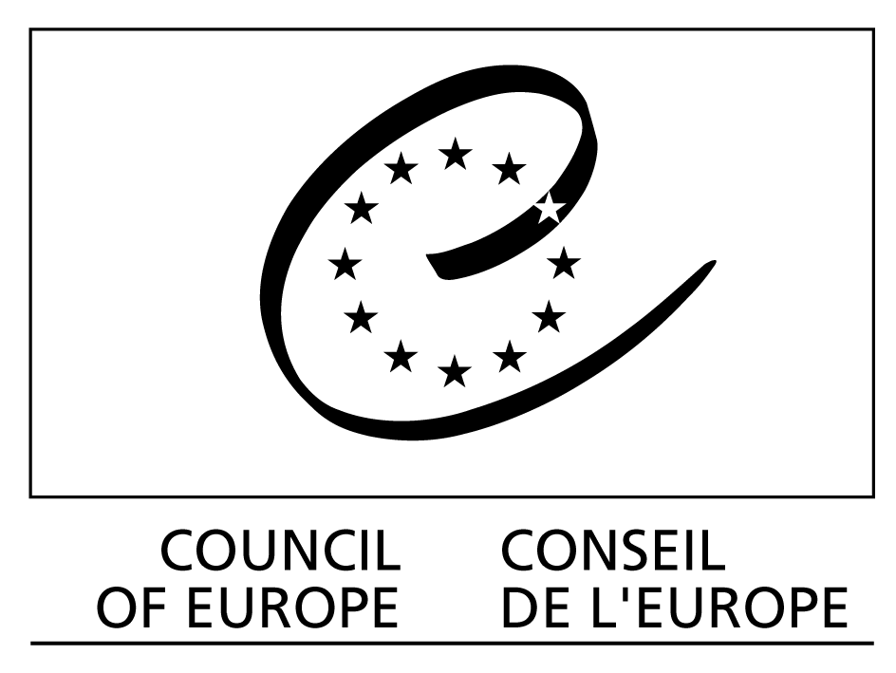

I. Evaluation by the team of the study session
This part of the form is to be filled in by the team of the study session, including the educational advisor, based on the discussions during the evaluation meeting.

- Aims and objectives of the session
Please give a short description of the aims and objectives of the session, specifying the relationship with the specific objectives of the DYS work priorities they are related to:

- Main contents
- What were the main issues discussed?

- What were the main educational methods used?

- Outcomes

- What were the most important outcomes or results of the session (including possible decisions/conclusions/resolutions)?

- How do the results contribute to the DYS priorities?

- Has any material (report, publication, exhibition, web site etc.) been produced on the basis of this activity?

- What were the main learning points for participants?

- What were the main outcomes or comments of the evaluation of the session by the participants?

- Has the activity developed any new methods or approaches?

- Expected impact and follow-up:

- What follow-up is planned or envisaged by the organisers of the session?

- How did the activity help the organisation to pursue its objectives?

- Has the activity contributed to the creation or reinforcement of organisations and networks? How?

- Were there projects developed requiring/expecting follow-up?

- Is there any expected or suggested follow-up of the activity within or by the Directorate of Youth and Sport?

- Information about the participants

- How was the profile of participants defined by the organisation?

- How did the organisation disseminate the information about this session? Was it difficult to find enough participants? If yes, what could possibly be a reason?

- Profile of the group

Expected Profile
How many participants (incl. team) did you apply for to the DYS?
How many people (incl. team) applied to participate in the session?
How many participants (incl. team) were finally expected?
Final Profile
How many participants (incl. team) actually did attend?
How many male participants (incl. team) did attend?
How many female participants (incl. team) did attend?
How many countries of resident did participants (incl. team) come from?
What was the average age of participants (incl. team)?

- Were the language and communication needs of participants adequately met?

- Lecturers or experts: please list the lecturers, speakers or experts invited to the session, their function and the team’s evaluation about their role:

- Preparation and implementation:

- Was the preparation of the activity by the team as well as by the secretariat of the organisation sufficient and effective?

- Were participants sufficiently prepared?

- How was the multicultural team composed?

- Did the participants have the profile desired by the organisers?

- Did you encounter any particular problems in preparing and running the activity?

- Any other comments:

II. Evaluation by the Educational Advisor
This part of the form is to be filled exclusively by the Educational Advisor

- EYC services

Please describe the adequacy of the support provided by the following services:

  - the EYC secretariat’s support during the preparation?

  - the services and support from the secretariat during the activity (technical support and secretariat assistance)

  - the services provided by the European Knowledge Centre (on youth policy) and other resources available in the EYCS / the Library in the EYCB

  - the working conditions for the team and consultant

  - the interpretation services (if appropriate)

  - the support by the EYC educational advisor or administrator
  - Any other suggestions for improvement

- The preparation and management of the session by the organisation

  - Which preparatory meetings did you attend?

  - Were there any particular difficulties in participating in those meetings?

  - Were you kept informed of major changes in the study session (e.g. programme, participants)

  - How would you evaluate in general your impact on the development of the programme and the educational methods of the study session?

- Miscellaneous
What recommendations would you give to:

    - The educational advisor working with the same organisation at the next session?

    - The secretariat of the EYC for a future session by the same organisation?

THANK YOU!

Please return to:
For study sessions taking place in EYCB: eycb.secretariat@coe.int
For study sessions taking place in EYCS: eyc.studysessions@coe.int

