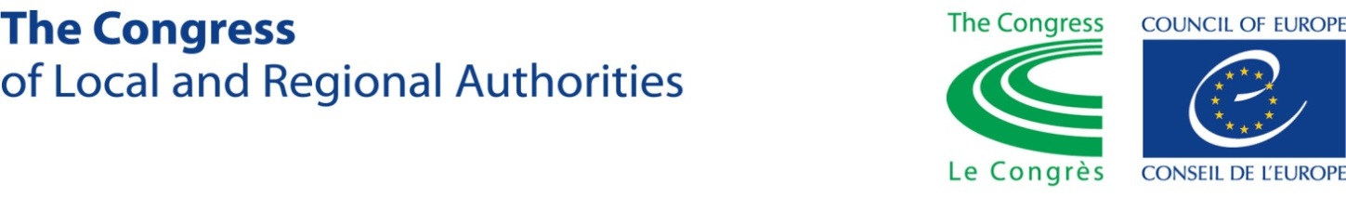
Application Form
for participation in the training seminar for young local leaders of Ukraine
organized by the Congress of Local and Regional Authorities

of the Council of Europe
4-6 April 2017, Dnipro, Ukraine

- Personal details

Family name |  |  |  | [color photo 3х4 cm]
Name
Patronymic
Age
Sex |  | Male | Female
Citizenship
Place of living

Oblast
City/region
Postal address and postal code
Phone:
E-mail:
Skype ID:

- Education, professional seminars, courses, internship programs, etc. (*please start with the latest)
Education
Dates | Diploma | Name of Educational Institution

Language skills (Please indicate languages spoken and level: not speaking, basic, intermediate, fluent)
 | Reading | Writing | Speaking
Ukrainian
Russian
English
Other
Other

Professional seminars, trainings, courses, internship programs, etc. (*add lines if needed)
Dates | Event/Program | Name of organization

- Professional activity (*Please start with latest)
Latest place of work and position
Name of organization
Organization’s field of activity
(NGO, Political unit/organization, local self-government, Mass media, etc.)
Position held
Date of appointment or election
For volunteers: date of accepting your obligations
Brief description of job responsibilities

Authorities, enterprises, organizations, civil unions etc., which you most often co-operate with in the framework of your job responsibilities

Previous professional experience
Dates | Name of organization and position held | Responsibilities

4. Social and political activities (*Please indicate your membership and position)
Political party
NGO
Local self-government authorities
Other ____________

5. Your motivation for participating in the seminar.
Please provide detailed answers to the following questions.

1. Have you been recently elected to the regional or local authorities? If so, please indicate the dates and post.

2. Do you plan to participate in the next elections to regional or local authorities? For which post?
3. Which issues related to the development of local self-governance do you personally deal with within your community today? Which aspects of development of local self-government would you like to develop in the future?
4. Please indicate and briefly describe in your own words max 3-4 key challenges which slow down the development of local self-government in Ukraine (please do not quote any State documents and/or research/analytical papers):
5. Please share a few words on your expectations from this seminar.

