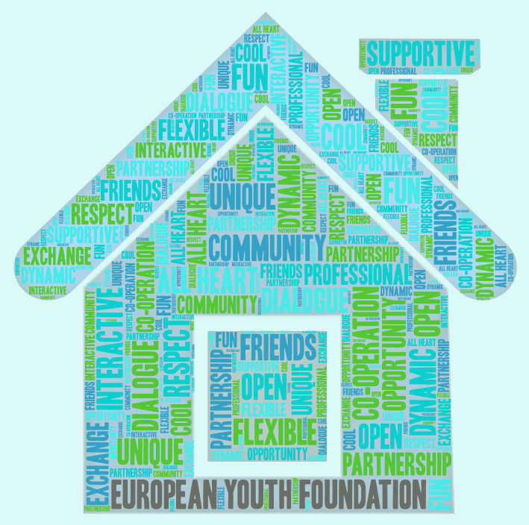  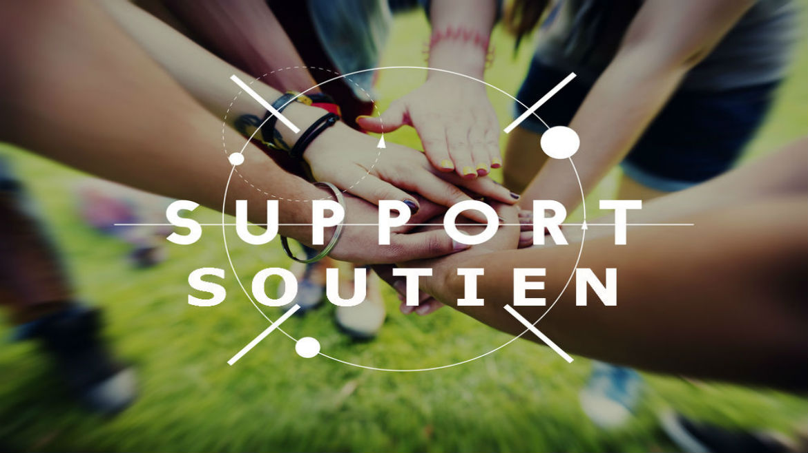  European Youth Foundation  30 rue Pierre de Coubertin  67000 Strasbourg  FRANCE |  |  | Who We Are  About Us  Set up in 1972, the European Youth Foundation (EYF) plays an essential role in the Council of Europe’s work to support youth civil society.  Its purpose is to encourage co-operation among young people in Europe by providing guidance and financial support to youth activities based on the Council of Europe's fundamental values: human rights, democracy and rule of law.  Our Values  Diversity, flexibility, respect, approachability and teamwork.  Contact Us  Phone: +33 (0)3 88 41 20 19  Fax: +33 (0)3 90 21 49 64  Email: eyf@coe.int  Visit Us  Web: http://eyf.coe.int – Facebook:  www.facebook.com/europeanyouthfoundation/ |  |  | Fact Sheet Holy See 2016  - European Youth Foundation Council of Europe
FACTS AND FIGURES 2016  In 2016, out of 320 grant applications evaluated by the European Youth Foundation, 167 were approved by the Programming Committee on Youth.  The EYF awarded over 3 million euros in grants.  Annual work plans account for 43% of the grants; international activities 16% and pilot activities 19%. The remaining 22% was devoted to 40 structural grants.  In total, 148 youth activities took place in member states: 67 pilot activities, 31 international activities and 50 activities within work plans.  The main themes tackled were: countering extremism and hate speech (19% of pilot activities, 16% of international activities, 10% of work plans), social inclusion of migrants, refugees, Roma (24% of pilot activities, 21% of work plans), peacebuilding (19% of international activities, 17% of work plans).  Nearly 800 NGOs in 45 countries are registered in the online system launched by the Foundation in 2013. |  |  | No youth NGOs from the Holy See are registered with the EYF. To register, an organisation has to be non-profit making and non-governmental, have its own statutes and run activities for and with young people (members are between 15 – 30 years old).  HOLY SEE 2016  Testimonial of Arci Chieti: “Thanks to this experience, we will include a gender perspective working session in all projects we will do in the future; it doesn’t matter which specific thematic they deal with. We want to proceed in this process of growing skills, competences and knowledge in order to address this important topic better and better.” |  |  | 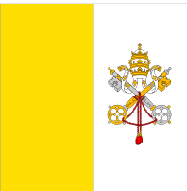  THE APPROACH  The EYF approach is based on the development of partnerships with NGOs.  The EYF is more than just a donor, offering financial but also educational support to youth NGOs, focusing on the content and methodology of projects. Through feedback, recommendations and questions the EYF hopes to create a reflective process, increasing the quality of projects. The focus is on the elaboration of projects that have a tangible, concrete impact. Two-way communication, flexibility, diversity and respect are the guiding principles of the Foundation and its staff.

