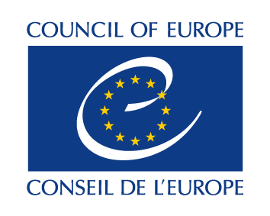
DIRECTORATE GENERAL OF DEMOCRACY

Consent form
Child safeguarding policy
Children’s Rights Division

Consent form for third parties working in the context of an activity of the Children’s Rights Division

Date and Place

I, the undersigned, [Full Name], confirm having read and understood the Child Safeguarding Policy of the Children’s Rights Division, including the Code of Conduct contained therein. I agree to implement the Code of Conduct in the activities I participate in or I am responsible for, namely child consultations on age assessment of children in migration for the Children’s Rights Division (VC1819).
I furthermore agree, to inform and seek approval in writing of the Policy and its Code of Conduct, of experts, consultants and contracted third parties that are recruited within the remit of my activities, involving the participation of children.

[Name, position,]

