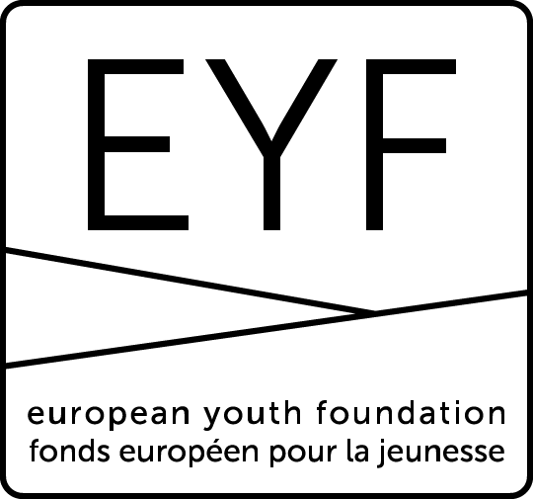
25/07/2017

EUROPEAN YOUTH FOUNDATION
GRANT APPLICATION FORM FOR 2018-2019 STRUCTURAL GRANT (SG2)
(awarded in principle for 2018 and 2019 and to be confirmed after one year)
This form is for drafting purposes only and must not be sent to the EYF.
It reproduces the information contained in the online form to help you prepare your application.
All grant applications must be submitted online.

PRESENTATION

NGO Name | Information taken from registration form
NGO Responsible | Information taken from registration form
NGO Number | Information taken from registration form
NGO Type | Information taken from registration form

Before filling in this form, I confirm that the information contained in the registration form is complete and up-to-date (box to tick)
It is important that you update the information contained in your registration form, in particular concerning your national branches/member organisations. This information will have a direct influence on the amount awarded for the structural grant (one of the criteria is the number of Council of Europe member states represented in the membership). Here are the allocation criteria for 2018-2019.

Person responsible
Who is in charge of communication with the EYF for this structural grant application?
This person will be the contact person for all questions and comments concerning this grant (application and report)

First name
Surname
Function
Email
Telephone

Structure

To be eligible, your organisation/network must have a European structure or secretariat. In addition to the information given in your registration form, you have 3,000 characters to explain the structure and role of the secretariat. Does your organisation employ paid staff in its secretariat or in its European structure? If so, please attach copies of the employment certificates below.

Attach certificates / employment contracts

Activities already supported
To be eligible, your organisation must have received support for at least 3 international activities during the three-year reference period. As this structural grant is for 2018-2019, the reference period for activities already supported concerns 2015-2017.
The following are considered as support for international activities during the reference period:
- an EYF grant for an international one-off activity;
- an EYF grant for an annual work plan;
- a study session in the programme of the European Youth Centres (Strasbourg or Budapest).

For example, you will be eligible if you had an EYF grant for an annual work plan in 2015, a study session in 2016 and an EYF grant for an international activity in 2017.
You will not be eligible if you have not had any EYF grant or EYC study session in 2016 or 2017 (i.e. if your last EYF grant or study session was in 2015), or if you did not receive any EYF grant during the two most recent years of the reference period (2016 and 2017), or if you have only organised study sessions over the 3-year period.

For the annual work plan, the number of international activities within a work plan will be taken into account up to a maximum of 2 per work plan.
For example, if an organisation did not have an EYF grant in 2015, but had a work plan with 2 international activities in 2016 and a work plan with one international activity in 2017, it will be eligible. On the other hand, if it only had a work plan with one international activity in 2015 and a work plan with one international activity in 2017, it will not be eligible.

You are asked to indicate the activities supported for each year. The international activity and work plan EYF grants awarded in the new online system since 2014 will automatically appear.

Example:
 | Title of the project | Supported by
2017 | Annual work plan and/or international activity EYF grant reference (automatic) | EYF
2016 | Study session “Title” (to be filled in manually) | EYC
2015 | Annual work plan and/or international activity EYF grant reference (automatic) | EYF

Annual activity report
Please attach a detailed report of your 2016 programme of activities. Do not attach here a list of activities (which we do not consider as a report) or your accounts (which will be asked later on in the form). A reflection on the way you implemented your activities in 2016 will be appreciated, being inserted in your report or presented in a separate document.

PLAN
Strategic approach for the next 2 years

Please attach a copy of your organisation’s strategic approach for 2018-2019.

Comment

You can provide additional information or comments here if necessary.

Links with the Council of Europe

You have 3,000 characters to explain the links between your strategic approach and the priorities of the Council of Europe’s youth sector for 2018-2019 (see EYF website http://eyf.coe.int).
Please explain how your future activities will contribute to achieving the objectives defined for the youth sector’s programme.

Programme of activities

Please attach a copy of your programme of activities for 2018 (as detailed as possible).

Comment

You can provide additional information or comments here if necessary.

BUDGET
Please attach a copy of your certified/audited accounts for 2016 (certified by the person legally responsible in your organisation or audited by an independent auditor).

Fill in the online budget table with an estimate of your expenditure and income for 2018 (in Euros).

You should indicate the amount of the grant requested from the EYF for one year (maximum € 25,000).
The amount granted will be decided by the Programming Committee on the basis of a certain number of criteria (number of branches or members, paid staff, strategic approach).

If the grant is awarded for 2018, the same amount will be awarded in principle for 2019, based on the validation by the EYF of an interim report after one year.

Expenditure
Activities | Please give a short description of all your activities (youth projects) and the corresponding budget (not limited to those funded by the EYF). This does not include statutory meetings and operating costs (see below). | €
Operating costs | Staff salaries | €
 | General (phone, postage) | €
 | Office rent | €
 | Statutory meetings | €
 | Other costs | €
 | Total | €

Income
 | Primary source of income | (description) | €
 | Second source |  | €
 | Third source |  | €
 | … |  | €
 | … |  | €
 | EYF grant requested |  | Maximum 25,000 €
Total |  |  | €

Exchange rate used (if applicable) …….

VALIDATION
Before submitting your application, you will be asked to confirm that you have taken note of the EYF operational regulations (see link on EYF website – About us/Official documents - paragraph 1.B on structural grants) and that the information you provide in the application is true and correct.

Additional attachments (optional, available at all times)

Other files to share with the EYF?
You can use this space at any time to share documents related to your request. Please make sure that they add relevant information and not just copy what has already been filled in.

